Practical work N°4
Cartilaginous tissue
TP N° 3 : Le tissu cartilagineux

Introduction
Cartilaginous tissue is one of the connective tissues composed of a single type of cell: chondrocytes. These cells are enclosed in small cavities called chondroplasts.
Chondrocytes are responsible for the synthesis and degradation of all components of the extracellular cartilaginous matrix.
Cartilaginous tissue is surrounded by a connective formation called the perichondrium, which ensures its nutrition and growth.
Description of the histological slides to be observed

Slides 01:
Hyaline cartilage is a type of cartilage that provides support and flexibility while maintaining a smooth surface for joint movement. It consists of chondrocytes embedded within chondroplasts, surrounded by an extracellular matrix rich in collagen fibers and proteoglycans. This cartilage is covered by the perichondrium, except in areas like articular cartilage. It plays a crucial role in fetal development, forming the initial framework for bones before they ossify.

- Overview of hyaline cartilage tissue: presence of small cavities (chondroplasts), inside which chondrocytes are found. The cartilage is surrounded by the perichondrium.
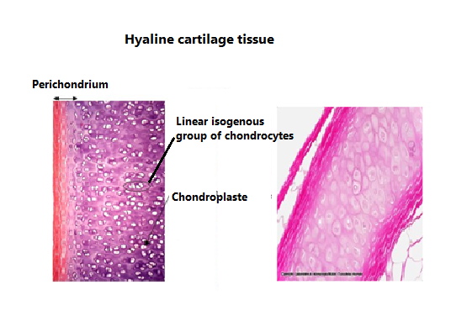

Slide 02
Elastic Cartilage
Elastic cartilage** is a specialized type of cartilage that provides both strength and flexibility due to its high content of **elastic fibers** in the extracellular matrix. It is structurally similar to **hyaline cartilage** but contains a dense network of elastin fibers, making it more resilient and capable of returning to its original shape after deformation.

Characteristics of Elastic Cartilage
- Cells: Chondrocytes are housed within lacunae (chondroplasts).
- Matrix: Contains type II collagen fibers along with abundant elastic fibers.
- Perichondrium: Present, providing nutrients and aiding in growth and repair.
- Flexibility: Highly flexible and elastic compared to hyaline cartilage.
Functions of Elastic Cartilage
- Provides structural support while maintaining flexibility.
- Allows tissues to return to their original shape after bending or stretching.
- Helps maintain the open passage of the auditory tube and epiglottis.

2- At high magnification, the **perichondrium** shows two distinct zones:
- **External fibrous zone**, containing the nuclei of fibroblasts.
- **Internal cellular zone**, where fibroblasts differentiate into chondroblasts.

