II. Connective Tissue
Of mesenchymal origin, connective tissue is composed of isolated cells dispersed within an abundant extracellular matrix. The extracellular matrix of connective tissue consistes of :
- Protein fibers: Collagen, reticular, and elastic fibers.
- Amorphous ground substance: An optically empty, gel-like substance.
This matrix fills the spaces between cells, facilitates cell-to-cell associations, and provides mechanical resistance (such as in bones or tendons). Connective tissue is separated from other tissues by a basal lamina.

Classification of Connective Tissue
The relative composition of fibers, ground substance, and cells allows connective tissue to be classified into dense and loose connective tissue:
- Dense connective tissue: Contains a high concentration of fibers, which are tightly packed together.
- Loose connective tissue: Contains moderately abundant fibers, which are loosely intertwined.
The term "connective" comes from the primary function of this tissue: forming links between tissues and organs.
Beyond its structural mechanical role, connective tissue also:
- Regulates exchanges of nutrients, metabolites, and waste products between tissues and the circulatory system.
- Participates in immune defence mechanisms. …and in inflammation. It is a highly vascularized tissue through which blood and lymphatic vessels circulate.

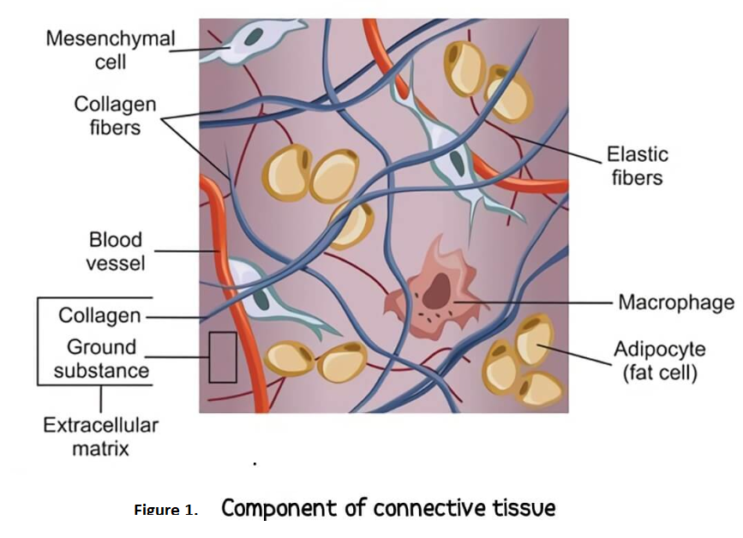

II.1. Basic Components of Connective Tissue

II.1.1. Connective Tissue Cells

Fibroblasts / Fibrocytes
Fibroblasts are the main cell type in connective tissue and are responsible for synthesizing collagen, elastic fibers, and ground substance. Fibrocytes are less active but can reactivate into fibroblasts when needed.

II.1.2. Fibers
Fibers are long, thin protein polymers present in varying proportions depending on the type of connective tissue. There are three main types of fibers:
- Collagen fibers
- Reticular fibers (Réticuline)
- Elastic fibers (Élastine)

A. Collagen Fibers
Collagen fibers are the most abundant in connective tissue and provide tensile strength and structural support. They are composed of collagen proteins, which are synthesized by fibroblasts.
Collagen is the most abundant fiber in supportive tissues. This protein is characterized by its high tensile strength rather than elasticity.
- In spreads (histological preparations), collagen fibers appear long, slightly wavy, and non-anastomosed (not branching).

B. Reticular Fibers
Reticular fibers are primarily composed of type III collagen. They are generally thin, irregular, and form interconnected networks. These fibers are particularly found in:
- Liver
- Lymph nodes
- Hematopoietic organs (e.g., bone marrow, spleen)

C. Elastic Fibers
In histological spreads of stained mesenteries, elastic fibers appear as a network of branched, flexible fibers.
- They can be stretched up to 150% of their resting length and return to their original shape once the tension is released.
- This elasticity is due to their lysine content.
- Elastic fibers are abundant in connective tissues of organs that must deform and recoil, such as:
  - Aorta
  - Alveolar septa of the lungs
  - Skin
  - Bladder

II.1.3. Ground Substance
Ground substance fills the space between cells and fibers in connective tissue.
- In fresh tissue, it appears translucent, colorless, and has the consistency of a highly hydrated gel.
- It is composed of:
  - Water and ions
  - Non-fibrillar organic compounds, including:
    - Glycosaminoglycans (GAGs) → long polysaccharide chains
    - Proteoglycans
    - Glycoproteins
The most abundant glycosaminoglycan is hyaluronic acid, a non-sulfated GAG. Other glycosaminoglycans form proteoglycan aggregates, which help retain water.

II.2.1. Loose Connective Tissues
In this type of tissue, there is a balanced distribution of cells, fibers, and ground substance.
- It is flexible and well-vascularized, providing support and nutrition to surrounding tissues.
- Due to its high ground substance content, it serves as a reservoir for water and ions.
- It plays a key role in immune defense, as it houses mobile immune cells.

II.2.2. Dense Connective Tissues
These tissues are characterized by a high abundance of collagen fibers embedded in a less prominent ground substance.

A. Dense Regular Connective Tissue
In this type, collagen fibers are arranged in a parallel, organized manner, which provides high tensile strength in one direction.

B. Dense Irregular Connective Tissue
In dense irregular connective tissue, collagen fibers are arranged randomly, rather than in a parallel structure. This disorganized fiber arrangement allows the tissue to resist mechanical stresses in multiple directions, providing strong structural support.

Key Features:
- High collagen fiber content
- Irregular fiber orientation
- Resistant to stretching and mechanical forces from different directions

II.2.3. Connective Tissues Predominantly Composed of Elastic Fibers
In this type of tissue, elastic fibers predominate over other components, including collagen fibers.
- The abundance of elastic fibers provides tissues with the ability to stretch and recoil.
- Example: The yellow ligament of the spinal column, which allows for flexibility and support while maintaining the structural integrity of the spine.

II.2.4. Reticular Tissues
Reticular tissue is composed of fine reticular fibers (type III collagen) arranged in a network (mesh), providing a structural framework. The reticular cells rest on this network.
- This tissue is primarily found in lymphoid and hematopoietic organs, where it supports the cells involved in immune responses and blood cell production.

Examples of Locations:
- Lymph nodes
- Spleen
- Bone marrow

