* **Quoting, Paraphrasing, Summarising**

**1. Quoting:**

Quotations are the exact words of an author, copied directly from a source, word for word. Quotations must appear with quotation marks.

* Over quoting is a common problem in academic writing and as you move further into your education; you will be expected to paraphrase instead of quote.

**2. Paraphrasing**:

Paraphrasing is stating an idea or a passage in your own words. You must significantly change the wording, phrasing, and sentence structure of the source.

A **paraphrase** is **a detailed restatement in your own words** of a written or sometimes spoken source material. Apart from the changes in organization, wording, and sentence structure, the paraphrase should be nearly identical in meaning to the original passage. It should also be near the same length as the original passage and present the details of the original.

**3. Summarizing:**

**Summarizing** involves putting the main idea(s) into your own words, including only the main point(s).

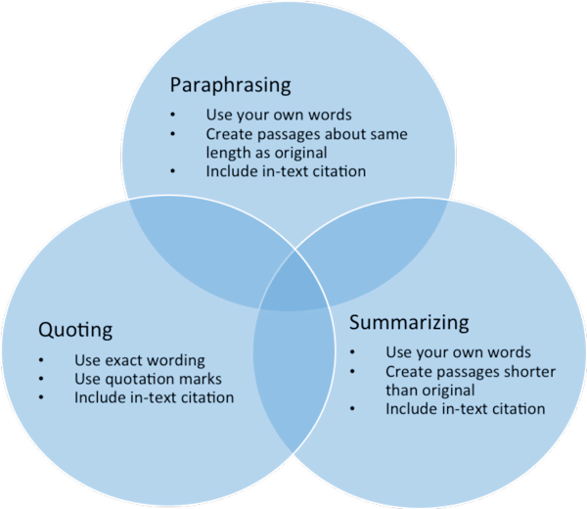A **summary** is **a condensed version of a passage**. Similar to paraphrasing, summarizing involves using your own words and writing style to express another author's ideas. Unlike the paraphrase, which presents important details, the summary presents only the most important ideas of the passage; it is significantly shorter than the original.



**Thanks for attending the session**

**Rahmane Amal**