Chapter I: General

I.1 INTRODUCTION
Concrete is a material that resists compression well, but little, and especially randomly, resistance to traction. It is therefore interesting to build in concrete, but avoiding this material being too tense and risking cracking. And for this, it must be compressed artificially and permanently, in areas where external loads develop traction so that overall the concrete remains compressed (or not very tense enough to avoid the risk of cracking) and therefore resistant. in any load case. The compressive force voluntarily developed for this purpose is called the prestressing force (or prestress). The remedy must not err on the side of excess: the total compression of the concrete must remain below a reasonable value so as to avoid any risk of longitudinal cracking of the prestressed elements due to excess compression (while tension generally develops transverse cracks).
In total, a concrete structure is said to be prestressed concrete when it is subjected to a system of forces artificially created to generate permanent stresses, which, combined with the stresses due to external loads, give total stresses between the limits that concrete can support indefinitely, safely (Figure 1).
G,Q

Figure I.1: Reinforced concrete beam [1]

The beam also undergoes shear stresses due to the shear forces which occur towards the supports. These constraints cause 45° cracks that the concrete cannot repair on its own. In this case, two solutions are possible:

- Solution No. 1: Adding a quantity of reinforcement capable of absorbing the tensile forces in the concrete (Principle of reinforced concrete).

Figure I.2: Principle of reinforced concrete [1]
- Solution No. 2: The application of an axial compressive force which opposes tensile stresses due to loading (Principle of prestressed concrete).
Figure I.3: Principle of prestressed concrete [1]

I.2 GENERAL PRINCIPLE OF PRE-STRESSING
Concrete is a material that resists compression well, but little, and especially randomly, resistance to traction. It is therefore interesting to build with concrete, but avoid this material being overstretched and risking cracking. To do this, it must be compressed artificially and permanently, in areas where external loads develop traction so that overall the concrete remains compressed (or not very tense enough so as not to risk cracking) and therefore resistant to any discharge case. The compressive force voluntarily developed for this purpose is called the prestressing force (or prestress).
The objective of prestressing, by imposing a judiciously applied axial compressive force on the elements, is to eliminate (or significantly limit) the tensile stresses in the concrete (Figure I.4).

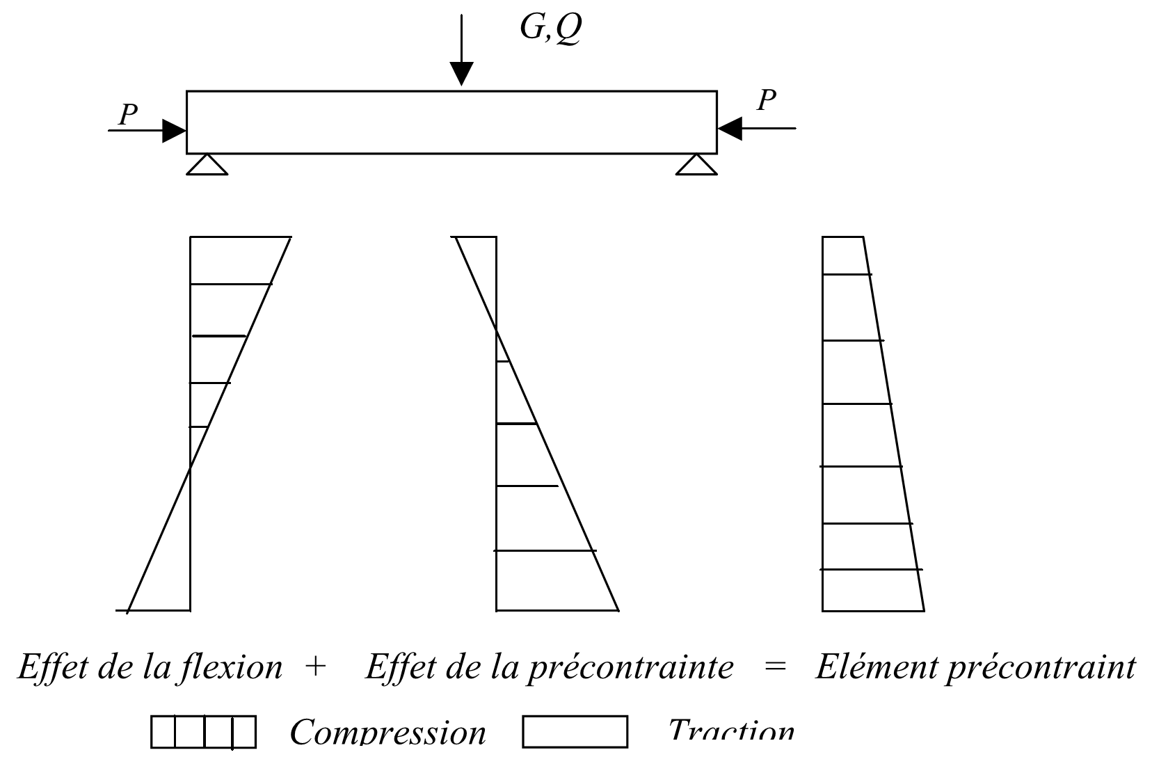

Figure I.4: Prestressed element [1]

This prestress can be:
- Total prestressing
The notion of total prestressing, introduced and defended by Freyssinet, implied the total absence of traction in the concrete, which constitutes a very severe condition. This design was somewhat theoretical in nature, since it required prestressing in all directions (horizontal, vertical and transverse).
- Limited prestress
If the tensions tolerated in the concrete are sufficiently low in relation to the tensile strength, cracking is avoided. This corresponds to the “limited prestress” (beschränkteVorspannung), according to the German standard DIN 4227, this standard indicates, for a B300 concrete (βw = 300 kg/cm²) for example, the following values:
σb (edge) = 30 kg/cm² σI(core) = 20 kg/cm² (combined shear force and torsion). These stresses correspond approximately to “The limit state of crack formation”
- Partial prestressing: authorization of limited tensile stresses.

I.3 PRE-STRESSING MODES
I.3.1 Introduction
The prestressing technique includes two main application methods: - Pre-tension (English: tensioning). - Post-tension (in English: post-tensioning). They are sometimes designated by other expressions, but the two terms above are the clearest to express the difference between the two methods.
I. 3.2 Pre-tension
It is a method used in factories to prefabricate prestressed beams intended to be incorporated into constructions as “products”. This process can be carried out in the factory or on site. The method generally follows the following procedure:
- Preparation of molds (cleaning, application of formwork oil, etc.),
- Unwinding of the reinforcements (adherent wires or strands) and blocking at the ends,
- Installation of passive reinforcements to take up the tensile forces,
- Tensioning of the wires or strands by jacks located at one of the ends
- Pouring of concrete, smoothing and vibration by external vibration,
- Steaming or heating of concrete to accelerate its hardening,
- After hardening deemed sufficient (by calculation and previous tests), stress relief and cutting of the wires,
- Handling and storage of items, taking care not to return them.
The pre-tension does not adapt well to a route of non-rectilinear cables or adhering wires. The eccentricity is therefore constant. This limits the use of this process. It is however possible, using deflectors, to create a route comprising three continuous rectilinear segments, better suited for future demands. Prestressing by pre-tension is widely used in the building sector. However, it is difficult to exceed beam lengths greater than 30 m.

Tensioning
Pouring concrete
Cable release
Prestressed beam

Figure I.5: Prestressing by pre-tension [1]

I. 3. 3 prestressing by post-tensioning
This is the most used method today, it offers a very wide variety of applications and is sometimes associated with the previous method (prefabricated adhering wires with cables stretched on site). The post-tensioning technique consists of taking support on the already hardened concrete to tension the prestressing cable. The concrete element is therefore poured beforehand, with reservations for the subsequent passage of the prestressing. When the concrete reaches sufficient strength, the prestressing cable is threaded and tensioned using jacks. There are two variants: internal post-tensioning and external post-tensioning. Case of prestressing by internal post-tension mise en place du coffrage,
- Installation of passive reinforcements and duct support chairs,
- Installation of solid sheaths and fixing on the reinforcing cage,
- Installation of support plates and hooping adjacent to the ends of the ducts,
- Pouring of concrete,
- During curing, threading of cables,
- After hardening deemed sufficient (by calculation and previous tests), installation of anchoring plates and locking keys for the strands in the cylinder,
- Tensioning on one side for short cables and on both sides for long cables.⎫ Injection of grout (or mineral grease) to protect the cables.
- Case of prestressing by external post-tension. The concrete is poured at room temperature or slightly heated by insulation.
- The sheaths are placed outside the concrete (in the interior zone of the box) and in the final position of the work.
- We slide the loose cables into the sheaths.
After a period deemed sufficient, the cables are tensioned at periods and intervals depending on the project and the methods of execution of the work. Blocking is done by different wedge systems on a zone of shrink concrete. A concrete grout (micro concrete) or mineral grease is injected.

Duct placement

Pouring concrete

Tensioning

Prestressed beam

Figure I.6: Prestressing by post-tensioning [1]

Tensioning can be done by tensioning the steel at both ends of the part (active - active) or by tensioning one end only (active - passive) (Figure I.7).

Active - Active

Active - Passive

Figure I.7: Tensioning [1]

The injection is an extremely important operation, because it plays a dual role:
1) Protection of prestressing reinforcements against corrosion.
2) Improving adhesion between the reinforcements and the sheaths. The injection operation must be carried out as soon as possible after tensioning of the armatures.
The injection product must meet the following requirements:
- Have a low enough viscosity to flow easily and penetrate all openings and between wires of prestressing cables;
- Maintain this low viscosity for a sufficient period of time so that the injection can be carried out in good conditions before the start of setting;
- After hardening, have sufficient strength to effectively ensure adhesion of the reinforcement to the concrete;
- Present minimal shrinkage;
- Do not be aggressive towards the prestressing steel.
The injection product was formerly a mortar made of cement, sand and water; today sand is almost completely abandoned, in favor of CPA cement grout, containing an adjuvant. The entire prestressing process generally includes the following elements:
Anchoring device: there are mainly two types of anchoring:
-Fixed anchors
Intended solely to hold the cable, without the possibility of pulling it. They can be made up of one or more loops (fig. I.8), by a curved plate if the wires are fitted with buttons (fig.I.8), by rectilinear seals, if they are strands (fig. I.8), by corrugated seals (fig.I.8), etc.
Mobile anchors can also be used as fixed anchors, by blocking them beforehand.
-Mobile anchors
On which the jack is applied during tensioning, which includes a locking device retaining the end of the cable, once it is tensioned. Most systems allow tensioning in stages, by unlocking and reblocking the cable.
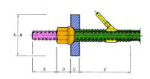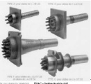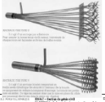
Figure I.8: Fixed and mobile anchoring system [2]

- Couplers
Device allowing extensions of reinforcements. Fixed couplers allow a section of cable to be connected to another already stretched section. Mobile couplers join two sections of a cable placed successively, but tensioned in one go. These possibilities are taken advantage of in the construction of span-advanced bridges. Coupling Dywidag bars is easy, since you just need to place a threaded sleeve at the junction of the bars.

Tensionin g equipment: cylinders, injection pumps, cylinder supply pump, etc. Accessories: sheaths, injection tubes, etc.

I.3. 4 Comparison of the two processes

A comparison between the two processes (post-tensioning and pre-tensioning) allows us to note the following observations:

Pre-tension

1) The economy of sheaths, anchoring devices and the injection operation.

2) The need for very heavy installations which consequently limits the choice of shapes.

3) The simplicity of carrying out the process.

4) Good collaboration of concrete and reinforcement.

5) The difficulty of producing curved reinforcement lines.

6) The impossibility of adjusting the force in the reinforcements after tensioning. Post-tensioning

1) Does not require any fixed installation since; it is on the part itself that the prestressing cylinder rests.

2) It allows the choice of different shapes.

3) The possibility of adjusting the prestressing force, which makes it possible to adapt the process to the evolution of the mass of the structure.

4) The ease of producing curved lines of prestressing reinforcement. Alongside these classic processes, there are special processes which are reserved for certain works or which use other principles for tensioning:
- Winding prestressing
- Prestressing by external compression
- Tensioning by thermal expansion
- Tensioning by expansion of concrete

I.4 PRE-RESTRAINT SYSTEMS
The prestressing systems are the subject of patents and are manufactured by their operators. The main systems are:
I.4.1 Freyssinet system
This system uses cables composed of T 13, T 13 S, T 15 and T 15 S strands. The letter T is replaced by the letter K (example 12 K 15)
PAC system This system uses cables composed of 1 to 37 T 13, T 13 S, T15 or T 15S.
CIPEC system This system uses 4 T 13 to 19 T 13, 4 T 15 to 27 T 15, normal and super cables.
VSL system This system uses 3 T 12 to 55 T 13, 3 T 15 to 37 T 15, normal or super units. Their name is of the form 5-n for n T 13 and 6-n for n T 15. (Example: 6-37 represents a cable or a 37 T15 anchor).

I.5 FIELD OF APPLICATION

The invention of prestressed concrete is due to the French engineer Eugène Freyssinet. The first practical applications were attempted in 1933. In the years that followed, the exceptional performance of this new concept was brilliantly demonstrated. Thanks to these advantages, prestressed concrete is used in structures and buildings of large dimensions: it is commonly used for bridges and is widely used for prefabricated beams for building floors. It is found in many other types of structures, including reservoirs, foundation piles and tie rods, certain maritime structures, dams, and nuclear reactor enclosures.

I.6 REGULATIONS

IP1: Provisional Instruction No. 1 of August 12, 1965

IP2: Provisional Instruction No. 2 of August 13, 1973

BPEL 91: Prestressed concrete at limit states

Euro code 2: (Reinforced concrete and prestressed concrete).

I.7 MATERIALS USED IN PRE-STRESSING

I.7.1 Mechanical characteristics: concrete

The concrete must also be of very good quality. Indeed, as long as it is not prestressed, it risks cracking due to the hindrance caused by the formwork during its removal; To avoid this, this concrete must be prestressed very early while, still young, it has limited strength. The concrete must therefore be of high strength and acquire this very quickly. It is in fact very popular at the time of tensioning:
- In current section, because the prestressing has its maximum value (the losses have not yet been made); moreover, the external loads (whose effect is opposite to that of the prestressing) are often incomplete (for example, if superstructures have not yet been put in place), locally, under anchorages, areas where a very concentrated effort is exerted. To limit the stress on young concrete, the cables are frequently tensioned in several successive phases: from a third to half of the cables approximately 7 days after pouring the concrete (to be able to unbend the beam, which can then carry its weight), and the rest at a date generally between 15 and 30 days after pouring. In addition, the anchors are often placed in a prefabricated end piece of shrink-wrapped concrete that is sufficiently old to be able to withstand the localized forces under the anchors. In any case, prestressing constitutes a decisive preliminary test for concrete which would not forgive any possible mediocrity.

I.7.1.1 Compression resistance
Concrete is characterized by its compressive strength at 28 days. This resistance is measured according to standard NF EN 12390. It can be done on a cylinder or on a cube. In France, it is usually done by crushing cylindrical test pieces with a section of 200cm² (diameter Φ = 160mm) and a height of 320mm (so-called “16/32” test piece). For the stresses exerted on concrete less than 28 days old, we refer to the characteristic resistance fcj. The BAEL and BPEL rules give, for an age j ≤ 28 days and for non-heat-treated concrete:
If fc28 ≤ 40 MPa donc :
fcj= j fc28
4.76+ 0.83j

And if fc28 > 40 MPa

Beyond j=28 days, we admit for the calculations that fcj= fc28

I.7.1.2 Tensile strength

The characteristic tensile strength, at the age of “j” days, denoted ftj, is conventionally defined by the formula: ftj= 0,6 + 0,06 fcj

Ftj and fcj are expressed in MPa (or N/mm²)
I.7.1.3 Instantaneous longitudinal deformations
In the absence of conclusive experimental results, we adopt for the instantaneous longitudinal deformation modulus of concrete noted Eij, a conventional value equal to: Eij=11000 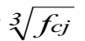
The deferred longitudinal deformation modulus Evj is given by: Evj=3700 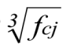
I.7.1.4 Stress-Strain Diagram
The characteristic stress-strain diagram of concrete has the appearance shown schematically in Figure I.9 called "parabole - rectangle".
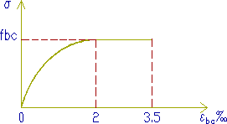
Figure I.9: The stress-strain diagram of concrete [4]

The calculation diagram includes an arc of second degree parabola from the origin of the coordinates and to its vertex with coordinates σbc = 2%o and a concrete compression stress given by:
σbc = 0.85. fcj/ᵧb θ The coefficient θ takes into account the probable duration of application of the combination of actions.
- θ = 1 t > 24heures
- θ = 0,9 1 h ≤ t ≤ 24 h
- θ = 0,85 t< 1 h

I.7.1.5 Deferred deformations
- Withdrawal
Shrinkage is the spontaneous shortening of concrete during its hardening in the absence of any stress. Shrinkage has several origins, but the two main effects are shrinkage of chemical origin, called “endogenous shrinkage” and shrinkage from desiccation or drying shrinkage. Endogenous shrinkage is due to a reduction in the volume of concrete due to the chemical reaction of concrete setting. The molecules before chemical reaction occupy a higher volume than the molecules after reaction, which therefore causes a reduction in volume. Desiccation shrinkage comes from the evaporation of water molecules not consumed by the chemical reaction. This also causes a shortening of the concrete. The relative shrinkage deformation which develops in a time interval (t1, t) can be evaluated using the formula:
εr (t1, t) = εr [r (t) - r (t1)]

With :
ɛr : the final shrinkage deformation
r(t) : the law of evolution of shrinkage, which varies from 0 to 1 when the time t, counted from the manufacture of the concrete, varies from zero to infinity. The law of evolution of shrinkage is given by:
r (t) = t/ t+ 9 rm
t : the age of the concrete, in days, counted from the day of manufacture, and rm the average radius of the part, expressed in centimeters:
rm= B/u
B: The section area
u: The perimeter of the section
In the case of prestressed concrete structures, made with Portland cement, the final shrinkage deformation can be evaluated by the formula:
ɛr= ks ɛ0
The coefficient ks depends on the percentage of adherent reinforcements ρs = As /B, ratio of the section of the longitudinal passive reinforcements (and, in the case of pre-tension, of the adherent prestressing reinforcements) to the cross section of the part.
Ks = 1/ 1+20 ρs
It is expressed by the formula: 0 depends on the ambient conditions and the dimensions of the room. ε the coefficient we will take in the water:ε0 = - 60.10-6
- Creep
By definition, it is the progressive shortening of concrete under constant stress, shrinkage deducted. This phenomenon is also linked to the migration of water inside the concrete.
- Poisson coefficient the Poisson's ratio of concrete is taken equal to:
- 0,20 in uncracked areas

0 in cracked areas
- Thermal expansion coefficient
In the absence of experimental results, the coefficient of thermal expansion is taken equal to 10⁻⁵ per degree C.

I.8 MECHANICAL CHARACTERISTICS: REINFORCEMENT
Prestressing reinforcements
I.8.1 Shapes
Prestressing reinforcements are found in three forms: wires; the bars; the strands.
I.8.1.1 Son
By convention, the wires have a diameter less than or equal to 12.2 mm, which allows them to be delivered in crowns. They can be either round or smooth (for post-tensioning) or on the contrary ribbed, or notched, or corrugated in order to improve their adhesion to the concrete (pre-tensioning). The most commonly used wires have diameters of 5mm, 7mm or 8mm.
I.8.1.2 Bars
With a diameter greater than or equal to 12.5 mm, they are only delivered straight (and with a maximum length of around 12 m). They can be either smooth or ribbed, the ribbing then acting as a coarse thread (case of Dywidag bars). The most common diameters are 26mm, 32mm and 36mm. But there are larger bars (Macalloyφ40, 50 and even 75 mm). Such reinforcements are only used in post-tensioning.
I.8.1.3 Strands
These are sets of wires wound helically on each other (case of three-wire twists) or around a central wire in one or more layers. The most common strands are 7 wires and are designated by their nominal diameter (diameter of the circle circumscribed by the wires in a straight section). The most commonly used diameters are: 12.5 mm (frequently referred to as T13) 12.9 mm (T13S) Prestressed concrete course 29 15.2 mm (T15) 15.7 mm (T15S). These reinforcements are used both in pre-tensioning (in large parts) and in post-tensioning. Finally, in the past, certain prestressing processes (PCB in particular) have used strands with several layers of peripheral wires (strands with 37 or 61 wires).

I.8.2 Stress-strain diagram
It is first linear (elastic phase OI, the slope of the line OI being the modulus of elasticity Ep of the reinforcement), then it curves, to arrive at a quasi-plastic level (Figure.10). Finally, rupture occurs for a stress fp and a relative elongation εuk. We attach fundamental importance to the fact that it only occurs with significant necking (characterized by the necking coefficient ζ, relative reduction in the area of ​​the cross section at the level of the rupture).

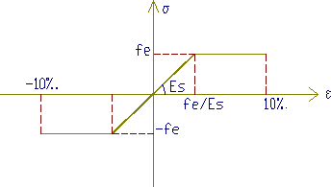
Figure I.10: Steel stress-strain diagram [3]

Generally, we require: ɛ≥20%; ɛuk≥3.5%, the stress-strain diagram makes it possible to define another important characteristic of the prestressing reinforcement: its conventional elastic limit fp0.1k. This is the ordinate of the point of intersection of the diagram with the line of slope 200,000 MPa passing through the point of ordinate zero and abscissa 10⁻³.
The ability of the reinforcement to remain united with the concrete.ψ and ηThis ability is characterized by the so-called cracking and sealing adhesion coefficients designated respectively by η =1 smooth roundsηCracking coefficients:
η =1.6 HA bars or HA wires with a diameter greater than or equal to 6mm
η =1 smooth rounds ψ =1.3 HA wires with a diameter less than 6mm Sealing coefficients:η =1.5 barres HA ou de fils HA.
- Active frames
The active steels are the prestressing steels, they are put under tension. Unlike reinforced concrete reinforcements which are satisfied with standard quality steel, prestressing reinforcements require steel satisfying a certain number of conditions.
They were classified by:
- Category: wires, bars, strands.
- Resistance class.
- Required qualities
- High mechanical resistance.
- Sufficient ductility.
- Good resistance to corrosion.
- Poor relaxation.
- Cost as low as possible.
I.8.2 Geometric characters
- The sons
The wires are reinforcements whose largest transverse dimension is less than 12.5mm; they are delivered crowned. We distinguish: the round and smooth steel wires of symbolL, wires other than round and smooth symbol L. The wires are defined by their nominal diameter to which a conventional nominal section corresponds, according to table.1

Table 1: Nominal wire diameter [1]
Diameter | 4 | 5 | 6 | 7 | 8 | 10 | 12.2
Section | 12.6 | 19.6 | 28.3 | 38.5 | 50.3 | 78.5 | 117

- The bars
Bars are defined as round and smooth reinforcement with a diameter greater than 12.5mm, or non-round or non-smooth reinforcement that cannot be delivered wrapped. The geometric characters are the diameter and the section conventionally defined according to table.2

Table 2: Diameter and conventional section of bars [1]
Diameter | 20 | 22 | 26 | 32 | 36
Section | 314 | 380 | 531 | 804 | 1018

- The strands
A strand is an assembly of 3 or 7 wires wound into a helix and distributed in a layer, possibly around a central wire. The strands are characterized by the number of their wires, their diameter, and their section. Table.3 provides the corresponding values.

Table 3: Diameter and conventional section of strands [1]
Type | 3fils | 7fils | 7fils | 7fils  standard | 7fils  standard |  | 7fils super | 7fils  super
Diamètre | 5.2 | 6.85 | 9.3 | 12.5 | 15.2 | 12.9 |  | 15.7
Section | 13.6 | 28.2 | 52 | 93 | 139 | 100 |  | 150

I.8.3 Calculation characters
The characteristics of the prestressing reinforcements to be taken into account in the calculations are:
- Nominal section of the reinforcement;
- The maximum stress guaranteed at rupture fprg
- The stress at the conventional limit of elasticity fpeg
- Relaxation coefficient ρ1000
- ρ000 = 2.5% for the TBR (Very Low Relaxation) class ρ000 = 8% for class RN (Normal Relaxation) adhesion to concrete;
- Coefficient of thermal expansion 10-5 per degree C.
- Longitudinal deformation modulus: Ep = 200,000 MPa for wires and bars Ep = 190,000 MPa for strands Force-deformation diagram.

I.9 GEOMETRIC CHARACTERISTICS DES SECTIONS
Solving RDM problems uses geometric characteristics of the cross sections of the bodies studied. σ≤σThe fundamental principle consists of determining the stresses acting in a section and comparing the maximum stress with the limit stress:
- Single traction σ =F/Bσ
- Simple inflection σ=MY/Iσ
- Compound flexion σ =F/B + M Y/Iσ
- The geometric characteristics to be studied are: Area of ​​section B[cm²]
- Static moments Sx and Sy [cm³]
- Axial moments of inertia Ix and Iy [cm⁴]
- Centrifugal moments of inertia Ixy[cm⁴]⎫
- Polar moments of inertia Ip[cm⁴]
- Resistance modulus Wx and Wy[cm³]
- Torsional resistance modulus Wp [cm³]⎫
- Radius of gyration ix and iy[cm]
- Yield of a section ρ
- Moment static
The static moments of the area of ​​a section with respect to the X and Y axes are given by the expressions If the X axis or the Y axis passes through the center of gravity of the section, the static moments Sx and Sy are zero.
- Moment of inertia
The moments of inertia of the area of ​​a section with respect to the X and Y axes are given by the formulas:
The polar moment of inertia of a section is given by: Ip=Ix+Iy
- Resistance module
The modulus of resistance is equal to the quotient of the axial moment of inertia by the distance from the axis to the furthest fiber.
Wx= Ix/y
Wy =Iy/x

- Radius of gyration
We call the radius of gyration the quantity given by the equation:
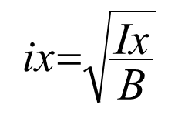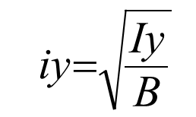

- Yield of a section
The yield of a section is given by: ρ= I/ B. Vi. Vs
I.10 EXERCISES
EXERCISE 1:
Consider the rectangular section (60.140) cm subjected to an external moment M=0.90 MNm. of prestressing P1 centered and P2 eccentric, assuming that we can eccentric a maximum of e= - 0.45 m the position of the cable.

P1 P1 h

Vs
Vi

Centered preload
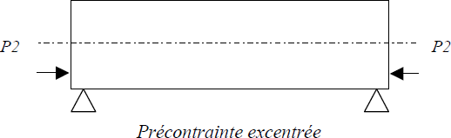
1. Determine the value of P1 and P2.
2. Schematize the constrained digraph P1 and P2 eccentric
Solution :
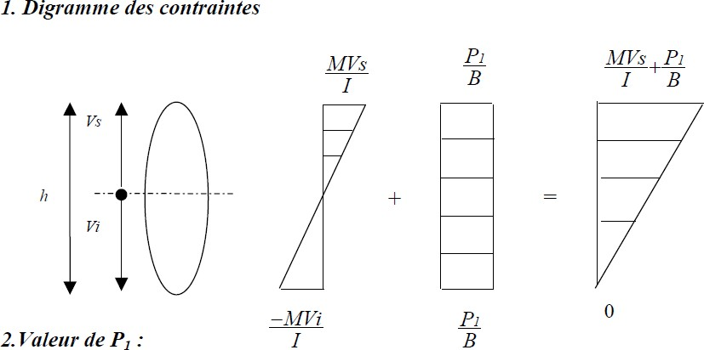

So P1= 4,07MN
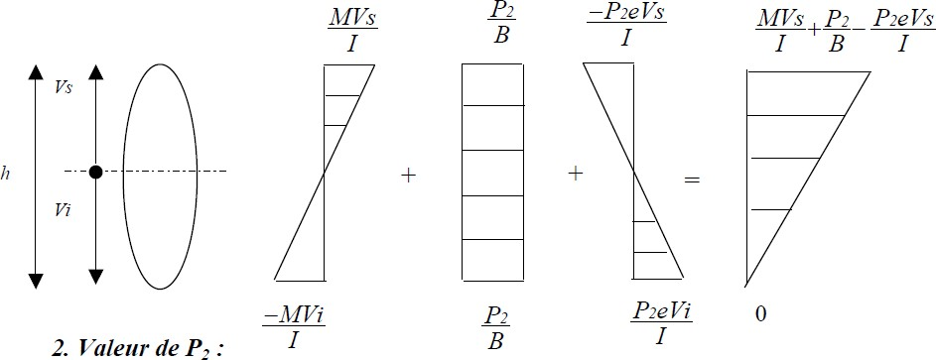

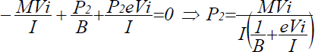

So P2= 3,93MN

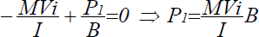
Exercice 2 :
1) Determine the prestressing force P0 applied to the jack so that the beam does not admit tension in the middle section, knowing that the sum of prestressing at mid-span represents 25% P0, g= 1.5t/m; q= 1.15 t/m; L=10m; Bb (30×60).
2) Determine the prestressing force P0 with an eccentricity e= h/6
Solution:

- Values ​​of P0 knowing that ΔP = 25% P0 According to the stress diagram we have:
- P(L/2) = P0- 0.25 P0= 0.75 P0
-Mg.vi/I –Mq.vi/I+ P(L/2) /Bb=0 with Mg = g.L²/8 et Mq = q.L²/8
So P0= 6(Mg +Mq)/ 0.75×h
P0= 441.67 t
- M (P(L/2)) = 0.75 P0.e so we have -6Mg/bh² –6Mq/bh²+ 0.75 P0/bh+0.75 P0.6.e/bh² =0
So P0= 4/h. (Mg+ Mq) = 4/0.6 (18.75 + 14.375)
P0= 220.83 t

Exercice 3:

Determine, for a concrete of fc28 = 30 MPa, the following mechanical characteristics: Compressive strength on day d = 7 and 90 days
Tensile strength on day d = 7 and 90 days
Instantaneous longitudinal deformation modulus on day d = 7 and 90 days
Delayed longitudinal deformation modulus on day d= 7 and 90 days
Solution
- Compressive strength on day d = 7 and 90 days
d= 7days : fc7= d/4.76 +0.83.d ×fc28= 19,86MPa
d= 90 days : we fc90 = fc28= 30 MPa
- Tensile strength on day d = 7 and 90 days
ftj= 0,6 + 0,06 fcj
d= 7 jours : ft7= 1.8 MPa
d= 90 jours : ft90= ft28= 2.4 MPa
- The instantaneous longitudinal deformation modulus of concrete Eij
Eij=11000
3fcj
Ei7= 29788.76MPa
Ei90= 34179.6 MPa
- The delayed longitudinal deformation modulus Evj:
Evj=3700
3fcj
Ev7= 10019, 85 MPa
Ev90= 11496, 76 MPa
Exercice 4 :
Determine, for a T-beam, the following geometric characteristics:
- The area of ​​the section (B)
- The static moment(S)
- The distance of the upper fiber (Vs) and the distance of the lower fiber (Vi)
- The moment of inertia (I)
- The resistance module (W)
- The radius of gyration(i)
- The efficiency of the sectionρ
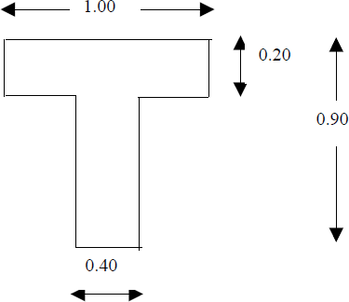
Solution
- The area of ​​the section (B)
B =Ʃ Bi = 0.48 m²
- The static moment (S)
S = Ʃ Bi.di = 0.174 m³
- The distance of the upper fiber (V_{s})
Vs = S/B = 0.363 m
- The distance of the lower fiber (Vi)
Vi= h-Vs = 0.537 m
- The moment of inertia (I)
I = Ʃ I + ƩBi.di²= 0.03572 m⁴
- The resistance module (W)
Ws = I/Vs = 0.0984 m³
Wi = I/ Vi = 0.0665 m³
The radius of gyration (i)
i=√I/B = 0.273 m
- The efficiency of the section (ρ)
ρ= I/ B.Vs.Vi= 0.382
Exercise 5
In order to eliminate the tensile stresses due to the maximum moment developed by the force Q, the console beam below is subjected to a prestressing force F. Neglecting the self-weight of the console. Determine:
- The resulting stress diagram.
- The value of F as a function of Q if:
- F is centered.
- F is eccentric by e = h/6.
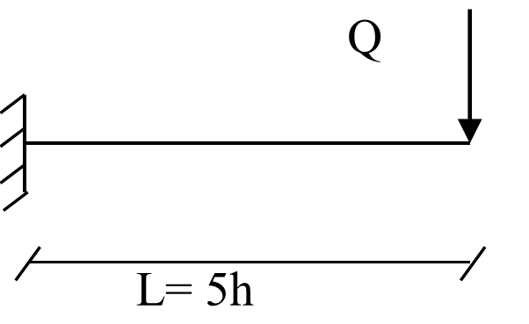

Exercise 6
The isostatic I-beam, L = 32m, shown below, is subjected to its own weight and a prestressing force P, eccentric by e = -40 cm.
- Draw the stress diagram.
- Deduce the value of P, if the final tensile stress, in the lower fibers, is assumed to be zero. We give: the density of concrete is 2.5 g/cm³.
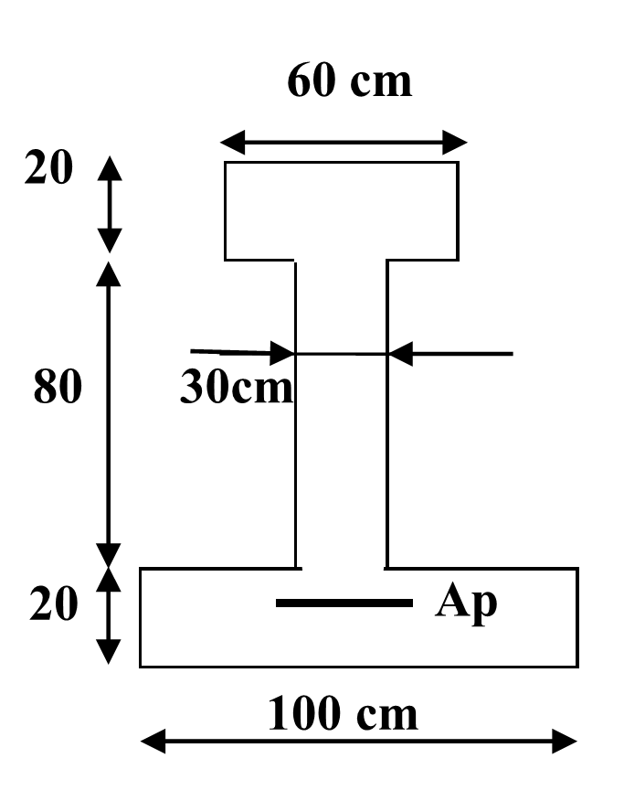

Exercise 7
The I-beam, shown below, is subjected to a prestressing force P, eccentric by e = 30 cm, and at an external moment M = 1 MN.m.
- Draw the stress diagram.
- Derive the value of P, if the final tensile stress, in the lower fibers, is assumed to be zero.

