CURRICULUM VITAE
CV OR RESUME
- DEFINITION: Is a short account of one’s career and qualifications prepared typically by an applicant for a position.
- How to structure the CV
The structure is a list of accomplishments, it being an advertisement for ourselves, it helps us a lot in planning what to say and how to say it.
- Personal details
- Personal profile
- Work experience
- Education
- Skills and Interests
- Languages,
- IT skills / computing skills,
- Interests/hobbies
- References
- Personal details :
- Name.
- Phone number.
- email address.
WHAT INFORMATION SHOULD YOU GIVE UP?
- Addresses; Put only one address on a CV, the one where you want to get important mail.
- Age or birthday; just type it as “25 years old.”
- Birthplace; Most birthplaces offer little useful information you can control.
- Marital status, not important
- Nationality; not important
- Photo of yourself : only if request
- Personal profile :
A short paragraph about yourself: Career, Objective, Your professional project.
- Work experience :
Experience of work is very important to talk about in a CV. In reverse chronological order.
The main parts in this section are:
- year,
- name of company,
- city,
- Country,
- Fonction.
Ex. 2015-Present: sonatrach, engineer, Hassi Messaoud, Algeria, engineer (main responsability)
- Education :
On most CV’s education goes top after the personal profile or after the work experience.
The main parts in this section are:
- Year,
- Degree,
- Speciality,
- Institution, (university, school…..)
- City,
- Country.
Ex. June 2016 Master’s in biology, majored in microbiology, faculty of science, Biskra university, Algeria.
- Skills and Intersts :
- LANGUAGES: the “Languages” heading is extremely important on CVs where applicants are offering skills to work internationally.
You can show different levels of skills by adding different adjectives like:
- mother tongue/ Fluent : language spoken
- excellent command: higher level of written and spoken English.
- good command or Fair level of … Understand TV and radio. Can write simple letters
- Basic skills : notions
- IT skills / computing skills,
- fully literate with/proficient with : excellent level of skills
- writing knowledge with/ competent with : Professional use
- basic knowledge with / Familiar with : basic level

- Interests/hobbies : they come from activities that are not work-related.(ok, but not really important)
For example, Movie going, reading, music, sports, arts. Etc.....
- References: The name of one or two person who know you.
- position.
- company / university .
- Telephon number.
- mail adress.

A good Example of CV
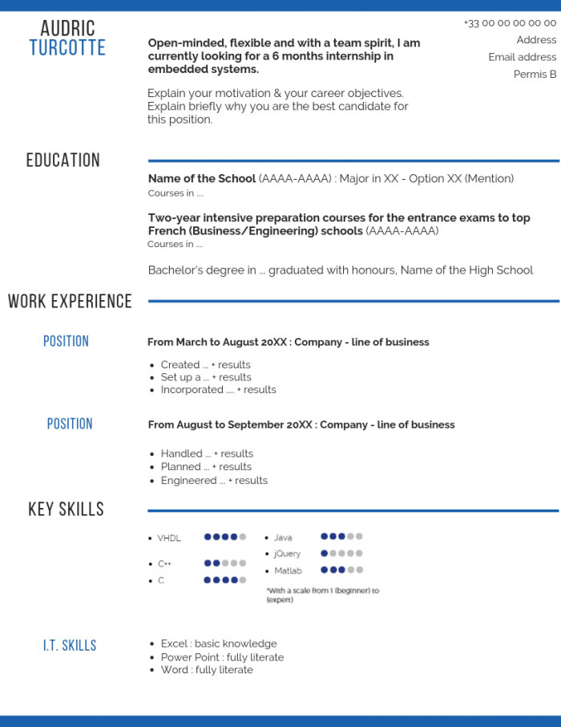
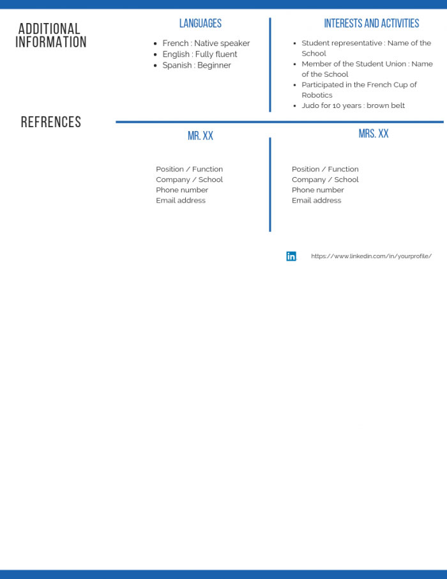

The cover letter

The Letter:From Top to Bottom
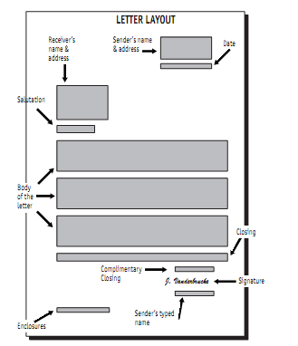

THE CONTENT OF THE LETTER

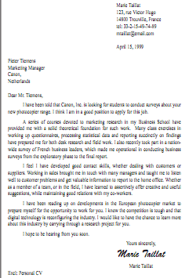

Mistakes to avoid......
In summary, common mistakes to avoid are:
• Talking to yourself:
• Touching on sensitive areas:
• Trying to say everything:
• Organizing badly:
• Providing irrelevant or negative information:
- Contractions where necessary. Ex. I’m or I ‘am. Don’t or Do not. I’d or I would.
- Use passive voice instead of active voice.
- Using weak verbs and adjectives instead of strong ones
Cover letter grammar
- Get instead of receive
- Give ……..provide
- Tell………..inform
- Help……….assist
- Answer……..reply
- Choose………select
- Talk about……discus
- Make sure …….ensure

