Mohammed Khider University of Biskra
Faculty of Science and Technology
2nd year License
Module: TP ELN Fond 1
Lab N 04 : Stabilized power supply and zener diode

1. Double-wave rectification (with Graetz bridge):
1.1 Theoretical part:
The double-wave rectification of an alternating signal V(t)=V_max sin(ωt) gives the signal U_d (t) represented by the following figure:
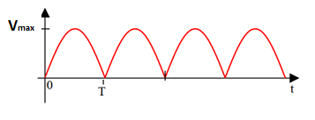
- Find the mathematical expression for the average value U_(d avg):
……………………………………………………………………… ……………………………..
……………………………………………………………………………………………………..
…………………………………………………………………. …………………………………
A.N : $U_{d avg}=……………..$
2. Calculate mathematically the effective value U_(d eff):

………………………………………………………………….. ……………………………………….

………………………………………………………………….. ………………………………………..

……………………………………………………………………… ……………………………….
…………………………………………………………………………………………………………..
…………………………………………………………………. ……………………………………….
…………………………………………………………………………………………………………..
…………………………………………………………………. ……………………………………….
……………………………………………………………………
N.A : $U_{d eff}=………………$…..

1.2 Practical part (double-wave rectifier circuit or Graetz bridge):
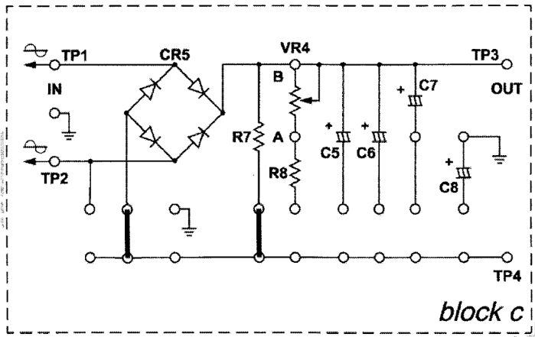

Fig. 23002-block c.2
- Handling:
- Insert the connecting clips according to Fig. 23002-block c.2
- Apply an alternating current source of Vpp = 18V between terminals TP1 and TP2.
- Plot only the voltage Vout (CH2) in AC and DC mode. (i.e. unplug CH1)
- Measure Vout using the multimeter in AC and DC mode (Table 3).
- Complete the Table (3)

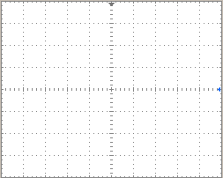
AC mode DC mode

Important note: To stabilize the signal, press “trigger Menu” then choose “Source: CH2” and adjust with LEVEL

Table (3)
 | Average Value (DC) | Effective value (AC)
Multimiter
Oscilloscope
$Vmax$
Calculation
Compare the frequency of the rectified signal with that of the input signal
……………………………………………………………………………………………………….
B. Filtering by capacitors:
Connect a capacitor C=1µF then C6 and draw the graphs obtained in DC mode:

C1 C6

 | C=1µF | C6
$Vavg$ ( DC mode)
$Veff$ ( AC mode)
Give your conclusion
 | Signal type | Frequency
Double wave | DC et AC
After filtring | DC

- Characteristic of the Zener diode

Test and verify the diode with the multimeter in ohmmeter mode (sign of the diode).
Carry out the following assembly and fill in the table:

Ue (V) | -10 | -9 | -7 | -6 | -5 | -4 | -3 | -2 | -1 | 0 | 0.5 | 1 | 2 | 3 | 4 | 5
V_{D} (V)
I_{D} (µA/mA)

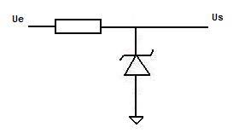
Draw the characteristic of the diode: ID = f(VD)
How much are the thresholds voltages in forward and reverse directions (from the graph)?
………………………………………………….
compare the characteristics of the classic diode and that of the zener diode
.....................................................................................................................................................................

