Mohammed Khider University of Biskra
Faculty of Science and Technology
2nd year License
Module: TP ELN Fund 1

Lab N 01: Electrical measurements
- Objectives of the Lab:
At the end of this practical work, the student will learn the following knowledge:
1. Recognize the various electronic components constituting an electrical circuit;
2. How to take measurements of voltages and electrical currents (and others) in a circuit;
3. Use the multimeter (voltmeter, ohmmeter, etc.), and take safety precautions;
4. Visualize a voltage (or more) on the oscilloscope.
2. Theoretical part:
- The average value of a voltage U(t) (or a current) is given by the following formula:
$$U_{moy}=\frac{1}{T}\int_{t_{0}}^{t_{0}+T}{U\left(t\right)dt}$$
T: period of the signal U(t).
- The effective value of a voltage U(t) (or a current) is given by the following formula:

$$U_{eff}=\sqrt{\frac{1}{T}\int_{t_{0}}^{t_{0}+T}{\left|U\left(t\right)\right|²dt}}$$
T: period of the signal U(t).
3. Course question:
For a signal U(t)=V_max sin⁡(ωt)+B, with: V_max: the amplitude of the signal and ω: pulsation of the signal (ω=2πf).
Calculate the average value U_moy and the effective value U_eff as a function of A. Give the numerical value of U_moy and U_eff for V_max=6V, B=2V and f=100Hz.

$$U_{moy}$$ | $$U_{eff}$$
………………………………………………………….  ……………………………………….  …………………………………………………………..  …………………………………………………………..  ………………………………………………………….  …………………………………………………………..  ………………………………………………………......  …………………………………………………………..  ………………………………………………………….  N.A. : ………………………………………………. | ………………………………………………………….  ……………………………………….  …………………………………………………………..  …………………………………………………………..  ………………………………………………………….  …………………………………………………………..  ………………………………………………………......  …………………………………………………………..  ………………………………………………………….  N.A : ……………………………………………….
4. Practical part:
Adjust the GBF (Low Frequency Generator) so that it delivers the following signal:
$$U\left(t\right)=6\sin\left(2π.100.t\right)+2 [V]$$

$V_{max}$=………V | Forme=…………………. | Fréquency=……………Hz | B=………………V
Visualize the voltage U(t) across the GBF using the oscilloscope in DC mode and take measurements using the “measure” button on the oscilloscope.
T=………………… […]
F=………………… […]
Vmax=…………… […]
Vmin=…………… […]
Vmoy=…………… […]
Veff=……………… […]

Visualize the voltage U(t) across the GBF using the oscilloscope in AC mode
T=………………… […]
F=………………… […]
Vmax=…………… […]
Vmin=…………… […]
Vmoy=…………… […]
Veff=……………… […]

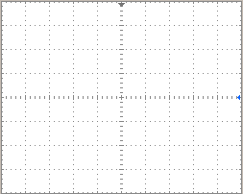

5. Take measurements with the voltmeter:
$$U\left(t\right)=6\sin\left(2π.100.t\right)+2 [V]$$
Note: We always choose the largest caliber of the value to be measured
Measure the voltage across the GBF using the voltmeter in DC mode
$V_{DC}= …………V$ it represents $U_{moy}$ $U_{eff}$
Measure the voltage across the GBF using the voltmeter in AC mode
$V_{AC}= …………V$ it represents $U_{moy}$ $U_{eff}$
complete the following table

 | Theoretical (Q3) | Oscilloscope(Q4) | Voltmetre (Q5)
V_{moy} | ……………………….. | ……………..…. | ……..…….
V_{eff} | …………………………… | ……………..…. | …..……….
What are your comments……………………………………………………………
6. Take measurements with the ammeter:
Now we will carry out the following experiment : U=5V, R1=1KΩ
Create the following circuit:  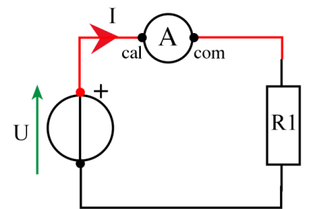 | Take the following measurements:  U=……………V  I=………… mA  Calculate :  R1 _{Calculated} =U/I=……………KΩ

7. Take measurements with the Ohmmeter:

Using the multimeter, measure the value of the resistance available:................................... Ω
………………………….. Ω

 | Color Code | Nominal value | Tolerance | value range
R₁ | ………………………… | ……………..….Ω | ……..….Ω | between : …….…..Ω and ……..…Ω
R₂ | …………………………. | ……………..….Ω | …..…….Ω | between : ………...Ω and…..……Ω

Comments……………………………..

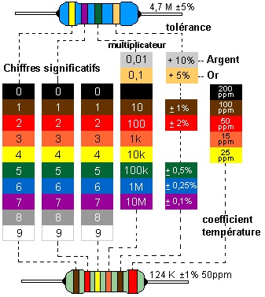

Noir
Marron
Rouge
Orange
Jaune
Vert
Bleu
Violet
Gris
Blanc

