**Introduction to Embryology**

**Embryology** is the study of the development of the egg from fertilization to the adult form. It aims to trace the stages of development of metazoans (multicellular animals) throughout the diploid phase of the individual, that is, from the unicellular stage (egg) to a fully differentiated stage where the organ primordia of the embryo are established, allowing it to lead an independent life.

There are five types of embryology:

* **Descriptive embryology**: This studies the morphology of embryos. Observation allows us to distinguish developmental stages that follow a strict chronological sequence.
* **Causal or experimental embryology**: This involves experimentally modifying specific parts of the embryo at a precise stage and observing the consequences. These observations help identify the factors involved in particular stages of embryogenesis.
* **Comparative embryology**: This is the study of the genesis of forms (ontogenesis) across species, using data from both descriptive and experimental embryology across various organisms.
* **Normal embryology**: This studies the normal development of an embryo. It provides insights into the anatomical and histological organization of a living being, enabling the identification and prevention of possible malformations.
* **Pathological embryology or teratology**: (Teratos: monster; Logos: study)  
  Teratology is the study of embryonic anomalies, which may be genetic or caused by teratogenic factors. Experimental embryology helps determine these factors.

**I. Gametogenesis**

**Gametogenesis** is the biological process by which gametes are formed in the organism. It allows haploid cells to be derived from diploid cells. In mammals, the process is known as **oogenesis** in females and **spermatogenesis** in males.

**I.1. Spermatogenesis**

**Spermatogenesis** refers to the process by which stem cells known as **spermatogonia** are transformed into specialized reproductive cells: the male gametes or **spermatozoa**. This process occurs in the **male reproductive system**, specifically in the **seminiferous tubules** of the testis.

**I.1.1. Male reproductive system:**

**A. Structure of the Mammalian Testis** (Figure 01)

In mammals, the testis is composed of seminiferous tubules. These tubes converge at the testicular hilum and connect with the straight tubules and rete testis, continuing through the efferent ducts, epididymis, and vas deferens (or Wolffian duct), which leads to the urethra. Between the seminiferous tubules is **interstitial connective tissue**. A fibrous connective tissue layer, the **tunica albuginea**, forms a protective sheath around the testis. It is lined internally with a highly vascularized layer that contains smooth muscle fibers. In some species, septa divide the testis into 200–300 **lobules**, each containing 1–4 seminiferous tubules. The testis is bounded by an epithelium.

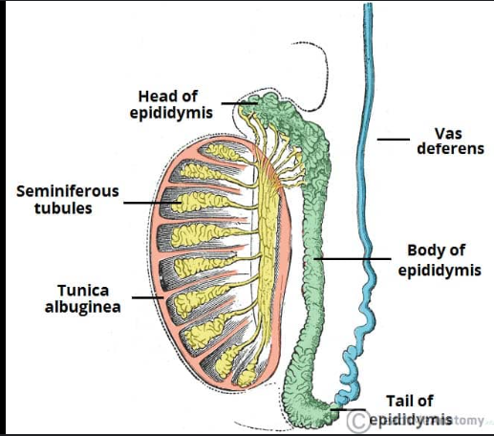

**A.1 Structure of the interstitial tissue**

It is highly vascularized connective tissue containing **Leydig cells** grouped in clusters. These produce 95% of the testosterone found in the blood.

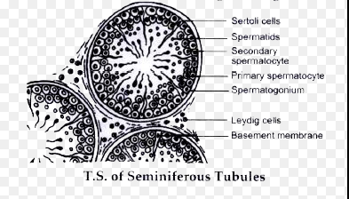

**A.2 Structure of the seminiferous tubule** (Figure 02)

In cross-section, a seminiferous tubule consists of:

* **Basement membrane**:

A thin outer connective membrane containing contractile **myoid cells**.

* **Germinal epithelium**:

This includes two types of cells:

* + **Sertoli cells**:

Large cells that provide nutrition to germline cells, phagocytose cellular debris from spermatogenesis, and synthesize inhibin and S.B.P. (Steroid Binding Protein).

* + **Germline cells**:

These are arranged between Sertoli cells in layers from the periphery to the center of the tubule. They represent successive stages of spermatogenesis:

* + - Spermatogonia
    - Primary spermatocytes (I)
    - Secondary spermatocytes
    - Spermatids
    - Spermatozoa

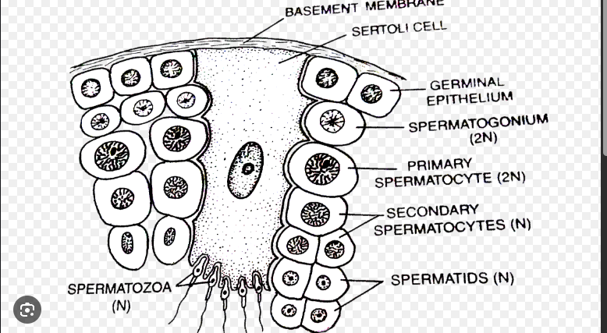

**I.1.2. Process of Spermatogenesis (Figure 03)**

Spermatogenesis consists of four phases: **multiplication**, **growth**, **maturation**, and **differentiation**.

1. **Multiplication phase**:

This involves **spermatogonia**, which are diploid stem cells of two types:

* **Spermatogonia A**: Includes two subtypes—those with pale nuclei (**Ap**, pale), and those with dark nuclei (**Ad**, dark).

At the beginning of the spermatogenic cycle, Ad spermatogonia undergo mitosis, each forming a new Ad (to replenish the stock) and an Ap.

From an Ap spermatogonium, four primary spermatocytes (diploid, 2n) are formed. These divide to produce two **spermatogonia B**, which each divide into two **primary spermatocytes** (again, 2n).

1. **Growth phase**:

The primary spermatocytes undergo cytoplasmic growth, transforming into large cells called **auxocytes** (diploid).

1. **Maturation phase**:

Auxocytes undergo the first meiotic division (reductional), forming two **secondary spermatocytes**.  
The second meiotic division (equational) produces, from each secondary spermatocyte, two **spermatids** (haploid cells).

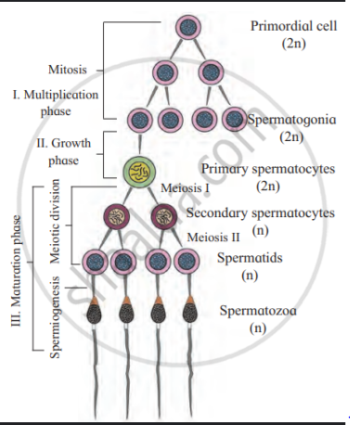

1. **Differentiation phase (spermiogenesis)**:

Spermatids undergo nuclear and cytoplasmic transformations, resulting in the formation of highly specialized reproductive cells: **spermatozoa**.

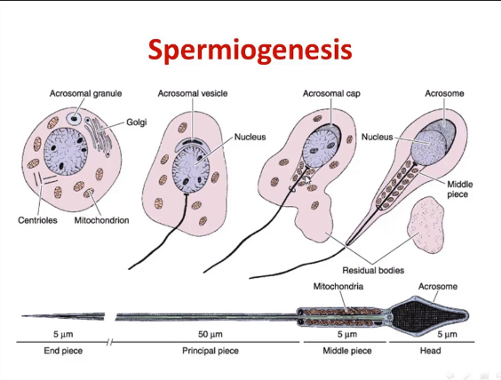

**I.2. Oogenesis**

**Oogenesis** is the process by which female gametes, called oocytes, are produced and mature into ova (egg cells).

**I.2.1. Overview of the Female Reproductive System**

**A. General Structure** (Figure 04)

From an anatomical perspective, the internal female reproductive system includes:

* An **ovary** on each side, which produces gametes contained within follicles, and also produces sex hormones via follicular cells, corpus luteum, and stromal cells;
* A **Fallopian tube** on each side, which is the site of fertilization;
* The **uterus**, where embryonic development takes place.

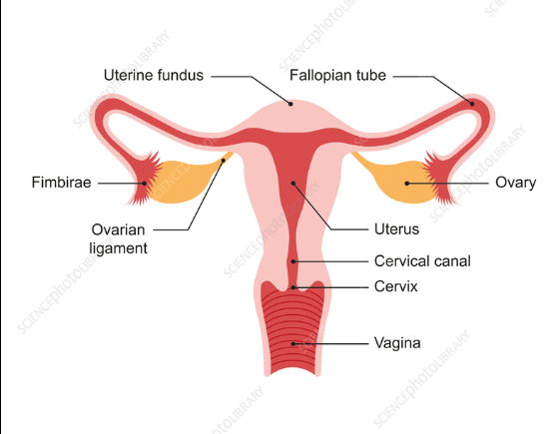

**B. The Ovary** (Figure 05)

It is an oval-shaped organ that, in sagittal section, shows a **cortical zone** and a **medullary zone**.

* **Cortical region**: From the outside to the inside, it includes:
  + A **surface epithelium**;
  + The **ovarian tunica albuginea**, a connective tissue that is low in cells and rich in ground substance;
  + A **cortical stroma**, which contains fibroblast-like cells and few fibers. It contains the following structures:
    - **Follicles**: associations of an oocyte and hormone-secreting (endocrine) glandular cells;
    - **Corpus luteum**: formed from the evolution of follicles after ovulation, also with an endocrine function;
    - **Atretic bodies**: remnants of degenerated follicles or corpus luteum.
* **Medullary region**:

Composed of loose connective tissue that ensures the **innervation and blood supply** to the ovary.

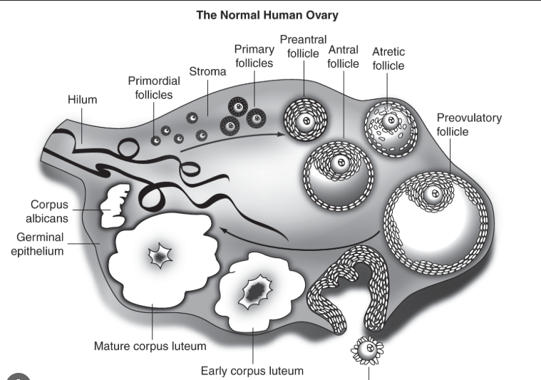

**I.2.2. Stages of Oogenesis (Figure 06)**

Oogenesis consists of **three stages**:

1. **Multiplication Phase**

Oogenesis begins in the gonads of the genetically female embryo (46XX) before birth. The **oogonia** actively multiply until they reach around 7 million in both ovaries. During the **prenatal period**, a large number of oogonia degenerate, and by birth, approximately **2 million germ cells** remain in the ovaries, in the form of **primordial follicles**. By puberty, only a few thousand primordial follicles are left.  
The multiplication of oogonia results in the production of **primary oocytes (oocyte I)**, which are diploid. Each cell is surrounded by flattened cells to form a primordial follicle.

1. **Growth Phase**

The **primary oocyte (oocyte I)** increases in size due to the accumulation of reserves.

1. **Nuclear Maturation Phase**

At **puberty**, during **ovulation**, **meiosis I** produces two unequal daughter cells: a **polar body** and a **secondary oocyte (oocyte II)**.

The **second meiotic division (meiosis II)** begins in the secondary oocyte but remains **arrested at metaphase II** until fertilization occurs. Upon fertilization, meiosis II completes and produces a **second polar body**.

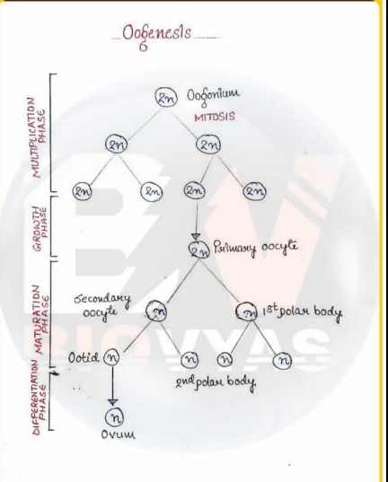

**I.3. Folliculogenesis (Figure 06)**

The **oocyte** is surrounded by flattened cells that form a **follicle**. These cells have both **trophic** (nutrient-supplying) and **endocrine** functions. The follicle undergoes **five successive stages**:

**1. Primordial Follicle**

It has a diameter of about **50 μm** and is formed by the association of a **primary oocyte** and a **discontinuous layer of follicular cells**, which are separated from the ovarian stroma by a **basement membrane** called the **Slavjanski membrane**.

**2. Primary Follicle**

Its diameter increases from **50 μm to 100 μm** due to **oocyte growth** and an **increase in the number of follicular cells**, which now form **4 or 5 layers** around the oocyte.

**3. Secondary Follicle**

The diameter increases from **100 μm to 200 μm**. The number of follicular cells reaches around **1 million**, arranged in **about twenty layers**. Outside the Slavjanski membrane, **stromal cells** organize into a structure called the **theca**.

**4. Tertiary Follicle (Antral Follicle)**

Its diameter increases from **200 μm to 12 mm**. The number of follicular cells rises to **5 to 10 million**.  
The theca **differentiates into two layers**:

* **Theca interna**
* **Theca externa**  
  Most importantly, a cavity called the **antrum** appears, which is filled with **follicular fluid**.

**5. Mature Follicle or Graafian Follicle**

Just before ovulation, the follicle reaches a diameter of approximately **23 mm**, and the number of follicular cells reaches **50 million**. Its structure is as follows:

* It is bounded by the **external theca**;
* The **internal theca** has the structure of an **endocrine gland**;
* The **Slavjanski membrane** separates the internal theca from the follicular cells;
* Several layers of follicular cells surround the **follicular cavity**;
* The follicular cavity is filled with a **complex fluid** composed of **proteins, lipids, and carbohydrates**;
* At one pole of the cavity, **follicular cells cluster densely**, forming the **cumulus oophorus**, inside which the oocyte is located;
* The **regular layer of cells surrounding the oocyte** is called the **corona radiata**, in contrast to the rest of the follicular cells grouped under the name **granulosa**;
* The oocyte is surrounded by a **membrane 10–20 μm thick**, called the **zona pellucida**, which is traversed by **extensions of the corona radiata cells**;
* The **zona pellucida is separated from the oocyte** by a space called the **perivitelline space**.

**Corpus Luteum:**

* After ovulation, the follicle transforms into the **corpus luteum**.
* The cavity becomes filled with **follicular cells**, now called **luteal cells**.
* In the **absence of pregnancy**, the corpus luteum **degenerates**.

