Practical work N°4

***Cartilaginous tissue***

**TP N° 3 : Le tissu cartilagineux**

**Introduction**

Cartilaginous tissue is one of the connective tissues composed of a single type of cell: **chondrocytes**. These cells are enclosed in small cavities called **chondroplasts**.

Chondrocytes are responsible for the synthesis and degradation of all components of the extracellular cartilaginous matrix.

Cartilaginous tissue is surrounded by a connective formation called the **perichondrium**, which ensures its nutrition and growth.

**Description of the histological slides to be observed**

**Slides 01:**

**Hyaline cartilage** is a type of cartilage that provides support and flexibility while maintaining a smooth surface for joint movement. It consists of chondrocytes embedded within chondroplasts, surrounded by an extracellular matrix rich in collagen fibers and proteoglycans. This cartilage is covered by the **perichondrium**, except in areas like articular cartilage. It plays a crucial role in fetal development, forming the initial framework for bones before they ossify.

1. **Overview of hyaline cartilage tissue: presence of small cavities (chondroplasts), inside which chondrocytes are found. The cartilage is surrounded by the perichondrium.**

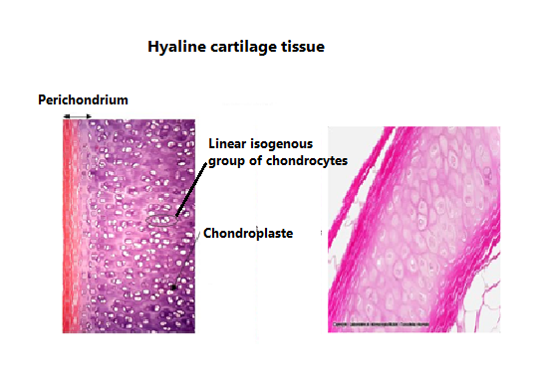

**Slide 02**

**Elastic Cartilage**

Elastic cartilage** is a specialized type of cartilage that provides both strength and flexibility due to its high content of **elastic fibers** in the extracellular matrix. It is structurally similar to **hyaline cartilage** but contains a dense network of elastin fibers, making it more resilient and capable of returning to its original shape after deformation.

**Characteristics of Elastic Cartilage**

- Cells: Chondrocytes are housed within lacunae (chondroplasts).

- Matrix: Contains type II collagen fibers along with abundant elastic fibers.

- Perichondrium: Present, providing nutrients and aiding in growth and repair.

- Flexibility: Highly flexible and elastic compared to hyaline cartilage.

**Functions of Elastic Cartilage**

- Provides structural support while maintaining flexibility.

- Allows tissues to return to their original shape after bending or stretching.

- Helps maintain the open passage of the auditory tube and epiglottis.

**2-** **At high magnification, the **perichondrium** shows two distinct zones:**

**- **External fibrous zone**, containing the nuclei of fibroblasts.**

**- **Internal cellular zone**, where fibroblasts differentiate into chondroblasts.**

