**VIII. The Nervous Tissue**

The nervous tissue is composed of nerve cells (neurons) and support cells (glial cells). Nerve cells are highly specialized to react to stimuli and conduct excitation from one region of the body to another. Thus, the nervous system is characterized by both the reception, integration, and emission of nerve messages, essential properties for providing rapid communication between different parts of the body and coordinating actions with the external environment.

**VIII.1. Organization of the Nervous System**

From an anatomical point of view, the mammalian nervous system is divided into two main parts, the central nervous system (CNS) and the peripheral nervous system (PNS).

**VIII.1.1. Central Nervous System**

The central nervous system consists of the brain and spinal cord located in the cranial cavity and the vertebral column.

**VIII.1.2. Peripheral Nervous System**

The peripheral nervous system consists of neurons, support cells, and spinal and cranial nerves located outside the central nervous system. The afferent peripheral nerves or sensory nerves conduct nerve impulses from various receptors scattered throughout the body to the central nervous system. Efferent peripheral nerves, also called motor nerves, carry nerve impulses from the CNS to effector organs such as muscles and glands.

The interaction zones that allow connections between two nerve cells are called synapses. The nerve impulse is transferred between nerve cells by electrical or chemical coupling, directly into the bloodstream, thus the brain is considered a neuroendocrine organ. Neurons can stimulate or inhibit the action of other neurons.

From a functional point of view, the nervous system can be divided into:

A**. Somatic nervous system**: controls voluntary actions of our body. It provides sensory and motor innervation to all parts of the body except the viscera, smooth and cardiac muscles, and glands.

**B. Autonomic nervous system**: provides involuntary motor efferent innervation to smooth muscle, cardiac muscle, and glands. It also provides afferent sensory innervation from the viscera (pain). The latter is divided into sympathetic and parasympathetic nervous systems.

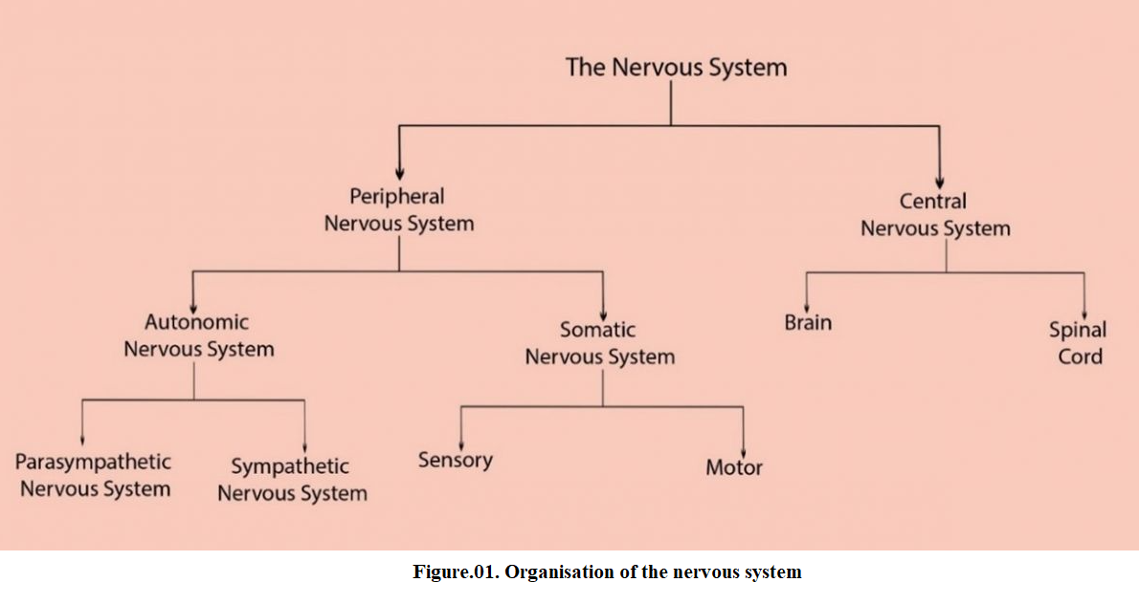

**VIII.2. Neuron**

**VIII.2.1. Structure of the neuron**

The neuron is the structural and functional unit of nervous tissue. Neurons are large cells with very varied and complex forms. They are composed of a body called perikaryon and numerous cytoplasmic extensions. Dendrites are cytoplasmic extensions that transmit nerve impulses to the perikaryon and are generally multiple. The only extension that conducts nerve impulses from the perikaryon is the axon. Neurons are mononuclear, amitotic cells and therefore have extreme longevity. In the cytoplasm, we find rough endoplasmic reticulum, Golgi apparatus, mitochondria, and neurofibrils that group together in bundles to form microtubules.

Each neuron has a single axon that conducts nerve impulses away from the perikaryon toward other nerve cells or effector organs. The axon is generally longer and has a larger diameter than dendrites. The axon hillock constitutes the origin of the axon. It ends by branching out, corresponding to the terminal arborization, with each branch ending in a swelling: the terminal button or synaptic button where synaptic vesicles containing a neurotransmitter accumulate.

Highly specialized cells present in both the CNS and PNS surround the axon to form a sheath called the myelin sheath. The sheath extends from the initial segments of the axon to the terminal branches. This myelin sheath is discontinuous, with small gaps interspersed along the axon. These gaps are called nodes of Ranvier. Axons in the CNS and PNS can be myelinated or remain unmyelinated.

In the PNS, Schwann cells surround the axons. In contrast, in the CNS, neuroglial cells called oligodendrocytes myelinate the axons.

Dendrites conduct nerve impulses to the cell body; they are afferent extensions. Axons are grouped into bundles, themselves connected by connective tissue (endoneurium and perineurium) forming tracts and nerves.

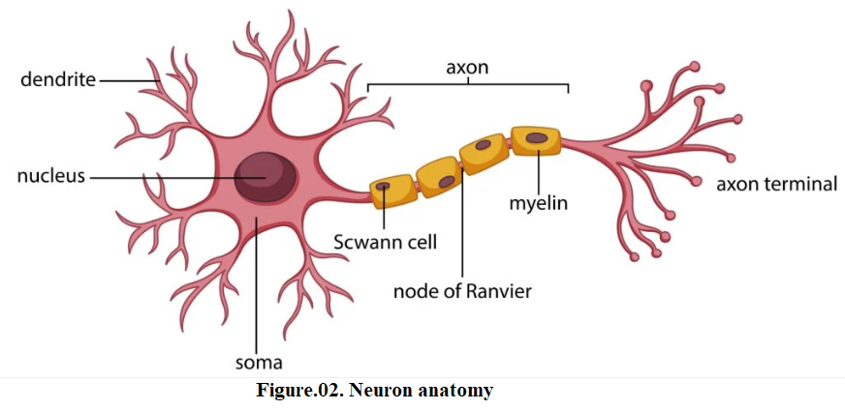

**VIII.2.2. Classification of neurons**

Neurons can be classified:

According to the number of extensions from the cell body, we distinguish:

* **Multipolar neurons**: which have several dendrites and a single axon.
* **Bipolar neurons**: which have a single axon and a single dendrite positioned at opposite poles of the same cell body.
* **Pseudounipolar neurons**: which have a single axon divided into two branches by the presence of the cell body.
* **Unipolar neurons**: which have a cell body and a single axon without dendrites (Fig. 42).

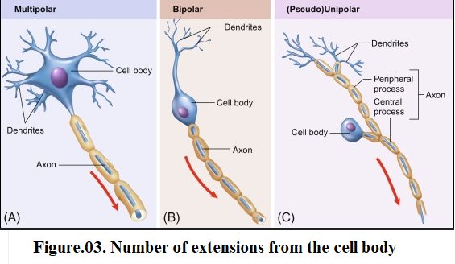

According to their function, we distinguish:

* **Afferent neurons or sensory neurons**: which transmit nerve impulses from receptors to the central nervous system.
* **Efferent neurons or motor neurons**: which transmit nerve impulses from the central nervous system to effector organs.
* **Interneurons**: these neurons form a communication and integration network between sensory and motor neurons. It is estimated that more than 99.9% of all neurons in our body belong to this integration network.
* **Vegetative neurons**: these are the ganglion cells of the sympathetic and parasympathetic systems.
* **Secretory neurons**: these are the neurosecretory cells of the hypothalamic nuclei.
* **Sensory neurons**: such as the sensory cell of the olfactory mucosa.

**VII.3. Glial cells**

Glial cells make up the neuroglia. Glial cells are nine times more numerous than nerve cells. They can be distinguished by their much smaller size and dark-coloured nuclei. These cells provide mechanical and metabolic support for neurons. There are four types of glial cell .

In the central nervous system, a distinction is made between

**VIII.3.1. Astrocytes**

Astrocytes are morphologically heterogeneous cells. They provide physical and metabolic support for the neurons of the CNS. Depending on the appearance of the extensions and the distribution of the astrocytes, a distinction is made:

- Protoplasmic astrocytes: with short, stocky extensions. They are found in the grey matter of the central nervous system.

- Fibrous astrocytes: with fine, tapering extensions. They are located in the white matter of the central nervous system.

**VIII.3.2. Oligodendrocytes**

Oligodendrocytes are small active cells that form and maintain myelin in the CNS.

**VIII.3.3. Microglia**

Microglia are discrete cells with a small, dark, elongated nucleus. These cells have phagocytotic properties.

**VIII.3.4. Ependymal cells**

Ependymal cells are cylindrical cells which line the cerebral ventricles and the ependymal canal of the spinal cord.

In the peripheral nervous system,

**VIII.3.5. Schwann cells**

Schwann cells produce the myelin sheath and provide support for nerve fibres without myelin.

**VIII.3.6. Satellite cells**

Satellite cells are cells present in the spinal glands.

