**VII. Muscle Tissue**

Muscle tissue is specialized in producing mechanical work through muscle contraction. This contraction is driven by the interaction of two proteins—**actin** and **myosin**—which together form structures called **myofibrils**.

Due to the highly developed functions of muscle cells—also known as **muscle fibers**—a specific terminology is used for certain cellular components:

* **Plasma membrane** = *sarcolemma*
* **Cytoplasm** = *sarcoplasm*
* **Endoplasmic reticulum** = *sarcoplasmic reticulum*

There are three types of muscle tissue: **skeletal**, **cardiac**, and **smooth**.

Here’s the English translation of that section:

**VII.1. Skeletal Muscle Tissue**

Skeletal muscle is responsible for moving the skeleton and various organs. It is often called **voluntary muscle** because it is under conscious control. This tissue is also referred to as **striated muscle**, due to the distinctive arrangement of contractile proteins that gives it a striped (striated) appearance under a microscope.

**VII.1.1. General Organization of Muscle Tissue**

Skeletal muscle tissue is made up of **striated muscle fibers**, which are connected to each other by connective tissue. The connective tissue surrounding individual muscle fibers and bundles of fibers is essential for transmitting mechanical force. At the ends of muscles, this connective tissue forms **tendons**, which attach the muscle to bone.

The connective tissue associated with muscle is named based on its relationship to the muscle fibers:

* **Endomysium**: A thin layer of reticular fibers that directly surrounds each individual muscle cell.
* **Perimysium**: A thicker sheath that surrounds a group of muscle fibers arranged side by side into a **fascicle** (bundle).
* **Epimysium**: A dense connective tissue layer that envelops the entire muscle.

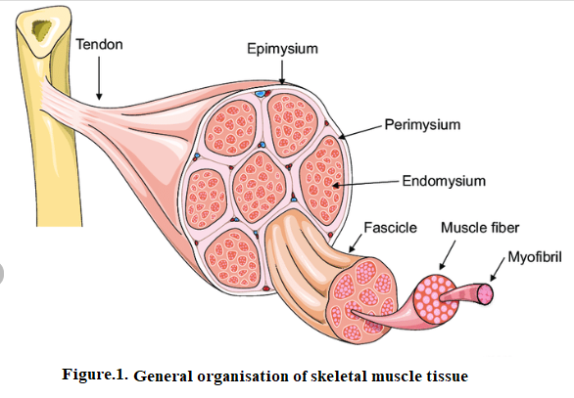

**VII.1.2. The Striated Muscle Cell**

Skeletal muscle is made up of long, cylindrical, **multinucleated cells** called **muscle fibers**. These fibers are extremely elongated. Their cytoplasm contains the usual cellular organelles but is distinguished by:

* The specific arrangement of **myofibrils** (also called **myofilaments**)
* A well-developed **smooth endoplasmic reticulum** (known here as the **sarcoplasmic reticulum**)
* A high number of **mitochondria**

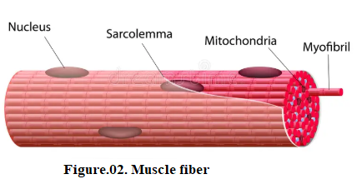

**VII.2. Smooth Muscle Tissue**

This tissue makes up the muscular component of **visceral organs**. It is called **smooth** muscle because the arrangement of its microfilaments does not produce a striated appearance. Its movements are **involuntary** and are controlled by the **autonomic nervous system** and **hormones**.

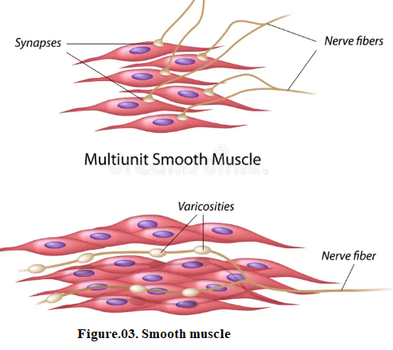

**VII.2.1. The Smooth Muscle Cell**

Under light microscopy, the smooth muscle cell appears **spindle-shaped**, like a shuttle, with **tapered ends** and a **thicker central region** containing the nucleus. The **nucleus is single**, cylindrical with rounded ends, and becomes deformed during contraction.

The **sarcoplasm** contains standard organelles such as the **Golgi apparatus**, **mitochondria**, **endoplasmic reticulum**, as well as **lipid** and **glycogen inclusions**. These organelles are mainly located at the two poles of the nucleus, where the cytoplasm lacks myofibrils.

The **myofilaments** are arranged in **irregular bundles** aligned roughly parallel to the cell's long axis. These bundles are grouped into **rosettes**, with a central **thick myosin filament** that has lateral projections pointing toward surrounding **thin actin filaments**.

Smooth muscle cells are organized into **bundles**, where adjacent cells are staggered so that the **tapered end of one myocyte aligns with the thick central part of the next**. A **fine network of collagen fibers** helps hold the entire structure together.

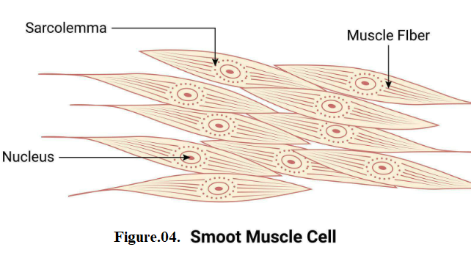

**VII.3. Cardiac Muscle Tissue**

**Cardiac muscle tissue** (or **myocardium**) is responsible for the **rhythmic and continuous contraction** of the heart. It has **structural and functional features that are intermediate** between those of skeletal muscle and smooth muscle.

**VII.31. The myocardial cells** Cardiac tissue is composed of individualized cells: cardiac myocytes. These cells form long cylindrical muscle fibers connected end-to-end at specialized junction zones called intercalated discs. Their extremities divide into a small number of branches that join with those of adjacent cells. This results in a rather complex three-dimensional organization. The cells are surrounded by a delicate tissue of collagenous nature similar to the endomysium, containing a highly developed network of blood capillaries.

Cardiomyocytes possess an ovoid nucleus with central localization. The myofibrils have the appearance of transverse striations similar to those of skeletal muscle.

However, this aspect is often difficult to observe under optical microscopy. The myofibrils diverge around the nucleus and, as in smooth muscle cells, leave a spindle-shaped axial region devoid of contractile material and containing various cytoplasmic organelles. Mitochondria are more numerous and glycogen granules more abundant than in rhabdomyocytes.

