**VI.Bone tissue**

**Bone tissue** is a specialized connective tissue characterized by a hard, dense, and highly resistant extracellular matrix (ECM), which has the unique ability to calcify (70% of the ECM is made up of inorganic elements, including calcium phosphate). Bone tissue serves multiple functions, including support, protection, mineral storage, and hematopoiesis. Bones enable articulation or movement through their specialized cartilaginous ends. Despite its strength and rigidity, bone is a dynamic, living tissue that is constantly renewed and remodeled throughout life.

**VI.1. Macroscopic Structure of Bone Tissue**

Bone is a vascular connective tissue made up of cells and a calcified intercellular substance. It can be dense (compact) or spongy (trabecular). Spongy bone consists of interconnected plates called trabeculae, which are made up of several layers or lamellae. These plates define a wide system of small, interconnected spaces called marrow cavities. Within the osteomedullary space of spongy bones lies the hematopoietic bone marrow. Compact bone is solid and appears as a continuous mass, with no visible spaces to the naked eye. The two types of bone are not sharply separated and gradually blend into each other.

In a long bone, the shaft or diaphysis appears as a hollow cylinder of compact bone. A central canal—the medullary cavity—runs through it, containing bone marrow. The ends of long bones, called epiphyses, are primarily made of spongy bone covered by a thin layer of compact bone. Bone is covered by a dense, irregular, fibroelastic connective tissue called the **periosteum**. Flat bones, such as those in the skull, also consist of both compact and spongy bone. The outer and inner surfaces are made of thick layers of compact bone, while the space between them is filled with spongy bone. Short bones are mostly made up of spongy bone and are surrounded by periosteum, except at their articular surfaces.

**I.2. Bone Tissue Cells**

**VI.2.1. Osteoblasts**

Osteoblasts are bone-forming cells with a cuboidal shape and more or less elongated cytoplasmic extensions. These cells are located on the surface of growing bone tissue. Their cytoplasm is rich in organelles involved in protein and glycoprotein synthesis (abundant rough endoplasmic reticulum and a large Golgi apparatus).

**VI.2.2. Osteocytes**

Osteocytes are osteoblasts that have become completely surrounded by the mineralized bone extracellular matrix. They are smaller in size and contain less developed organelles compared to osteoblasts. Their bodies are spindle-shaped, with many fine, variably long cytoplasmic extensions. Osteocytes reside in small cavities called **lacunae**, from which tiny canaliculi radiate, containing their cytoplasmic processes.

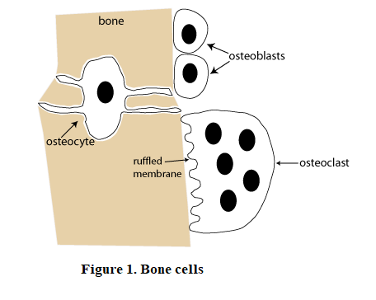

**VI.3. The Extracellular Matrix (ECM) of Bone Tissue**  
The bone's extracellular matrix is made up of an organic matrix (ground substance and collagen fibers) that becomes mineralized.

**VI.3.1. The Organic Matrix**  
The organic ECM is primarily composed of numerous type I collagen microfibrils. The ground substance is minimal and contains glycoproteins, mucopolysaccharides, serum proteins, water, and electrolytes.

**VI.3.2. Mineral Salts**  
The hardness of bone is due to the mineralization of its organic matrix. This mineral content is made up of hydroxyapatite crystals (crystallized calcium phosphate) and calcium carbonate. Bone contains 98% of the body’s calcium, making it a major calcium reservoir and playing a key role in calcium-phosphate metabolism.