**II. Connective Tissue**

Of **mesenchymal origin**, connective tissue is composed of **isolated cells** dispersed within an **abundant extracellular matrix**. The extracellular matrix of connective tissue consistes of :

* **Protein fibers**: Collagen, reticular, and elastic fibers.
* **Amorphous ground substance**: An optically empty, gel-like substance.

This **matrix** fills the spaces between cells, facilitates cell-to-cell associations, and provides **mechanical resistance** (such as in bones or tendons). Connective tissue is **separated from other tissues** by a **basal lamina**.

**Classification of Connective Tissue**

The relative composition of **fibers, ground substance, and cells** allows connective tissue to be classified into **dense** and **loose** connective tissue:

* **Dense connective tissue**: Contains a **high concentration of fibers**, which are tightly packed together.
* **Loose connective tissue**: Contains **moderately abundant fibers**, which are loosely intertwined.

The term **"connective"** comes from the **primary function** of this tissue: forming links between tissues and organs.

Beyond its **structural mechanical role**, connective tissue also:

* **Regulates exchanges** of nutrients, metabolites, and waste products between tissues and the circulatory system.
* **Participates in immune defence mechanisms**. …and in **inflammation**. It is a **highly vascularized tissue** through which **blood and lymphatic vessels** circulate.

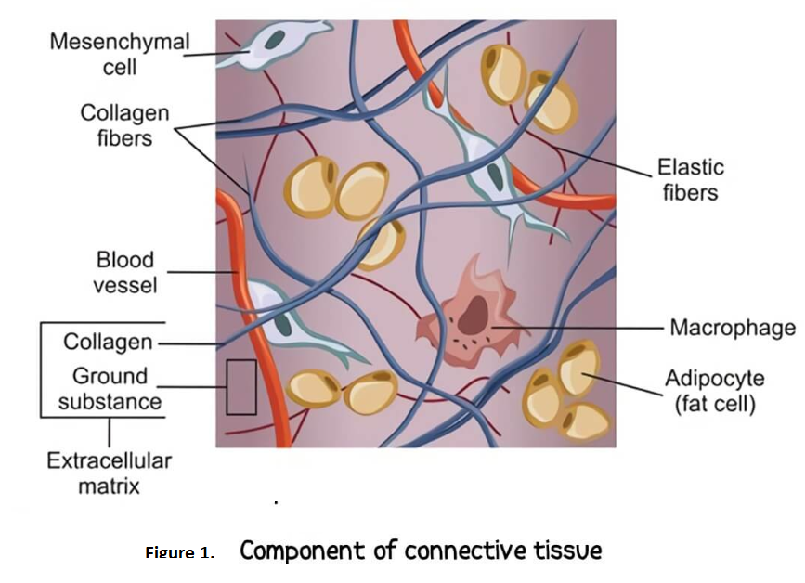

**II.1. Basic Components of Connective Tissue**

**II.1.1. Connective Tissue Cells**

**Fibroblasts / Fibrocytes**

Fibroblasts are the **main cell type** in connective tissue and are responsible for synthesizing **collagen, elastic fibers, and ground substance**. **Fibrocytes** are less active but can **reactivate into fibroblasts** when needed.

**II.1.2. Fibers**

Fibers are **long, thin protein polymers** present in varying proportions depending on the type of connective tissue. There are **three main types of fibers**:

1. **Collagen fibers**
2. **Reticular fibers** (Réticuline)
3. **Elastic fibers** (Élastine)

**A. Collagen Fibers**

Collagen fibers are the **most abundant** in connective tissue and provide **tensile strength** and **structural support**. They are composed of **collagen proteins**, which are synthesized by **fibroblasts**.

Collagen is the **most abundant fiber** in supportive tissues. This protein is characterized by its **high tensile strength** rather than elasticity.

* In **spreads** (histological preparations), collagen fibers appear **long, slightly wavy, and non-anastomosed** (not branching).

**B. Reticular Fibers**

Reticular fibers are primarily composed of **type III collagen**. They are generally **thin, irregular, and form interconnected networks**. These fibers are particularly found in:

* **Liver**
* **Lymph nodes**
* **Hematopoietic organs** (e.g., bone marrow, spleen)

**C. Elastic Fibers**

In histological spreads of **stained mesenteries**, elastic fibers appear as a **network of branched, flexible fibers**.

* They can be **stretched up to 150%** of their resting length and return to their original shape once the tension is released.
* This elasticity is due to their **lysine content**.
* Elastic fibers are abundant in connective tissues of organs that must **deform and recoil**, such as:
  + **Aorta**
  + **Alveolar septa of the lungs**
  + **Skin**
  + **Bladder**

**II.1.3. Ground Substance**

Ground substance **fills the space** between cells and fibers in connective tissue.

* In fresh tissue, it appears **translucent, colorless**, and has the **consistency of a highly hydrated gel**.
* It is composed of:
  + **Water and ions**
  + **Non-fibrillar organic compounds**, including:
    - **Glycosaminoglycans (GAGs)** → long polysaccharide chains
    - **Proteoglycans**
    - **Glycoproteins**

The most abundant glycosaminoglycan is **hyaluronic acid**, a **non-sulfated GAG**. Other glycosaminoglycans form **proteoglycan aggregates**, which help **retain water**.

**II.2.1. Loose Connective Tissues**

In this type of tissue, there is a **balanced distribution** of **cells, fibers, and ground substance**.

* It is **flexible** and **well-vascularized**, providing **support and nutrition** to surrounding tissues.
* Due to its **high ground substance content**, it serves as a **reservoir for water and ions**.
* It plays a key role in **immune defense**, as it houses **mobile immune cells**.

**II.2.2. Dense Connective Tissues**

These tissues are characterized by a **high abundance of collagen fibers** embedded in a **less prominent ground substance**.

**A. Dense Regular Connective Tissue**

In this type, **collagen fibers are arranged in a parallel, organized manner**, which provides **high tensile strength** in one direction.

**B. Dense Irregular Connective Tissue**

In **dense irregular connective tissue**, **collagen fibers** are arranged **randomly**, rather than in a parallel structure. This disorganized fiber arrangement allows the tissue to **resist mechanical stresses in multiple directions**, providing **strong structural support**.

**Key Features:**

* **High collagen fiber content**
* **Irregular fiber orientation**
* **Resistant to stretching and mechanical forces from different directions**

**II.2.3. Connective Tissues Predominantly Composed of Elastic Fibers**

In this type of tissue, **elastic fibers** **predominate** over other components, including **collagen fibers**.

* The abundance of **elastic fibers** provides tissues with the ability to **stretch and recoil**.
* **Example:** The **yellow ligament** of the **spinal column**, which allows for flexibility and support while maintaining the structural integrity of the spine.

**II.2.4. Reticular Tissues**

Reticular tissue is composed of **fine reticular fibers** (type III collagen) arranged in a **network** (mesh), providing a structural framework. The **reticular cells** rest on this network.

* This tissue is primarily found in **lymphoid** and **hematopoietic organs**, where it supports the **cells** involved in immune responses and blood cell production.

**Examples of Locations:**

* **Lymph nodes**
* **Spleen**
* **Bone marrow**