Introduction

The cell is the fundamental structural and functional biological unit of all living beings. While sharing several common mechanisms, such as protein synthesis and energy transformation, the specific functions of each type of cell vary greatly. In the human body, the estimated number of cells is 100 trillion. Under a light microscope, cells and extracellular components of different organs display a distinct organizational pattern. This organized arrangement reflects the cooperative effort of cells to perform a specific function.

Thus, an organized aggregation of cells working collectively is called a tissue. Tissues carry out various functions in the body through the collaborative efforts of their individual cells. In animal tissues, neighboring cells are connected by specialized intercellular junctions, facilitating this collaboration and ensuring harmonious functioning. Other mechanisms, such as specific membrane receptors and anchoring junctions between cells, enable the unified operation of tissue cells.

Human general histology is the study of the various tissues that make up an individual. This study is not static, as tissue structures vary according to their functions. In an organ, different tissues are always found side by side. Despite variations in structure and physiological properties, all organs are composed of only four basic types of tissues.

* **Epithelial tissue:** Covers body surfaces and cavities and forms glands.
* **Connective tissue:** Supports the other three basic tissues both structurally and functionally.
* **Muscle tissue:** Composed of contractile cells and responsible for movement.
* **Nervous tissue:** Receives, transmits, and integrates information from both the external and internal environments of the body.

**Epithelial Tissues**

The **epithelium** is a fundamental tissue composed of tightly connected cells forming a continuous layer that covers external surfaces or lines internal cavities. Epithelium can also function as secretory elements, forming glands.

In its simplest form, epithelium consists of **polygonal cells** arranged in a single layer. In more complex epithelial tissues, multiple layers of cells may be present. In all cases, the **basal cells** rest on a supportive layer called the **basement membrane**.

Epithelial cells are tightly joined through specialized **cell junctions**, which provide **physical strength** and regulate **the exchange of information and metabolites**. These cells exhibit **polarity**, with one side facing the **basement membrane and underlying tissues** (basal side) and the other side exposed to the **external environment or internal cavities** (apical side).

Epithelial tissues can originate from the **ectoderm, mesoderm, or endoderm**. Their **organization and function** are adapted to local needs. On **external surfaces**, epithelium specializes in **protection against mechanical and chemical abrasions**. On various **internal surfaces**, it can be specialized for **absorption, secretion, or the movement of fluids and particles along its surface** (Fig. 01).

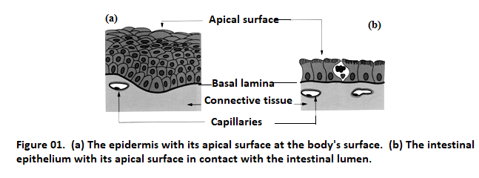

There are two types of epithelium:

* **Covering epithelium**, which covers the surface of the body and the natural cavities of the organism.
* **Glandular epithelium**, specialized in the production of a secretion.

**.1. Covering Epithelium**

These are tissues composed of contiguous cells, closely opposed to one another. Covering epithelium forms sheets that cover the external surface of the body and line its internal surfaces. Epithelial tissues are avascular, and their nutrition depends on blood capillaries located in the underlying connective tissue. The membranes lining the serous cavities of the body are called **mesothelium**, while those lining blood and lymphatic vessels as well as the cavities of the heart are called **endothelium**.

**I.1.1. Morphological Classification of Covering Epithelium**

Covering epithelium is usually classified according to three morphological criteria:

**A. Number of Cell Layers**

Based on the number of cell layers above the basal membrane, epithelium is classified as follows:

* **Simple epithelium**: Composed of a single layer of cells.
* **Stratified epithelium**: Composed of multiple layers of cells.
* **Pseudostratified epithelium**: Contains nuclei positioned at different levels, giving the false impression of stratification. However, all cells rest on the basal lamina, but not all reach the surface, hence the term **pseudostratified**.
* **Transitional epithelium (Urothelium)**: This epithelium lines a large portion of the urinary tract. Its free surface is characterized by large dome-shaped cells. Depending on whether the bladder is empty or full, the urinary epithelium transitions from a **pseudostratified-like** appearance to a **simpler** one (Fig. 02).

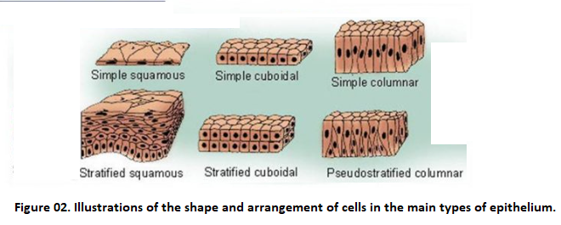

**B. The Shape of Epithelial Cells**

When observed in cross-sections, at the epithelial surface, the cells are:

* **Squamous**: The cells are wider than they are tall, appearing fusiform or like flat, long rectangles. The surface appears as a pavement of juxtaposed polygonal cells.
* **Cuboidal**: The cells are square or rectangular, with height and width approximately equal.
* **Columnar or Cylindrical**: The cells are taller than they are wide.

For stratified epithelium, the shape of the cells in the outermost layer determines the structural classification.

**C. Specialization of the Apical Surface**

Cells of covering epithelium are often specialized. The most common specializations are:

**C.1. Microvilli**

These are protrusions of the plasma membrane that are immobile. There are several types of microvilli, distinguished by the length and width of the membrane projections.

**C.2. Cilia**

These are mobile cellular extensions. Cilia perform synchronized wave-like movements that propel superficial layers of mucus or fluids across the surface of the epithelium in a coordinated direction.

**D. Presence of Specialized Cells**

Specialized cells may include **goblet cells** or **keratinocytes**.

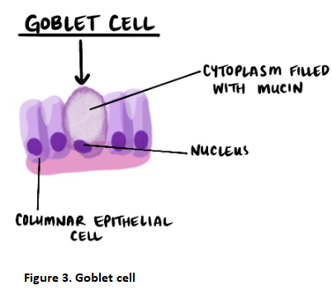

**To classify epithelia, we base it on:**

* **The shape of the cells**
* **The number of cell layers**
* **The apical specialization**
* **The presence of specialized cells (Fig. 04)**

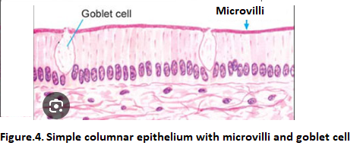

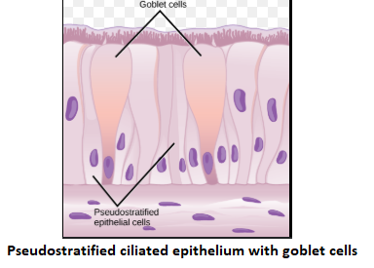

**I.2. Glandular Epithelium**

Secretory cells extract small molecules from the blood and use them to synthesize a specific product that accumulates in the apical cytoplasm in the form of secretory granules. These secretory cells form invaginations of the epithelium: the **glandular epithelium**. Thus, epithelial cells are the main component of all glands in the body.

**I.2.1. Classification of Glands**

There are three types of glands: exocrine glands, endocrine glands, and amphicrine glands.

**A. Exocrine Glands**

Exocrine glands secrete their products via a system of ducts that direct the secretion to the epithelial surface. They can be unicellular (e.g., goblet cells) or multicellular. Multicellular exocrine glands are more common and vary in size, ranging from small cellular clusters to large glands with tens of thousands of cells forming the majority of the parenchyma of organs such as the pancreas or liver.

Morphologically, exocrine glands have secretory units (acini) that synthesize the secretion product and ducts that transport it to an internal or external epithelial lumen.

**A.1. Classification of Exocrine Glands**

Exocrine glands can be classified according to three main criteria:

**A.1.1. Gland Morphology**

Based on the morphological characteristics of the secretory unit and the excretory duct, the following forms are found:

* **Canalicular system**:
  + **Branched (compound gland)**
  + **Unbranched (simple gland)**
* **Secretory portion**:
  + **Acinar**: Secretory units are spherical, with small lumens that can be either simple or branched.
  + **Tubular**: A single straight or coiled tube (simple) or branched.
  + **Alveolar**: Secretory cells form sac-like structures with large lumens.

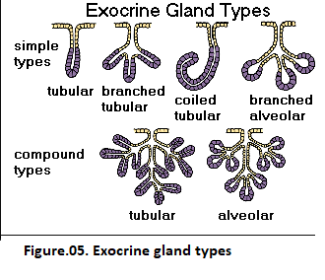

**B. Endocrine Glands**

Endocrine glands synthesize various chemical messengers in the body: **hormones**, which act at a distance from their site of production. Endocrine glands lack excretory ducts and release their secretions **directly into the bloodstream**. These glands vary significantly in **size, location, and appearance**.

**C. Amphicrine Glands**

Amphicrine glands release their secretion **both into the external environment and into the bloodstream**.

An amphicrine gland can be classified as:

* **C.1. Heterotypic**: The exocrine and endocrine functions are performed by **different cells** (e.g., **pancreas**).