**CHAPTER IV: Resistance of a beam section at the ultimate limit state**

**IV.1 GENERAL**

Justifications with respect to the ULS, in addition to verifications with respect to the SLS, are essential for the following reasons:

• An excess of the characteristic loads (taken into account in the calculations at the SLS) is always possible,

• The behavior of the structures under ULS combinations must be examined. To do this, it is not possible to proceed by extrapolation, but to carry out specific verifications.

**IV.2 EQUILIBRIUM OF A SECTION AT THE RUPTURE**

To the extent that the prestress is adherent to the concrete, experience shows that the behavior of a section at the exhaustion of its resistance can be correctly understood by relying on the following hypotheses:

• Conservation of the flatness of the straight sections,

• Non-intervention of the tensioned concrete,

• Non-slippage of the materials.

**IV.3 CHARACTERIZATION OF AN ULTIMATE LIMIT STATE**

Physically, an ultimate limit state is characterized by the fact that at least one of the materials constituting the section reaches its ultimate deformation. Regulatory, it is conventionally accepted that an ULS is reached when the deformation diagram is a limit diagram passing through one of the pivots A, B, C (Figure IV.1). Pivots A and B corresponds:

• For steels, to ultimate elongations. This limit was set at 10-2 in BPEL 91. In the Eurocode, its value is 2.5. 10-2 or 5.0. 10-2 or 7.5.10-2,

• For concrete, to an ultimate shortening of 3.5. 10-3. Pivot C, for its part, makes it possible to take into account the fact that when a part perishes while being compressed everywhere; the shortenings measured there are significantly lower than on the compressed fiber of a part partially stretched to rupture.

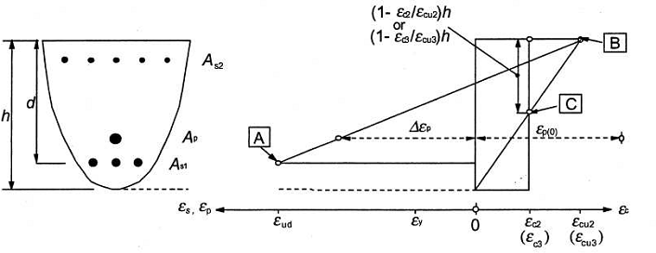

Figure IV.1: The deformation diagram [6]

**IV.4 PRINCIPLE OF JUSTIFICATIONS**

This is to ensure that the regulatory design stresses, which we will designate by sa, do not lead to the appearance of an ultimate limit state in the section.

**IV.4.1 Design stresses**

Even when the external loads only generate simple bending, they are composite bending stresses, due to the prestress Pm characterized by two parameters which are the normal component of the resultant and the resulting moment at a point.

**IV.4.2 Justification at ULS**

The justifications of the elements of a beam with respect to the ultimate limit state include the verification, on the one hand, of the resistance of the transverse reinforcements and, on the other hand, that of the compressed connecting rods.

The first step is to determine the angle ßu that the concrete balls form with the average fiber of the beam, this angle is given by:



ßu being however limited below 30°. The PBEL rules then define the ultimate shear stress τuilm corresponding to the full use of the resistance of the transverse, active and passive reinforcements.



With the following notations At: total area of ​​the sections of a course of transverse passive reinforcements;

St: spacing of two courses of these reinforcements, measured along the mean fibre of the beam;

Fe: yield strength of the steel;

α: angle of these reinforcements with the mean fibre of the beam (angle between 45° and 90°);

Ftu: resistant force of the steels of a course of transverse prestressing reinforcements;

st': spacing of two courses of these reinforcements, measured along the mean fibre of the beam;

α': angle of these reinforcements with the mean fibre of the beam (angle between 45° and 90°).

With: γp=γs=1.15 for justifications with respect to fundamental combinations. γp=γs=1 for justifications with respect to accidental combinations.

We must verify that τu≤τulim It is also possible, in the case of a section that is not entirely tensioned, to add to τulim the complementary term ftj/3. This term takes into account the fact that part of the shear force is balanced by the compressed part of the beam. In the very frequent case where the web only has passive reinforcement’s perpendicular to the mean fiber of the beam, we will have the following inequality:



The BPEL rules also impose constructive provisions:

⮚ A minimum of web reinforcement is required in all areas of the beam. It is given by the condition  that the quantity is at least 0.4 Mpa

The spacing **st'** of the transverse reinforcements of the prestressing web must be at most equal to 0.8h.

The spacing **st** of the transverse reinforcements of the passive web must be at most equal to the smallest of the three values ​​0.8h, 3bo and one meter; h designating the total height of the section and bo the minimum gross thickness of the web.

These provisions are intended to avoid excessive fragility of the concrete of the beam web.