Mohammed Khider University of Biskra

Faculty of Science and Technology

2nd year License

Module: TP ELN Fond 1

**Lab N 03 :** Electrical characteristic of the diode

1. **Objectives of the TP:**

The objective of this practical work is to record the characteristic (I as a function of V) of the diode in both directions (direct and reverse) and extract their thresholds (conductivity threshold of the diode and breakdown threshold). As well as the use of the diode for the rectification of an alternating signal.

1. **Characteristic of the diode**

A silicon diode (for example) is made up of two junctions, one N-doped and the other P-doped.

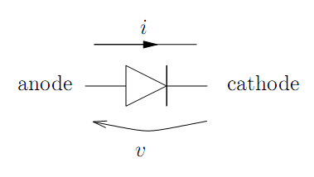

Fig.02 : diode symbol

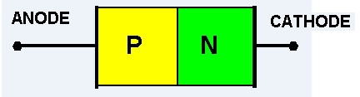

Fig.01 : PN jonction

**2.1 Theoretical part**

The formula for the diode current:is given by:

the voltage across the diode puts the latter in two states.

• If V<VD, the diode is blocked

• If V>VD, the diode is Passing

the equivalent diagram for the two cases (V>VD and V<VD)

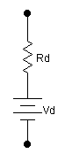

V

VD

In the ideal case the diode is replaced by a short circuit (CC, forward direction) or a CO (reverse direction).

**2.2 Practical part:**

Test and verify the diode with the multimeter in ohmmeter mode (sign of the diode).

Forward direction: 0.560 [V]

Reverse direction: O.L (open circuit)

Carry out the following assembly and fill in the table:

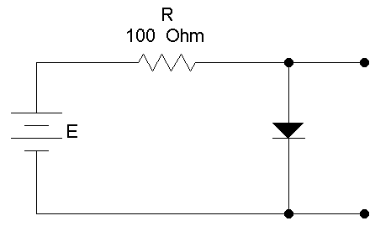

mA

V

VD

ID

|  |  |  |  |  |  |  |  |  |  |  |  |  |  |  |  |  |
| --- | --- | --- | --- | --- | --- | --- | --- | --- | --- | --- | --- | --- | --- | --- | --- | --- |
| **E (V)** | **-5** | **-4** | **-3** | **-2** | **-1** | **0** | **0.5** | **1** | **1.5** | **2** | **2.5** | **3** | **3.5** | **4** | **4.5** | **5** |
| **VD (V)** |  |  |  |  |  |  |  |  |  |  |  |  |  |  |  |  |
| **ID (µA/mA)** |  |  |  |  |  |  |  |  |  |  |  |  |  |  |  |  |

Note: for the opposite direction take measurements of the ID current in µA.



Draw the characteristic of the diode: ID = f(VD)

How much is the threshold voltage V0 (from the graph)?

**………………………………………………….**

Calculate the dynamic resistance rd from the curve

**…………………………………………………..**

**3. Single-wave rectification**

**3.1 Theoretical part** ( Vmax=9V,f=1KHz)

The half-wave rectification of an alternating signal V(t)=Vmax sin(ωt) gives the signal Us(t) represented by the following figure:

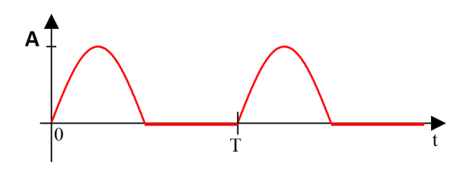

Develop the average value mathematically Us avg

..............................................................................................................................................................................................................................................................................................................................................

**N.A. :**

Develop the effective value mathematically Us eff

..................................................................................................................................................................

.................................................................................................................................................................

...............................................................................................................................................................

**N.A :**

**3.2. Practical part (single-wave rectifier circuit):**

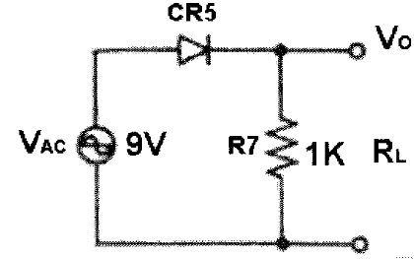

CH1

CH2

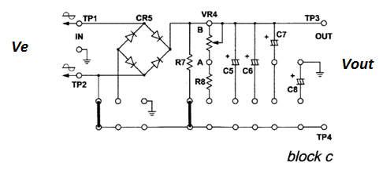

**Fig. 23002-block c.1**

Handling:

1. Insert the connecting clips according to Fig. 23002-block c.1
2. Apply an alternating voltage source of Vpp = 18 V between terminals TP1 and TP2.
3. Plot the voltage Vout (CH2) in AC and DC mode and Ve (CH1) in AC mode only.
4. Measure Vout using the multimeter in AC and DC mode (Table 2).
5. Complete Table (2).

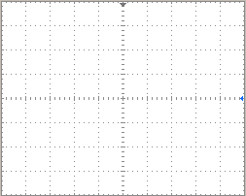 

AC mode DC mode

|  |  |  |
| --- | --- | --- |
|  | **Average value** | **Effective value** |
| Multimeter |  |  |
| **Oscilloscope** |  |  |
| **Calculation** |  |  |

Compare the practical results with those of the theory

................................................................................................................................................................