**Continuous regime and fundamental theorems**

**1.Definitions**

An electrical component can only function if an electric current flows through it. It must therefore be able to let the electric current in and out.

**- Terminal**

This is the part of an electrical component that can let the electric current in or out (see Figure I.1). Terminals also allow connections to be made, i.e. to connect an electrical component to another electrical component.

**- Dipole**

This is an electrical component that has two terminals (Fig. 1). Lamps, switches, generators, batteries, diodes, LEDs, resistors and motors are dipoles.



Figure I. Dipole

The dipole is an electrical component with two terminals: an electric current input terminal and an output terminal. An electrical component cannot have less than two terminals. On the other hand, there are electrical components more complex than dipoles with three, four or more terminals, we then speak of tripoles, quadrupoles, etc. For example, transistors, transformers, or operational amplifiers are not dipoles. Each dipole has a simplified representation called a standardized symbol. We generally distinguish two types of dipoles:

* Active dipole: Generators that can produce electric current.
* Passive dipole: Receivers that receive electric current.

The behavior of a dipole can be described by a characteristic curve either

I = f(U)

or

U = f(I)

A dipole is passive if its characteristic passes through zero. The behavior of a dipole is characterized by two dual electrical quantities: voltage and current. The voltage across a dipole represents the potential difference u(t) between the two terminals of the dipole. The voltage is expressed in Volts (V).

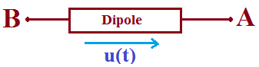

Figure 2. Voltage across a dipole

u(t) = VA − VB

The current flowing through a dipole corresponds to the movement of electric charges under the effect of the electric field induced by the potential difference across the dipole. At any time, the current entering one terminal of a dipole is equal to the current leaving the other terminal. The intensity i(t) is the flow rate of electric charges flowing through a section of conductor for a duration of time dt:

i(t) = dq(t) / dt

The intensity is expressed in Amperes (A). The electric current is an oriented quantity. Conventionally the positive direction corresponds to the direction of movement of positive charges.

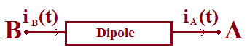

Figure 3. The current in a dipole

i(t) = iA(t) = iB(t)

There are two possibilities for the choice of the conventional directions of the voltage and current. Depending on whether u and i are in the same direction or not we have:

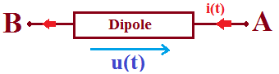

Figure 4. Receiver

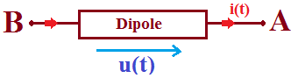

Figure 5. Generator

In steady state, independent of time, there is a relationship between the intensity i crossing the dipole and the voltage u between its terminals. This relationship can be expressed in the form

i = i(u) or u = u(i).

The graphs obtained are called static characteristics:

* i = i(u): static current-voltage characteristic of the dipole
* u = u(i): static voltage-current characteristic of the dipole

A dipole is passive if its short-circuit intensity and its open-circuit voltage are zero: its static characteristics pass through the origin. It is said to be active otherwise. A dipole is linear if:

i (αv1 + βv2) = α i(v1) + β i(v2)

u (αi1 + βi2) = α u(i1) + β u(i2)

**- Network**

A network is a set of dipoles connected together by conductive wires of negligible resistance.

**- Node**

In electricity as in electronics, a node is the electrical connection point between several components.

**- Branch**

A branch of a network is a set of dipoles connected in series.

**- Mesh**

A mesh of a network is a set of branches forming a closed circuit in which each node is encountered only once.

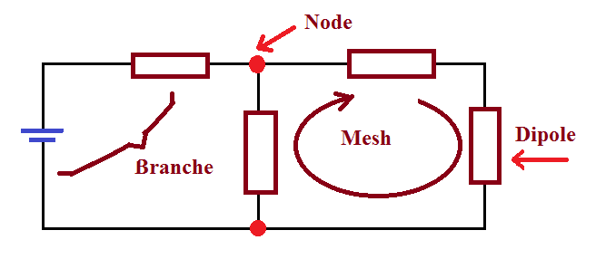

Figure 6. Electrical network

**2. Kirchhoff's laws**

**2.1 Law of nodes**

At any node of a circuit, and any instant, the sum of the currents that arrive is equal to the sum of the currents that leave. This is a consequence of the conservation of electric charge.

ΣiArrive at the node =ΣiLeave from the node



Figure 7. Currents in a node

The law of nodes can also be written in the following form: At any node of a network, the algebraic sum of the currents is zero ΣNk=1 ± Ik = 0

**2.2 Mesh law**

Along any mesh of an electrical network, at any time, the algebraic sum of the voltages is zero.

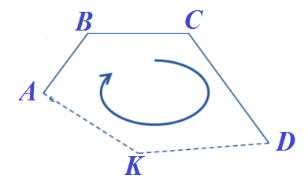

Figure 8. Voltages in a mesh

(VA− VB)+(VB −VC)+(VC−VD)+⋯+(V?−VA)=0

If we call the potential difference (VA− VB)=V1, (VB −VC)=V2, .........(V?−VA)=Vk

So the law of meshes becomes ΣNk=1 ± Vk=0

1. **Direct voltages and currents:**

Depending on the shape of the voltage (or current) delivered by the generator that supplies a circuit, we say that this circuit operates according to a certain regime. If it delivers a constant voltage, the circuit operates in Direct Current regime DC.

1. **Ideal voltage generator:**

An ideal voltage generator delivers a constant potential difference independent of the current it delivers.

VA−VB=e=constante ∀ i

i: the current delivered by the voltage source.

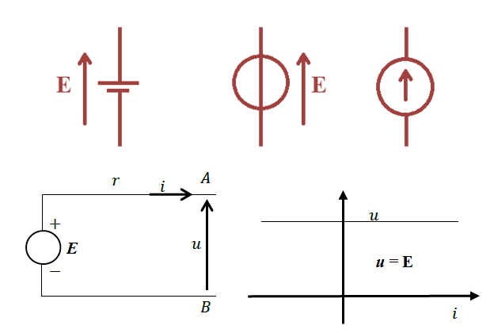

Figure 9 : Ideal voltage generator

1. **Ideal current generator**

An ideal current generator delivers a constant current regardless of the potential difference between its terminals. i = iS=constante ∀ u

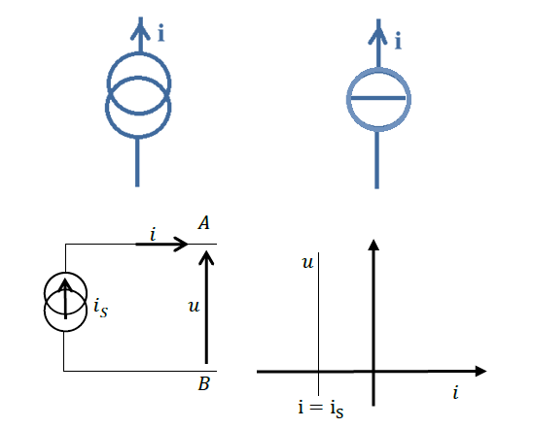

Figure 10 : Ideal Current generator

1. **Real voltage generator**

A real voltage generator often has an internal resistance Rg placed in series with the ideal voltage generator. In generator convention, the static voltage-current characteristic of the real voltage generator becomes: u = e − r i

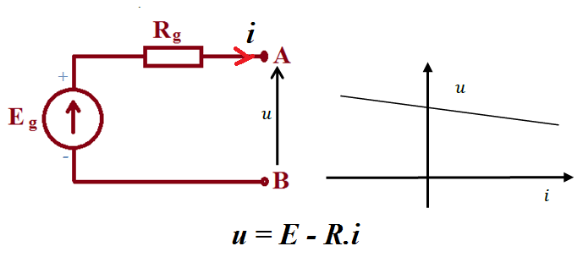

Figure 11 : Real voltage and Current generators

1. **Real current generator**

The internal resistance of an ideal current source is infinite. For a real generator, its internal resistance is taken into account by modeling it by an ideal current source ***Ig*** in parallel with its internal resistance ***Rg***. In generator convention, the static current-voltage characteristic of the real current generator is therefore as shown below

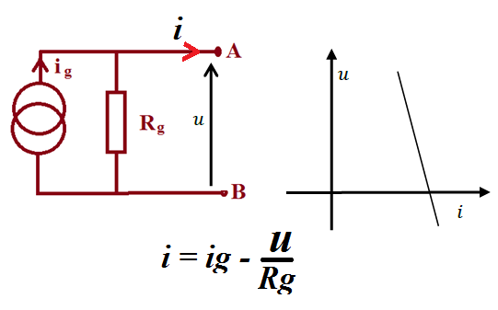

Figure 12 : Real Current generator

1. **Types of Current Source According To Circuit Dependency**

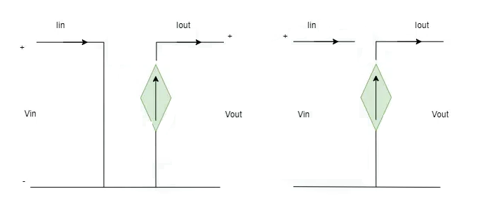Current Source on the Basis of the Circuit Dependency can be categorized as :

* Independent Current Source
* Dependent Current Source

1. **Dependent Current Source**

In this type of Current Source the Output Current Depends on the Circuit Variables, as the Value to the Output Current is Controlled by the other voltage or current of the circuit. So, it is Also called Controlled Current Sources and It can be Further Classified as :

**Voltage Controlled Current Source (VCCS):**When the Output Current of the Current Source is Controlled by the Voltage Present in Some other Branch, then it is known as Voltage Controlled Current Source.

The Output Current of the Voltage Controlled Current Source (VCCS) can be Written as

*Iout​=****μ****Vin*

Where ***μ*** is the Coefficient of Current Source

**Current Controlled Current Source (CCCS) :**When the Output Current of the Current Source is Controlled by the Current Present in Some other Branch, then it is known as Current Controlled Current Source.

The Output Current of the Current Controlled Current Source (VCCS) can be Written as

*Iout*​=***μ****Iin*

1. **Difference between current source and voltage source**

Given Below is the Table for the Comparison of the Current Source and Voltage Source

| **Current Source** | **Voltage Source** |
| --- | --- |
| It provides fixed current in circuit independent of voltage across it. | It provides fixed Voltage in circuit independent of current being drawn. |
| It has very high resistance almost infinite | It usually has small negligible resistance |
| load resistance is always lower than the internal resistance. | load resistance is always higher than the internal resistance. |
| Examples include Photovoltaic cells, current regulator ICs and diodes, HID & LED driver | Examples include Batteries, Generators, Alternators and Single Cell with internal resistance connected in series etc. |

1. **Voltage-current relationship:**
2. **Case of a Resistor**

The resistance is defined by the relationship established between the voltage at its terminals and the current flowing through it, called Ohm's law: **U(t)= R i(t) V**

The electrical energy produced by the passage of a current I in a resistance is converted by the Joule effect into heat. The instantaneous power dissipated by a resistor is is expressed by the relation: **P(t) = u(t) i(t)** watt Or **P= R∙I2**

1. **Case of a capacitor**

For a capacitor, the equation**: i(t)=c du(t)/dt**

shows that if **u(t) = cte** we have therefore **i(t) = 0.**

Therefore in continuous mode, no current crosses a capacitor, and the capacitor behaves as an open circuit.

1. **Case of a coil**

If an inductance L carries a current of intensity i, the voltage across the inductance is:

**U(t) = Ldi(t)/dt**

In continuous mode, a coil will always have a zero potential difference across its terminals, and the coil behaves as a short circuit.

1. **Fundamental theorems:**
2. **Dipole Associations**

Dipoles are said to be in series if they are traversed by the same intensity of electric current. And they are said to be in parallel if they have the same potential difference at their terminals

1. **Series connection of resistors**

Let there be n resistors connected in series and carrying the same current I (figure 7).



Figure 13. Series resistors

If we consider that the resistances between A and N behave as a single resistance and as the resistances are in series; then the same current I which passes from A to N therefore we can write: UAN=Req. ***I***

By applying Ohm's law to each of these resistances we can write the following relationships:

UAB=R1*I*; UBC=R2*I*;UCD=R3*I*;UDE=R4*I*;…;UYN=Rn*I*;

The ddp between the ends A and N i.e. of the circuit is equal to the sum of the ddp between A and B, between B and C, between C and D, …, and between Y and N. ie UAN UAB UBC UCD UYN

UAN=R1I+R2I+R3I+R4I+⋯+RnI

UAN=(R1+R2+R3+R4+⋯+Rn)

So by comparison we will have:

Req=R1+R2+R3+R4+⋯+Rn

So we can conclude that the resistances of a branch (connected in series) are equivalent to a single resistance equal to the sum of these resistances of the latter.

1. **Parallel or shunt connection of resistors**

Let us place several resistances (for example four resistances, figure 9) between two points N and M. The current I in the circuit creates several derived currents, the intensity of which is equal to the sum of the intensities of these derived currents.



Figure 14. Resistors in parallel.

If we consider that the resistances between M and N behave like a single resistance, we can write: **UMN=Req . I**

So

We know that I=I1+I2+I3+I4+.....+In

Applying Ohm's law between nodes M and N to each of the resistors, knowing that the voltage between M and N is constant, we can write the following relations:R1; R2; R3;R4;….;Rn

UMN=R1I1=R2I2=R3I3=R4I4=.......=RnIn



We replace the values of currents in the previous equation we will have ***I***





Therefore

From the last relation, we can conclude that the inverse of the equivalent resistance is equal to the sum of the inverses of the resistances connected in parallel

The inverse of resistance is known as: conductance we can write the relationship G (G =1/R).



In the following manner using the conductance



1. **Voltage divider:**

When we have a series association of resistors, we can express the voltage across one of them, knowing the voltage across the whole.

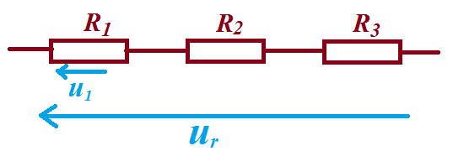

Figure 15

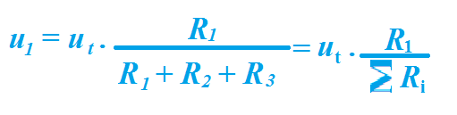 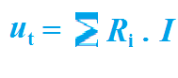

1. **Current divider:**

When we have a parallel association of resistors, we can express the current in one of them, knowing the overall current. Gi=1/Ri : is the conductance

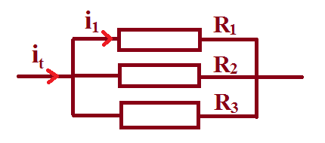

Figure 16

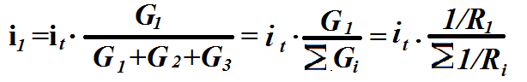

we have It= V(Σnk=1Gk) and

The Curtrent in branche j is . . . .

In terms of resistance . . . .

1. **Superposition theorem:**

Let us consider a linear network comprising n independent voltage and current sources that we can denote: S1, S2, . . ., Sn, and a quantity to be calculated, such as IK the current in branch K. Let us call IK1, IK2, . . . , IKn, the values ​​of this quantity created individually in this branch by each source acting alone assuming that the other sources being passivated or deactivated.

IK = IK1 + IK2 + • • • + IKn

**NB**: Pacify a source means replacing it with its internal resistance. In other words, this means short-circuiting the voltage sources and opening the current sources.

Example for the circuit below: U1 and U2 known, we wish to determine the voltage U3



Figure 17

The value of the potential U3 can be found in two steps:

* We turn off the source U2 (replaced by a short circuit) and we calculate U31, as a function of U1, R1 and R2.
* We turn off the source U1 (replaced by a short circuit) and we calculate U32, as a function of U2, R1 and R2.
* The potential difference U3 is then U31+U32.