Mohammed Khider University of Biskra

Faculty of Science and Technology

2nd year License

Module: TP ELN Fund 1

**Lab N 01: Electrical measurements**

1. **Objectives of the Lab:**

At the end of this practical work, the student will learn the following knowledge:

1. Recognize the various electronic components constituting an electrical circuit;

2. How to take measurements of voltages and electrical currents (and others) in a circuit;

3. Use the multimeter (voltmeter, ohmmeter, etc.), and take safety precautions;

4. Visualize a voltage (or more) on the oscilloscope.

**2. Theoretical part:**

* The average value of a voltage U(t) (or a current) is given by the following formula:

T: period of the signal U(t).

* The effective value of a voltage U(t) (or a current) is given by the following formula:

T: period of the signal U(t).

**3. Course question:**

For a signal U(t)=V\_max sin⁡(ωt)+B, with: V\_max: the amplitude of the signal and ω: pulsation of the signal (ω=2πf).

Calculate the average value U\_moy and the effective value U\_eff as a function of A. Give the numerical value of U\_moy and U\_eff for V\_max=6V, B=2V and f=100Hz.

|  |  |
| --- | --- |
|  |  |
| ………………………………………………………….  ……………………………………….  …………………………………………………………..  …………………………………………………………..  ………………………………………………………….  …………………………………………………………..  ………………………………………………………......  …………………………………………………………..  ………………………………………………………….  N.A. : ………………………………………………. | ………………………………………………………….  ……………………………………….  …………………………………………………………..  …………………………………………………………..  ………………………………………………………….  …………………………………………………………..  ………………………………………………………......  …………………………………………………………..  ………………………………………………………….  N.A : ………………………………………………. |

**4. Practical part:**

Adjust the GBF (Low Frequency Generator) so that it delivers the following signal:

|  |  |  |  |
| --- | --- | --- | --- |
| =………V | Forme=…………………. | Fréquency=……………Hz | B=………………V |

Visualize the voltage U(t) across the GBF using the oscilloscope in DC mode and take measurements using the “measure” button on the oscilloscope.

**T=………………… […]**

**F=………………… […]**

**Vmax=…………… […]**

**Vmin=…………… […]**

**Vmoy=…………… […]**

**Veff=……………… […]**

Visualize the voltage U(t) across the GBF using the oscilloscope in AC mode

**T=………………… […]**

**F=………………… […]**

**Vmax=…………… […]**

**Vmin=…………… […]**

**Vmoy=…………… […]**

**Veff=……………… […]**

**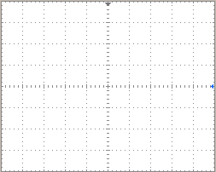**

**5. Take measurements with the voltmeter:**

Note: We always choose the largest caliber of the value to be measured

Measure the voltage across the GBF using the voltmeter in DC mode

it represents 🞎 🞎 🞎

Measure the voltage across the GBF using the voltmeter in AC mode

it represents 🞎 🞎 🞎

complete the following table

|  |  |  |  |
| --- | --- | --- | --- |
|  | **Theoretical (Q3)** | **Oscilloscope(Q4)** | **Voltmetre (Q5)** |
| ***Vmoy*** | ……………………….. | ……………..…. | ……..……. |
| ***Veff*** | …………………………… | ……………..…. | …..………. |

What are your comments……………………………………………………………

**6. Take measurements with the ammeter:**

Now we will carry out the following experiment : **U=5V, R1=1KΩ**

|  |  |
| --- | --- |
| Create the following circuit:  **elec_012** | Take the following measurements:  **U=……………V**  **I=………… mA**  **Calculate :**  **R1 Calculated =U/I=……………KΩ** |

**7. Take measurements with the Ohmmeter:**

Using the multimeter, measure the value of the resistance available:................................... Ω

………………………….. Ω

|  |  |  |  |  |
| --- | --- | --- | --- | --- |
|  | **Color Code** | **Nominal value** | **Tolerance** | **value range** |
| **R1** | ………………………… | ……………..….Ω | ……..….Ω | between : …….…..Ω and ……..…Ω |
| **R2** | …………………………. | ……………..….Ω | …..…….Ω | between : ………...Ω and…..……Ω |

Comments……………………………..

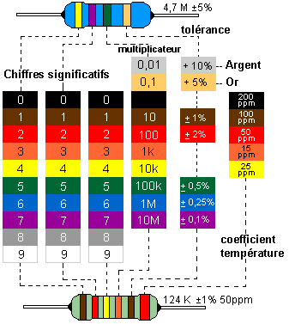

|  |
| --- |
| Noir |
| Marron |
| Rouge |
| Orange |
| Jaune |
| Vert |
| Bleu |
| Violet |
| Gris |
| Blanc |