**CURRICULUM VITAE**

**CV OR RESUME**

1. **DEFINITION:** Is a short account of one’s career and qualifications prepared typically by an applicant for a position.
2. **How to structure the CV**

The structure is a list of accomplishments, it being an advertisement for ourselves, it helps us a lot in planning what to say and how to say it.

1. **Personal details**
2. **Personal profile**
3. **Work experience**
4. **Education**
5. **Skills and Interests**

* **Languages,**
* **IT skills / computing skills,**
* **Interests/hobbies**
* **References**

1. **Personal details :**

* Name.
* Phone number.
* email address.

**WHAT INFORMATION SHOULD YOU GIVE UP?**

* **Addresses;** Put only one address on a CV, the one where you want to get important mail.
* **Age or birthday;** just type it as “25 years old.”
* **Birthplace;** Most birthplaces offer little useful information you can control.
* **Marital status,** not important
* **Nationality;** not important
* **Photo of yourself :** only if request

1. **Personal profile :**

A short paragraph about yourself: Career, Objective, Your professional project.

1. **Work experience :**

Experience of work is very important to talk about in a CV. In reverse chronological order.

The main parts in this section are:

* **year,**
* **name of company,**
* **city,**
* **Country,**
* **Fonction.**

Ex. 2015-Present: sonatrach, engineer, Hassi Messaoud, Algeria, engineer (main responsability)

1. **Education :**

On most CV’s education goes top after the personal profile or after the work experience.

The main parts in this section are:

* **Year,**
* **Degree,**
* **Speciality,**
* **Institution, (university, school…..)**
* **City,**
* **Country.**

**Ex.** June 2016 Master’s in biology, majored in microbiology, faculty of science, Biskra university, Algeria.

1. **Skills and Intersts :**

* **LANGUAGES**: the “Languages” heading is extremely important on CVs where applicants are offering skills to work internationally.

You can show different levels of skills by adding different adjectives like:

* **mother tongue/** **Fluent** : language spoken
* **excellent** **command:** higher level of written and spoken English.
* **good command or Fair level of** … Understand TV and radio. Can write simple letters
* **Basic skills :** notions
* **IT skills / computing skills,**
* **fully literate with/proficient with** : excellent level of skills
* **writing knowledge with/ competent with :** Professional use
* **basic knowledge with / Familiar with :** basic level
* **Interests/hobbies :** they come from activities that are not work-related.(ok, but not really important)

For example, Movie going, reading, music, sports, arts. Etc.....

* **References:** The name of one or two person who know you.
* **position.**
* **company / university .**
* **Telephon number.**
* **mail adress.**

**A good Example of CV**

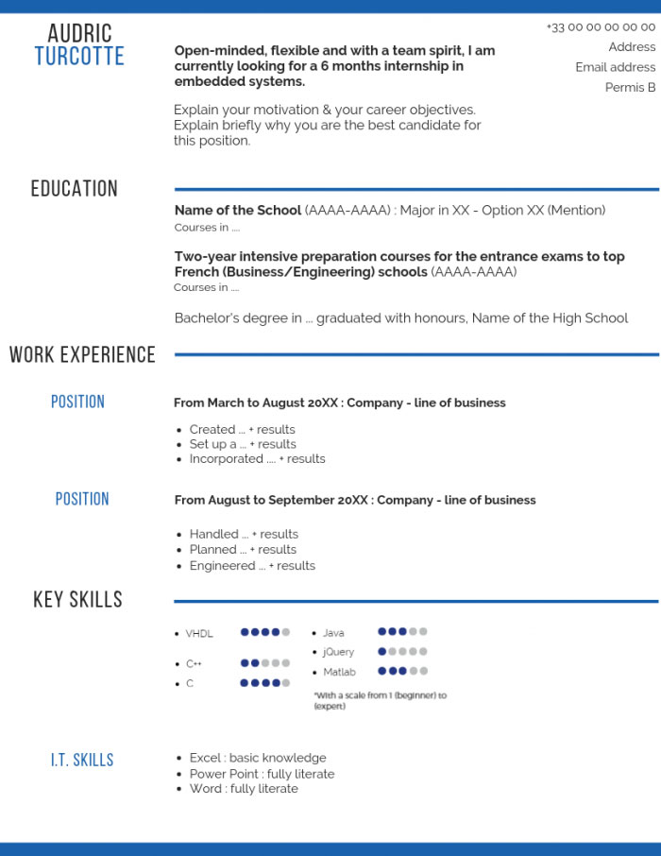

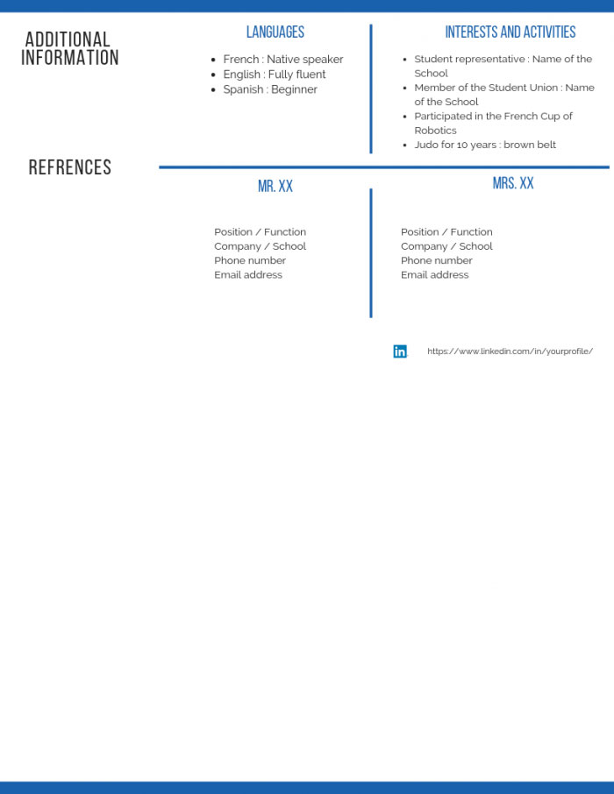

**The cover letter**

**The Letter:From Top to Bottom**

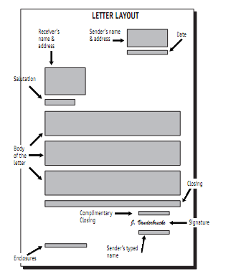

**THE CONTENT OF THE LETTER**

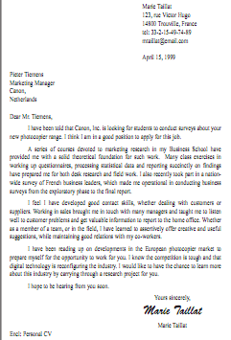

**Mistakes to avoid......**  
In summary, common mistakes to avoid are:

• Talking to yourself:

• Touching on sensitive areas:

• Trying to say everything:

• Organizing badly:

• Providing irrelevant or negative information:

* Contractions where necessary. Ex. I’m or I ‘am. Don’t or Do not. I’d or I would.
* Use passive voice instead of active voice.
* Using weak verbs and adjectives instead of strong ones

**Cover letter grammar**

* Get instead of receive
* Give ……..provide
* Tell………..inform
* Help……….assist
* Answer……..reply
* Choose………select
* Talk about……discus
* Make sure …….ensure