Mohammed Khider University of Biskra

Faculty of Science and Technology

2nd year License

Module: TP ELN Fond 1

**Lab N 04 : Stabilized power supply and zener diode**

**1. Double-wave rectification (with Graetz bridge):**

**1.1 Theoretical part:**

The double-wave rectification of an alternating signal V(t)=V_max sin(ωt) gives the signal U_d (t) represented by the following figure:

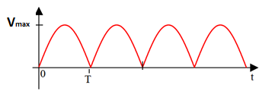

1. Find the mathematical expression for the average value U_(d avg):

……………………………………………………………………… ……………………………..

……………………………………………………………………………………………………..

…………………………………………………………………. …………………………………

**A.N :**

2. Calculate mathematically the effective value U_(d eff):

………………………………………………………………….. ……………………………………….

………………………………………………………………….. ………………………………………..

……………………………………………………………………… ……………………………….

…………………………………………………………………………………………………………..

…………………………………………………………………. ……………………………………….

…………………………………………………………………………………………………………..

…………………………………………………………………. ……………………………………….

……………………………………………………………………

**N.A : …..**

**1.2 Practical part (double-wave rectifier circuit or Graetz bridge):**

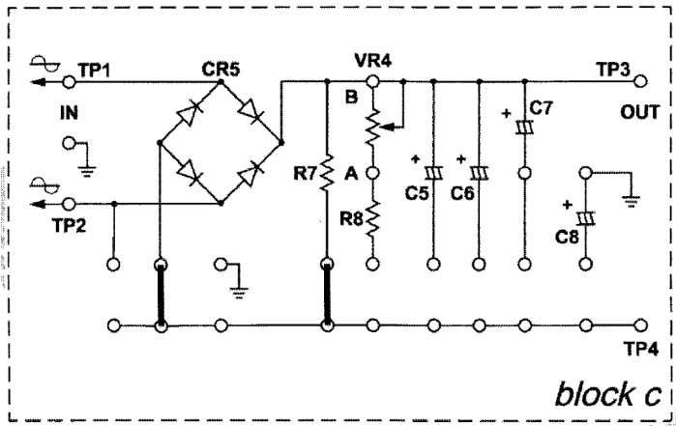

**Fig. 23002-block c.2**

1. **Handling:**
2. Insert the connecting clips according to Fig. 23002-block c.2
3. Apply an alternating current source of Vpp = 18V between terminals TP1 and TP2.
4. Plot only the voltage Vout (CH2) in AC and DC mode. (i.e. unplug CH1)
5. Measure Vout using the multimeter in AC and DC mode (Table 3).
6. Complete the Table (3)

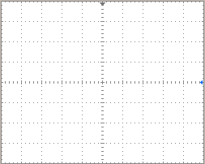 

AC mode DC mode

**Important note**: To stabilize the signal, press “trigger Menu” then choose “Source: CH2” and adjust with LEVEL

**Table (3)**

|  |  |  |
| --- | --- | --- |
|  | **Average Value (DC)** | **Effective value (AC)** |
| **Multimiter** |  |  |
| **Oscilloscope** |  |  |
|  |  |  |
| **Calculation** |  |  |

Compare the frequency of the rectified signal with that of the input signal

……………………………………………………………………………………………………….

**B. Filtering by capacitors:**

Connect a capacitor C=1µF then C6 and draw the graphs obtained in DC mode:

 

C1 C6

|  |  |  |
| --- | --- | --- |
|  | **C=1µF** | **C6** |
| **( DC mode)** |  |  |
| **( AC mode)** |  |  |

Give your conclusion

|  |  |  |
| --- | --- | --- |
|  | **Signal type** | **Frequency** |
| **Double wave** | **DC et AC** |  |
| **After filtring** | **DC** |  |

1. **Characteristic of the Zener diode**

Test and verify the diode with the multimeter in ohmmeter mode (sign of the diode).

Carry out the following assembly and fill in the table:

|  |  |  |  |  |  |  |  |  |  |  |  |  |  |  |  |  |
| --- | --- | --- | --- | --- | --- | --- | --- | --- | --- | --- | --- | --- | --- | --- | --- | --- |
| **Ue (V)** | **-10** | **-9** | **-7** | **-6** | **-5** | **-4** | **-3** | **-2** | **-1** | **0** | **0.5** | **1** | **2** | **3** | **4** | **5** |
| **VD (V)** |  |  |  |  |  |  |  |  |  |  |  |  |  |  |  |  |
| **ID (µA/mA)** |  |  |  |  |  |  |  |  |  |  |  |  |  |  |  |  |

 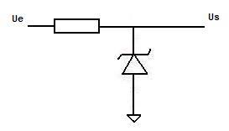

Draw the characteristic of the diode: ID = f(VD)

How much are the thresholds voltages in forward and reverse directions (from the graph)?

**………………………………………………….**

compare the characteristics of the classic diode and that of the zener diode

.....................................................................................................................................................................