Mohammed Khider University of Biskra

Faculty of Science and Technology

2nd year License

Module: TP ELN Fond 1

**Lab N 02 :** characteristics of passive filters

**Objective of the lab:**

Study of the behavior of an RC circuit as a function of frequency.

**A. Theoretical part**

**A.1. RC filter (low pass):**

***C***

***R***

***Vs***

***Ve***

***I***

***Vr***

***Figure 1 :*** *RC filter*

In a low pass filter the output voltage V_s is taken across the capacitor C (see figure 1). A low pass filter is a filter that passes low frequencies and attenuates high frequencies. That is to say frequencies higher than a frequency fc called cutoff frequency. It could also be called a high cut filter.

**A.1.1 Low pass filter transfer function**

H(ω): The transfer function obtained by considering the voltage across the capacitor as the output voltage V_s.

We can write the transfer function in the form:

Where G is the gain of the dipole and φ its phase.

et



***Figure 2 :***Bode diagram for a low pass filter.

**A.2. CR filter (high pass):**

***R***

***C***

***Vs***

***Ve***

***I***

***Vc***

***Figure 3 :*** *CR filter*

In a high pass filter the output voltage Vs is taken across the resistor (figure 3). A high-pass filter is a filter that lets high frequencies pass and attenuates low frequencies, that is to say frequencies below fc.

**A.2.1. Transfer function**

The transfer function obtained by considering the voltage across the resistor as the output voltage.

We can write the transfer function in the form:

Where G is the gain of the dipole and φ its phase.

et

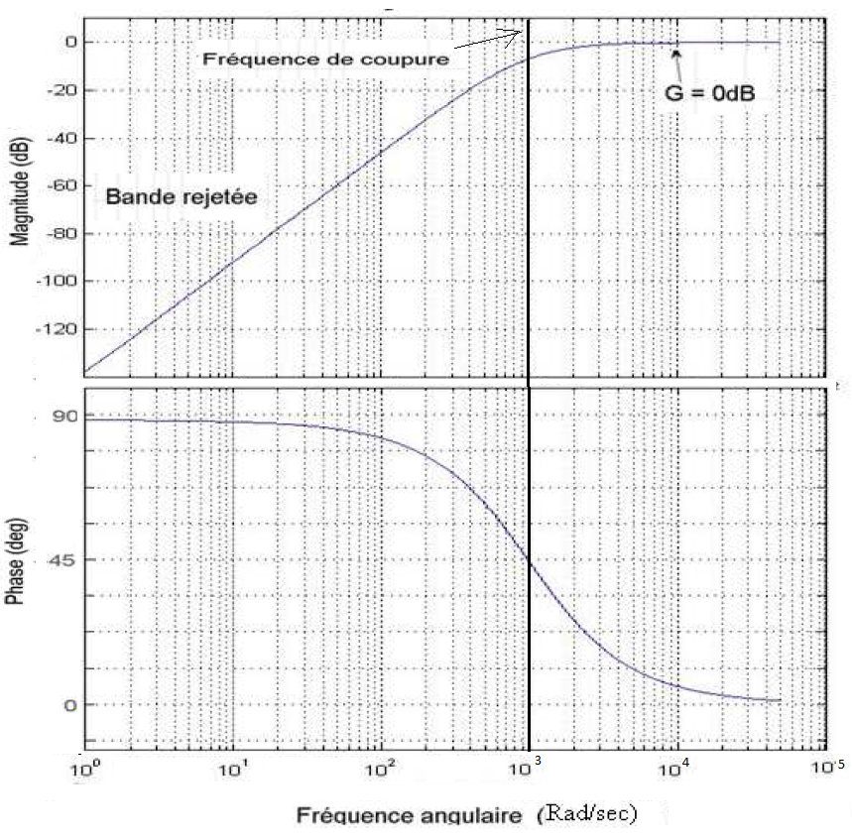

***Figure 4:***Bode diagram for a high pass filter.

**B. Practical part:**

**B.1 RC Filter (low pass):**

Carry out the following assembly with R = 4.7 kΩ and C = 0.22 µF.

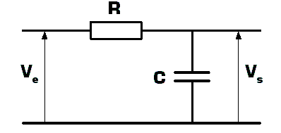The circuit is supplied with a sinusoidal voltage.

avec= 5 V.

Using an oscilloscope, record the voltage Vs across the capacitor and the phase shift ∆T between the latter and Ve, for frequencies ranging from 50Hz to 10 kHz, according to Table I:

|  |  |  |  |  |  |  |  |  |  |  |  |  |  |
| --- | --- | --- | --- | --- | --- | --- | --- | --- | --- | --- | --- | --- | --- |
| ***F(kHz)*** | **0.05** | **0.06** | **0.08** | **0.1** | **0.146** | **0.2** | **0.4** | **1** | **2** | **3** | **4** | **6** | **10** |
| ***Ve*** | **Crête à crête 10 v** | | | | | | | | | | | | |
| ***Vs*** |  |  |  |  |  |  |  |  |  |  |  |  |  |
| ***ΔT [µs]*** |  |  |  |  |  |  |  |  |  |  |  |  |  |
| ***Gdb*** |  |  |  |  |  |  |  |  |  |  |  |  |  |
| ***=360°ΔT/T*** |  |  |  |  |  |  |  |  |  |  |  |  |  |

Note: The cutoff frequency will be measured when .

1. Calculate the voltage gain GdB= 20 log(Vs/Ve) and its phase φ?
2. Represent the amplitude diagram (practice)? compare with the theoretical diagram
3. Represent the practical phase diagram? Compare with the theoretical diagram
4. Compare the theoretical and measured cutoff frequency?

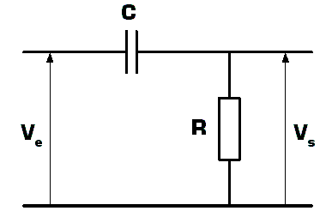**B.2 CR Filter (high pass):**

Carry out the following assembly with R = 2.2 kΩ and C = 10 nF.

The circuit is supplied with a sinusoidal voltage.

avec= 5 V.

Using an oscilloscope, record the voltage Vs across the resistor and the phase shift ∆T between the latter and Ve, for frequencies ranging from 400Hz to 30 kHz, according to Table II:

|  |  |  |  |  |  |  |  |  |  |  |  |  |  |
| --- | --- | --- | --- | --- | --- | --- | --- | --- | --- | --- | --- | --- | --- |
| ***F(Khz)*** | **0.4** | **0.6** | **1** | **3** | **5** | **6** | **7.1** |  | **7.5** | **8** | **10** | **20** | **30** |
| ***Ve*** | **Crête à crête 10 v** | | | | | | | | | | | | |
| ***Vs*** |  |  |  |  |  |  |  |  |  |  |  |  |  |
| ***ΔT (ms)*** |  |  |  |  |  |  |  |  |  |  |  |  |  |
| ***Gdb*** |  |  |  |  |  |  |  |  |  |  |  |  |  |
| ***=360°*ΔT/T*** |  |  |  |  |  |  |  |  |  |  |  |  |  |

1. Calculate the voltage gain GdB= 20 log(Vs/Ve) and its phase φ?
2. Represent the amplitude diagram (practice)? compare with the theoretical diagram
3. Represent the practical phase diagram? compare with the theoretical diagram
4. Compare the theoretical and measured cutoff frequency?

**………………………………………….**

**B.3 Bandpass Filter:**

Create the following assembly with: R1= 2.2kΩ, C2= 0.22 µF, R2= 4.7 kΩ et C1= 10 nF.

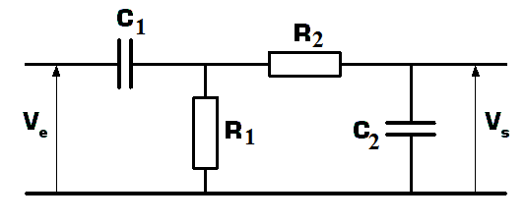

* Vary the frequency between 50 Hz to 30 KHz
* What are your comments ……………………………………………