**الجمهورية الجزائرية الديمقراطية الشعبية**

**وزارةالتعليم العالي والبحث العلمي**

People's Democratic Republic of Algeria Ministry of Higher Education and Scientific Research

**جامعة محمد خيضر بسكرة**

Med Khider Biskra University



Faculty of Science and Technology

Department of Civil & Hydraulic Engineering

Course handout

PRESTRESSED CONCRETE

**Courses and corrected exercises**

**Developed by: Dr CHADLI mounira**

**Year 2024/2025**

Foreword

This document, a course handout entitled prestressed concrete, course and corrected exercises, is a course support intended primarily for students of master 2 materials in civil engineering, master 2 structures. It will allow them to better assimilate and deepen their basic knowledge of the concrete material and that concerning the calculation of prestressed concrete structures. This support is structured as follows:

- The first chapter covers the presentation of prestressed concrete and the materials used and the prestressing methods,

Chapter 2: Prestressing losses: Instantaneous losses, deferred losses, construction losses, pretension losses.

Chapter 3: Calculation of isostatic beams at the service limit state: Calculation section, load combination, verification class, justification of normal stresses, dimensioning of sections, dimensioning of the prestressing force, trace of cables, longitudinal passive reinforcement, and justification of tangential stresses.

Chapter 4: Resistance of a beam section at the ultimate limit state: combination of loads and behavior of materials, calculation of moment of resistance, justification of tangential stresses

Chapter 5: Constructive provisions

Foreword

Introduction General

CHAPTER I: General

I.1 INTRODUCTION

I.2 GENERAL PRINCIPLE OF PRE-STRESSING

**I.3 PRE-STRESSING MODES**

I.4 PRE-RESTRAINT SYSTEMS

**I.5 FIELD OF APPLICATION**

**I.6 REGULATIONS**

I.7 MATERIALS USED IN PRE-STRESSING

**I.8 MECHANICAL CHARACTERISTICS: REINFORCEMENT**

**I.9 GEOMETRIC CHARACTERISTICS DES SECTIONS**

**I.10 EXERCISES**

**CHAPTER II : Prestress Losses**

**II.1 DEFINITION**

**II.2 INSTANTANEOUS LOSSES**

II.3 DEFERRED LOSSES

II.4 ORIGINAL TENSION

**II.5 VOLTAGE LOSSES (POST-TENSION)**

**II.6 PRE-STRESSING BY PRE-TENSION OR BY ADHERENT WIRE**

II.7 EXERCISES

**CHAPTER III: Calculation of isostatic beams at the service limit state**

**III.1 GENERAL**

**III.2 DEFINITION OF CALCULATION SECTIONS**

III.3 LOAD COMBINATION

**III.5 JUSTIFICATION OF NORMAL CONSTRAINTS**

**III.6 EVALUATION OF THE PRESTRESS**

**III.7 MINIMUM CONCRETE SECTION**

III.8 LONGITUDINAL PASSIVE REINFORCEMENT

**III.9 JUSTIFICATION OF TANGENTIAL STRESSES**

II.10 EXERCISES

**CHAPTER IV: Resistance of a beam section at the ultimate limit state**

**IV.1 GENERAL**

**IV.2 EQUILIBRIUM OF A SECTION AT THE RUPTURE**

**IV.3 CHARACTERIZATION OF AN ULTIMATE LIMIT STATE**

**IV.4 PRINCIPLE OF JUSTIFICATIONS**

**CHAPTER V: CONSTRUCTIVE PROVISIONS**

**V.1 INTRODUCTION**

**V.2 CABLE ROUTES**

**V.3 PRACTICAL ARRANGEMENTS FOR CABLING TRACES**

**V.4 FICTITIOUS AVERAGE CABLE**

**V.5 PASSAGE SPINDLE**

**V.6 IN POST-TENSIONING PRESTRESSING**

**V.7 Prestressing by Pretensioning**

**V.8 EXERCISES**

**References Bibliographiques**

**LISTE DES FIGURES**

Figure I.1: Reinforced concrete beam **[1]**

Figure I.2: Principle of reinforced concrete **[1]**

Figure I.3: Principle of prestressed concrete [1]

Figure I.4: Prestressed element [1]

Figure I.5: Prestressing by pre-tension [1]

Figure I.6: Prestressing by post-tensioning [1]

Figure I.7: Tensioning [1]

Figure I.8: Fixed and mobile anchoring system [2]

Figure I.9: The stress-strain diagram of concrete [4]

Figure I.10: Steel stress-strain diagram [3]

Figure II.1: Friction tension [3]

Figure III.1: Beam with transverse reinforcement [5]

Figure IV.1: The deformation diagram [6]

LISTE DES TABLEAUX

Table 1: Nominal wire diameter [1]

Table 2: Diameter and conventional section of bars [1]

Table 3: Diameter and conventional section of strands [1]

Figure III.4

Introduction General

Prestressing is certainly the most important innovation of our century in the field of concrete structures. The idea of ​​prestressing concrete in order to reduce cracking is already old, since in 1886P. H. Jackson, in the United States, proposed compressing concrete pavements using steel bars tensioned using a screw thread and a nut. At that time, many attempts at prestressing failed, because normal steel was used whose maximum elastic deformation is of the same order of magnitude as the shortening of concrete due to shrinkage and creep, so that the prestress gradually disappeared with the time.

The eminent French engineer Eugène Freyssinet (1879 –1962), often called the father of prestressing, was the first to highlight the need to use very high strength steel to create a state of permanent self-stressing, as early as 1928 , he developed this new technique, both in the theoretical domain and in that of practical applications. He saw in prestressing a new philosophy of concrete structures considering it as a completely new construction material, free from cracks thanks to the complete absence of traction, he therefore envisaged that total prestressing, while today this concept has lost much of its importance.

After the Second World War, prestressed concrete experienced a meteoric rise (there were many bridges to rebuild) and a large number of prestressing systems were invented and patented throughout industrialized countries. We will not describe them in this course.

Prestressing currently holds a large place in the field of concrete structures. Among its advantages we cite firstly the possibility, essential for Freyssinet, of avoiding or at least reducing cracking and, consequently, also deformations in the service state. However, if we consider the constructive and economic aspects, it becomes obvious that the decisive advantage of prestressing lies in the use of very high strength steels. Two solutions are then commonly considered: mixed steel-concrete structures, in which the concrete in the tension zone is replaced by structural steel which works well in tension, and the two materials are adequately connected; and prestressed concrete structures, the subject of this course. The use of prestressed concrete remains widespread in developing countries which do not have the necessary infrastructure to construct, transport and assemble metal beams under economic conditions.

Chapter I: General

I.1 INTRODUCTION

Concrete is a material that resists compression well, but little, and especially randomly, resistance to traction. It is therefore interesting to build in concrete, but avoiding this material being too tense and risking cracking. And for this, it must be compressed artificially and permanently, in areas where external loads develop traction so that overall the concrete remains compressed (or not very tense enough to avoid the risk of cracking) and therefore resistant. in any load case. The compressive force voluntarily developed for this purpose is called the prestressing force (or prestress). The remedy must not err on the side of excess: the total compression of the concrete must remain below a reasonable value so as to avoid any risk of longitudinal cracking of the prestressed elements due to excess compression (while tension generally develops transverse cracks).

In total, a concrete structure is said to be prestressed concrete when it is subjected to a system of forces artificially created to generate permanent stresses, which, combined with the stresses due to external loads, give total stresses between the limits that concrete can support indefinitely, safely (Figure 1).

*G,Q*



Figure I.1: Reinforced concrete beam **[1]**

The beam also undergoes shear stresses due to the shear forces which occur towards the supports. These constraints cause 45° cracks that the concrete cannot repair on its own. In this case, two solutions are possible:

* **Solution No. 1**: Adding a quantity of reinforcement capable of absorbing the tensile forces in the concrete (Principle of reinforced concrete).

Figure I.2: Principle of reinforced concrete **[1]**

* **Solution No. 2**: The application of an axial compressive force which opposes tensile stresses due to loading (Principle of prestressed concrete).

Figure I.3: Principle of prestressed concrete [1]

I.2 GENERAL PRINCIPLE OF PRE-STRESSING

Concrete is a material that resists compression well, but little, and especially randomly, resistance to traction. It is therefore interesting to build with concrete, but avoid this material being overstretched and risking cracking. To do this, it must be compressed artificially and permanently, in areas where external loads develop traction so that overall the concrete remains compressed (or not very tense enough so as not to risk cracking) and therefore resistant to any discharge case. The compressive force voluntarily developed for this purpose is called the prestressing force (or prestress).

The objective of prestressing, by imposing a judiciously applied axial compressive force on the elements, is to eliminate (or significantly limit) the tensile stresses in the concrete (Figure I.4).

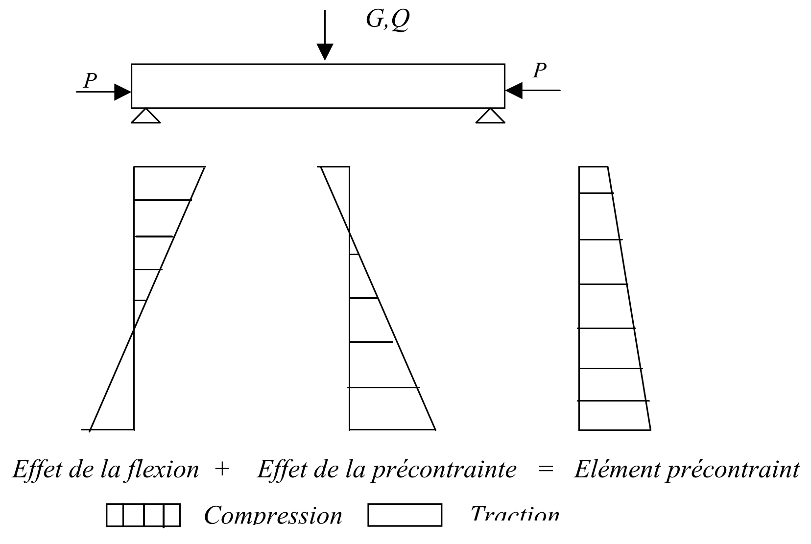

Figure I.4: Prestressed element [1]

This prestress can be:

* **Total prestressing**

The notion of total prestressing, introduced and defended by Freyssinet, implied the total absence of traction in the concrete, which constitutes a very severe condition. This design was somewhat theoretical in nature, since it required prestressing in all directions (horizontal, vertical and transverse).

* **Limited prestress**

If the tensions tolerated in the concrete are sufficiently low in relation to the tensile strength, cracking is avoided. This corresponds to the “limited prestress” (beschränkteVorspannung), according to the German standard DIN 4227, this standard indicates, for a B300 concrete (βw = 300 kg/cm2) for example, the following values:

σb (edge) = 30 kg/cm2 σI(core) = 20 kg/cm2 (combined shear force and torsion). These stresses correspond approximately to “The limit state of crack formation”

* **Partial prestressing**: authorization of limited tensile stresses.

**I.3 PRE-STRESSING MODES**

**I.3.1 Introduction**

The prestressing technique includes two main application methods: - Pre-tension (English: tensioning). - Post-tension (in English: post-tensioning). They are sometimes designated by other expressions, but the two terms above are the clearest to express the difference between the two methods.

**I. 3.2 Pre-tension**

It is a method used in factories to prefabricate prestressed beams intended to be incorporated into constructions as “products”. This process can be carried out in the factory or on site. The method generally follows the following procedure:

* Preparation of molds (cleaning, application of formwork oil, etc.),
* Unwinding of the reinforcements (adherent wires or strands) and blocking at the ends,
* Installation of passive reinforcements to take up the tensile forces,
* Tensioning of the wires or strands by jacks located at one of the ends
* Pouring of concrete, smoothing and vibration by external vibration,
* Steaming or heating of concrete to accelerate its hardening,
* After hardening deemed sufficient (by calculation and previous tests), stress relief and cutting of the wires,
* Handling and storage of items, taking care not to return them.

The pre-tension does not adapt well to a route of non-rectilinear cables or adhering wires. The eccentricity is therefore constant. This limits the use of this process. It is however possible, using deflectors, to create a route comprising three continuous rectilinear segments, better suited for future demands. Prestressing by pre-tension is widely used in the building sector. However, it is difficult to exceed beam lengths greater than 30 m.

Tensioning

Pouring concrete

Cable release

Prestressed beam

Figure I.5: Prestressing by pre-tension [1]

**I. 3. 3 prestressing by post-tensioning**

This is the most used method today, it offers a very wide variety of applications and is sometimes associated with the previous method (prefabricated adhering wires with cables stretched on site). The post-tensioning technique consists of taking support on the already hardened concrete to tension the prestressing cable. The concrete element is therefore poured beforehand, with reservations for the subsequent passage of the prestressing. When the concrete reaches sufficient strength, the prestressing cable is threaded and tensioned using jacks. There are two variants: internal post-tensioning and external post-tensioning. Case of prestressing by internal post-tension mise en place du coffrage,

* Installation of passive reinforcements and duct support chairs,
* Installation of solid sheaths and fixing on the reinforcing cage,
* Installation of support plates and hooping adjacent to the ends of the ducts,
* Pouring of concrete,
* During curing, threading of cables,
* After hardening deemed sufficient (by calculation and previous tests), installation of anchoring plates and locking keys for the strands in the cylinder,
* Tensioning on one side for short cables and on both sides for long cables.⎫ Injection of grout (or mineral grease) to protect the cables.
* Case of prestressing by external post-tension. The concrete is poured at room temperature or slightly heated by insulation.
* The sheaths are placed outside the concrete (in the interior zone of the box) and in the final position of the work.
* We slide the loose cables into the sheaths.

After a period deemed sufficient, the cables are tensioned at periods and intervals depending on the project and the methods of execution of the work. Blocking is done by different wedge systems on a zone of shrink concrete. A concrete grout (micro concrete) or mineral grease is injected.

Duct placement

Pouring concrete

Tensioning

Prestressed beam

Figure I.6: Prestressing by post-tensioning [1]

Tensioning can be done by tensioning the steel at both ends of the part (active - active) or by tensioning one end only (active - passive) (Figure I.7).

Active - Active



Active - Passive

Figure I.7: Tensioning [1]

The injection is an extremely important operation, because it plays a dual role:

1) Protection of prestressing reinforcements against corrosion.

2) Improving adhesion between the reinforcements and the sheaths. The injection operation must be carried out as soon as possible after tensioning of the armatures.

The injection product must meet the following requirements:

* Have a low enough viscosity to flow easily and penetrate all openings and between wires of prestressing cables;
* Maintain this low viscosity for a sufficient period of time so that the injection can be carried out in good conditions before the start of setting;
* After hardening, have sufficient strength to effectively ensure adhesion of the reinforcement to the concrete;
* Present minimal shrinkage;
* Do not be aggressive towards the prestressing steel.

The injection product was formerly a mortar made of cement, sand and water; today sand is almost completely abandoned, in favor of CPA cement grout, containing an adjuvant. The entire prestressing process generally includes the following elements:

Anchoring device: there are mainly two types of anchoring:

**-Fixed anchors**

Intended solely to hold the cable, without the possibility of pulling it. They can be made up of one or more loops (fig. I.8), by a curved plate if the wires are fitted with buttons (fig.I.8), by rectilinear seals, if they are strands (fig. I.8), by corrugated seals (fig.I.8), etc.

Mobile anchors can also be used as fixed anchors, by blocking them beforehand.

**-Mobile anchors**

On which the jack is applied during tensioning, which includes a locking device retaining the end of the cable, once it is tensioned. Most systems allow tensioning in stages, by unlocking and reblocking the cable.

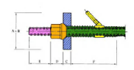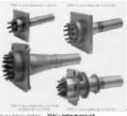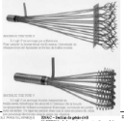

Figure I.8: Fixed and mobile anchoring system [2]

* **Couplers**

Device allowing extensions of reinforcements. Fixed couplers allow a section of cable to be connected to another already stretched section. Mobile couplers join two sections of a cable placed successively, but tensioned in one go. These possibilities are taken advantage of in the construction of span-advanced bridges. Coupling Dywidag bars is easy, since you just need to place a threaded sleeve at the junction of the bars.

Tensionin g equipment: cylinders, injection pumps, cylinder supply pump, etc. Accessories: sheaths, injection tubes, etc.

I.3. 4 Comparison of the two processes

A comparison between the two processes (post-tensioning and pre-tensioning) allows us to note the following observations:

Pre-tension

1) The economy of sheaths, anchoring devices and the injection operation.

2) The need for very heavy installations which consequently limits the choice of shapes.

3) The simplicity of carrying out the process.

4) Good collaboration of concrete and reinforcement.

5) The difficulty of producing curved reinforcement lines.

6) The impossibility of adjusting the force in the reinforcements after tensioning. Post-tensioning

1) Does not require any fixed installation since; it is on the part itself that the prestressing cylinder rests.

2) It allows the choice of different shapes.

3) The possibility of adjusting the prestressing force, which makes it possible to adapt the process to the evolution of the mass of the structure.

4) The ease of producing curved lines of prestressing reinforcement. Alongside these classic processes, there are special processes which are reserved for certain works or which use other principles for tensioning:

* Winding prestressing
* Prestressing by external compression
* Tensioning by thermal expansion
* Tensioning by expansion of concrete

I.4 PRE-RESTRAINT SYSTEMS

The prestressing systems are the subject of patents and are manufactured by their operators. The main systems are:

I.4.1 Freyssinet system

This system uses cables composed of T 13, T 13 S, T 15 and T 15 S strands. The letter T is replaced by the letter K (example 12 K 15)

PAC system This system uses cables composed of 1 to 37 T 13, T 13 S, T15 or T 15S.

CIPEC system This system uses 4 T 13 to 19 T 13, 4 T 15 to 27 T 15, normal and super cables.

VSL system This system uses 3 T 12 to 55 T 13, 3 T 15 to 37 T 15, normal or super units. Their name is of the form 5-n for n T 13 and 6-n for n T 15. (Example: 6-37 represents a cable or a 37 T15 anchor).

**I.5 FIELD OF APPLICATION**

The invention of prestressed concrete is due to the French engineer Eugène Freyssinet. The first practical applications were attempted in 1933. In the years that followed, the exceptional performance of this new concept was brilliantly demonstrated. Thanks to these advantages, prestressed concrete is used in structures and buildings of large dimensions: it is commonly used for bridges and is widely used for prefabricated beams for building floors. It is found in many other types of structures, including reservoirs, foundation piles and tie rods, certain maritime structures, dams, and nuclear reactor enclosures.

**I.6 REGULATIONS**

IP1: Provisional Instruction No. 1 of August 12, 1965

IP2: Provisional Instruction No. 2 of August 13, 1973

BPEL 91: Prestressed concrete at limit states

Euro code 2: (Reinforced concrete and prestressed concrete).

I.7 MATERIALS USED IN PRE-STRESSING

I.7.1 Mechanical characteristics: concrete

The concrete must also be of very good quality. Indeed, as long as it is not prestressed, it risks cracking due to the hindrance caused by the formwork during its removal; To avoid this, this concrete must be prestressed very early while, still young, it has limited strength. The concrete must therefore be of high strength and acquire this very quickly. It is in fact very popular at the time of tensioning:

* In current section, because the prestressing has its maximum value (the losses have not yet been made); moreover, the external loads (whose effect is opposite to that of the prestressing) are often incomplete (for example, if superstructures have not yet been put in place), locally, under anchorages, areas where a very concentrated effort is exerted. To limit the stress on young concrete, the cables are frequently tensioned in several successive phases: from a third to half of the cables approximately 7 days after pouring the concrete (to be able to unbend the beam, which can then carry its weight), and the rest at a date generally between 15 and 30 days after pouring. In addition, the anchors are often placed in a prefabricated end piece of shrink-wrapped concrete that is sufficiently old to be able to withstand the localized forces under the anchors. In any case, prestressing constitutes a decisive preliminary test for concrete which would not forgive any possible mediocrity.

**I.7.1.1 Compression resistance**

Concrete is characterized by its compressive strength at 28 days. This resistance is measured according to standard NF EN 12390. It can be done on a cylinder or on a cube. In France, it is usually done by crushing cylindrical test pieces with a section of 200cm² (diameter Φ = 160mm) and a height of 320mm (so-called “16/32” test piece). For the stresses exerted on concrete less than 28 days old, we refer to the characteristic resistance fcj. The BAEL and BPEL rules give, for an age j ≤ 28 days and for non-heat-treated concrete:

If fc28 ≤ 40 MPa donc :

**fcj= j fc28**

4.76+ 0.83j

And if fc28 > 40 MPa



Beyond j=28 days, we admit for the calculations that fcj= fc28

I.7.1.2 Tensile strength

The characteristic tensile strength, at the age of “j” days, denoted ftj, is conventionally defined by the formula: ftj= 0,6 + 0,06 fcj

Ftj and fcj are expressed in MPa (or N/mm²)

**I.7.1.3 Instantaneous longitudinal deformations**

In the absence of conclusive experimental results, we adopt for the instantaneous longitudinal deformation modulus of concrete noted Eij, a conventional value equal to: Eij=11000 

The deferred longitudinal deformation modulus Evj is given by: Evj=3700 

**I.7.1.4 Stress-Strain Diagram**

The characteristic stress-strain diagram of concrete has the appearance shown schematically in Figure I.9 called "parabole - rectangle".

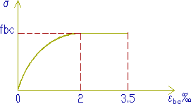

Figure I.9: The stress-strain diagram of concrete [4]

The calculation diagram includes an arc of second degree parabola from the origin of the coordinates and to its vertex with coordinates σbc = 2%o and a concrete compression stress given by:

σbc = 0.85. fcj/ᵧb θ The coefficient θ takes into account the probable duration of application of the combination of actions.

* θ *= 1 t > 24heures*
*  = 0,9 1 h  t  24 h
*  = 0,85 t 1 h

**I.7.1.5 Deferred deformations**

* **Withdrawal**

Shrinkage is the spontaneous shortening of concrete during its hardening in the absence of any stress. Shrinkage has several origins, but the two main effects are shrinkage of chemical origin, called “endogenous shrinkage” and shrinkage from desiccation or drying shrinkage. Endogenous shrinkage is due to a reduction in the volume of concrete due to the chemical reaction of concrete setting. The molecules before chemical reaction occupy a higher volume than the molecules after reaction, which therefore causes a reduction in volume. Desiccation shrinkage comes from the evaporation of water molecules not consumed by the chemical reaction. This also causes a shortening of the concrete. The relative shrinkage deformation which develops in a time interval (t1, t) can be evaluated using the formula:

**r (t1, t) = r [r (t) - r (t1)]**

With :

ɛr : the final shrinkage deformation

r(t) : the law of evolution of shrinkage, which varies from 0 to 1 when the time t, counted from the manufacture of the concrete, varies from zero to infinity. The law of evolution of shrinkage is given by:

**r (t) = t/ t+ 9 rm**

t : the age of the concrete, in days, counted from the day of manufacture, and rm the average radius of the part, expressed in centimeters:

**rm= B/u**

B: The section area

u: The perimeter of the section

In the case of prestressed concrete structures, made with Portland cement, the final shrinkage deformation can be evaluated by the formula:

**ɛr= ks ɛ0**

The coefficient ks depends on the percentage of adherent reinforcements ρs = As /B, ratio of the section of the longitudinal passive reinforcements (and, in the case of pre-tension, of the adherent prestressing reinforcements) to the cross section of the part.

**Ks = 1/ 1+20 ρs**

It is expressed by the formula: 0 depends on the ambient conditions and the dimensions of the room. ε the coefficient we will take in the water:0 = - 60.10-6

* **Creep**

By definition, it is the progressive shortening of concrete under constant stress, shrinkage deducted. This phenomenon is also linked to the migration of water inside the concrete.

* Poisson coefficient the Poisson's ratio of concrete is taken equal to:
* 0,20 in uncracked areas

0 in cracked areas

* **Thermal expansion coefficient**

In the absence of experimental results, the coefficient of thermal expansion is taken equal to 10-5 per degree C.

**I.8 MECHANICAL CHARACTERISTICS: REINFORCEMENT**

**Prestressing reinforcements**

**I.8.1 Shapes**

Prestressing reinforcements are found in three forms: wires; the bars; the strands.

**I.8.1.1 Son**

By convention, the wires have a diameter less than or equal to 12.2 mm, which allows them to be delivered in crowns. They can be either round or smooth (for post-tensioning) or on the contrary ribbed, or notched, or corrugated in order to improve their adhesion to the concrete (pre-tensioning). The most commonly used wires have diameters of 5mm, 7mm or 8mm.

**I.8.1.2 Bars**

With a diameter greater than or equal to 12.5 mm, they are only delivered straight (and with a maximum length of around 12 m). They can be either smooth or ribbed, the ribbing then acting as a coarse thread (case of Dywidag bars). The most common diameters are 26mm, 32mm and 36mm. But there are larger bars (Macalloyφ40, 50 and even 75 mm). Such reinforcements are only used in post-tensioning.

**I.8.1.3 Strands**

These are sets of wires wound helically on each other (case of three-wire twists) or around a central wire in one or more layers. The most common strands are 7 wires and are designated by their nominal diameter (diameter of the circle circumscribed by the wires in a straight section). The most commonly used diameters are: 12.5 mm (frequently referred to as T13) 12.9 mm (T13S) Prestressed concrete course 29 15.2 mm (T15) 15.7 mm (T15S). These reinforcements are used both in pre-tensioning (in large parts) and in post-tensioning. Finally, in the past, certain prestressing processes (PCB in particular) have used strands with several layers of peripheral wires (strands with 37 or 61 wires).

**I.8.2 Stress-strain diagram**

It is first linear (elastic phase OI, the slope of the line OI being the modulus of elasticity Ep of the reinforcement), then it curves, to arrive at a quasi-plastic level (Figure.10). Finally, rupture occurs for a stress fp and a relative elongation εuk. We attach fundamental importance to the fact that it only occurs with significant necking (characterized by the necking coefficient ζ, relative reduction in the area of ​​the cross section at the level of the rupture).

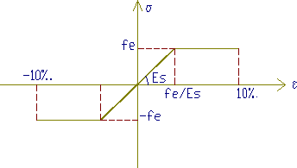Figure I.10: Steel stress-strain diagram [3]

Generally, we require: ɛ≥20%; ɛuk≥3.5%, the stress-strain diagram makes it possible to define another important characteristic of the prestressing reinforcement: its conventional elastic limit fp0.1k. This is the ordinate of the point of intersection of the diagram with the line of slope 200,000 MPa passing through the point of ordinate zero and abscissa 10-3.

The ability of the reinforcement to remain united with the concrete.ψ and ηThis ability is characterized by the so-called cracking and sealing adhesion coefficients designated respectively by η =1 smooth roundsηCracking coefficients:

η =1.6 HA bars or HA wires with a diameter greater than or equal to 6mm

η =1 smooth rounds ψ =1.3 HA wires with a diameter less than 6mm Sealing coefficients:η =1.5 barres HA ou de fils HA.

* **Active frames**

The active steels are the prestressing steels, they are put under tension. Unlike reinforced concrete reinforcements which are satisfied with standard quality steel, prestressing reinforcements require steel satisfying a certain number of conditions.

They were classified by:

* Category: wires, bars, strands.
* Resistance class.
* **Required qualities**
* High mechanical resistance.
* Sufficient ductility.
* Good resistance to corrosion.
* Poor relaxation.
* Cost as low as possible.

**I.8.2 Geometric characters**

* **The sons**

The wires are reinforcements whose largest transverse dimension is less than 12.5mm; they are delivered crowned. We distinguish: the round and smooth steel wires of symbolL, wires other than round and smooth symbol L. The wires are defined by their nominal diameter to which a conventional nominal section corresponds, according to table.1

**Table 1: Nominal wire diameter [1]**

|  |  |  |  |  |  |  |  |
| --- | --- | --- | --- | --- | --- | --- | --- |
| Diameter | 4 | 5 | 6 | 7 | 8 | 10 | 12.2 |
| Section | 12.6 | 19.6 | 28.3 | 38.5 | 50.3 | 78.5 | 117 |

* **The bars**

Bars are defined as round and smooth reinforcement with a diameter greater than 12.5mm, or non-round or non-smooth reinforcement that cannot be delivered wrapped. The geometric characters are the diameter and the section conventionally defined according to table.2

**Table 2: Diameter and conventional section of bars [1]**

|  |  |  |  |  |  |
| --- | --- | --- | --- | --- | --- |
| Diameter | 20 | 22 | 26 | 32 | 36 |
| Section | 314 | 380 | 531 | 804 | 1018 |

* **The strands**

A strand is an assembly of 3 or 7 wires wound into a helix and distributed in a layer, possibly around a central wire. The strands are characterized by the number of their wires, their diameter, and their section. Table.3 provides the corresponding values.

**Table 3: Diameter and conventional section of strands [1]**

|  |  |  |  |  |  |  |  |  |
| --- | --- | --- | --- | --- | --- | --- | --- | --- |
| Type | 3fils | 7fils | 7fils | 7fils  standard | 7fils  standard | | 7fils super | 7fils  super |
| Diamètre | 5.2 | 6.85 | 9.3 | 12.5 | 15.2 | 12.9 | | 15.7 |
| Section | 13.6 | 28.2 | 52 | 93 | 139 | 100 | | 150 |

**I.8.3 Calculation characters**

The characteristics of the prestressing reinforcements to be taken into account in the calculations are:

* Nominal section of the reinforcement;
* The maximum stress guaranteed at rupture fprg
* The stress at the conventional limit of elasticity fpeg
* Relaxation coefficient ρ1000
* ρ000 = 2.5% for the TBR (Very Low Relaxation) class ρ000 = 8% for class RN (Normal Relaxation) adhesion to concrete;
* Coefficient of thermal expansion 10-5 per degree C.
* Longitudinal deformation modulus: Ep = 200,000 MPa for wires and bars Ep = 190,000 MPa for strands Force-deformation diagram.

**I.9 GEOMETRIC CHARACTERISTICS DES SECTIONS**

Solving RDM problems uses geometric characteristics of the cross sections of the bodies studied. σ≤σThe fundamental principle consists of determining the stresses acting in a section and comparing the maximum stress with the limit stress:

* Single traction σ =F/Bσ
* Simple inflection σ=MY/Iσ
* Compound flexion σ =F/B + M Y/Iσ
* The geometric characteristics to be studied are: Area of ​​section B[cm2]
* Static moments Sx and Sy [cm3]
* Axial moments of inertia Ix and Iy [cm4]
* Centrifugal moments of inertia Ixy[cm4]⎫
* Polar moments of inertia Ip[cm4]
* Resistance modulus Wx and Wy[cm3]
* Torsional resistance modulus Wp [cm3]⎫
* Radius of gyration ix and iy[cm]
* Yield of a section ρ
* **Moment static**

The static moments of the area of ​​a section with respect to the X and Y axes are given by the expressions If the X axis or the Y axis passes through the center of gravity of the section, the static moments Sx and Sy are zero.

* **Moment of inertia**

The moments of inertia of the area of ​​a section with respect to the X and Y axes are given by the formulas:



The polar moment of inertia of a section is given by: Ip=Ix+Iy

* **Resistance module**

The modulus of resistance is equal to the quotient of the axial moment of inertia by the distance from the axis to the furthest fiber.

Wx= Ix/y

Wy =Iy/x

* **Radius of gyration**

We call the radius of gyration the quantity given by the equation:

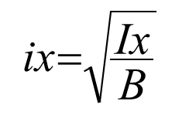 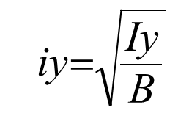

* **Yield of a section**

The yield of a section is given by: ρ= I/ B. Vi. Vs

**I.10 EXERCISES**

**EXERCISE 1:**

Consider the rectangular section (60.140) cm subjected to an external moment M=0.90 MNm. of prestressing P1 centered and P2 eccentric, assuming that we can eccentric a maximum of e= - 0.45 m the position of the cable.

*P1 P1 h*



*Vs*

*Vi*

Centered preload

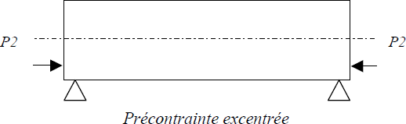

1. Determine the value of P1 and P2.

2. Schematize the constrained digraph P1 and P2 eccentric

**Solution :**

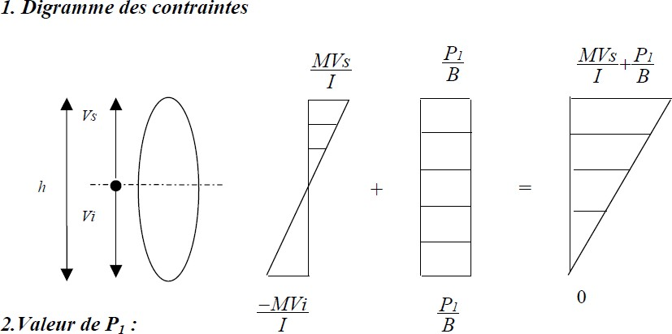

So P1= 4,07MN

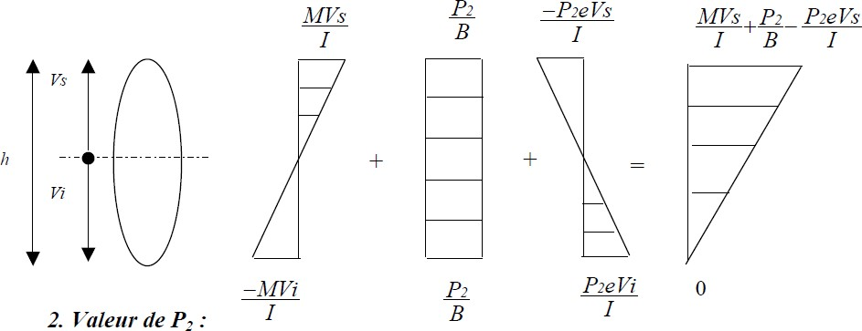

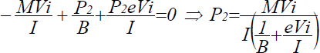

So P2= 3,93MN

**Exercice 2 :**

1) Determine the prestressing force P0 applied to the jack so that the beam does not admit tension in the middle section, knowing that the sum of prestressing at mid-span represents 25% P0, g= 1.5t/m; q= 1.15 t/m; L=10m; Bb (30×60).

2) Determine the prestressing force P0 with an eccentricity e= h/6

**Solution:**

1. Values ​​of P0 knowing that ΔP = 25% P0 According to the stress diagram we have:
2. P(L/2) = P0- 0.25 P0= 0.75 P0

-Mg.vi/I –Mq.vi/I+ P(L/2) /Bb=0 with Mg = g.L2/8 et Mq = q.L2/8

So P0= 6(Mg +Mq)/ 0.75×h

**P0= 441.67 t**

1. M (P(L/2)) = 0.75 P0.e so we have -6Mg/bh2 –6Mq/bh2+ 0.75 P0/bh+0.75 P0.6.e/bh2 =0

So P0= 4/h. (Mg+ Mq) = 4/0.6 (18.75 + 14.375)

**P0= 220.83 t**

**Exercice 3:**

Determine, for a concrete of fc28 = 30 MPa, the following mechanical characteristics: Compressive strength on day d = 7 and 90 days

Tensile strength on day d = 7 and 90 days

Instantaneous longitudinal deformation modulus on day d = 7 and 90 days

Delayed longitudinal deformation modulus on day d= 7 and 90 days

**Solution**

1. Compressive strength on day d = 7 and 90 days

**d= 7**days **:** fc7= d/4.76 +0.83.d ×fc28= 19,86MPa

**d= 90 days :** we fc90 = fc28= 30 MPa

1. Tensile strength on day d = 7 and 90 days

ftj= 0,6 + 0,06 fcj

**d= 7 jours** : ft7= 1.8 MPa

**d= 90 jours** : ft90= ft28= 2.4 MPa

1. The instantaneous longitudinal deformation modulus of concrete Eij

Eij=11000

*3*fcj

Ei7= 29788.76MPa

Ei90= 34179.6 MPa

1. The delayed longitudinal deformation modulus Evj:

Evj=3700

*3*fcj

Ev7= 10019, 85 MPa

Ev90= 11496, 76 MPa

**Exercice 4** :

Determine, for a T-beam, the following geometric characteristics:

* The area of ​​the section (B)
* The static moment(S)
* The distance of the upper fiber (Vs) and the distance of the lower fiber (Vi)
* The moment of inertia (I)
* The resistance module (W)
* The radius of gyration(i)
* The efficiency of the sectionρ

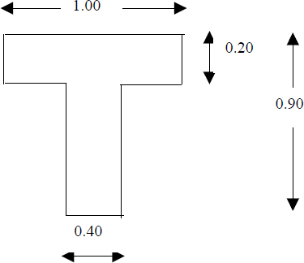**Solution**

* The area of ​​the section(B)

B =Ʃ Bi = 0.48 m2

* The static moment (S)

S = Ʃ Bi.di = 0.174 m3

* The distance of the upper fiber (Vs)

Vs = S/B = 0.363 m

* The distance of the lower fiber (Vi)

Vi= h-Vs = 0.537 m

* The moment of inertia(I)

I = Ʃ I + ƩBi.di2= 0.03572 m4

* The resistance module (W)

Ws = I/Vs = 0.0984 m3

Wi = I/ Vi = 0.0665 m3

The radius of gyration (i)

i=√I/B = 0.273 m

* The efficiency of the section ()

ρ= I/ B.Vs.Vi= 0.382

**Exercise 5**

In order to eliminate the tensile stresses due to the maximum moment developed by the force Q, the console beam below is subjected to a prestressing force F. Neglecting the self-weight of the console. Determine:

- The resulting stress diagram.

- The value of F as a function of Q if:

- F is centered.

- F is eccentric by e = h/6.

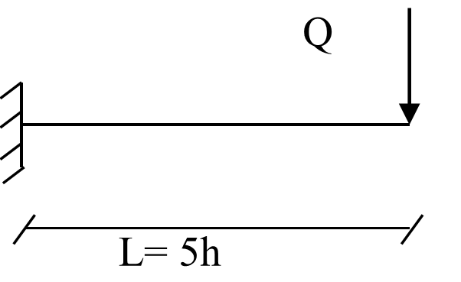

**Exercise 6**

The isostatic I-beam, L = 32m, shown below, is subjected to its own weight and a prestressing force P, eccentric by e = -40 cm.

- Draw the stress diagram.

- Deduce the value of P, if the final tensile stress, in the lower fibers, is assumed to be zero. We give: the density of concrete is 2.5 g/cm3.

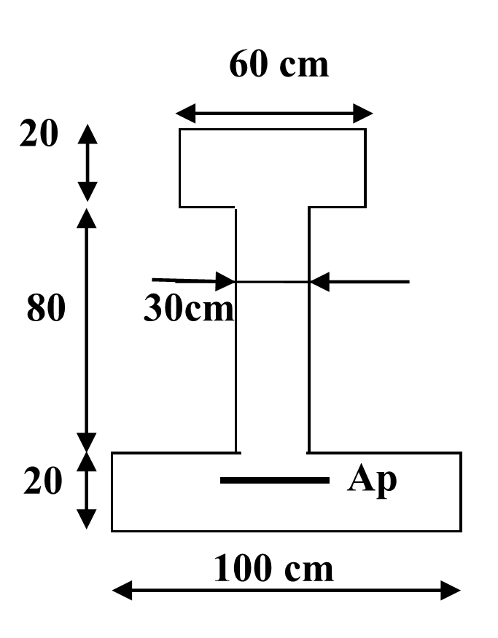

**Exercise 7**

The I-beam, shown below, is subjected to a prestressing force P, eccentric by e = 30 cm, and at an external moment M = 1 MN.m.

- Draw the stress diagram.

- Derive the value of P, if the final tensile stress, in the lower fibers, is assumed to be zero.

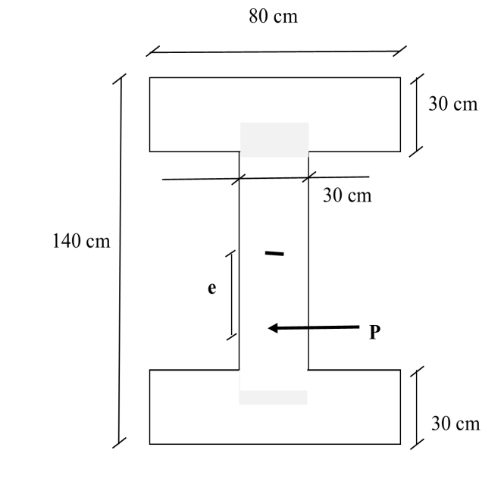

**CHAPTER II :**

**Prestress Losses**

**II.1 DEFINITION**

The prestressing force in a cable varies both in space (along the abscissa of the cable) and in time. The tension at a point of the cable in the structure differs from the force of the jack with which the cable was tensioned, due to a certain number of losses which significantly lower the tension of the cable. It is also because of these losses that we are obliged to use cables with very high elasticity limits. Losses are usually grouped into two families:

**II.2 INSTANTANEOUS LOSSES**

These are the losses that occur when the cable is tensioned. They include:

Losses due to friction

Losses at anchors

By abuse of language, we also classify as instantaneous losses, all the losses which occur “in the short term” during the construction process of the structure:

Losses due to non-simultaneous tensioning of the different cables.

Losses by application of permanent loads after tension.

II.3 DEFERRED LOSSES

Deferred losses are losses that develop over time:

* Losses due to concrete shrinkage
* Losses due to concrete creep
* Losses due to cable relaxation.

In post tension, the prestressing force varies at the same time:

* In space, with the abscissa along the cable, due to strongly;
* Over time, due to shrinkage and creep of concrete and relaxation of steel.
* In pretensioning, the prestressing force varies mainly over time due to the successive application of actions.

II.4 ORIGINAL TENSION

This is the tension that is imposed on the reinforcements in front of an active anchorage and the associated expansion device (trumpet or trumpet), on the concrete side, at the time of tensioning, before the transfer of the force to the anchorage. The prestressing forces are variable along the reinforcements and over time. “σpo”.

They must also not exceed the lowest of the following values:

σThey are evaluated based on the probable value of the original voltage, noted

Min (0.80fprg, 0.90fpeg) in post-tension

Min (0.85 fprg, 0.95fpeg) in pre-voltage

**II.5 VOLTAGE LOSSES (POST-TENSION)**

**II.5.1 Instantaneous voltage losses**

In the case of post-tensioning, the prestressing reinforcements undergo instantaneous tension losses which are:

- Tension losses due to friction; - tension losses due to retreat of the anchor;

- Tension losses due to instantaneous deformation of the concrete.

Δσpi(x) The total value of these instantaneous voltage losses, in a section of abscissa “x” of the reinforcement, is noted the tension at the point of abscissa x, after instantaneous tension losses, called initial tension, is noted:

σpi (x) =Δσpo - σpi (x)

**II.5. 1.1 Loss of voltage through friction**

This type of loss occurs by heavily cables on the sheath when tensioned. The applied voltage σpo at the origin decreases between the point of application and a given point of abscissa “x” (Figure II.1), its new value is given by the relation:

**p(x) po e -(f + x)**

po: The original tension;

e : The base of natural logarithms;

f : Curved friction coefficient (rd-1 ) ;

 : Sum of arithmetic angular deviations of the cable over distance x (rd) ;

: Line friction coefficient (m-1 ) ;

x : The distance of the section considered (m).

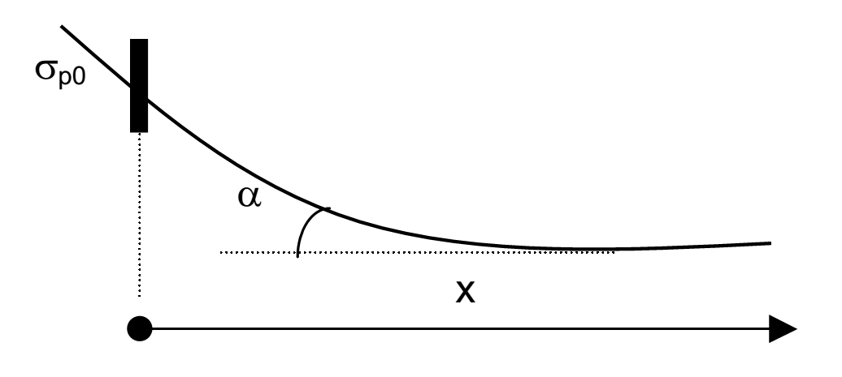

Figure II.1: Friction tension [3]

The tension loss due to friction is estimated by the formula:

**frot (x)=po - p (x)= po (1-e -(f  +  x))**

If the exponent is small, we can admit the following relationship:

**frot (x) po (f  +  x)**

**II.5. 1.2 Loss of tension due to retreat of the anchor**

This loss of tension results from the sliding of the reinforcement in relation to its anchoring, from settling or from deformation of the anchoring. Its influence decreases from anchoring until it disappears at a distance “d” from which the tension remains unchanged. The slip at anchor “g”, which depends on the type of anchor, is given by the relation:



In practice, by assimilating the branches of exponential to straight lines, the loss by anchoring recoil can be evaluated from the area of ​​a rod in this case, we have:

**g Ep= (σpA- σpA1) d/2**

The slip length of the anchor block is given by:

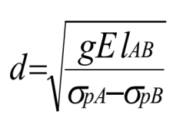

**II.5. 1.3 Loss of tension due to instantaneous deformation of concrete**

The application of any stress to the concrete results in its instantaneous deformation. If it shortens under the effect of compression, the cables under tension which are incorporated in it shorten by the same amount and, as a result, lose their tension. When tensioning a family of n cables, tensioning can only be carried out cable by cable. The stress brought by each of them is: σb/n, with σb final stress on the concrete.

**∆σracc (x) = n-1/2n. Ep/Eij .σb(x)**

with :

n : number of sheaths

EP : modulus of elasticity of reinforcements;

Eij : instantaneous modulus of concrete per day « d » ;

b(x) : normal stress of concrete:



**P=(po - frot- recu) Ap**

e(x) : eccentricity of the prestressing cable.

**Noticed**

The BPEL recommends taking a coefficient of “2” for the stress variations due to the stress relating to the tensioning phase and the permanent actions applied simultaneously to this tensioning, and the value of “1” for the variations of stress due to permanent actions subsequent to this prestressing phase, including those due to prestressing reinforcements subsequently placed in tension.

**II.5.2 Delayed voltage losses**

In the case of post-tensioning, the prestressing reinforcements undergo delayed tension losses which are:

- Loss of tension due to removal of concrete

- Loss of tension due to concrete creep

- Loss of tension due to relaxation of the steel.

The total value of these deferred voltage losses, in a section of abscissa “x” of the reinforcement, is denoted Δσ pd (x)

The voltage at the point of abscissa x, after instantaneous voltage losses, called final voltage, is noted: **pf (x) = po - pi (x) - pd(x)**

**II.5.2.1 Loss of tension due to concrete shrinkage**

The shortening of the concrete due to shrinkage causes an equal shortening in the steels. This results in a reduction in tension in the prestressing cables, the Value of which is:

**r= Ep×ɛr[r(t) –r (t1) ]**

r : total removal of concrete

t1 : the age of the concrete at the time of its prestressing

r(t) : a function reflecting the evolution of shrinkage as a function of time very often, we can neglect r(t1) in front of 1, which leads to the following simplified formula:

≈ Ep×ɛr

**II.5.2.2 Loss of tension due to concrete creep**

When a part is subjected, from its prestressing, to permanent actions undergoing variations over time, the final loss of tension due to creep of the concrete is taken equal to:

**fl= (bM + bF ) Ep /Eij**

bM : maximum stress in concrete; after instantaneous losses

bF: final stress in concrete; after deferred losses

d : the age of the concrete when it was prestressed.

If **bM ≤1,5 bF**, it is possible, for the sake of simplification, to evaluate the final loss of tension due to the creep of the concrete at:

**fl= 2,5bF Ep /Eij**

And like Ep /Eij 6, we will therefore have:

**fl= 15 bF**

**II.5.2.3 Loss of tension due to steel relaxation**

The final loss of tension due to relaxation of the steel is given by:



pi(x): Stress in prestressing reinforcement; after instant losses.

1000: Relaxation coefficient at 1000 h

fprg: Guaranteed limit stress at breakage

µ0 : being a coefficient taken equal to:

0,43 : for very low relaxation reinforcements (TBR).

0,30 : for normal relaxation frameworks (RN).

0, 35: for other reinforcements.

**II.5.2.4 Total delayed voltage loss**

The formula given for relaxation assumes that the length of the armature is constant; however, the relaxation loss is reduced by the effect of shortening due to shrinkage and creep of the concrete. To take this interaction into account, the BPEL proposes to reduce the relationship flat rate by the coefficient 5/6. Thus, the final deferred loss is taken equal to**:  σd = σr+σfl + 5/6 σrel**

When it is necessary to take into account the evolution of the prestressing losses as a function of time, it can be assumed that the total value of the deferred losses Δσd(t), evaluated "d" days after the group is tensioned reinforcement considered, follows the following law: **d (t) = r (j) d**

The function r(j) being identical to the function r(t)

**II.6 PRE-STRESSING BY PRE-TENSION OR BY ADHERENT WIRE**

The prestressing reinforcements (wires or strands) are tensioned before concreting (in prestressing benches over 100 m long) using jacks between two anchor blocks. The fresh concrete is placed in contact with the reinforcements. When it has acquired sufficient resistance (the increase in resistance can be accelerated by steaming), the tension in the wires is released, which is transmitted to the concrete by adhesion and by reaction causes it to become compressed (the relaxed wires want to return to their initial length, but their adhesion to the concrete prevents this shortening and the effort that had to be exerted to stretch them is transmitted to the concrete).

This technique is only applied to PREFABRICATION: It makes it possible to produce joists, posts, beams, hollow core slabs, pre-slabs. We first record the instantaneous losses In this type of prestressing, we begin by determining a first loss of prestressing, as soon as the reinforcement is put under tension, as a result of the sliding g of this reinforcement inside the keys which hold it and which are themselves at the The interior of an anchoring cylinder presents a loss:

The loss Δg is written**: σg= Ep.g/l**

Ep : is the modulus of elasticity of the prestressing steel (200000MPa).

L : is the length of the prestressing bench

g : is the anchor retraction when the reinforcement is relieved of around 2mm; it is defined for each type of anchor in the technical instructions.

**II.6.1 Loss due to shrinkage of concrete on the precast bench**

**σr = Ep. ɛr (t0, t)**

t : is the age of the concrete at the time of effective prestressing of the prefabricated element.

**II.6.2 Loss due to relaxation of steel on the bench**

It is expressed as a function of the tension σpmt (x) of the reinforcement after it is blocked at the anchor, i.e.: **σpmt= σ0 - σg**

And consequently: **σp= 6/100× ρ1000× (σpmt/fprg - µ0). σpmt (x).**

In prestressing by pre-tension, it is common for the concrete to be subjected to a heat treatment in order to accelerate its hardening and thus allow early demoulding. In this case: - The loss per withdrawal is practically zero,

- Loss by relaxation is accelerated by the effect of temperature,

- The loss of thermal origin is estimated at:

**σɵmax= Ep.αc. (Ɵmax-θ0)(1-λ)**

αc: is a coefficient taken equal to 0.10

θ0 and θmax are the temperatures of the reinforcement at tensioning, then maximum.

On the bench, the additional loss by relaxation, following the heat treatment, can reach 50 to 70% of the final relaxation at 1000 hours, with TBR reinforcements. Δσρ is very important here. The loss

**II.6.3 Loss by instantaneous deformation of concrete**

**σc = Ep. σcj/Eij (1+ Ki)**

Or **Ki =0** if the compressive stress σcj on the concrete is less than or equal to 0.5 fcj and Ki = 4(σcj/fcj – 0.5)2

If σcj is comprised between 0.5 Fcj and 0.66 Fcj.

After these instantaneous losses, the initial tension of the wire or strand is:

**Ʃpi = σp0 - Ʃσp**avec**Ʃσp = σg + σp+ σθmax + σc**

It is now necessary to add the deferred losses due to shrinkage, creep, relaxation during heat treatment with instantaneous deformation due to the loading phases.

**I.6.4 Loss by total withdrawal**

Leading to record a shrinkage value varying from 1.5 to 4 × 10-4 depending on the regionsEp= 200000 MPa, the stress drop in the steel can thus be Δσr= ɛr × Ep and vary from 30 to 80 MPa

**II.6.5 Loss by delayed creep**

Corresponds to twice the instantaneous shortening, which theoretically corresponds to three times the instantaneous shortening, it is however admitted that the final loss due to concrete creep is:

**σfl= 2.5. σc. Ep/ Eij**

σc: is the final stress of the concrete in the section, at the level of the prestressing reinforcements.

**II.6.6 Loss due to final relaxation**

Could correspond to the formula noted above, but by introducing: σpi instead of σpmt because σpi, at a point of the reinforcement, resulting from σp0 reduced by all the instantaneous losses and possibly by a part already noted of the lossesq by withdrawal and by relaxation, hence the formula:

**σp = 0.06 ρ1000 (σpi/fprg - µ0) σpi**

We can now indicate that the final loss (initial and deferred) is taken equal to:

**σd = σ+σfl + 5/6 σp**

And that consequently the final value σend of the tension of the reinforcement most often called probable value of the prestress is expressed from the initial tension σp0.

**σfin= σpi - σd**

This is the value taken in pre-tensioning with rectilinear reinforcements but in the case of use for non-rectilinear reinforcements using deflectors, only tests will be able to determine the friction loss due to the deviators. However, if the tensioning of the wires or strands is carried out after rectilinear tensioning followed by a vertical deviation.

II.7 EXERCISES

Exercise 1

A post-tensioned isostatic beam of rectangular section 1m×0.8m with a span of 20m, armed with 5 cables, whose main characteristics with the modulus of elasticity of steel of 200,000 MPa, are as follows:

* Guaranteed breaking stress: Fprg = 1750 MPa
* Guaranteed elastic stress: Fpeg = 1550 MPa

- Relaxation at 1000 hours R.N ρ1000= 5%, the cable route is parabolic. The anchoring setback of the method used is g= 1mm

- The coefficient of friction in curve is f= 0.18 rad

- The voltage loss per meter due to parasitic deviations is φ = 0.002 /m the cables are tensioned on one side only and therefore each have a passive anchor.

- For concrete the characteristic stress fc28= 48 MPa, σbc =9.68 MPa, j=10 days

- Shrinkage strain ɛr = 2.5 ×10-4, μ=0.3

1) Determine the instantaneous losses at mid-span:

2) Calculate the initial tension at mid-span.

3) Calculate deferred losses

4) Calculate the final half-span voltage.

**Solution**

**The original tension**

σPo =min (0,9ƒpeg,0,8ƒprg) so σp0=1395MPa

1. **Instant losses**

* **Loss due to friction**

∆σfrott(x)=σpO(1— e–(αf+φx))

With :α=1.718°→α=0.03(rd) so ∆σfrott(10)= 35,43MPa

* **Loss due to anchor recoil**

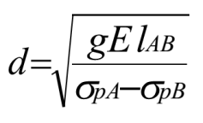

d *=*→d=7,5m, as d<x=10m donc:∆σrec(10)=0MPa

* **Loss due to concrete shortening**

∆σracc (x) = n-1/2n. Ep/Eij .σb(x) = 5-1/2.5 . 200000/38842.65. 9.68

∆σracc (10)= 19,93MPa

* + **Total instantaneous losses**: ∆σpi(10) =55,36MPa
  + **The initial tension**: σpi(10)=σp0— ∆σpi=1339,64MPa

1. **Deferred losses**
   * **Loss due to concrete shrinkage**:

∆σret(x)=Epɛr so: ∆σret(10)= 50MPa

* **Loss due to concrete creep**

**fl= 15 Bf so fl=**145, 2 MPa

* **The loss due to the relaxation of the prestressing reinforcements:**



∆σ

Δσrel (10) = 187.084 MPa

* + **Total deferred losses: σd = σr+σfl + 5/6 σrel =**330.50MPa
  + **The final tension:**

**pf (x) = po - pi (x) - pd(x) =** 1009.14 MPa

**Exercise 2**

We study an isostatic post-tensioning rectangular section beam 22.00 m long which supports the decking of a footbridge located by the sea. The permanent load taken up by this beam, excluding its own weight, is 7 kN/ml. The operating loads are 6 kN/ml. This beam is prestressed by post-tensioning using 3 7T13S cables, with an elastic limit of 1660 MPa and a breaking limit of 1860 MPa, and a unit strand section of 100 mm2. The sheaths are strip type, 60 mm in diameter, injected with cement grout. Concrete with strength fc28 = 35MPa. After 14 days of hardening of the concrete, prestressing is carried out from a single end section and the cables are successively tensioned. The average route of the cables is parabolic up to 6 m from the support then rectilinear, as shown in the longitudinal section. The figures below show the route of the cables along the beam and the route of the average cable on the half-span.

Calculate the geometric and mechanical characteristics.

1) Calculate the maximum demands.

2) Determine the instantaneous losses at mid-span, in M:

a) Loss through friction. = 0.001m-1.ϕWe will take f = 0.19rd-1 and you will also indicate the values ​​of friction losses at characteristic points B, C and D.

b) Loss by anchoring recoil, the keys retracting by 5 mm. If d>x therefore ∆σrecu(x)=2.P.(d-x) With P= ∆σfrott(x)/X

c) Loss due to elastic deformation of concrete.

d) Calculation of the initial tension at mid-span.**Solution**

1. Calculation of geometric and mechanical characteristics.

* The area of ​​the section (Bb)

Bb =Ʃ Bi = 0.44 m2

* The distance of the upper and lower fiber (Vs)(Vi)

Vs =Vi = 0.55 m

* The moment of inertia (I)

I = b×h3/12= 0.0443 m4

* ep = - (Vi-C) = - 0.46 m
* The radius of gyration (i)

i=√I/B = 0.317 m

* The performance of the section ()

ρ= I/ B.Vs.Vi= 0.332

* Compressive strength to day j= 14 jours

d= 14 days : fc7= j/4.76 +0.83.J ×fc28= 29,91MPa

* Tensile strength to day d= 7 and 90 days

ftj= 0,6 + 0,06 fcj

d= 14 days : ft14= 2.394 MPa

* The instantaneous longitudinal deformation modulus of concrete Eij

Eij=11000

*3*fcj

Ei14= 34145.34MPa

* The delayed longitudinal deformation modulus Evj:

Evj=3700

*3*fcj

Ev14= 11485, 25 MPa

1. **Calculation of maximum demands**

Mg = g.L2 /8= 423.5 KN.m

Mq = q. L2/ 8= 363 KN.m

* + The original tension:

σpO=min(0,9ƒpeg,0,8ƒprg)→σp0=1488MPa

* + Instant losses:
  + **Loss due to friction**: in M

∆σfrott(x)=σpO(1— e–(αf+φx))

With : α=10.57°→α=0.184(rd) donc: ∆σfrott(11)= 68,39MPa

* In B (6m): :∆σfrott(6)= 60,94MPa
* In C (16m): :∆σfrott(16)= 75,83 MPa
* In D (22m): :∆σfrott(22)= 136,78MPa
* **Loss due to anchor recoil**

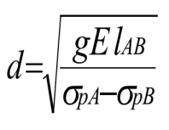 →d=12,36m, as d˃x=11m so:

∆σrec (11)=2P(d-x)= 16.91MPa

* + **Loss due to concrete shortening :**

∆σracc (x) = n-1/2n. Ep/Eij .σb(x)



with σpi(11)=σp0—∆σfrt-∆σrecul- ∆σpi=1402.7 - ∆σpi

∆σpi=∆σracc (11)= 130,45MPa

σb= 78.813 – 0.0597 ∆σpi(x)= 71.02 MPa

* + **Total instantaneous losses**:
  + ∆σpi(11) =215,75MPa

**The initial tension**:σpi (11)=σp0—∆σpi= 1272.25 MPa

**Exercise 3**

Consider a 42m long beam, prestressed by cables made of very low relaxation strands with a guaranteed relaxation at 1000 hours equal to 2.5%, elastic limit 1584 MPa and guaranteed breaking stress 1775 MPa. Tensioning takes place after 13 days on concrete with strength fc28=35MPa. The final withdrawal is equal to εr=3.10-4. The slippage of the anchor is 5mm, the friction coefficients are: f=0.18 rd-1,ϕ=0.0017m-1. The stress at the center of gravity of the reinforcements due to the action of the existing permanent loads upon tensioning and the action of the prestressing is: 7.6MPa. The additional stress brought by the permanent actions applied at 50 days is worth 1MPa. The final stress is worth 7.3MPa. For the mid-span section (x=21m, α=0.12rd),

Determine:

* The voltage at the origin loss due to friction
* Loss due to anchoring recoil
* Loss due to instantaneous deformation of concrete
* Instantaneous loss
* Loss due to concrete shrinkage
* Loss due to concrete creep
* Loss due to relaxation of steels
* Deferred loss

**Solution**

**The original tension:**

σpO=min(0,9ƒpeg,0,8ƒprg)→σp0=1314 MPa

1. **Instant losses:**

* **Loss due to friction:**

∆σfrott(x)=σpO(1— e–(αf+φx))

So :∆σfrott (21)= 79,07MPa

* **Loss due to anchor recoil:**

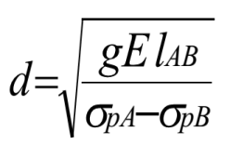

d=15,88m, as d<x=21m so: ∆σrecul (21)=0MPa

* **Loss due to concrete shortening**:

∆σracc(21)=n-1/2n .Ep/Eij. σb (l/2)

∆σracc(21)=4-1/2.4 .190000. (7.6/Ei12 + 1/Ei28)

Ei12= 34179.55 MPa; Ei28= 35981.72 MPa

∆σracc(21) = 17,61MPa

**Instant losses**: ∆σpi(21) = 76,16MPa

**The initial tension:** σpi(21)=σp0— ∆σpi=1338,94 MPa

1. Deferred losses:

**Loss due to concrete shrinkage**

∆σret(x)=Epɛr So: ∆σret(21)= 38MPa

**Loss due to concrete creep**:

**fl= (bM + bF ) Ep /Eij = (7.3 + 7.3) .190000/35981.72 = 77.094 MPa**

**The loss due to the relaxation of the prestressing reinforcements:**



**∆σrel(21) = 6. 2.5/ 100 [1338,94/1775 – 0.43]. 1338,94= 65.13 MPa**

**Total deferred losses:  σd = σr+σfl + 5/6 σrel**

**σd =38 +77.094 + 5/6 . 65.13= 169.37 MPa**

**Exercise 4:**

Consider a beam of isostatic rectangular section (130 × 72) cm and 40m in length prestressed by 4 cables. This beam is subject to the following actions:

- Permanent action (own weight) G= 6 KN/m.

- Variable action Q=10 KN/m, knowing that the cables are put under tension at both ends at d= 10 days and assuming that the calculation section is the raw concrete section.

1. Determine the voltage at the origin For the mid-section in M
2. Determine the instantaneous loss. You will also indicate the values ​​of friction losses at characteristic points B, C and D.
3. Deduce the initial voltage
4. Determine deferred loss
5. Deduce the final voltage

We give: **f = 0,18rd-1 et φ = 0,002 m-1; g= 1mm ; Ap= 16722 mm2; fprg= 1720 MPa ; fpeg = 1460 MPa ; φ1000= 2% ; µ0= 0.3 ; Ep= 190000 MPa, ɛr = 2 ×10-4, fc28= 30 MPa**

**Solution**

* + **The original tension:**

σpO=min(0,9ƒpeg,0,8ƒprg)→σp0=1314MPa

1. Instant losses:
   * **Loss due to friction**: M

∆σfrott(x)=σpO(1— e–(αf+φx))

With : α=3.67°→α=0.064(rd) so : ∆σfrott(20)= 67,69MPa

* in B (14m): :∆σfrott(14)= 51,93MPa
* in C (26m): :∆σfrott(26)= 83,46MPa
  + **Loss due to anchor recoil:**

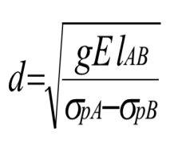

→d=7,50m, as d˂x=20m so:

∆σrec (20)=0

**Loss due to concrete shortening:**

∆σracc (x) = n-1/2n. Ep/Eij .σb(x) ………….………………………………………..(1)

………………………….(2)

with σpi(20)=σp0—∆σfrt-∆σrecul- ∆σpi=1246 - ∆σpi …………………………(3)

∆σpi=∆σracc (20)= 98,62MPa

σb= 48.591 – 0.0541∆σpi(x)= 43.02 MPa

**Total instantaneous losses**:

∆σpi(11) = 215,75MPa

**The initial tension:** σpi(11) =σp0—∆σpi= 1147.38MPa

1. Deferred losses:
   * **Loss due to concrete shrinkage**:

∆σret(x)=Epɛr So: ∆σret(20)= 38MPa

* + **Loss due to concrete creep**:

**fl= 15 bF So fl=**157, 07MPa

* + **Loss due to relaxation of prestressing reinforcement:**



Δσrel (20) = 50.54MPa

* + **Total deferred losses: σd = σr+σfl + 5/6 σrel =**330.50 MPa

**The final tension:**

**pf (x) = po - pi (x) - pd(x) =** 1009.14 MPa

**Exercise 5**

Calculate, at mid-span, the instantaneous and deferred losses for the I-beam below (whose length is 36 m) subjected to prestressing in post tension by 7 cables at 25 days.

**Data**:

α = 0,072 rd, fpeg = 1460 Mpa, εr = 0,0003, ψ = 0,0016 m-1, fprg = 1720 MPa. fc28 = 35 MPa, f = 0,18 rd-1, Ap = 4200 mm2, ρ1000 = 2,5 %. μ0 = 0, 3,

g = 2 mm, σbM= 16,3 MPa. σbF= 12,5 MPa. Ep = 190000 MPa.

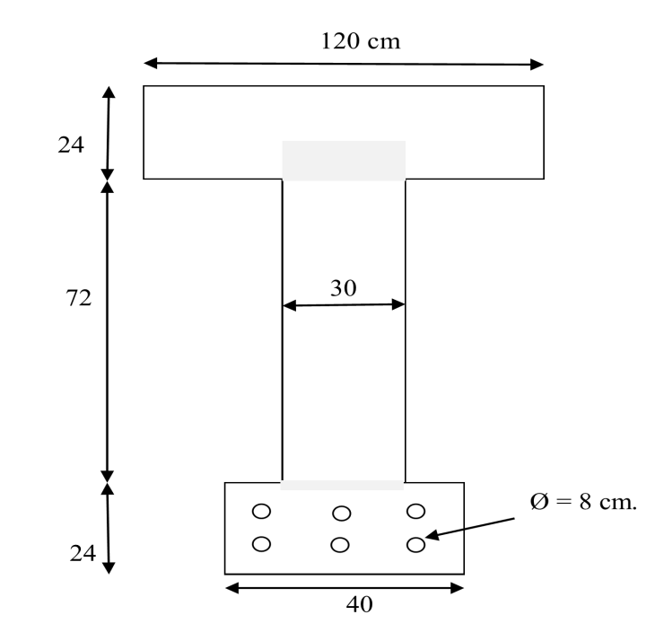

**CHAPTER III: Calculation of isostatic beams at the service limit state**

**II.1 GENERAL**

As with any request, it is necessary to proceed, with regard to normal requests, to two categories of justification:

* At ULS to ensure the resistance of the structure,
* To the ELS to check compliance with operating and sustainability conditions.

While in the ELS, we limit ourselves to the elastic operating range of the materials, in the ELU, we admit the plasticization of the sections. This chapter concerns the study with regard to ELS, ELU will be treated in the following chapter. The principle of justification for the ELS is simple: it is enough to calculate the constraints which appear in the sections under the effect of the calculation requests and to verify that they do not exceed the regulatory limit constraints. As long as the tensile stresses in the concrete remain moderate (which we assume here), the calculations are carried out from the characteristics of the uncracked sections:

• Clear sections with regard to the stresses developed by permanent loads and by prestressing,

• Homogenized sections for stresses due to variable loads. In practice, the characteristics of the raw, net and homogenized sections are often very similar and they can be confused at the pre-sizing stage.

**III.2 DEFINITION OF CALCULATION SECTIONS**

**Raw section**

For taking into account the self-weight and rigidity calculations of the structure. Gross section= total section of the concrete without reduction of conduits and anchors



Bb =h*b

h

b

**Uncracked sections**

**Net sections** for calculating ELS stresses in uncracked sections. Net section = Total section of the concrete with deduction of conduits and anchors.

**Homogeneous sections**, to take into account a passive part of adherent active reinforcements.

Homogeneous section = net section + (adherent longitudinal reinforcement section) x n + passive reinforcement sections under the same conditions if they comply with articles A.6 and A.8.1 of BAEL91

n: Equivalence coefficient: take n= ni = 5 if instantaneous or n = nv=15 if long term

n=Bb-BV

**Cracked sections**

For the calculation at ELS in cracked sections: (Homogenized and reduced section) = (Section of compressed concrete alone) + (passive reinforcement section)x(nv)+ (prestressing reinforcement section)x(nv)x (ρ= 1 in case of pre-tension)

0.5 in case of post-tensioning with grout injection

0 in case of post-tensioning with greased sheathed strands.

**Coating section**

It is the surface delimited by the contour of the section and two parallel to the axis of flexion considered framing all the prestressing reinforcements, at a minimum admissible equal distance “c”. This section is used for certain checks in class II.

III.3 LOAD COMBINATION

III.3.1 Ultimate limit state (ULS)

Exceeding this state leads to the ruin of the structure. Beyond the ultimate limit state, the strength of concrete and steel materials is reached, safety is no longer guaranteed and the structure risks collapsing. We distinguish:

Limit state of resistance of one of the materials.

Limit state of static equilibrium.

Limit state of shape stability: buckling

III.3.2 Service limit state (ELS)

The service limit state reached calls into question the serviceability of the structure (cracks, leaks, various disorders). This state is defined taking into account operating and/or sustainability conditions. We distinguish:

Limit state of crack opening:

risk of crack opening.

Limit state of compression of concrete: we voluntarily limit the compressive stress to a reasonable value.

Limit state of deformation: maximum deflection.

NB: A structure must satisfy both ultimate limit state and state conditions. service limit.

* 1. III.3.3 Actions
  2. The actions are all the loads (forces, torques, etc.) applied to the structure, as well as the consequences of static or state deformations (shrinkage, settlement of supports, temperature variation, etc.) which lead to deformations of the structure.

**III.3.3.1 Types of actions**

The three types of actions applied to the structure are as follows: Permanent actions: Permanent actions, denoted G, represent an action whose intensity is constant or varies very little over time. They understand:

The own weight of the structural elements,⎫

The weight of fixed equipment of all kinds (floor and ceiling coverings; partitions etc.),

The forces (weight, thrusts, and pressures) exerted by earth, by solids or by liquids whose levels vary little,

The differential displacements of the supports, forces due to deformations (shrinkage, creep, etc.) permanently imposed⎫ to construction, In most cases, self-weight is represented by a single nominal value, G0, calculated from project drawings and average material densities. Variable actions: variable actions, denoted Q, represent actions whose intensity varies frequently and significantly over time. They are defined by regulatory texts in force, we distinguish: operating loads (weight and related effects such as braking force, centrifugal forces, and dynamic effects),

The forces (weight, thrusts, and pressures) exerted by solids or by liquids whose level is variable, non-permanent loads applied during execution (construction site equipment, machines, material deposits, etc.),

**Climatic actions**: snow, wind, temperature, etc.

**Variable actions** are divided into two categories:

A so-called basic action noted Q1θ the other actions, called accompanying actions and denoted Qi (iθ>1)

The basic action Qi is: The unique action if this is the case

Otherwise: The most common

The highest

One or the other variable action

Accidental actions: Accidental actions, noted FA, originating from rare phenomena, and should only be considered if public documents or the market provide for it. Example: earthquakes, explosions, shocks.

**Representative values ​​of shares**

The different values ​​of the intensity of actions, called representative values, are: Qk: characteristic values ​​of the action

0i Qik: combination values ψ

1i Qik: frequent valuesψ

2i Qik: quasi-permanent values ψ

The prestress is represented by a calculation value Pd which is: the most unfavorable of two characteristic values ​​P1 and P2 for the justifications with regard to the service limit states,

P1 (x, t) = 1,02 P0 - 0,80 P (x, t)

P2 (x, t) = 0,98 P0 - 1,20 P (x, t)

* Its probable value Pm for the justifications with regard to the ultimate limit states.

Pm (x, t) = P0 - P (x, t)

P0 representing the prestress “at the origin”, corresponding to the tension p0.

P (x, t) the loss of prestress at the point of abscissa x, at the instant t.

**III.5 JUSTIFICATION OF NORMAL CONSTRAINTS**

This verification consists of calculating the stresses in the concrete and comparing them to the authorized limit stresses. It must be established for each of the construction phases and the service phase. The stress calculation is carried out by applying the following general formula, in algebraic value: In the general case, we must have: σmin≤σ(y)≤σmax

The limiting constraints are not the same for the different load combinations, for verifications during the construction phase and for verifications during the service phases.

**III.5.1 Calculation hypotheses**

The calculations in the current section are carried out using the following two fundamental assumptions: Straight sections remain flat;

❑ The stresses of the materials are proportional to their deformations. Depending on the type of verification considered, the additional hypotheses are:

Calculation in uncracked section

❑ tensioned concrete resists traction;

❑ The materials do not suffer any relative slippage. This last hypothesis means that the normal stresses due to all actions other than permanent actions can be calculated on the entire homogeneous section. Calculation in cracked section

❑ Tensioned concrete is neglected;

❑ The materials do not undergo any relative sliding;

❑ When the deformation of the concrete is canceled at the level of reinforcement, the tension in the latter is worth:

* 0 if it is a passive reinforcement,
* σpd+niσbpd (with ni=5) if it is a prestressing reinforcement With ni=5) if it is a prestressing reinforcement

**III.5.2 Dimensioning of sections**

The objective of dimensioning the prestressing is to determine the effective force P (after subtraction of the tension losses) which must prevail in the section studied so that the limit stresses are ensured.



σs1 : upper fiber limit stress under loading 1 (P et Mm)

σs2 : upper fiber limit stress under loading 2 (P et MM)

σi1 : limit stress at lower fiber under loading 1(P et Mm)

σi2 : limit stress at lower fiber under loading 2(P et MM)

**II.5.2.1 Pressure center and line**

Under any real load case, a section is subjected to the following stresses:

•A force N = P due to the prestress,

•A bending moment M = P e0 + Mext. These reduction elements can be considered as generated by a single force P of eccentricity

*e*=*eo*+*Mf*

P



P

Mf

e

eo

P

This eccentricity defines the ordinate of a point C called the depression center.

In a given section, when the external moment varies between Mm and MM, the center of pressure moves between the ordinate m and the ordinate M em emeeM with

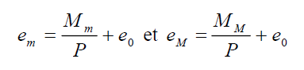

**III.5.2.2 Limit core, limit spindle**

In a given section, the limit core is the interval in which the pressure center must be located to comply with the admissible stresses. When the section describes the entire length of the beam, the pressure line must therefore be located inside the limit spindle.

**III.5.4 Passage core, passage spindle**

In a given section, the passage core is the interval in which the cable must be located to comply with the limit core. When the section describes the entire length of the beam, the passage core generates the passage spindle.

**III.5.5 Concept of critical section**

**Subcritical section**: If all the passage segments are inside the zone that allows sufficient cover, the section is said to be subcritical.

**Critical section**: In the case where it is possible that the passage segment is reduced to a point, the section is critical.

**Supercritical section**: If the passage segment at one of its boundaries cuts the coating zone (open segment), the section is said to be supercritical.

**Subcritical section Critical section Supercritical section III.6 EVALUATION OF THE PRESTRESS**

**Case of subcritical and critical section**

The passage segment is limited to a point





* + **Section case on criticism**

**Positive moment**



**Negative moment**



**Note**

If PI>PII the section is under critical

If PI< PII the section is over critical

**Special case** If we assume σs1=σi2=o, then we has:

**Subcritical section:** PI= ΔM

ρ

L h

**Section on criticism**

**Positive moment**

*PII=Vi*+*MM*−*di*

ρ*Vs*

**Negative moment**

*PII*= −*Mm*

Vs+ρVi-ds

By comparison, we can see the savings obtained on the prestressing force when tensile stresses are tolerated in the concrete. (σs1=σi2<o).

**III.7 MINIMUM CONCRETE SECTION**

The minimum concrete section is obtained when the compression limit stresses are reached. In the following, it is assumed that we systematically adopt the minimum values ​​previously found for the prestressing (PI, PII).

**Cas d’une section sous critique**

*I*≥*MM* −*Mm*=Δ*M*

*Vs* σ*s2*−σ*s1*Δσ*s*

*I*≥*MM* −*Mm*=Δ*M*

*Vi* σ*i1*−σ*i2* Δσ*i*

**Case of a section on criticism**

**Positive moment**

*I*≥ ρ*Ph*

*Vs*σ*s2*+*Vs*σ*i2*

Vi

*I*≥ *MM* −*Mm*=Δ*M*

*Vi* σ*i1*−σ*i2* σ*fi*

Negative moment

*I*≥*MM* −*Mm*=Δ*M*

*Vs* σ*s2*−σ*s1*Δσ*s*

*I*≥ ρ*Ph*

*Vi*σ*i1*+*Vi*σ*s1*

Vs

III.8 LONGITUDINAL PASSIVE REINFORCEMENT

They result from the most severe of the following requirements:

III.8.1 Skin reinforcements µ

The purpose of these reinforcements is essentially to limit the cracking of the concrete before the application of the prestressing force under the action of phenomena such as differential shrinkage. The section of the skin reinforcements must be at least 3 cm2 per meter of length, without being able to be less than 0.10% of the concrete section.

**III.8.2 Reinforcement of tensioned areas**

In the parts of the section where the concrete is tensioned, it is necessary to have a minimum reinforcement section As

With : 

Bt: the area of ​​the part of the concrete in tension

NBt: the resultant of the corresponding tensile stresses.

σBt: the absolute value of the maximum tensile stress.

**III.9 JUSTIFICATION OF TANGENTIAL STRESSES**

A beam subjected to a shear force must be the subject of the following justifications:

In all areas of the beam with respect to:

The serviceability limit state,

The ultimate limit state

In the simple support and end areas of the beam. , additional justifications relating to the equilibrium of the shear force connecting rod and possibly the lower corner. The presence of the prestress induces a new data in the calculation of the prestressed elements. Thus, to the effects of permanent loads and operating loads is added that of prestressing: V = Vg + Vq + Vp

For the case of a prestress of force P inclined at an angle "α" relative to the average fiber, the action of the prestressing force on the section can be broken down into two forces: one "N" normal and the other "Vp" perpendicular.

**N=Pcosα N>0**

**Vp=-Psinα Vp<0**

Consequently, the value of the shear force to be considered is a reduced shear force defined by: **Vréd=(Vg+Vq)-Psinα**

**N.B**: Depending on the sign of "sinα", the shear force can be favourable or unfavourable.

**III.9.1 Justification at SLS**

The justifications are carried out for a given section of the beam from the stresses σx, σt and τt, calculated for the element considered at the verification level, assuming elastic and linear deformations of the materials and assuming the concrete is not cracked. In the general case of a beam element comprising transverse prestressing reinforcements of unit tensile force Ft inclined at α' on the mean fibre and spaced at st' (Figure III.1), we have:

Ft

st

'

α’

Figure III.1: Beam with transverse reinforcement [5]



σx: normal stress at the section;

σt: normal stress at the cross-section;

τ: shear stress of the element;

τred: shear stress due to the shear force reduces the element which can be calculated by the formula:

**τ*réd*= *VrédS***

***bnIn***

Vréd: reduced shear force

S: static moment

bn: net width of the section

In: net moment of inertia of the section under the effect of service stresses in the case of the most unfavourable loads; and whatever the sections considered, the following conditions are verified:



**III.10 EXERCISES**

**EXERCISE 1:**

Let a beam of rectangular section (60x120) cm subjected to the moments Mmin = 1.3MNm and Mmax = 3.3MNm with a value of the cover such that di = 0.15m.

* Determine the value of the prestress (P1 and P2).
* Give an observation on the nature of the section.
* Determine the value of the eccentricity eO.

**Solution**:

In subcritical section, the value of the prestress is determined by the equation:

PI=ΔM

ρh

With:

ΔM=2 MNm

ρ=0.33 ,h=1.20m

From where: P1=5.05MN

In supercritical section (positive moment), the value of the prestress is determined by the equation:

PII = MM / Vi + ρ.Vs- di

With:

Mmax=3.2MNm

ρ=1/3

Vs=Vi=0.60m

di =0.15m

From where: P2=5.09MN

We note that P1>P2 hence the section is subcritical The value of the eccentricity eO is given by:

−Ci−Mm=eo=Cs−MM

PI PI

With:

Cs= ρVs= 0.2m P1=5MN

From where: e0=-0.44m

**Exercise 2**

Let us consider a beam with a rectangular section (60x130) cm subjected to the moments Mmin=1.8 MNm and Mmax= 2.5 M N m with a value of the cover such that di = 0.16m.

Determine the value of the prestress (P1 and P2).

Sketch the stress diagram

**Exercice 3**

Consider a slab (1 m, h) with a span of 16 m, subject to an operational load q=0.06 MN/m2 with no value of the coating as i = 0.108 m. The concrete used has strength of 25 MPa. Tensile limit stress σ t = 0, Compressive limit stress σb= 15 MPa

Determine the height h

Determine the value of the pre-stress P and the value of the centrifugal stress eO.

Give an observation on the nature of the section.

**CHAPTER IV: Resistance of a beam section at the ultimate limit state**

**IV.1 GENERAL**

Justifications with respect to the ULS, in addition to verifications with respect to the SLS, are essential for the following reasons:

• An excess of the characteristic loads (taken into account in the calculations at the SLS) is always possible,

• The behavior of the structures under ULS combinations must be examined. To do this, it is not possible to proceed by extrapolation, but to carry out specific verifications.

**IV.2 EQUILIBRIUM OF A SECTION AT THE RUPTURE**

To the extent that the prestress is adherent to the concrete, experience shows that the behavior of a section at the exhaustion of its resistance can be correctly understood by relying on the following hypotheses:

• Conservation of the flatness of the straight sections,

• Non-intervention of the tensioned concrete,

• Non-slippage of the materials.

**IV.3 CHARACTERIZATION OF AN ULTIMATE LIMIT STATE**

Physically, an ultimate limit state is characterized by the fact that at least one of the materials constituting the section reaches its ultimate deformation. Regulatory, it is conventionally accepted that an ULS is reached when the deformation diagram is a limit diagram passing through one of the pivots A, B, C (Figure IV.1). Pivots A and B corresponds:

• For steels, to ultimate elongations. This limit was set at 10-2 in BPEL 91. In the Eurocode, its value is 2.5. 10-2 or 5.0. 10-2 or 7.5.10-2,

• For concrete, to an ultimate shortening of 3.5. 10-3. Pivot C, for its part, makes it possible to take into account the fact that when a part perishes while being compressed everywhere; the shortenings measured there are significantly lower than on the compressed fiber of a part partially stretched to rupture.

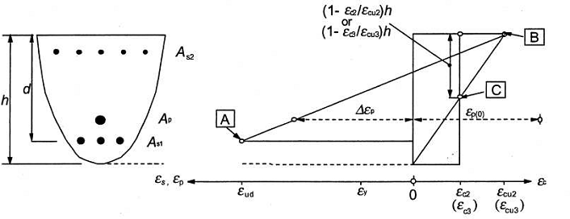

Figure IV.1: The deformation diagram [6]

**IV.4 PRINCIPLE OF JUSTIFICATIONS**

This is to ensure that the regulatory design stresses, which we will designate by sa, do not lead to the appearance of an ultimate limit state in the section.

**IV.4.1 Design stresses**

Even when the external loads only generate simple bending, they are composite bending stresses, due to the prestress Pm characterized by two parameters which are the normal component of the resultant and the resulting moment at a point.

**IV.4.2 Justification at ULS**

The justifications of the elements of a beam with respect to the ultimate limit state include the verification, on the one hand, of the resistance of the transverse reinforcements and, on the other hand, that of the compressed connecting rods.

The first step is to determine the angle ßu that the concrete balls form with the average fiber of the beam, this angle is given by:



ßu being however limited below 30°. The PBEL rules then define the ultimate shear stress τuilm corresponding to the full use of the resistance of the transverse, active and passive reinforcements.



With the following notations At: total area of ​​the sections of a course of transverse passive reinforcements;

St: spacing of two courses of these reinforcements, measured along the mean fibre of the beam;

Fe: yield strength of the steel;

α: angle of these reinforcements with the mean fibre of the beam (angle between 45° and 90°);

Ftu: resistant force of the steels of a course of transverse prestressing reinforcements;

st': spacing of two courses of these reinforcements, measured along the mean fibre of the beam;

α': angle of these reinforcements with the mean fibre of the beam (angle between 45° and 90°).

With: γp=γs=1.15 for justifications with respect to fundamental combinations. γp=γs=1 for justifications with respect to accidental combinations.

We must verify that τu≤τulim It is also possible, in the case of a section that is not entirely tensioned, to add to τulim the complementary term ftj/3. This term takes into account the fact that part of the shear force is balanced by the compressed part of the beam. In the very frequent case where the web only has passive reinforcement’s perpendicular to the mean fiber of the beam, we will have the following inequality:



The BPEL rules also impose constructive provisions:

⮚ A minimum of web reinforcement is required in all areas of the beam. It is given by the condition  that the quantity is at least 0.4 Mpa

The spacing **st'** of the transverse reinforcements of the prestressing web must be at most equal to 0.8h.

The spacing **st** of the transverse reinforcements of the passive web must be at most equal to the smallest of the three values ​​0.8h, 3bo and one meter; h designating the total height of the section and bo the minimum gross thickness of the web.

These provisions are intended to avoid excessive fragility of the concrete of the beam web.

**CHAPTER V: CONSTRUCTIVE PROVISIONS**

**V.1 INTRODUCTION**

In common cases, the dimensions of the structure are previously defined. If we consider the prestressed elements of the structure, the cross-section of each element is therefore known. It is then a question of calculating the prestress and its losses and defining, after checking the stresses, the layout of the cables. In other more specific cases, the section must be defined when a technical or economic choice is necessary. Concerning concrete, the shape and dimensions of the section to be prestressed must be chosen so that the beam can withstand the imposed stresses. For example, in the case of bending, simple or composite and for the sake of saving weight and concrete, the ratios (I/v) and (I/v') and must be maximum for a minimum area B. The efficiency ρ must be as high as possible.

**V.2 CABLE ROUTES**

After defining the stresses, the characteristics of the sections and the prestress (P and e0), it is necessary to determine the route to be given to the cables in the sections throughout the beam. Two cases arise:

- The beam is isostatic: the prestress P and the eccentricity e0 apply in the most stressed central section. The cables are raised near the supports to take up the shear forces (because there are no more bending forces at the supports). It should be noted that the exception is: the cables are straight when using bonded wires.

- The beam is hyperstatic: the prestress Pi and the eccentricity e0i must be calculated in all sections. If the prestress is made up of continuous cables, the unknown is the eccentricity e0i, defined by the passage spindle. But this generates an increase in pre-stressing, for the sake of economy; the cables must be stopped in the span. The cables thus sized in certain sections and stopped in others must meet the requirements of:

- Longitudinal bending resistance: in construction and in service (ELS and ULS).

- Resistance to shear force (lifts near supports).

- Numerous practical requirements (coatings, assemblies, vacuum thrust, anchoring, etc.).

**V.3 PRACTICAL ARRANGEMENTS FOR CABLING TRACES**

**V.3.1. Transverse arrangements**

**V.3.2. Longitudinal arrangements**

Longitudinally, duct whistles must be avoided. For high constraints, it is advisable to place gussets to deflect and turn the cables.

**V.3.3. Coverings**

The coating of a duct in relation to any formwork surface is at least 5 cm. For a half-duct in relation to any non-formwork surface, the coating is at least 3 cm. For straight cables in thin slabs (upper or lower slabs of bridges): parasitic deviations create thrusts in the void which can "laminate" the slab and cause it to break during injection. A special case arises for cables outside the concrete: special precautions must be taken for injections.

**V.3.4. Spacing of prestressing reinforcement**

In current section, the horizontal spacing eh and vertical spacing ev of the active reinforcement must be at least 5 cm.

**V.4 FICTITIOUS AVERAGE CABLE**

The prestressing cables in each section form a set that can be quite complex. This is why, for calculations, this set is often replaced by a fictitious average cable that would have, in each section, the same effect as the cables actually installed. The eccentricity of the effective average cable e0 is between (-c' - Mmin/P) and (c - Mmax/P). The segment in which the cable passes is called the passage segment.

**V.5 PASSAGE SPINDLE**

It presents the area delimited by all the passage segments over the entire length of the element.

**V.6 IN POST-TENSIONING PRESTRESSING**

**GROUPING OF PRESTRESSING REINFORC**E**MENT**

The grouping of prestressing reinforcement must satisfy the following conditions: the number of conduits in each bundle is limited: in the horizontal direction to:

q=2 if Փ≤5cm

q=1 if Փ>5cm

In the vertical direction to:

P=3 if Փ≤5cm

p= 2 if 5 cm <Փ< 10 cm

p=1, if Փ≥10cm

**Spacing of prestressing reinforcements**

In current section the horizontal spacing eh and the vertical spacing eV of the isolated conduits or bundles of conduits must satisfy the following conditions:

eh≥ Փ if p ≤ 2

1,5Փ if p=3

1,5Փ if q=2

5cm

eV≥: Փ if q=1

1,2Փ if q=2

4cm

With: p: number of conduit lines (p≤3)

q:number of conduit columns (q≤2)

**V.6.1 Distance of prestressing reinforcements to facings**

The minimum distance between a conduit or a bundle of conduits and a facing must meet the following conditions:

c≥ 3/4a

Փ limited to 80mm

d=3cm: case of structures sheltered from bad weather

d=4cm: case of standard structures

d=5cm: case of structures exposed to an aggressive atmosphere

**V.7 Prestressing by Pretensioning**

**V.7.1 Grouping of prestressing reinforcements**

Prestressing reinforcements by pretensioning must not be grouped in bundles

**V.7.2 Spacing of prestressing reinforcements**

The minimum center distance to be provided between the reinforcements (wires or strands) must not be less than three times their diameter.

**V.7.3 Distance of prestressing reinforcements from the facings**

The distance from the axis of these reinforcements to the nearest facing must not be less than 2.5 times their diameter. In addition, the cover must be at least equal to:

⮚ 1cm for formwork walls located in covered and enclosed premises and not exposed to condensation;

⮚ 3cm for formwork walls exposed to the elements or likely to be exposed to condensation or to contact with a liquid;

⮚ 3 and 4cm, respectively, for non-formwork walls, in the cases defined in the two preceding cases;

⮚ 5cm for structures exposed to an aggressive atmosphere.

**V.7.4 Coating of passive reinforcements**

The coating of any reinforcement must be at least equal to:

⮚ 1 cm for walls located in covered and enclosed premises and which are not exposed to condensation;

⮚ 3 cm for formwork or non-formwork walls which are subjected (or are likely to be) to aggressive actions, or bad weather, or condensation, or to contact with a liquid;

⮚ 5 cm for structures at sea or exposed to sea spray or salt fog, as well as for structures exposed to an aggressive atmosphere.

**V.8 EXERCISES**

**EXERCISE 1:**

We consider an isostatic beam of length 25m, prestressed by three cables of diameter 80mm:

90



45



40

300

**Data:**

G=61 kN/m, Q=158 kN/m, fcj=30 MPa, P=8.45 MN, Z=2.484 m

1. Determine at a distance of 1 m from the support (α=8°69):

The shear force ELSVG

The shear force ELSVQ

The reduced shear force Vr1 in ELS

The reduced shear force Vr2 in ELS

Shear stress ELS

Compressive stress

1. Determine at a distance of 1 m from the support (α=8°69):

The ultimate shear force Vru

The ultimate shear force V′ru

Ultimate shear stress

Angle of inclination of the connecting rods

**References Bibliographiques**

**[1]** ABDELAZIZ YAZID. «Béton précontraint: Cours et exercices». Université de Bechar. (2006).

[10] AURELIO MUTTONI. «Conception et dimensionnement de la précontrainte». Ecolepolytechniqueféderale de Lausanne (2012).

**[2]**KONIN.A. «  Cours de Béton Précontraint» . Institut international d’ingénierie de l’eau et de l’environnement.

**[3]**.THONIER. H. « Le béton précontraint aux états limites ». Presses de l’école nationale des ponts et chaussées (1992).

**[4]** J. FUENTES. «La précontrainte dans le bâtiment». Eyrolles (1983).

**[5]** CHERAIT YACINE. «Le béton précontraint aux états limites». Direction de la production universitaire de Guelma, DPUG (2004).

**[6]** A. E. NAAMAN. «Prestressed concrete analysis and design». Mac Graw Hill (1983).

**[7]** AURELIO MUTTONI. «Conception et dimensionnement de la précontrainte». Ecole polytechnique féderale de Lausanne (2012).

**[8]**CHAUSSIN, R.et al .«La précontrainte » . Presses de l’école nationale des ponts et chaussées (1992).

**[9]**GERWICK,B.«Construction of prestressed concretestructures».MorrisNY(1971).