University of Biskra

Faculty of Engineering

**Course: Fundamental Electricity 1**

**TD 1 : Continuous regime and fundamental theorems**

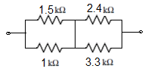

Exercise 01:

The dipole AB is formed by connecting four resistors. Determine the equivalent resistance of this dipole?

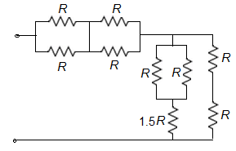

Exercise 02:

Determine the equivalent resistance of this resistance network

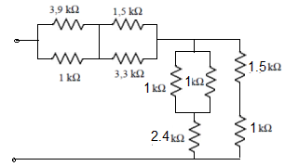

Exercise 03:

Same question as above.

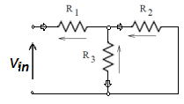

Exercise 04:

Express Currents and voltages across all resistors as a function of Vin

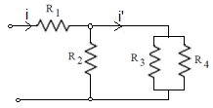Exercise 05:

Express current i′ as a function of current i.

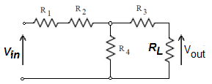

Exercise 06:

Express voltage Vout as a function of the input voltage Vin.

 Exercise 07:

Consider the electrical circuit in the opposite figure

Calculate the currents I1, I2 and I3

AN: E=6V, R1=270Ω, R2=470Ω, R3=220Ω



Exercise 08:

Soit le circuit électrique de la figure ci-contre.

- Calculer les courants I’, I’2 ?

- Calculer les tensions U1, U2?

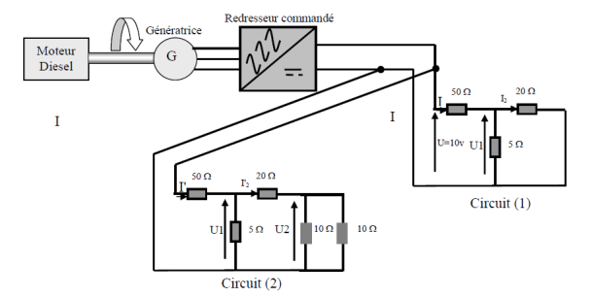**Exercice 09:**

The electrical circuits are given below.

Calculate the equivalent resistance of each circuit.

1. What is the role of the following devices: diesel engine, generator and rectifier

2. Calculate the current I2.

3. Calculate the voltage U1.

4. Calculate the voltage U2

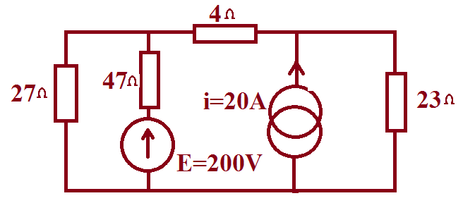

Exercice 10:

Calculate the current in the 23Ω resistor using the superposition principle, in the following circuit:



**Exercise 11 :**

Calculate the power in the 6V source of the following circuit.

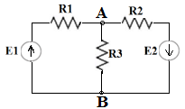

**Exercise 12:**

Find the Voltage **VAB** across resistor R3 using the following methods: Superposition, Thevenin, Norton and Millman**.**

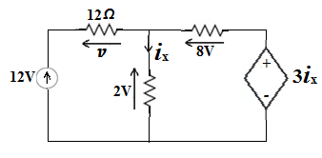

**Exercise 13 :**

Calculate the voltage v and current ***i*x** in the following circuit that contains a fixed value voltage source and a current controlled voltage source**.**

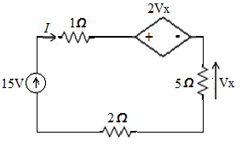

**Exercise 14 :**

Find the value of Voltage **Vx** in the following circuit

that contains a fixed value voltage source and a voltage controlled voltage source.

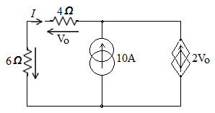

**Exercise 15 :**

Find the value of Voltage V0 in the following circuit that contains a fixed value current source and a voltage controlled current source.

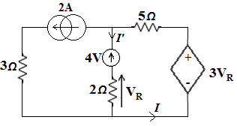Calculate the dissipated power from the controlled current source

**Exercise 16 :**

Proof that the current *I* equals -12A

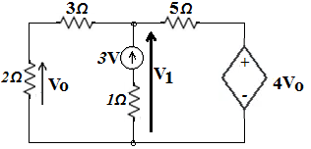

**Exercise 17 :**

Using Nodal analysis and kirchhoff laws, find the value of voltage V0

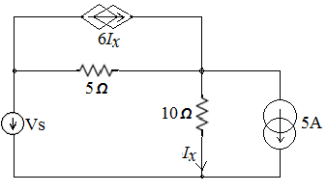

**Exercise 18:**

Find the value of the source voltage Vs if the current ***Ix=5A.***



**Exercise 19:**

In the following circuit determine the elements of the **Thévenin equivalent generator**.

**Exercise 20:**

For the previous circuit determine the elements of the **Norton equivalent generator**.

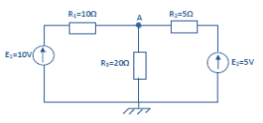

**Exercise 21:**

In the circuit, determine the voltage at point A using Millman's theorem:

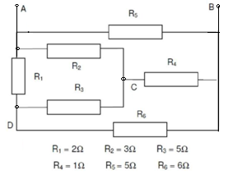

**Exercise 22**

By applying **Kennelly's theorem**, determine RAB:

**Home Work**

Given the Electrical circuit below where:

* K1, K2, K3, K4 are switches.
* L1, L2 , L3 , L4 lamp where

L1 15W/24V; L2: 15W/24V

L3 24W/24V; L4 60W/24V

***A*** is a 3 amp ammeter, protected by a 3.2 A fast-blow fuse.

1) What is the ammeter reading when:

a) K1 is closed alone? b) K2 is closed alone? c) K3 is closed alone? d) K4 is closed alone?

2) What is the ammeter reading when K1, K2 and K3 are closed at the same time?

3) K3 and K4 are closed (the other switches are open); what is the ammeter reading ?

a) Why the current has taken this value?

b) Which lamps are shining?

c) What is the role of the fuse?

4) What modifications must be made to the circuit to be able to light all the lamps at the same time (i.e switches K1, K2, K3, K4 all closed)?

5) According to the diagram below, what is the role of the rectifier?

For this specific circuit would be there any changes on the load behavior if we omit the rectifier.

