Mohammed Khider University of Biskra

Faculty of Science and Technology

2nd year License

Module: TP ELN Fond 1

**Lab N 05 :** Characteristics of a transistor and operating point

**Aims of the practical work**: Know the operating modes of a bipolar transistor by tracing its different characteristic curves.

**A. Theoretical part**

Transistor: it is a semiconductor device, which can amplify electrical currents.

The bipolar transistor is the basic technical operator of electronic functions such as amplification or switching. It is obtained by inserting a semiconductor bar between two of the opposite type. Thus, we obtain two possibilities:

Le transistor NPN : Le transistor PNP :

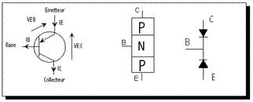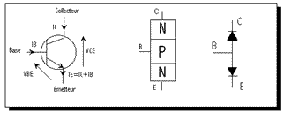…….

The names of the 3 terminals thus constituted are: the base (B), the emitter (E) and the collector (C). The symbolic representations of transistors inform us about their type (PNP or NPN) as well as the direction of the currents.

Two junctions constitute the transistor, junctions which can be compared to 2 diodes (between B-C and B-E) whose direction depends on the type.

**Working principle:**

There are 2 operating modes of the transistor: linear and non-linear mode (blocked/saturated).

The curve representing the collector current (IC) as a function of the base current (IB) makes it possible to identify these 3 operating modes:

• Blocked: there is no current in the transistor.

• Linear: the current IC is directly proportional to the current IB, we then exploit the amplification properties of the transistor: IC = βIB.

• Saturated: from a certain current IB, called saturation current IBsat, the current IC reaches a maximum value, the transistor is said to be “saturated”.

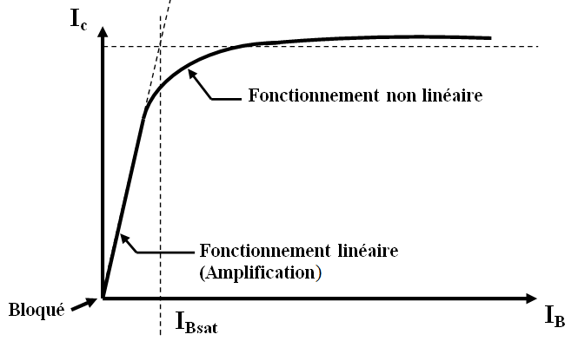

Study of an NPN transistor:

**ICsat**

observe and assimilate the following sentences

1. For , le Transistor is **blocked.**
2. For , le Transistor is in linear mode
3. For , le Transistor is **blocked.**
4. For , le Transistor is **saturated.**
5. For ,le Transistor is **saturated.**
6. For , le Transistor is in **linear mode**.

**B. Practical part :**

**B**

**B.1 Transistor test :**

**C**

**E**

Use the multimeter (diode test mode) to test your transistor

Check the following values

**C→E=O.L E→C=O.L B→C=O.L C→B=0.666v E→B=0.777v B→E=O.L.**

Le transistor type is : 🞎NPN or 🗹PNP ?

**B.2 Characteristics of the bipolar transistor.**

**B.2.1 Transfer characteristic Ic = f(Ib).**

Carry out the following assembly:

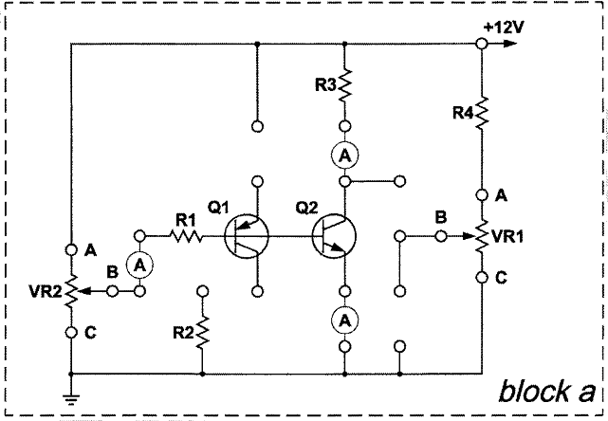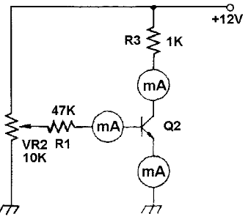

**Fig. 1 :** Montage pour le traçage de la caractéristique de transfert

- Connect ammeters to measure Ib and Ic

- Adjust VR2 (10KΩ) so that Ib = 0, 10,…150 µA and complete the following table:

|  |  |  |  |  |  |  |  |  |  |  |  |  |
| --- | --- | --- | --- | --- | --- | --- | --- | --- | --- | --- | --- | --- |
| **IB(µA)** | **0** | **10** | **20** | **25** | **30** | **40** | **50** | **60** | **75** | **90** | **100** | **150** |
| **IC(mA)** |  |  |  |  |  |  |  |  |  |  |  |  |

**Table 1**

What is the value of Icsat (according to table 1).

**…………………………………………………………..**

Trace the current transfer characteristic .



Specify on this curve the different operating zones of the bipolar transistor.

Read the value of IBsat from the curve.

....................................................................................................................................................

The ratio β= Ic/Ib in the linearity domain of the curve is called "current amplification coefficient". Calculate the value of β

.....................................................................................................................................................

**B.2.2 Output characteristic Ic = f (Vce) at constant Ib**

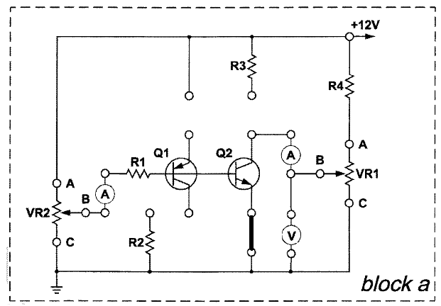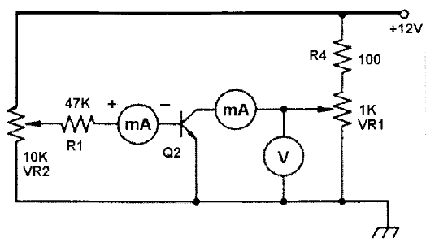

- Insert the connection clip according to Fig2 (23002-block a)

- Connect ammeters and the voltmeter to measure Ib, Ic and VCE

- Adjust VR2 (10k) to have different values ​​of Ib, For each Ib, Adjust VR1 (1k) to have different values ​​of Vce according to the tables (2 to 4).

|  |  |  |  |  |  |  |  |  |  |  |
| --- | --- | --- | --- | --- | --- | --- | --- | --- | --- | --- |
| **VCE (V)** | **0.1** | **0.2** | **0.3** | **0.4** | **0.5** | **0.7** | **1.0** | **3.0** | **5.0** | **8.0** |
| **IC(mA)** |  |  |  |  |  |  |  |  |  |  |

**Table 2** ()

|  |  |  |  |  |  |  |  |  |  |  |
| --- | --- | --- | --- | --- | --- | --- | --- | --- | --- | --- |
| **VCE (V)** | **0.1** | **0.2** | **0.3** | **0.4** | **0.5** | **0.7** | **1.0** | **3.0** | **5.0** | **8.0** |
| **IC (mA)** |  |  |  |  |  |  |  |  |  |  |

**Table 3** ()

|  |  |  |  |  |  |  |  |  |  |  |
| --- | --- | --- | --- | --- | --- | --- | --- | --- | --- | --- |
| **VCE (V)** | **0.1** | **0.2** | **0.3** | **0.4** | **0.5** | **0.7** | **1.0** | **3.0** | **5.0** | **8.0** |
| **IC (mA)** |  |  |  |  |  |  |  |  |  |  |

**Table 4** ()

Tracer the curves IC=f(VCE) for different values ​​of IB.



Specify on the curve the operating zones of the transistor (1) blocked, (2) saturated and (3) linear.

Draw the static load line and calculate the coordinates of the rest point