Université Mohamed Khider -Biskra-
Faculté des Sciences Exactes et des SNV. Département des SNV
TD n° 6

Exercice 1:

We aim to study the functionality of a gene M from a bacterium. To do this, we attempt to clone, at the EcoRI site of the plasmid vector pBR330 (see diagram), an EcoRI–EcoRI fragment of genomic DNA from the bacterium of interest.

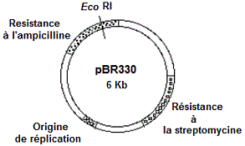

1. Propose a cloning protocol and indicate how you would select the recombinant clones.
2. One of the recombinant plasmids containing the M gene (called pBM1) is digested with the restriction enzymes BamHI and EcoRI.
After migration and separation of the DNA fragments on an agarose gel followed by staining with ethidium bromide, the following restriction profiles are obtained:

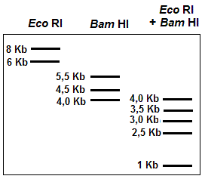

a. What is the rôle of bromure d'éthidium ?
b. Restriction Maps of plasmide recombinant pBM1.

Exercise 1

1. Preparation of the insert:
- Genomic DNA extraction:
Genomic DNA is extracted from the bacterium containing gene M using standard techniques (cell lysis and DNA purification).
- Partial digestion with EcoRI:
The genomic DNA is partially digested with the restriction enzyme EcoRI.
- Fragment purification:
The DNA fragments are separated by agarose gel electrophoresis and then recovered by gel extraction. The size range is selected according to compatibility with the cloning capacity of the plasmid vector.

2. Preparation of the vector (pBR330):
- Complete digestion with EcoRI:
The plasmid pBR330 is cut at its EcoRI restriction sites to generate cohesive ends compatible with the insert.
- Dephosphorylation of vector ends:
The 5′ ends of the vector are dephosphorylated using alkaline phosphatase to prevent self-ligation of the plasmid (i.e. recircularization of the vector without insertion of genomic DNA).

3. Cloning:
- Ligation:
Genomic fragments containing gene M are mixed with the prepared vector in the presence of DNA ligase, allowing insertion of the DNA fragment into the plasmid.

4. Transformation:
The recombinant plasmid is introduced into competent E. coli cells by heat shock or electroporation.

5. Selection of recombinant clones:
- Selection on streptomycin-containing medium:
The plasmid pBR330 confers resistance to streptomycin. Only cells that have taken up the plasmid (recombinant or non-recombinant) can grow on this medium.
- Differential selection on ampicillin-containing medium:
Some colonies are replica-plated onto medium containing ampicillin. If the insert is correctly integrated at the EcoRI site, it disrupts the ampicillin resistance gene. Consequently, only colonies carrying a plasmid without an inserted DNA fragment can grow.
- Identification of gene M (molecular hybridization):
  - Recombinant colonies are transferred onto a membrane filter.
  - A molecular probe specific for gene M is used for colony hybridization.
  - Clones containing gene M are identified by the signal produced by the probe.

6. Interpretation of antibiotic resistance:
1. Without DNA insertion:
If the plasmid is ligated without insertion of a DNA fragment (empty vector), the ampicillin resistance gene remains intact. Cells containing this plasmid can therefore grow on ampicillin-containing medium.
2. With DNA insertion (recombinant):
If a DNA fragment is inserted into the EcoRI site, it disrupts the ampicillin resistance gene. The gene can no longer produce the resistance protein. As a result, cells containing a recombinant plasmid do not grow on ampicillin-containing medium.

7. Analysis of restriction profiles:
a. Role of ethidium bromide:
Ethidium bromide is an intercalating agent that binds to double-stranded DNA. Under UV light, it fluoresces, allowing visualization of DNA fragments after electrophoresis.
b. Carte de restriction du plasmide recombinant pBM1 :

Bcor
4
Eor
2,5
5,5
Bcor
4,5
Bcor
3
3,5

1

Eor

