Université Mohamed Khider -Biskra-
Faculté des Sciences Exactes et des SNV. Département des SNV
TD n° 6

Exercice 1:

We aim to study the functionality of a gene M from a bacterium. To do this, we attempt to clone, at the EcoRI site of the plasmid vector pBR330 (see diagram), an EcoRI–EcoRI fragment of genomic DNA from the bacterium of interest.

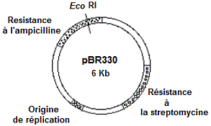

1. Propose a cloning protocol and indicate how you would select the recombinant clones.
2. One of the recombinant plasmids containing the M gene (called pBM1) is digested with the restriction enzymes BamHI and EcoRI.
After migration and separation of the DNA fragments on an agarose gel followed by staining with ethidium bromide, the following restriction profiles are obtained:

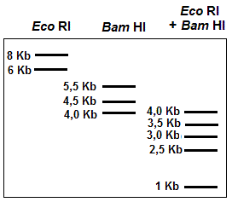

a. What is the rôle of bromure d'éthidium ?
b. Restriction Maps of plasmide recombinant pBM1.

