To Be and To Have

To Be:
I am
You are
(S)He / It is
We are
They are
To Have:
I have
You have
(S)He / It has
We have
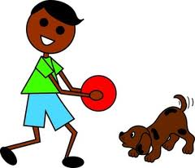
They have

Fill in the blanks with the appropriate verb.

- Samuel ______________ a dog named Fido.
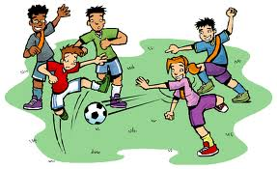
- Today, you __________ coming over to my house to play.
- We __________ too big for the baby swings.
- The soccer team _____________ won nearly all their games.
- I played outside all day and now I _____________ tired.
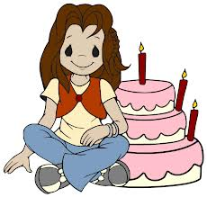
Circle the correct answer:
- You has / have a loose tooth.
- It’s Melanie’s birthday today. She is / are 8 years old.
- My mom and I has / have blue eyes.
- I am / are the youngest in my family.
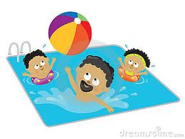
- Tim and Michael has / have a pool in their back yard.

