PARTIE 2 : génie génétique :
Chapitre 1 : clonage in vivo :

Introduction
Genetic engineering is mainly based on molecular cloning, which allows the recombination of a double-stranded DNA fragment with a vector and its introduction into an appropriate host.
This technology initially focused on the simplest organisms, which often have small genomes such as bacteria (e.g., E. coli, B. subtilis, Agrobacterium tumefaciens, etc.) and yeasts (S. cerevisiae). Only later did the stable transgenesis of plant and animal cells become possible. Today, genetically modified organisms (GMOs), including transgenic plants and animals, are numerous, and some have already reached our food supply.
The first major contribution of this technology to medicine was the production of therapeutic proteins such as insulin and human growth hormone (HGH) in sufficient quantities. Medicine has gained many other benefits from recombinant DNA technology, including vaccines (against hepatitis, rabies, etc.), probes (for diagnosis and identification, etc.), and therapeutic agents (antisense nucleic acids, gene therapy, etc.).
Recombinant DNA technology has also been applied to other products of agro-food and industrial interest, such as enzymes (rennet, proteases, etc.), amino acids (glutamate, succinate, etc.), and vitamins (B2, B12, C, etc.). Over the last two decades, several thousand biotechnology companies have been created worldwide, particularly in the USA and Japan.

I. Cloning

I.1 Definition of a Clone
A clone corresponds to a large number of identical molecules or cells derived from a single ancestor (a single cell or molecule). The process of obtaining this large number of identical cells or molecules is called cloning.

I.1.1 Nucleic (DNA) Cloning
Nucleic cloning is a molecular biology technique that consists of inserting a DNA fragment into a vector, which is then propagated inside a host cell. Culturing this cell and subsequently purifying the vector makes it possible to produce virtually unlimited quantities of the cloned DNA fragment of interest.
This molecular biology technique can be used for partial cloning, involving only a fragment of genetic material (DNA), as well as for cloning an entire gene, allowing the production of the corresponding recombinant protein.

I.1.2 Vectors
The obtained DNA fragments lack the ability to replicate (origin of replication) and do not possess protected ends. It is therefore necessary to include them within a structure that ensures both their propagation and their protection. These structures are called vectors.
A cloning vector is a small autonomously replicating genetic element used to produce multiple copies of a gene of interest. A vector is called native when it contains only its own DNA, and recombinant when it has integrated a foreign DNA fragment, whatever its origin may be.
An origin of replication is adapted to the replication mode of the cell in which the vector multiplies. A eukaryotic-type origin of replication will not function in a bacterium, and vice versa. When it is necessary to transfer a vector from one cell type to another, vectors carrying both types of origins of replication are required.
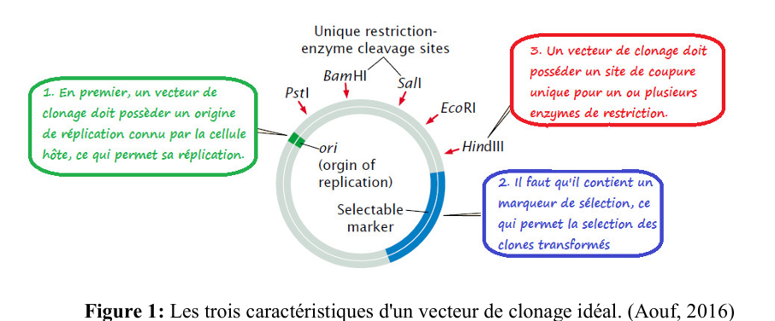

I.1.2 Recombinant DNA
This refers to a hybrid DNA molecule obtained in the laboratory by combining two DNA molecules originating from two different species.

I.1.2.B Clone Libraries (DNA Libraries)
The construction of a clone library is a necessary preliminary step for physical mapping. The study of a genome always begins with the fragmentation of DNA (digestion by restriction enzymes) into fragments, which are then inserted into molecular constructs called cloning vectors. These vectors are subsequently introduced into cells that ensure the maintenance and replication of the DNA fragment.
A set of cells carrying DNA fragments from the studied species constitutes a clone library (one fragment per clone). The objective of the library is therefore to preserve a collection of DNA fragments that are:
• well identified,
• easily manipulated,
• and producible in large quantities (for further study).
It then becomes possible, in particular, to sequence each of these fragments.

II. Elements Required for Cloning

II.1 Cloning Vectors
Plasmids; cosmids; phages; BACs; YACs.

General Definition
A vector is defined as the DNA into which the fragment of DNA to be studied is inserted. The inserted DNA is called the insert or foreign DNA or exogenous DNA. This nucleotide sequence is capable of self-replication. Vectors are therefore small DNA molecules into which a DNA fragment of interest is inserted. These small DNA molecules are generally plasmids or bacteriophages.
It is necessary to introduce these bacteriophages or plasmids into bacteria in order to achieve their multiplication.

II.1.A Plasmids
Plasmids are small circular DNA fragments present in bacterial cells and independent of the bacterial genome.

II.1.A.1 General Properties of Plasmids
Plasmids have the following characteristics:
- Their DNA is double-stranded and circular, with a nucleotide number of less than 10 kb (1 kilobase = 1,000 nucleotides).
- The number of plasmids in a bacterial cell can be considerable (several hundred).
- Plasmids usually carry genes that confer a selective advantage, such as resistance to antibiotics, resistance to heavy metals, or the degradation of aromatic compounds.
- Their replication is independent of that of the bacterial genome.
- Plasmids are excellent cloning vectors in bacteria because they replicate in high copy numbers and are easily purified.

Selection Markers
Selection markers (e.g., antibiotic resistance genes) allow the identification of recombinant (transformed) bacteria that carry them.

II.1.A.2 Preparation of Plasmids
Bacteria containing plasmids are cultured in a large volume (up to 2 liters of culture medium). When the bacterial concentration reaches a sufficient level, the culture is treated with an antibiotic (such as chloramphenicol), which blocks the replication of the bacterial chromosome but not that of the plasmid. The bacteria are then recovered by centrifugation.
Next, the bacterial cell wall is permeabilized using a mild treatment that allows plasmids, which are lighter than bacterial DNA, to pass into solution. Plasmid purification can then be carried out by high-performance liquid chromatography or by density gradient ultracentrifugation.
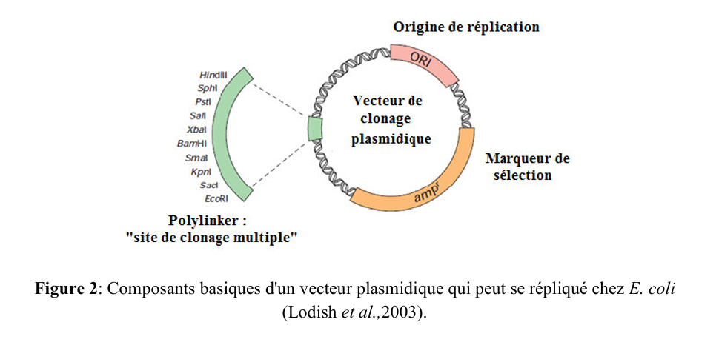

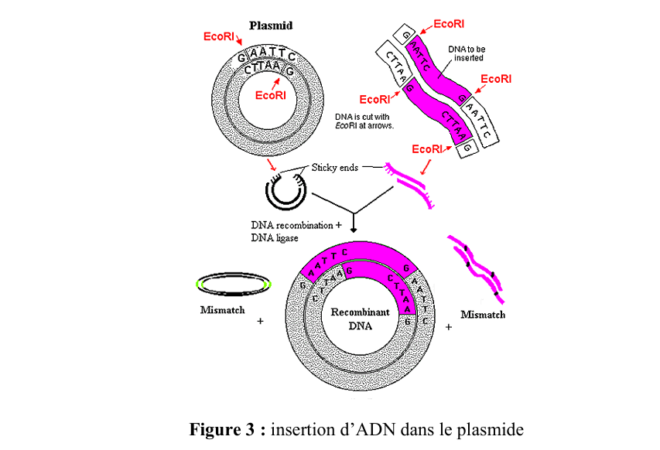

II.1.4 Selection of Bacteria Transformed by Plasmids
The transformation efficiency of bacteria is generally very low. It is therefore essential to have methods that allow the recovery of bacteria transformed by plasmids and only those bacteria. For this purpose, a resistance to an antibiotic (for example, ampicillin) is used. The transformation of an antibiotic-sensitive bacterium by plasmids carrying a resistance gene to the same antibiotic results in the appearance of resistance only in bacteria that have incorporated the plasmids.
This technique makes it possible to separate bacteria that contain plasmids from bacteria without plasmids, since the latter are killed. However, it does not allow discrimination between bacteria carrying intact (non-recombinant) plasmids and bacteria carrying recombinant plasmids. To achieve this, resistance to a second antibiotic is used, for example tetracycline. The insertion of the DNA fragment into the plasmid must inactivate the gene conferring resistance to the second antibiotic. Bacteria transformed with recombinant plasmids are therefore resistant to the first antibiotic (ampicillin) and sensitive to the second antibiotic (tetracycline). Non-transformed bacteria are sensitive to both antibiotics.
An enzymatic system belonging to the lactose operon can be used instead of a second antibiotic marker. The insertion of the DNA fragment into the plasmid results in the inactivation of the gene encoding β-galactosidase. To verify the presence or absence of β-galactosidase enzymatic activity, a galactoside is used whose color changes from colorless to blue when cleaved by β-galactosidase; this compound is called X-gal.
For the cell to metabolize X-gal, it must be exposed to an inducer, which is IPTG (isopropylthio-β-D-galactoside). In culture, in the presence of IPTG and X-gal, bacteria resistant to ampicillin and transformed with recombinant plasmids appear as white colonies because they have lost the ability to cleave the colored lactose analogue (X-gal) by β-galactosidase.
In contrast, bacteria that are resistant to ampicillin but transformed with non-recombinant plasmids appear as blue colonies. Visual selection of bacteria transformed with recombinant plasmids is therefore possible.(figure 5).
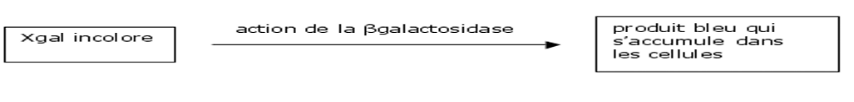
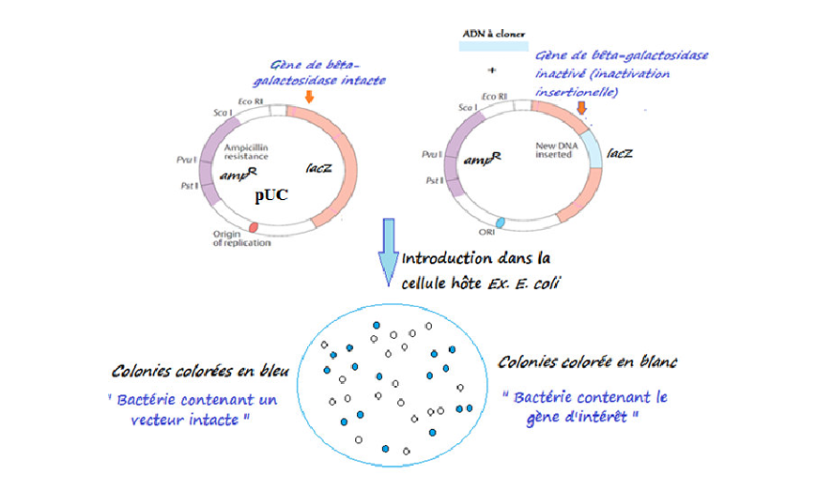

Figure 5 : Sélection des bactéries transformées portant un plasmide pUC recombiné (Aouf, 2016)

II.1.6 Advantages and Disadvantages of Plasmids

Advantages:
- Small size of the vector, allowing easy experimental handling.
- Selection of recombinant plasmids (selection by antibiotics).

Disadvantages:
- Low efficiency of bacterial transformation (plasmid uptake).
- Inability to insert large DNA fragments (the maximum capacity of this plasmid is about 10 kb of foreign DNA).

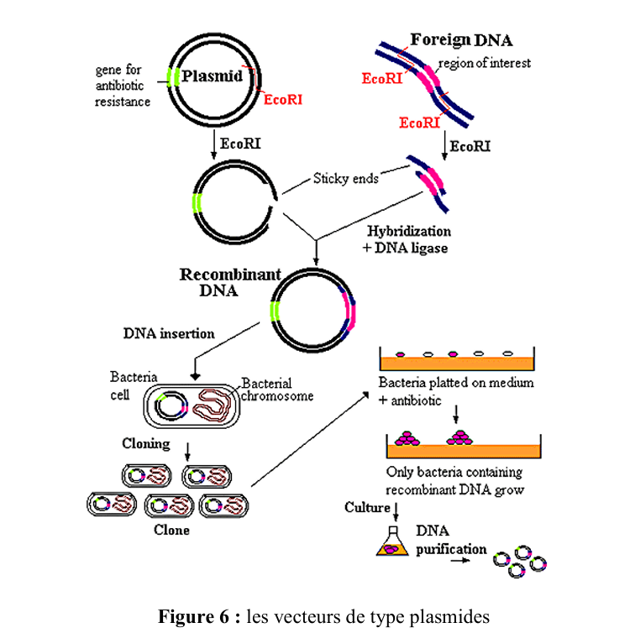

II.2 Phages

II.2.A General Properties of Phages
Phages are viruses that infect bacteria. Two phages are widely used as vectors: lambda (λ) phage and M13 phage (now mainly their derivatives). The sequences of these phages used as vectors are known (40–50 kb of double-stranded DNA). The ends of this DNA are single-stranded over a short length, complementary to each other, and form cohesive ends. These sequences are called cos sequences (from cohesive).

II.2.A.1 Bacteriophage λ
Bacteriophage λ was discovered by E. M. Lederberg in 1950. It is a virus of E. coli. The DNA of this phage is a linear double-stranded DNA molecule of 48 kb. At each 5′ end, there is a single-stranded region of 12 nucleotides, complementary to each other, and their association gives the DNA a circular structure inside the host cell.
The association of these natural cohesive ends forms the cos site (Figure 7) [cos: important elements for the replication and encapsidation of bacteriophage λ]. Two main parts can be distinguished in lambda phage:
- The viral head: it contains the viral DNA.
- The viral tail: it contains proteins and allows the attachment of the virus to the bacterial host cell.

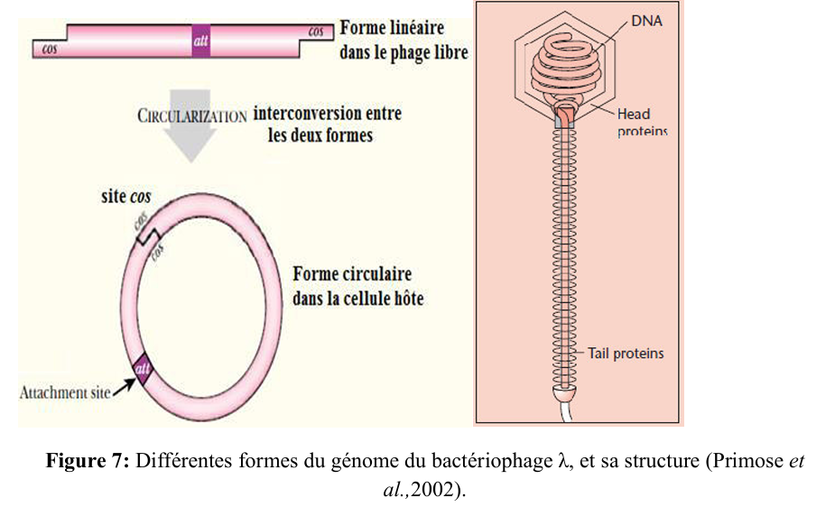

The lambda (λ) virus can multiply according to two possible modes: lytic multiplication or lysogenic multiplication.

Lytic Multiplication
The virus specifically adsorbs onto the surface of bacteria. It injects its DNA into the host cell. The viral DNA then circularizes inside the bacterium. Next, a complex replication phase begins and leads to the formation of numerous viral particles within the bacterial cytoplasm. Bacterial lysis causes the release of viral particles.
The lytic phase is a replication cycle of bacteriophages (viruses that infect bacteria), in which the virus uses the resources of the host cell to produce new virions, leading to the lysis (destruction) of the cell. It is divided into two key stages:
the expression of early genes and late genes.
Early genes are expressed immediately after infection and encode proteins involved in taking control of the host cell, such as enzymes required for replication of the viral genome. Then, late genes are expressed and produce structural viral proteins (capsid, tail) as well as enzymes responsible for the release of virions. This temporal organization ensures efficient replication and the formation of new viruses before the destruction of the cell.

Lysogenic Multiplication
As in lytic multiplication, the virus adsorbs to and penetrates the bacterium. The viral DNA integrates into the bacterial DNA and is replicated along with it.
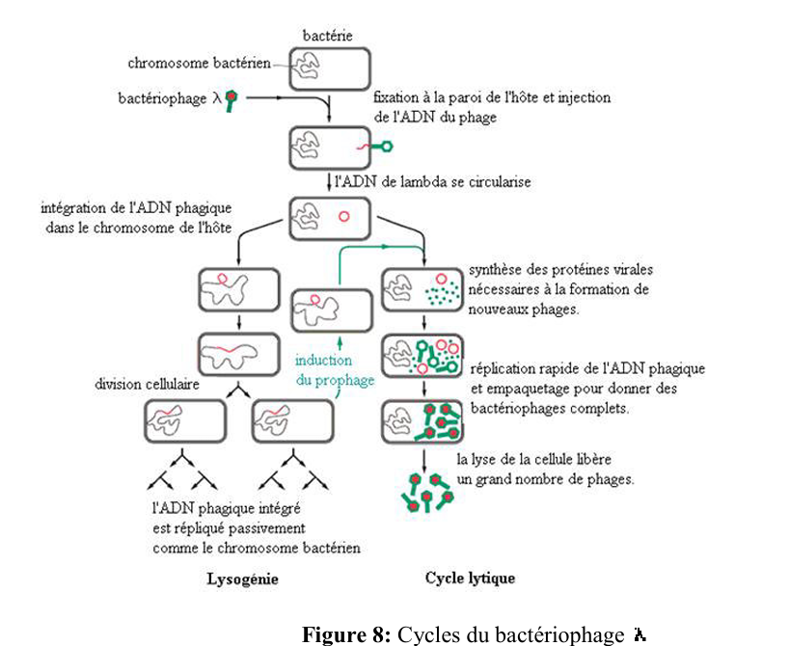

The genome of bacteriophage lambda can be divided into:

Essential regions, including:
- The genes encoding the proteins located in the head and the tail of the virus.
- The cos sites.
- The viral DNA replication site.

Non-essential regions:
- These include the genes involved in lysogeny
(Figure 9).
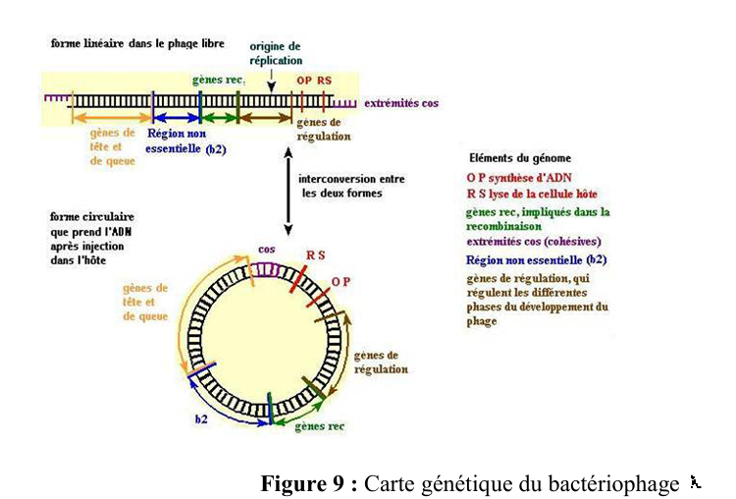

II.2.B.1 Main Steps in the Construction of a Phage Vector
- Produce a large quantity of phage, purify it, then extract its genomic DNA, which is digested with a restriction enzyme.
- Hybridize the two phage arms with the DNA fragment to be cloned (the latter must have an appropriate size), then ligate using DNA ligase.
- Proceed with in vitro encapsidation of the recombinant DNA by adding the phage head and tail proteins. These proteins will self-assemble to form new infectious recombinant virions.
- Infect bacteria (host cells) and spread them onto Petri dishes; each lysis plaque corresponds to one recombinant phage that can be recovered.
- Verify the presence of an insert in the recombinant DNA using any appropriate method (DNA–DNA hybridization, sequencing).

Recognition of cos Sites by the Terminase Enzyme and Encapsidation
These are key steps in the assembly of linear DNA phages such as phage λ. The cos sites are specific sequences located at the ends of the viral DNA. The terminase, a viral enzyme, recognizes these sites and binds to them. It cuts the DNA at these sequences to generate cohesive ends, then loads the DNA into the forming capsid.
During encapsidation, the terminase uses ATP energy to translocate the DNA into the capsid until it is full, after which the DNA is cut again at the cos site, thus completing the process.

II.2 Advantages and Disadvantages of Phages

Advantages:
- The size of insertable DNA fragments is larger than that allowed by plasmids.
- The possibility of in vitro packaging of naked recombinant phage DNA into phage heads.
- Very rapid ability to infect (transfect) the host.
- A high copy number per host cell.
- The efficiency of this transfection is much higher than that obtained with plasmid transformation.

Disadvantages:
- A limited number of restriction sites in the phage genome.
- Obligation to package the DNA.
- Size constraints on the DNA fragment to be inserted.

II.3 Cosmids

II.3.A General Properties of Cosmids
Cosmids (≈ 5 kb) are artificial hybrid vectors: lambda phage–plasmid hybrids. In practice, they behave like plasmids and contain restriction sites that allow the insertion of foreign DNA. They also carry a gene conferring resistance to antibiotics (ampicillin).
In addition, a cos site from lambda virus has been included in their circular DNA, which allows the cosmid to be packaged into the head of a lambda virus (Figure 11).
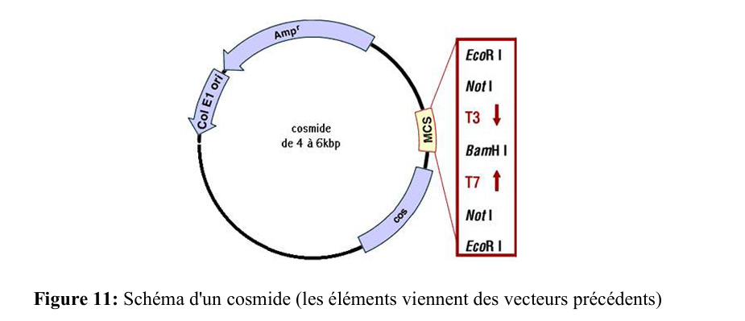
Cosmids, after in vitro assembly, are capable of attaching to the host cell wall and injecting their DNA. Thanks to the cos ends, the DNA circularizes and replicates like a plasmid, but none of the phage functions can be expressed. Therefore, the cells survive and form clones.

II.3.B Advantages and Disadvantages of Cosmids

Advantages:
- Insertable DNA fragments can reach up to 50 kb.
- Their incorporation into bacteria (transformation) is more efficient than with plasmids. Transformed cells are selected on a medium containing an antibiotic (ampicillin).
- Cosmids are more stable than plasmids.

Disadvantages:
- DNA must be packaged.

II.4 Other Types of Vectors
Other vectors exist that allow cloning of large DNA fragments (up to at least 500 kb).

II.4.1 BACs (Bacterial Artificial Chromosomes)
BACs are constructed from the F plasmid (99.2 kb) because of its interesting properties (e.g., Hfr phenotype: mobilization of all or part of the bacterial chromosome from a donor cell to a recipient cell after integration into the chromosome).
A BAC contains only a small fraction of the F plasmid and, like plasmid vectors, possesses:
- A polylinker (multiple cloning site)
- An antibiotic resistance gene as a selection marker (e.g., cat: chloramphenicol resistance)
- A replication origin and repE, necessary for replication
- Replication regulators (sopA, sopB) to maintain a low copy number
Its size is approximately 6.5 kb.
The typical host of a BAC is a mutant strain of E. coli. This strain lacks the modification and restriction systems of wild-type strains, preventing BAC destruction. Additionally, it has lost normal recombination abilities, which prevents recombination and rearrangement of the cloned BAC DNA with the host chromosome. BACs can accommodate DNA inserts of up to 300 kb.

YACs (Yeast Artificial Chromosomes)
YACs must have:
- A replication origin
- Telomeres for replication of DNA at chromosome ends
- A centromere (for segregation during mitosis)
- A multiple cloning site (MCS or polylinker)
- A selection marker
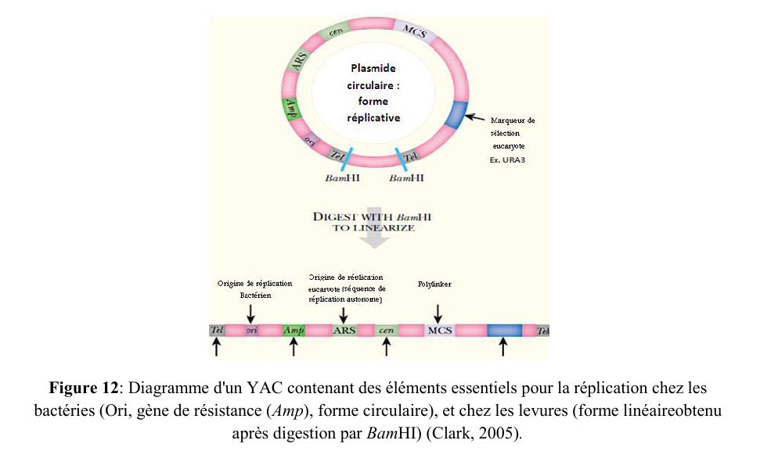
They can accommodate large DNA fragments (up to 400 kb). They are essential for analyzing large genomes (notably the human genome).
Note: To obtain large DNA fragments, rare-cutting restriction enzymes are used.
Disadvantage: Inserted fragments may sometimes undergo rearrangements (insertions, deletions); therefore, YACs cannot be considered completely representative of the original region introduced.

