TD N°4 OF GEOLOGY
Types of rocks

Exercise No. 1:
A rock is entirely crystallized; it is composed of 5 minerals A, B, C, D and E in the mass proportions of 25%, 45%.7%, 15% and 7% respectively. The chemical composition (in g.mol-1 of the molar mass of chemical elements) is given in the table below.
 | O | Si | Al | Mg | Fe | K | Ca | Na | H | F
Minéral A | 32 | 28 | 00 | 00 | 00 | 00 | 00 | 00 | 00 | 00
Minéral B | 128 | 84 | 27 | 00 | 00 | 39 | 00 | 00 | 00 | 00
Minéral C | 176 | 84 | 27 | 72,9 | 167,4 | 39 | 00 | 00 | 1 | 19
Minéral D | 128 | 56 | 52 | 00 | 00 | 00 | 40 | 23 | 00 | 00
Molar weight | 16 | 28 | 27 | 24,3 | 55,8 | 39 | 40 | 23 | 1 | 19

1°) Propose a name for each of the minerals A, B, C and D. knowing that mineral E is an amphibole.
2°) Assuming it is a magmatic rock, name that rock. (Use given diagram in progress)

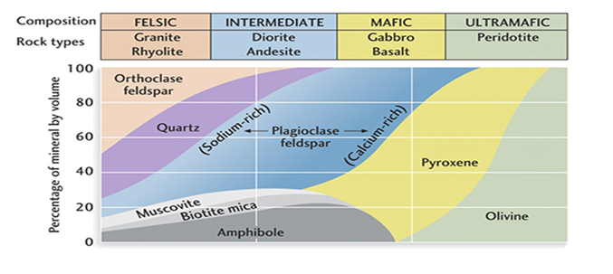Exercise no. 2
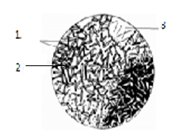

The figure above shows a thin section under a microscope of a magmatic rock.
- What is the type of this rock (from a formation point of view)?
- Determine its texture.
- Give the legend to the figure.
- Determine the cooling conditions to which it is subjected.
Exercise no. 3
Respond true or false to the following proposals and justify false responses
a) A loose rock is a rock composed of elements cemented together.
b) The sedimentation of particles depends on ly on their mass and size.
c) Substances dissolved in water can crystallize and give sedimentary rocks.
d) The compaction of a sediment is enough to transform it into coherent rock.
e) A carbonate rock is rich in carbon.
f) The glacier is a factor in sediment transport
Exercise no. 4
1- Cite the different factors of metamorphism.
2- Three types of pressure intervene in metamorphism, which ones?
3- What is the type of metamorphism that results from a granitic intrusion?
Exercise no. 5
Reproduce and complete the table using the appropriate words:
Protolith (parent rock) | Metamorphic rock obtained | Grad of metamorphic
Shale |  | Low grade
 | marble
Granulite |  | High grade

