Université Mohamed Khider -Biskra-
Faculté des Sciences Exactes et des SNV. Département des SNV
TD n° 4

Exercice 1 :

We are trying to determine the DNA sequence isolated from a transgenic monocotyledonous plant (Bt maize = maize resistant to the corn borer) using the Sanger method (see electrophoresis).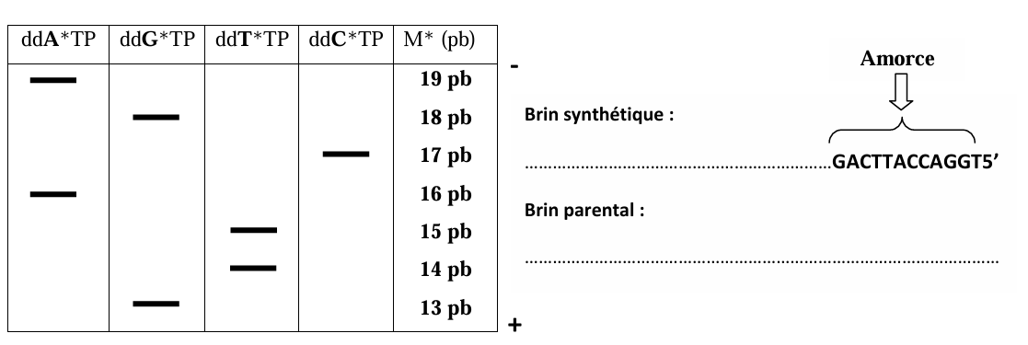

Determine the DNA sequence (the synthetic strand and the parental strand).

Exercice 2:

The DNA template to be sequenced has, at its 3′ end, an additional sequence on which the primer will hybridize, thus creating the initiation site for DNA polymerase.
Complete the table by indicating the composition of the different reaction mixtures and, for each mixture, the type and size of the newly synthesized fragments, knowing that ddATP is in mixture 1, ddGTP in mixture 2, ddCTP in mixture 3, and ddTTP in mixture 4, respectively.
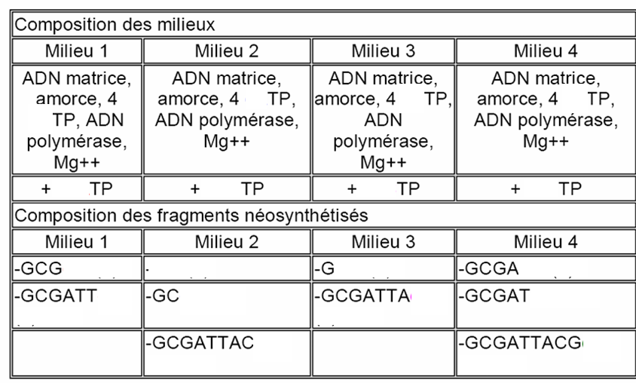

(2)
(1)

(10)
(6)
(5)
(8))
(9)
(4)
(3)
(7)

3 — On the gel below, indicate the size of the newly synthesized fragments in each reaction mixture (use the size scale shown on the left of the diagram).
4 — On the right, report the sequence of the synthesized strand and then the target sequence, indicating the reading direction of the determined sequences.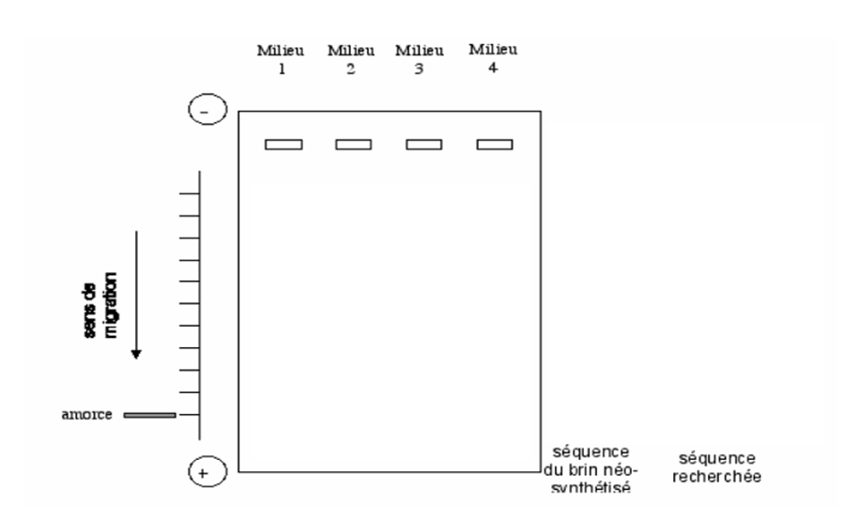

Exercice 3 :
A small DNA fragment was sequenced using the chain-termination method (Sanger method). Once the sequencing reaction is complete, the size of the obtained fragments is determined by chromatography. The automatic sequencer, equipped with a laser or infrared source that excites the fluorochromes attached to the ddNTPs, detects the fluorescence emitted from the chromatography columns, thereby identifying the DNA fragments and their precise size. The result is presented as curves showing the detected fluorescence, which are then interpreted in terms of nucleotides.
Provide the DNA sequence (the arrow in the diagram indicates the direction of migration).

