In Vitro Amplification of Nucleic Acids: PCR and RT-PCR
Historical Background:
This molecular biology method was developed in 1985 by Kary Mullis, who received the Nobel Prize in Chemistry in 1993 for this work. Today, this revolutionary technique, combined with the use of a thermostable DNA polymerase, makes it possible to obtain a considerable amplification of a given DNA fragment without cloning.

2. Principle
PCR (Polymerase Chain Reaction) allows the in vitro amplification of a specific region of a given nucleic acid in order to obtain sufficient quantity for detection and analysis. This is achieved through repeated cycles of reactions that replicate a double-stranded DNA template. During PCR, the products generated at the end of each cycle serve as templates for the following cycle, leading to an exponential amplification.
To replicate double-stranded DNA, three main steps are required:
- Denaturation: The DNA is denatured to obtain single-stranded templates.
- Annealing: Specific oligonucleotide primers bind to the target sequence, defining and initiating replication.
- Extension: The complementary strand is synthesized. At the end of each cycle, the products are double-stranded DNA.
These three steps, which constitute one PCR cycle, are performed at different temperatures to control enzymatic activity. To achieve the required temperature transitions, microtubes containing the reaction mixture are placed in a programmable device called a thermocycler. This instrument exposes tubes to defined temperatures for durations chosen by the experimenter.
PCR is extremely rapid and typically lasts only a few hours (2–3 hours for a 30-cycle PCR).

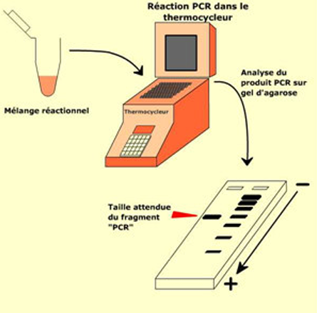

Figure 1: Réaction d’amplification d’ADN dans le thermocycleur et visualisation du produit de PCR par électrophorèse.

3. Primers
In setting up the PCR reaction, choosing the primers is crucial. They play a dual role: by hybridizing to the template DNA, they delimit the region to be amplified (step 2 of the cycle), and their free 3'-OH ends serve as initiation points for DNA polymerase (step 3 of the cycle). The oligonucleotide primers hybridize to the ends of the sequence to be amplified; therefore, the nucleotide sequences of the ends of the target DNA region must be known. It is at these ends that the primers will hybridize. To facilitate primer selection, sequence-analysis software can be used to check the following:
• Similar melting temperatures (Tm): The primers must hybridize to the template under the same temperature conditions.
• Non-complementary sequences: The primers should not be complementary to each other. Review the other criteria for primer selection in the course
Once selected, the two oligonucleotides (around 20 bases long) can be chemically synthesized. Chemical DNA synthesis produces oligonucleotides whose 5' ends are not phosphorylated (5'-OH), unlike natural DNA. Therefore, all PCR-amplified DNA fragments lack 5'-phosphate groups.

4. Temperatures
The three steps that constitute a PCR cycle are carried out at different temperatures to control enzymatic activity:
• Denaturation step: about 95°C, allowing complete separation of the two DNA strands.
• Annealing step: at a temperature defined according to primer properties (generally 50–60°C). This temperature determines the stability of the hybrids once primer-template pairing has occurred.
• Extension step: about 72°C, the optimal "working" temperature of the thermostable DNA polymerase used. During this step, complementary DNA strands are synthesized from the free 3'-OH ends of the annealed primers.
The denaturation and extension temperatures are fixed; only the annealing temperature must be calculated for each new PCR. The annealing temperature depends on primer base composition and is slightly lower (≈5°C) than the melting temperature (Tm), which is the half-denaturation temperature. For oligonucleotides shorter than 30 nucleotides, Tm is calculated using the following equation:
Tm = 2(A + T) + 4(G + C)
(where A, T, G, and C represent the number of each base in the oligonucleotide).

5. Template DNA
In theory, a single DNA copy of the target sequence is sufficient for amplification; however, the probability of encounters between template molecules and primers must be considered. In practice, multiple copies are required to obtain reliable results. However, poor DNA quality and/or excessive amounts of template may lead to nonspecific amplification or even enzyme inhibition. Such inhibition may result from contaminants from the sample or from reagents used during DNA extraction.

6. DNA Polymerase
The first DNA polymerases used were obtained from thermophilic bacteria (resistant to very high temperatures), such as Thermus aquaticus (Taq polymerase). Today, the enzymes used are recombinant, simplifying their production, and their properties have been largely modified to improve efficiency and fidelity.

7. Buffer
The buffer used in PCR maintains the pH of the reaction mixture at the optimal level for Taq polymerase (Tris-HCl, basic pH 8.5–9). It contains divalent cations (Mg²⁺), which are essential cofactors for polymerization by Taq polymerase. The presence of divalent cations (Mg²⁺) and monovalent cations (K⁺ or NH₄⁺) in the reaction stabilizes DNA/DNA hybrids by neutralizing the negative charges of phosphate groups in DNA.
In practice, the salt concentration must remain compatible with DNA polymerase activity.

8. Quantitative Aspects of PCR
The number of cycles is defined by the experimenter according to the desired amplification yield; in most cases, this number is about 30. In theory (and only in theory!), the amplification factor is on the order of 2³⁰, approximately one billion. In practice, experimental conditions change throughout the cycles, affecting polymerization efficiency. With 30–40 cycles, a realistic amplification factor is between 10⁵ and 10⁶.
