Université Mohamed Khider -Biskra-
Faculté des Sciences Exactes et des SNV. Département des SNV
TD n° 3

Exercice 1 :
Genomic clones of the cDNA of a phosphatase enzyme were isolated.
The cDNA fragment was removed from the plasmid and its ends were labeled with P-32.
It was then digested with restriction enzymes. The analyses produced the following results.
Determine the restriction map of this cDNA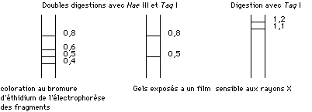
Exercice 2 :
You have two probes: a 250-bp probe X and a 200-bp probe Y. For each of these probes, several Southern blots are performed:
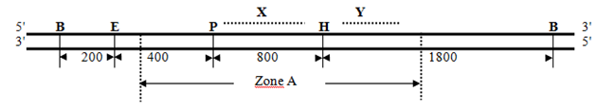

Les distances ci-dessus sont exprimées en pb, B : site de restriction BamHI; E : site de restriction EcoRI; H : site de
restriction HindIII; P : site de restriction PstI
1. What result(s) should you obtain when digesting the DNA simultaneously with the enzymes BamHI, HindIII and EcoRI while using probe X, and simultaneously with the enzymes BamHI, HindIII and EcoRI while using probe Y?
2. Draw a probe that would allow you to visualize the fragments of region A after enzymatic digestion by the 3 enzymes (BamHI, HindIII and EcoRI) simultaneously.
Exercise 3 You are working on the analysis of a gene responsible for a genetic disease.
This gene carries a point mutation that affects a restriction site.
- The target gene is 1200 bp long.
- Normal restriction site (R1): An EcoRI site located at position 600 bp.
- Mutant restriction site (R2): A HindIII site located at position 650 bp (the mutation replaces the EcoRI site with a HindIII site).
Probe A: Probe A is a 250-bp sequence located around the EcoRI site (between 500 bp and 750 bp).
Probe B: Probe B is a 200-bp sequence located around the HindIII site (between 600 bp and 800 bp).
Questions:
- After digesting the DNA with EcoRI and using probe A, what should you observe for a normal individual and for an individual carrying the mutation?
- After digesting the DNA with HindIII and using probe B, what should you observe for a normal individual and for an individual carrying the mutation?

