Ministry of Higher Education and Scientific Research
University of Mohamed Khider Biskra
Chemistry 1
Practical work N°:01
Laboratory glassware

I. INSTRUCTIONS OF SECURITY IN THE LABORATORIES

The practices outlined below are designated to guide you in developing efficient laboratory techniques and to make your laboratory a pleasant place to work. You should follow the practices listed below:
- Wear safety glasses, lab coat and shoes while working in the laboratory.
- Check and read the label of the reagent bottle carefully before using its content.
- Read procedures and precautions carefully and follow them.
- It is a bad practice to leave the reagent bottles on the working table. Put the stoppers properly on the bottles and keep them on the shelf immediately after use.
- If a reagent bottle on your seat is empty, ask the laboratory attendant to fill it.
- If you require a reagent from the bottle kept on side shelf, take the test tube or the beaker to the shelf. Do not bring the bottle to your seat.
- Avoid using excessive amounts of reagents unless you are advised to do so.
- Never return unused chemicals to the stock bottles. If you commit a mistake in putting the material back into the correct bottle, experiments of other students will be spoiled.
- Never mix the chemicals unless it is required in the experiment. Failure in following this rule may result in serious accidents.
- Use only properly cleaned droppers, spatulas or pipettes etc. to take out the reagents from the stock solutions and reagent bottles.
- Do not keep the stopper of the bottle on the table. Impurities may stick to it and the content of the bottle may be contaminated. Whenever you require a chemical from the reagent bottle, pick up the bottle with one hand and remove or replace the stopper with the other hand and keep it on a clean glazed tile. To take out dry solid reagents use spatula and keep it on watch glass, never use filter papers. Do not keep the reagent on your palm or touch it with your fingers.
- Never throw used match sticks, litmus papers, broken glass apparatus, filter papers or any other insoluble solid material into the sink or on the floor. Dispose them off in the waste bin provided at your seat. Only waste liquids should be thrown in the sink while keeping the tap water running so that nothing stinks and sticks and the waste liquid is drained completely.
- Do not waste water or gas. Close the taps whenever they are not in use. Do not leave the lighted burner under the wire gauze when nothing is being heated. Extinguish it.
- Hot apparatus should not be placed on working table directly because it may spoil the working table. Place it on a glazed tile or wire gauze.
- Do not heat the apparatus which is made of thick glass, e.g., graduated cylinder, bottles, measuring flasks etc., as these break on heating. Also heating distorts the glass and calibrations on the measuring apparatus may become invalid. Test tubes may break if they are heated above the level of the liquid filled in them. Crucibles may be heated to red-hot.
Clean every piece of apparatus as soon as the work is finished and keep these at proper place. A dirty seat and apparatus indicate careless habit and it hinders successful performance of the experiment.
- Use fume cupboard for performing experiments in which poisonous and irritating fumes are evolved.
- Keep the doors and windows open and the exhaust fan on while working in the laboratory, so that poisonous vapours are quickly sucked out and flow of fresh air is facilitated.

BASIC LABORATORY EQUIPMENT:
Heating, filtration, decantation, measuring volumes and weighing solids and liquids are some of the basic laboratory procedures, which are required frequently during the experimentations in the chemistry laboratory. Some of the specific equipment required for this purpose are shown in Fig. 1. You will learn about the use of these while performing experiments.

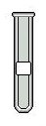 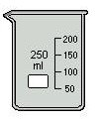 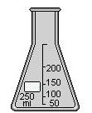 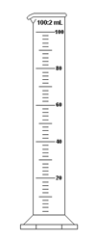 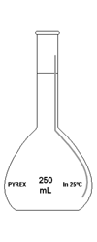 Test tube Beaker Erlenmeyer flask Graduated cylinder Volumetric flask

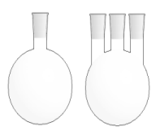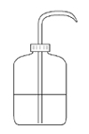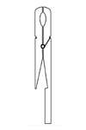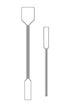
Round-bottom flasks Wash Bottle Glass Crystallizer Tong Spatula

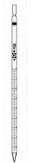 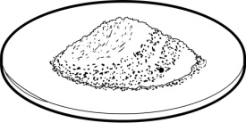 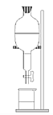 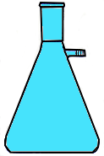 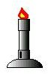 Graduated pipette Watch glass Separatory funnel Buchner flask Bunsen burner

Fig. 1 : Common laboratory glass apparatus

