CHAP. 5 IGNEOUS ROCKS

INTRODUCTION:
Igneous rocks (from the Latin ignis, meaning “fire”) form by crystallization from magma.
A magma is a mixture of crystals in varying proportions, melting at high temperatures (600°c – 1500°c) which gives rocks by solidification (when cooled to different depths (slow: intrusive or plutonic rocks and fast: extrusive or volcanic rocks).
- PROPERTIES AND BEHAVIOR OF MAGMA
Either primary magma (mantle) or anatexis magma (melting of pre-existing rocks) or both. According to their chimism. We distinguish
- Granitic magma: acid or saturated because rich in SiO₂ formed around 20 - 30 km below the continents, of high viscosity, and giving mainly plutonic masses (batholiths).
- Basaltic magma: basic and under-saturated because poor in SiO₂ formed at 40 km or more below the continents, and at 10km under the oceans, of low viscosity, and giving above all effusive rocks.
- ENVIRONMENTS OF MAGMA FORMATION
Magma forms in three tectonic environments:
Spreading centers (mid-oceanic ridge), mantle plumes (hot spot) , and subduction zones.
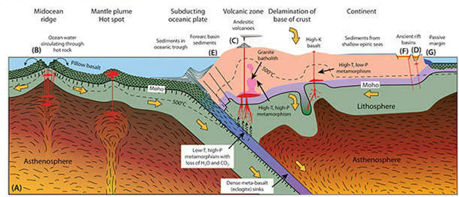

- PROCESSES THAT FORM MAGMA:
Three different processes melt the asthenosphere: rising temperature, decreasing pressure, and addition of water
- PROCESSES THAT FORM CRYSTALLS:
To crystallize magma: cool the liquid or increase pressure or remove water to raise the melting point
- Experimental
One of the most important aspects of the formation of igneous rock is that different minerals crystallize at different temperatures.

Case of minerals forming an isomorphic series;
Isomorphs are crystals that have the same crystal structure, but different chemical composition.
Example of plagioclases: Na (AlSi₃O₈) Albite – Ca (Al₂ Si₂ O₈) Anorthite.
Either a liquid mixture of composition A that cools, the first minerals appear when the temperature T reaches T1 (we cut the liquidus) the minerals that form have the composition B (given by the projection of point B1, where the T cuts the solidus), they are enriched in anorthite with respect to the initial liquid, these minerals isolate from a liquid which contains more and more albite, this liquid cools down following the liquidus curve (path A1 C1). The last crystals formed have exactly the composition of the original mixture.
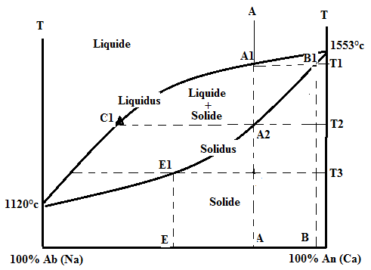

- BOWEN’S REACTION SERIES
Bowen has generalized this type of experiments on complex compounds and defined areas of mineral coexistence according to the temperature and composition of the initial magma.
Two reaction sequences account for the different phenomena.
The first one corresponds to mafic (ferromagnetic), it is discontinuous (we do not go directly from one mineral to another) because the crystal structures are different.
As magma cools to about 1500° C, the first minerals that begin to crystallize are olivine and calcium-rich feldspar; this is followed, in sequence, by the crystallization of minerals pyroxene, amphibole, biotite mica, potassium- and sodium rich feldspars, and muscovite mica. The last mineral to crystallize, at about 600°C, is quartz, solidifying any of the remaining silica.
The second reaction sequence corresponds to plagioclases. It forms a continuous series because the different plagioclases have the same crystal structure. Thus, during the temperature drop we have:
Anorthites (plagioclases rich in Ca) + bytownite liquid (plagioclases less rich in Ca but containing Na) + liquid and so on until the obtaining of the sodium pole, the albite.
The two series work together. Thus when plagioclase releases Ca and Al in the liquid to incorporate Na and Si, the Ca and Al ions back into the liquid are incorporated into the amphiboles and appear at similar temperatures in the ferromagnetian series.
These reaction mechanisms, associated with crystallization can explain the evolution of magmas. Thus, from a basaltic magma, under saturated in silica, one can arrive at a rhyolitic type magma rich in silica.

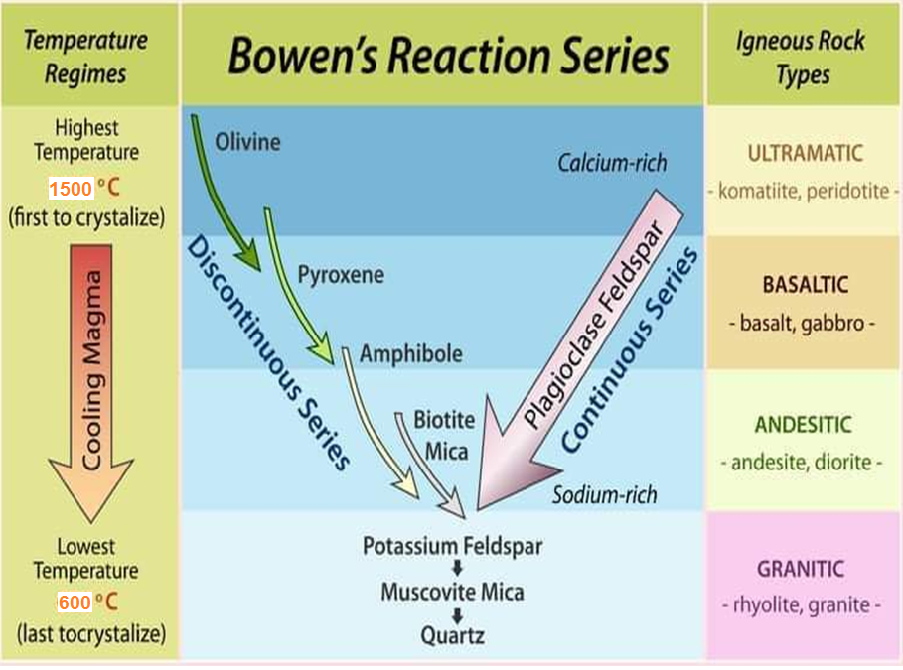

- TEXTURES OF IGNEOUS ROCKS
The texture of a rock refers to the size, shape, and arrangement of its mineral grains, or crystals as it can be studied at sample scale both with the naked eye and with an optical (polarizing) microscope..
The most common textures are:
a- Grained texture: it is a texture where the minerals are large enough to be visible to the naked eye. Their crystallization results from slow cooling, this texture is typical of plutonic rocks. Depending on the size we distinguish:
- Coarse grained texture: More than 5 millimeters).
- Fine grained Texture: Up to 1 millimeter.
- Pegmatitic texture: large crystals > cm (see more)
- Porphyroid texture: mixed cm + mm (Relatively large grains in a finer-grained matrix).

b- Micrograined texture: As in the previous textures, the mass is whole crystallized but the crystals are invisible to the naked eye (characterizes the rocks of veins).
c- Microlitic texture: in this structure, there are small crystals (microlites) elongated invisible to the naked eye in a vitreous amorphous paste that indicates rapid cooling; it is a texture of volcanic rocks.
d- Vitreous (or glassy) texture: rare entirely, or largely made of glass.
- CLASSIFICATION OF IGNEOUS ROCKS
Several approaches are possible to classify magmatic rocks, the approach based on mineralogical composition is the easiest to use. It is interested in:
- The cardinal (or essential) minerals that allow specifying lithological types are: quartz, feldspar K, plagioclases, muscovite, biotite, olivines, pyroxenes and amphiboles.
- Acidity according to the SiO₂ content is divided into: acid rocks (SiO₂ > 65%), intermediate rocks (52% < SiO2 < 65%), basic rocks (45% < SiO₂ < 52%) and ultra-basic rocks (SiO₂ < 45%).
- At saturation, it takes into account the mineralogical expression of SiO₂ richness. Thus a quartz rock is said to be supersaturated (meaning silica), a rock without quartz or feldspar is under-saturated (minerals poor in Si).
- At alkalinity, a rock is said to be alkaline if it contains sodium-potassium feldspar K (Si₃ AlO₈) orthoclase, Na (Si₃ AlO₈) albite, or calco-alkaline rock if it contains in addition of the previous minerals plagioclases (sodi-calcic feldspar) from the Na (Si₃ AlO₈) albite to the anorthite Ca(Si₂Al₂O₈) and calci-sodic rock if the feldspar fraction is formed only of plagioclases.
- The colouring according to the percentage of ferromagnetic minerals (black minerals) (mainly micas biotite, amphiboles, pyroxenes, peridots or olivines) is then:

- COMMON IGNEOUS ROCKS

Descriptive  Terms | Felsic  (granitic) | Intermediate  (andesitic) | Mafic  (basaltic) | Ultramafic
Intrusive  Extrusive | Granite  Rhyolite | Diorite  Andesite | Gabbro  Basalt | Peridotite
Major  minerals | Quartz  Potassium feldspar  Sodium feldspar  (plagioclase) | Amphibole  Intermediate  plagioclase  feldspar | Calcium feldspar  (plagioclase)  Pyroxene | Olivine  Pyroxene
Minor  minerals | Muscovite  Biotite  Amphibole | Pyroxene | Olivine  Amphibole | Calcium feldspar  (plagioclase)
Most common  color | Light colored | Medium gray or  medium green | Dark gray to  black | Very dark green  to black
Composition | Silica 72%  Aluminum oxide 14%  Iron oxides 3%  Magnesium oxide 1%  Other 10% | Silica 59%  Aluminum oxide 17%  Iron oxides 8%  Magnesium oxide 3%  Other 13% | Silica 50%  Aluminum oxide 16%  Iron oxides 11%  Magnesium oxide 7%  Other 16% | Silica 45%  Aluminum oxide 4%  Iron oxides 12%  Magnesium oxide31%  Other 8%

