Execise 1:
Tetrahedron (SiO4)⁴ ⁻ is the common elemental motif for all silicate crystals and silica.
The classification is based on possible links between Tetrahedron or between Tetrahedron and cations ensuring neutrality and cohesion.
The pooling of a variable number of oxygen between neighbouring tetrahedrons distinguishes:
Assembly diagram | Nb of O in commun | Description | Formula (no cations) | Name | Examples
Figure 1 | ? | Tetrahedrons isolated | (SiO4)⁴⁻ | Nesosilicates | ?
Figure 2 | ? | Simple chain | ? | ? | ?
Figure 3 | 2 ou 3 | double Chaîns | (Si4O11) ⁶⁻ | ? | Amphiboles
Figure 4 | 3 | sheets | ? | ? | ?
Figure 5 | ? | Tridimensional | (SiO₂) | Tectosilicates | ?
N.B: Al³⁺ can replace Si⁴⁺ within the tetrahedron (similar dimension).
Study the table above and the diagrams below to relate information and figures then:
1- Fill in the free boxes of the table.
2- Number from 1 to 5 the figures below illustrating the tetrahedron associations of different minerals.
3- Circle the figures with the sector taken into account in order to establish the chemical formula of the table.
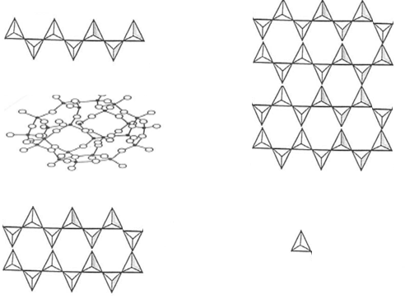

Execise 2:
Feldspars are a family of tectosilicates minerals.
Knowing that the structural formula of tectosilicates must be multiplied by 4, give the formula of:
- Albite = feldspar with an aluminum atom and sodium
- Anorthite = feldspar with two aluminum and calcium atoms
- Orthoclase = feldspar with an aluminum atom and potassium
- How many isomorphic series exist between these three feldspars? Which ones?
Exercise3:
a. Find the basic formula for Cordierite, knowing that:
- Cyclosilicate with a 6-tetrahedrons base motif
- In one of the tetrahedron, silicon has been replaced by aluminum
- The cations entering the structure are: 4 atoms of aluminum in total, and a certain amount of iron and magnesium
b. Find the basic formula of the Diopside, knowing that it is a single chain inosilicate with as much Mg as Ca.
Exercice4:
Consider the Fayalite with chemical formula Fe₂ SiO₄, and the Forstérite, with chemical formula Mg₂ SiO₄
a. In these minerals, the substitution of Mg by Fe possible? Justify your answer.
b. During substitution, minerals with the chemical formula (Fe, Mg) ₂ SiO₄ are formed.
1- What is the name of this mineral family?
2- How are the terms between Fayalite and Forsterite defined?
c. Knowing that these minerals crystallize in the same crystal system, how is such a family of compounds designated?

