Université Mohamed Khider -Biskra-
Faculté des Sciences de la nature et de vie et science de la terre et de l’univers SNVSTU. Département des SNV
TD 2 Enzymes de restriction

Exercice 1:
The sequence of a double-stranded DNA corresponding to a gene is partially shown below.
5’ ATACGGGATCCGAGCTCTCGATCGTCTGCAGAAATTCC 3’
1. Write the sequence and orientation of the second strand of this fragment.
2. Let the restriction enzymes be BamH I, Pst I, Xho I et Mbo I , whose recognition sites are :
BamH I : 5' G/GATCC 3' ; Pst I : 5' CTGCA/G 3' ; Xho I : 5' C/TCGAG 3' ; Mbo I : 5' C/GATC 3'.
- Copy the DNA sequence and mark the restriction sites, indicating the positions of the cuts.
B. For each enzyme, write the sequences of the ends of the digested DNA molecules and specify the type of ends obtained ?
C. Here is the sequence of a primer : 5’ - TTTCTGCA- 3’
Where will this primer bind on the DNA sequence? What sequence will be obtained after elongation by DNA polymerase?
Exercice 2 :
The digestion products of a DNA molecule by a restriction enzyme consist of the following fragments:
- Fragment 1 : 100 kpb
- Fragment 2 : 800 kpb
- Fragment 3 : 400 kpb
- Fragment 4 : 150 kpb
1. Represent schematically the profile of this molecule after migration on an agarose gel.
2.What is the total length of the initial DNA molecule?
3.How many restriction enzyme cutting sites does it have on the DNA molecule?
4.Propose a restriction map of this DNA molecule.
Exercice 3:
Consider a linear DNA molecule:
NNNNNNNNNNNNACGCCAAGCTTGGCTGCANNNNNNNNNNNN
NNNNNNNNNNNNTGCGGTTCGAACCGACGTNNNNNNNNNNNN
Knowing that the recognition and cutting sites of:
- NcoI: cuts between the two cytosines in CCATGG
- HindIII: cuts between the two adenines in AAGCTT
Give the results of the following experiments, indicating the sequences of the ends:
Digestion with NcoI
Digestion with HindIII
Digestion with HindIII+Nucléase S1
Digestion with HindIII+S1+ADN ligase
Digestion with HindIII+S1+ADN ligase ensuite +hindIII
Digestion with HindIII+S1+ADN ligase ensuite +Ncol

Exercice 4:
A restriction digestion is performed on a circular plasmid DNA using two restriction enzymes: PstI and EcoRI.
The electrophoretic profile obtained is as follows: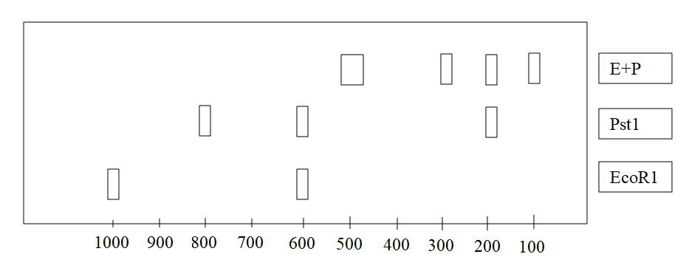
Pb
Q1: Determine the sizes of the observed restriction fragments.
A restriction map shows the positions of the restriction sites of an enzyme on the digested DNA sequence. The EcoRI restriction map of the plasmid DNA is shown below.

Q2: Construct a possible map for PstI, then the map obtained by the action of both restriction enzymes.

E
E
600

EcoR1

1000

