Molecular Biology
Chapter II: Regulation of Gene Expression
1 . Transcriptional Regulation in Prokaryotes
The expression of a gene can be regulated at several stages, the most common being the initiation of transcription. There are two main reasons for this:
- The energy and resource cost required for transcription.
- Regulation at the initiation step is the easiest to achieve.
This regulation is often controlled by extracellular signals; in bacteria, these signals are provided by molecules present in the environment. They are then transmitted to the genes through regulatory proteins. These regulatory proteins control the access of RNA polymerase to the bacterial DNA promoters (they control the rate of transcription).
Thus, these proteins help cells evaluate their environment. The genes encoding these proteins are called regulatory genes.
There are two types of regulatory proteins:
- Activators (positive regulators): increase the transcription of a gene.
- Repressors (negative regulators): decrease or block its transcription.

2. Negative Control of Transcription — “Repression and Induction”
In bacteria, an operon is a group of genes transcribed into a single polycistronic mRNA under the control of a single promoter. The genes of a given operon are subject to coordinated control, making this system remarkably economical.
The most studied example of this type of regulation is the control of the lactose operon (lac operon) in E. coli. Historically, genetic analysis of bacterial mutants has made it possible to identify all the regulatory elements of lactose metabolism (a disaccharide found in mammalian milk), particularly through the pioneering research of François Jacob and Jacques Monod in the late 1950s.

3 .Regulation of Expression of the lacZYA Operon
When E. coli is grown in a culture medium where lactose is the only carbon source, the cellular concentration of three proteins increases:
- β-galactosidase: an enzyme that hydrolyzes lactose into glucose and galactose.
- Permease: an inner membrane protein that allows the absorption of lactose.
- Transacetylase: its exact role in lactose metabolism remains unclear.
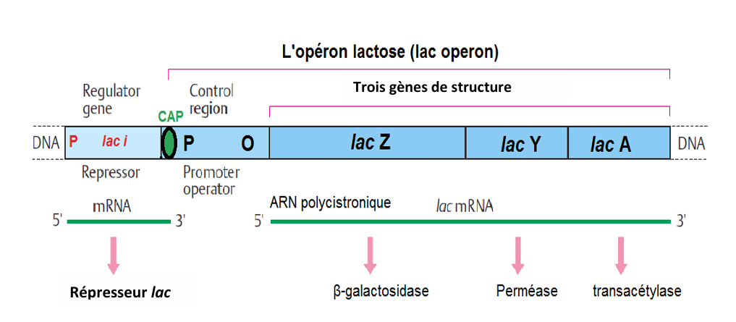
Fig.1: Organization of the E. coli Lactose Operon (Passarge, 2007).
The lac Operon Genes are Highly Expressed Only in the Presence of Lactose and the Absence of Glucose (the Preferred Carbon and Energy Source)
Two regulatory proteins are involved in this control:
- An activator called CAP (Catabolite Activator Protein), also known as CRP (cAMP Receptor Protein).
CAP binds to a specific DNA site called the CAP site.
- The lac repressor, encoded by the lacI gene, binds to the operator region of the operon.
Each of these regulatory proteins responds to a specific environmental signal and communicates it to the lac genes:
- CAP/CRP conveys the glucose signal.
- The lac repressor conveys the lactose signal.
- Catabolite Repression
The inhibition of lac operon expression in the presence of glucose or any other readily metabolizable carbon and energy source is known as catabolite repression.
- Positive Control by the CAP–cAMP Complex
The binding of RNA polymerase to the promoter must be stimulated by a specific activator protein, known as the cAMP Receptor Protein (CRP) or Catabolite Activator Protein (CAP) — this is called positive control.
- In the absence of glucose, the level of cAMP (cyclic AMP, synthesized from ATP by adenylate cyclase) increases.
- cAMP then binds to the CRP protein, forming the CRP–cAMP complex.
- This complex binds to the CAP site upstream of the promoter.
When bound, facilitating the binding of the RNA polymerase (trans-acting elements) to the promoter (cis elements), thus increasing the transcription
- Induction by Lactose (Allolactose)
In the absence of glucose and the presence of lactose, a derivative of lactose called allolactose (β-D-galactopyranosyl–(1-6)-β-glucopyranose) is formed by a transglycosylation reaction from lactose (β-1,4 bond).
- Allolactose acts as an inducer molecule.
- It binds to the lac repressor and inactivates it.
- The inactivated repressor can no longer bind to the operator sequence.
This allows the RNA polymerase, activated by the CRP–cAMP complex, to initiate transcription of the lacZYA genes at a high rate.
- Global Gene Regulation
The CAP (or CRP)–cAMP complex represents a typical example of global regulation of gene expression in bacteria.
This mechanism allows the cell to conserve energy and resources by prioritizing the use of the most efficient carbon source available.
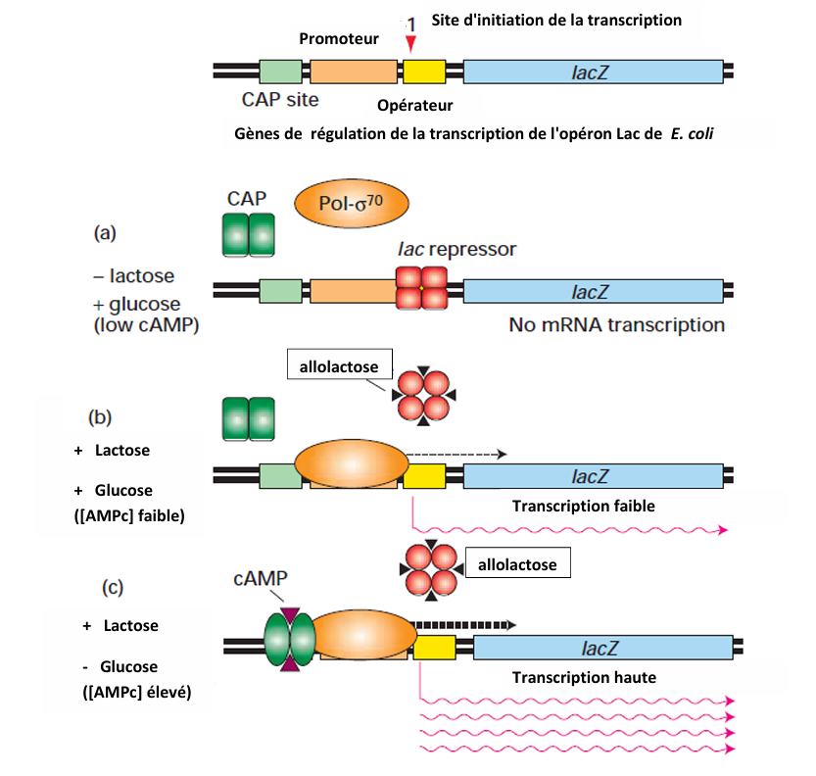
Fig.2: Expression des gènes lac en présence/absence du glucose et le lactose. Quand le répresseur Lac est lié sur l'opérateur, il exclut la polymérase, que CAP soit présente ou non. CAP recrute la polymérase sur le promoteur lac où elle s'isomérise spontanément en complexe ouvert. L'allolactose (inducteur) résulte d'une transglycosylation du lactose (Lodish et al., 2003).
4. Regulation of Expression of the argCBH Operon:
Another example of gene expression regulation through repression and induction mechanisms is the control of arginine biosynthesis.
In this system, the expression of genes involved in the synthesis of arginine, an amino acid, is repressed when arginine is abundant in the cell, and induced (activated) when arginine levels are low.
Thus, the argCBH operon serves as a model for negative feedback regulation, where the end product of the biosynthetic pathway (arginine) acts as a corepressor to inhibit the transcription of its own biosynthetic genes.
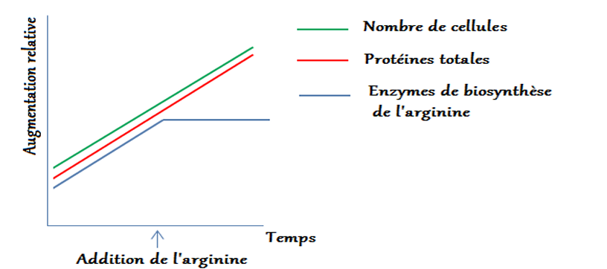
Fig.3: Effet de l'addition de l'arginine dans un milieu de culture dépourvu de l'arginine et ensemencé par E. coli.
The addition of arginine to the culture medium inhibits (blocks) the production of enzymes involved in arginine biosynthesis.
No effect is observed on cell growth or on the total protein concentration.
Transcription of the operon occurs only when the repressor cannot bind to the operator.
When a small molecule, called a corepressor—in this case, arginine—binds to the repressor, the resulting repressor–corepressor complex attaches to the operator region and blocks transcription of the argCBH operon.
Thus, arginine acts as a corepressor, ensuring that the biosynthetic enzymes are produced only when arginine is scarce, preventing unnecessary energy expenditure.
.
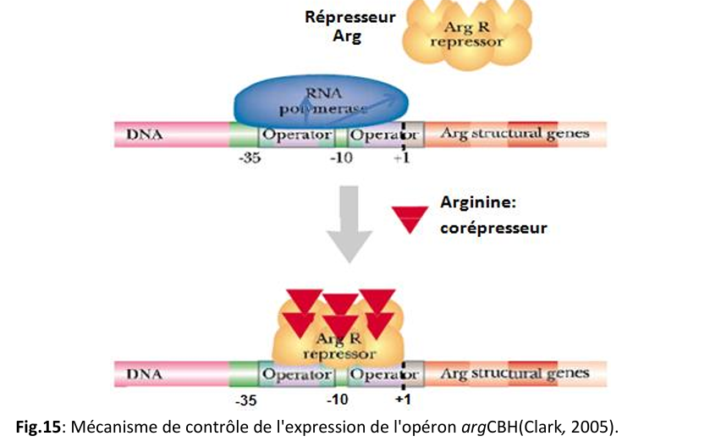
4
Control of Gene Expression by Attenuation
Attenuation is a mechanism of gene regulation that depends on the fact that transcription and translation are tightly coupled in prokaryotes.
In E. coli, the biosynthetic operons of amino acids (for example, the tryptophan operon) are controlled by this mechanism.
The trp operon consists of five adjacent genes encoding the enzymes required for tryptophan biosynthesis. These genes are regulated by a repressor and are expressed only when tryptophan levels are low (the absence of tryptophan lifts the repression).
The attenuation mechanism controls whether a full-length mRNA is transcribed or not.
- When tryptophan levels are high, most transcripts are terminated prematurely (incomplete mRNAs are produced).
- When tryptophan levels are low, RNA polymerase transcribes the entire set of genes, allowing full synthesis of the enzymes.

Attenuation in Other Amino Acid Operons
This type of regulation is also observed in at least six other operons involved in amino acid biosynthesis, such as:
- Thr (threonine)
- His (histidine)
- Phe (phenylalanine)
The leader peptides of these operons contain in their sequences several repeats of the corresponding amino acid:
- 8 threonines in the thr operon,
- 7 histidines in the his operon,
- 7 phenylalanines in the phe operon.
These leader peptides act as sensors of the intracellular concentration of the amino acid.
- Differences Among Amino Acid Operons
Not all amino acid biosynthetic operons share the same combination of regulatory mechanisms as the trp operon.
For example:
- In the his operon, attenuation is the only control mechanism (there is no operator–repressor system).
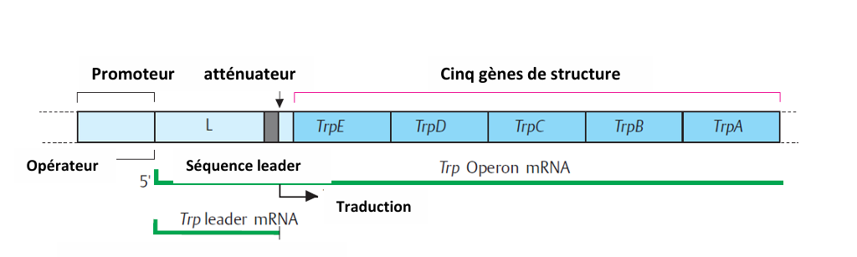
Fig.5: L'opéron tryptophane chez E. coli(Lodish et al., 2003).

- Detection of quorum (Quorum Sensing: QS)
Quorum sensing is a widespread signaling mechanism among Gram-negative bacteria. This type of communication was first observed in Vibrio fischeri, a bioluminescent bacterium.
It is based on the production of small signaling molecules called autoinducers. When a threshold concentration of these molecules is reached, they interact with a transcriptional regulator, leading to the specific expression of a set of genes.
One of the best-studied autoinducers is N-acyl homoserine lactone (AHL).
- Mechanism of Quorum Sensing
A bacterium capable of quorum sensing transcribes and translates the genes encoding the enzyme acyl homoserine lactone synthase at basal levels.
As the population density increases, the concentration of AHL in the environment rises. Once it reaches a critical threshold, AHL binds to a regulatory protein (activator or inducer).
The resulting AHL–protein complex then activates transcription of genes involved in quorum-dependent functions.
- Examples of Quorum Sensing
One of the best-studied examples of quorum sensing is found in Pseudomonas aeruginosa, where this mechanism controls:
- Biofilm formation, a multicellular structure that protects bacteria.
- Regulation of virulence factor production, which increases the pathogenicity of the organism and prevents antibiotic penetration.
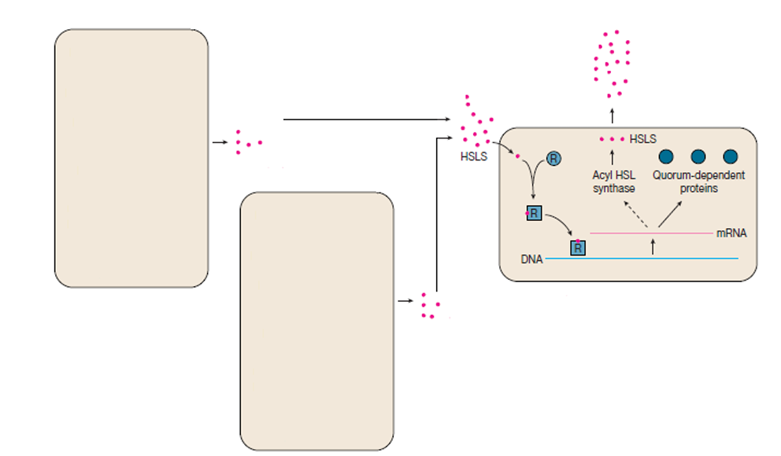
Fig.6: Détection de quorum (quorum sensing).Lorsqu'un seuil de concentration est atteint, ces molécules interagissent avec un régulateur transcriptionnel, permettant l'expression spécifique d'un groupe de gènes. R: protéine activatrice (inducteur) (Prescott, 2002).
- Regulatory RNAs and Riboswitches
In most cases of gene regulation, regulatory proteins play a key role. However, in this type of regulation, the key role is played by RNAs themselves.
This form of regulation is known in both prokaryotic and eukaryotic cells.
Experiments with E. coli have shown that small RNAs (sRNAs)—ranging from 40 to 400 nucleotides—participate in the regulation of various physiological functions of the bacterium by binding either to other RNAs or, in some cases, to small molecules.
These regulatory RNAs do not code for proteins, rRNAs, or tRNAs.

- Mechanisms of Action of Regulatory RNAs
There are three main mechanisms by which these molecules act:
- Participation in ribonucleoprotein complexes —
Some sRNAs become part of ribonucleoprotein particles (e.g., signal recognition particles) involved in identifying newly synthesized proteins destined for secretion.
- Base pairing with target mRNAs (antisense RNAs) —
Certain sRNAs base pair with specific regions of mRNAs (for example, near the Shine–Dalgarno (S/D) sequence).
  - This pairing can block translation.
  - It can also accelerate degradation of the mRNA by specific ribonucleases.
  - In this case, these sRNAs are called antisense RNAs.
- Riboswitches
Riboswitches are found in some bacteria, plants, and fungi.
They are a special type of sRNA—actually segments of mRNA that contain regulatory sequences located upstream of the coding region.
These regions can bind directly to small metabolites (without any protein intermediates).
Examples of biosynthetic pathways controlled by riboswitches include the synthesis of:
- Vitamins: thiamine (B₁), riboflavin (B₂), and cobalamin (B₁₂),
- Amino acids,
- Purine bases: adenine and guanine.

- Mechanism of Riboswitch Action
The molecule produced by the protein encoded by the riboswitch-containing mRNA can bind to a specific site within the riboswitch region.
This binding induces a conformational change—the formation of a secondary RNA structure—that can:
- Block transcription, or
- Prevent translation.
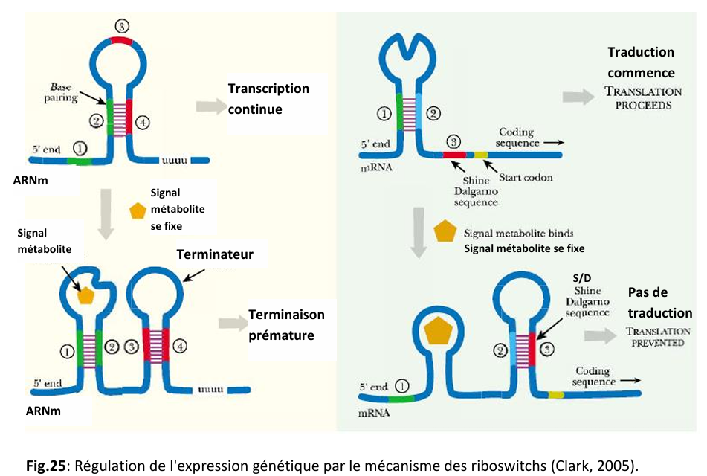
7

