Mohamed Khider University Biskra  Academic year 2025 –2026
Department of Medicine
First year Medicine

Practical work N°1
Determination of the molarity of an electrolytic solution by conductometric titration
I- Work objective
Measurement of the conductivity of some electrolytic solutions (distilled water, drinking water, rainwater, seawater).
- Conductimetric titration: Determination of the molarity of a solution of AgNO₃ by NaCl using the conductimeter.
II - Reminders on the Conductivity of Solutions
Conductivity is a quantity used to assess the ion concentration of a solution. Any charged species is capable of carrying an electric current within a solution. The current is carried by the movement of positive charges (cations) in the direction of the electric field, toward the negative pole. Anions (negative charges) flow in the opposite direction. The more mobile an ion is, the more it will contribute to current transport. The most mobile ions are (in S.cm².mol⁻¹): H⁺ (350), OH⁻ (150).
I.1 - Conductivity σ of an Ionic Solution
The conductance value G of an ionic solution depends on the nature of the solution and the geometry of the measuring cell. It can be determined by the relationship:

G = σ.S/l

where G is in Siemens (S), S is in m², l is in m, and σ is in Siemens per meter (S.m⁻¹). Furthermore, conductance is the inverse of resistance: G = 1/R where G is in Siemens (S) and R is in ohms (Ω). As a reminder, the resistance of a portion of parallelepiped-shaped electrolyte, located between the two electrodes (Fig. 1), has the same expression as that of a metallic conductor of cross-section S and length L:
R = r. (L/S)
where: ρ is the resistivity, L is the distance between the electrodes, and S is the cross-section of the electrodes.

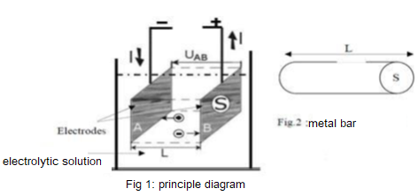

We using a simple cell, a UAB voltage generator, and an ammeter connected in series, we can deduce the conductance using Ohm's law:
U = R.I = I/G where: G = 1/R With U in volts (V), R in ohms (Ω), I in amperes (A), and G in siemens (S) or in Ω⁻¹.
We can also write: G = I/U The conductance depends on the two electrodes used for the measurement (the set of two electrodes is called a conductivity cell).
The larger the submerged surface area S of the electrodes and the smaller the distance L between them, the greater the conductance. We have the following relationship:
G = s (S/L)
Where s = 1/r, representing the conductivity of the solution.
Its unit is S.m⁻¹ (siemens per meter), with the surface area S in m2 and the distance L in m. The S/L ratio, called the "cell constant," can be determined by measuring the conductance of a standard solution.
Conductivity represents the ability of a solution to conduct an electric current. It does not depend on the measurement system used; it depends only on the characteristics of the solution (concentration, nature of the ions, and temperature). The conductivity of the solution is called σ (sigma). This quantity is characteristic of the solution.
It depends on:
- ion concentration
- the temperature of the solution.
A previously calibrated conductivity meter can directly display the conductivity value σ of the solution.
II.2 - Ionic molar conductivity λi
- Monocharged species
The conductivity value σ can be calculated from the ionic molar conductivities λi of the ions that make up this solution (see the table below for information purposes), as well as their concentration [Xi]: with σ in S.m⁻¹, λi in S.m².mol⁻¹, and [Xi] in mol.m⁻³.
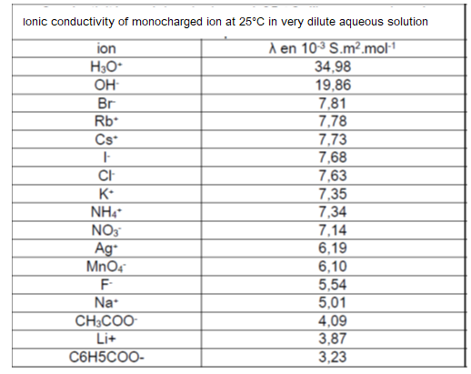
Table 1: Ionic molar conductivities at 25 °C of mono-charged ions
in very dilute aqueous solution.

It is noted that the H3O+ and OH- ions have, in aqueous solution, a higher ionic molar conductivity than the other ions. These two ions are derived from water, and their mobility in water is indeed very high. However, in the case of pure water, their concentration is very low (10⁻⁷ mol.L⁻¹) and their contribution is therefore negligible: a pure water solution conducts electricity very poorly.
Example: The conductivity of a sodium chloride solution with a concentration of C = [Cl-] = [Na+] = 2.00 mol.m⁻³ is equal to:
σ = λ(Cl-).[Cl-] + λ(Na+).[Na+] And, σ = 7.63.10⁻³ x 2.00 + 5.01.10⁻³ x 2.00 = 2.53.10⁻² S.m^{-1.}
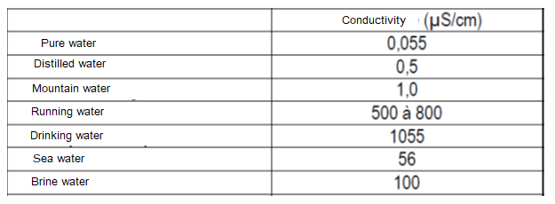

Table 2: Conductivity value for water
III - Application of Conductance or Conductivity Measurements
We propose to perform a conductometric titration of AgNO₃ with NaCl. We can, in fact, monitor the changes in the conductivity of the AgNO₃ electrolyte as the NaCl reagent is added. The chemical reaction proceeds according to the equation:

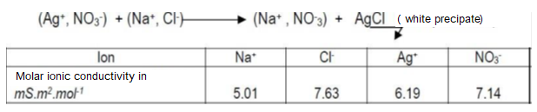
Table 3: Molar conductivity value of some ions

The overall balance shows that the Ag+ ions are replaced by Na+ ions. By comparing the molar conductivity of the ions (Table 3), we understand that the conductivity of the solution decreases as volumes of NaCl solution are added. Neutralization point:
The curve presents a sharp point at the moment of total neutralization of the Ag+ ions by the Cl⁻ ions. At this point, the number of moles of Cl⁻ ( = N1. V1) contained in the volume V1 of NaCl added is equal to the number of moles of Ag+ (= N2.V2) contained in the initial volume V₂ of AgNO₃.
This is expressed by the following relationship: N1. V1 = N2. V2 Where: N1 = Molarity of NaCl (known) V1 = Volume of NaCl added to achieve total neutralization (unknown)
N2 = Molarity of AgNO₃ (unknown). V2 = Volume of the AgNO₃ solution (known)
Once precipitation is complete (complete neutralization), the conductivity begins to increase as NaCl is added, because the Cl- ions will remain free (due to the absence of Ag+ ions) in the solution. This consequently increases the number of ions in the solution and the conductivity. Knowing the volume V1, the molarity of NaCl, and determining the volume V₂ of NaCl (taken from the neutralization point) then allows us to calculate the molarity of AgNO₃.

IV – Experiment: Titration of an electrolytic solution using conductimetry.
- Conductivity measurement
· The conductivity of a solution is linearly related to the concentrations of the ions in solution. That is, the conductance depends directly on the ions. Conductimetry can, in principle, determine the concentrations of the elements that make up the solution. In our lab, we will monitor the variation in conductivity during a titration.
The titrant can be introduced using a burette. Before measuring the conductivity of an electrolytic solution, the instrument must first be calibrated using a standard solution with a known conductivity value. - Determining the molarity of an electrolytic solution by conductometric titration (Fig. 3) Immerse the conductivity probe into the sample to be measured, ensuring that the holes are submerged. Gently tap the probe on the bottom of the beaker to remove any air bubbles. Fig.3

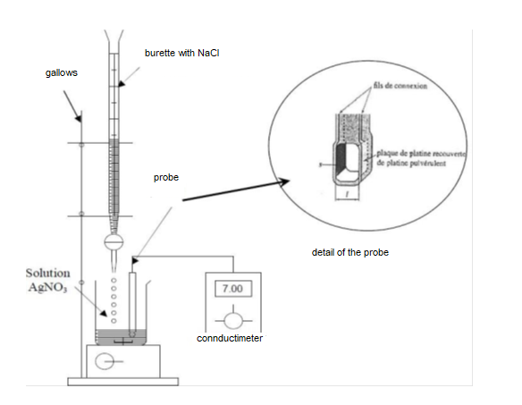

Fig. 3: Experimental setup

· Pour 30 ml of AgNO₃ solution into a beaker.
· Measure the conductance.
· Add 5 cm³ of NaCl.
· Measure the new conductance of the resulting mixture.
· Repeat the measurement by successively adding the quantities of NaCl indicated in the table below, remembering to rinse the probe between measurements.

Determination molarity of electrolytic solution using conductimetry titration in table 1and 2.

Solutions | Conductivity σ S/cm)
Distilled water
Drinking water
Sea water

Table 1

Volume AgNO₃ | Volume (cm³)  NaCl added | Conductivity σ S/cm)
20 ml | 0
/ | 5
/ | 10
/ | 15
/ | 20
/ | 25
/ | 30
Table 2

