TD N° 2 OF GEOLOGY
Crystallography and mineralogy
Exercise 1:
Which crystalline systems have equal horizontal axes?
What are the crystal systems that have all equal angles?
What are the crystal systems which have equal angles α and γ?
What is the system that has two right angles and the third not?
Exercise 2:
Define the following terms: center of symmetry, axis of symmetry, plane of symmetry.
What are the different axes of symmetry in the different crystalline systems? How are they named and how are they noted?

Exercise 3:

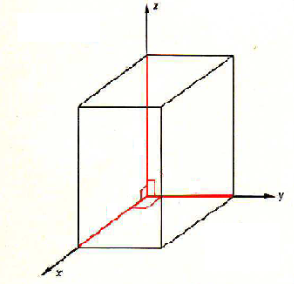
On the figure above determine the lengths a, b, c and angles α, β, γ what do you notice? What is the name of this system?
Knowing that this system has the following symmetry elements:
A center of symmetry, 1 axis of order 4 and 4 axes of order 2.
Represent these symmetry elements on the figure.
Exercise 4:
1- Why is the same mineral found in several colors?
2- What is used to obtain the true color of a mineral?
3- When we scratch one mineral against another, what property do we want to determine?
4- What minerals can a piece of glass scratch on the Mohs scale?
5- What are the minerals of the Mohs scale that the nail can scratch?
6- What is the mineralogical property of a mineral when it breaks according to a plan to determine?

