Translation
Genome Expression and Protein Synthesis
The expression of the genome results in the synthesis, within cells, of macromolecules – nucleic acids and proteins – whose primary structure is determined by that of DNA.
- This expression occurs through two main mechanisms:
— The primary structure of DNA is first expressed through the synthesis of ribonucleic acids whose primary structure parallels that of DNA. This is transcription.
— The sequence transcribed into certain RNAs, called messenger RNAs (mRNAs), is finally expressed through the synthesis of proteins, whose primary structure (amino acid sequence) reflects the information carried by the DNA primary structure. This is translation.
- Translation occurs in the cytoplasm of the cell:
— either to release cytoplasmic proteins,
— or to direct these proteins to cell membranes or organelles (endoplasmic reticulum, Golgi apparatus, plasma membrane, lysosomes, mitochondria, nucleus, etc.),
— or to secrete these proteins through membranes to the outside of the cell.
After maturation reactions, the primary transcript (RNA) becomes messenger RNA (mRNA) and exits the nucleus to the cytoplasm.
- In the next step, the mRNA is “read” in groups of three nucleotides (letters) by complementary RNAs carrying the corresponding amino acids.
- The “reading” of mRNA occurs from 5’ to 3’, and protein synthesis occurs simultaneously from the N-terminal (NH2) end to the C-terminal (COOH) end.
- After maturation reactions, the “mature” protein is ready to fulfill its function within the cell.
Codon
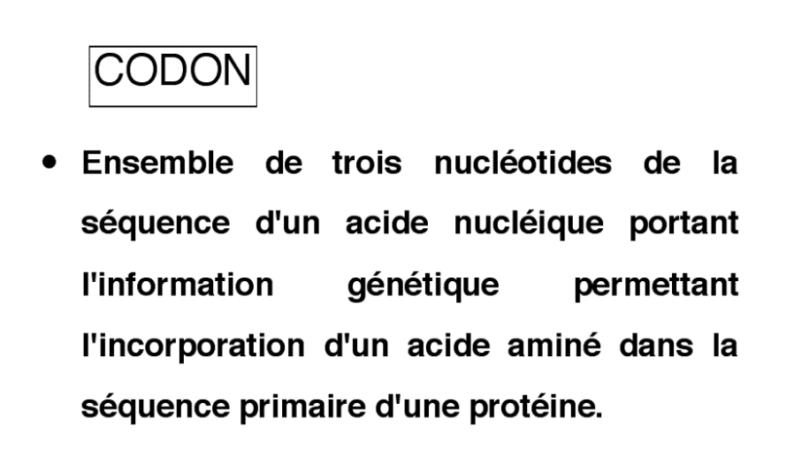
The binding of transfer RNA (tRNA) to messenger RNA (mRNA) carrying the genetic information occurs through complementarity between three nucleotides on each of these RNAs. The three nucleotides on the mRNA form a codon, and the three nucleotides on the tRNA form an anticodon. During translation, the anticodon and codon pair in an antiparallel orientation, and the amino acid carried by the tRNA is incorporated into the growing protein.
- Therefore, the primary sequence of mRNA is translated in groups of three nucleotides (codons). A nucleotide in the mRNA can occupy position 1, 2, or 3 within a codon during translation, depending on whether the number of nucleotides separating it from the initiation codon AUG is or is not a multiple of three. This position is called the reading frame.
Genetic Code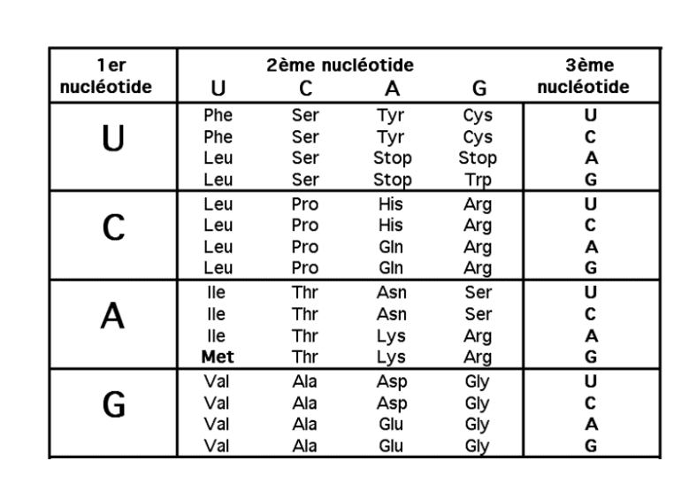
Coding Sequence and Genetic Code
The coding sequence is a series of codons, each of which specifies the incorporation of a particular amino acid during protein synthesis.
- The genetic code is the same for all living organisms (universal), although there are a few variations, such as codons specific to protein biosynthesis in mitochondria.
- The genetic code includes 61 codons for the 20 amino acids involved in protein synthesis: each amino acid can be encoded by multiple codons (from one to six), which generally differ in the third nucleotide. This is why the code is described as degenerate.
- The genetic code is the result of long evolution and is not random. Codon–amino acid correspondences have been selected so that base changes have minimal impact on the expressed protein.
  - All codons whose second letter is U correspond to hydrophobic amino acids, thus sharing similar physical properties.
  - Similarly, acidic amino acids correspond to codons starting with GA, so that changes in the third base do not eliminate the anionic charge of the side chain.
  - The codon closest to stop codons is that of tryptophan. A change in either or both G nucleotides creates a stop codon, terminating translation. However, tryptophan is the rarest amino acid in commonly translated proteins.
- When the genetic code is written from amino acids to codons, it shows that many amino acids have synonymous codons.
  - Some amino acids have six codons, others four, three, or two.
  - These synonymous codons are not used randomly, because the corresponding tRNAs are not present at the same concentrations in all cells. As a result, some codons are less likely to be used in tissues where the corresponding tRNA is rare.
  - Many tRNAs do not bind specifically to the third base of the codon. This base is therefore recognized less specifically or not at all, explaining the common degeneracy of the third codon position.
Eukaryotic Ribosome
The cytoplasmic ribosomes of eukaryotic cells are multi-enzyme complexes composed of 82 protein chains and 4 ribosomal RNAs. These molecules assemble into two distinct particles: the 60S subunit (Large, 2,800,000 daltons) and the 40S subunit (Small, 1,400,000 daltons), which can easily dissociate.
- Ribosomal RNAs and proteins have binding sites for:
  - mRNA sequences,
  - tRNAs carrying amino acids to be incorporated (A site) and for the growing peptide (P site),
  - a catalytic site for forming peptide bonds,
  - binding sites for protein initiation cofactors (eIF2, eIF3),
elongation and termination, as well as regulatory sites (S6 protein).

Transfer RNA (tRNA, Cloverleaf Structure)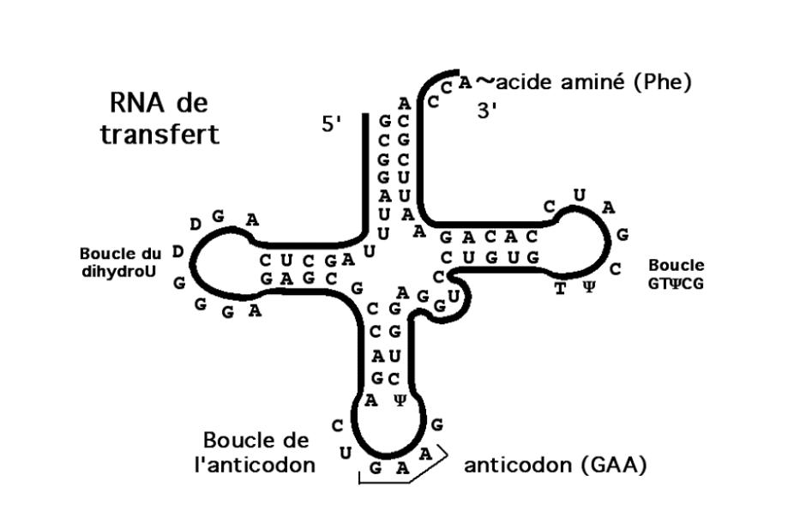
Transfer RNAs (tRNAs) – The Chemical Link in Translation
tRNAs provide the essential chemical link between the codon sequence on mRNA, recognized by the anticodon, and the specific amino acid carried by the tRNA. In a way, tRNAs act as the “dictionary” of translation.
- The anticodon is a sequence of three nucleotides located at the end of the lower loop of the tRNA. It is complementary and antiparallel to the codon sequence of the corresponding amino acid.
- Each amino acid is specifically attached (according to the genetic code) by an aminoacyl-tRNA synthetase to the 3’ end of the tRNA whose anticodon matches it (charged tRNA).
- Ribosomes bind charged tRNAs at the A site during elongation if their anticodon pairs with the codon of the mRNA at that position. The elongation process then transfers the growing peptide chain to the new amino acid, which is itself carried by the tRNA.

Activation d’un acide aminé
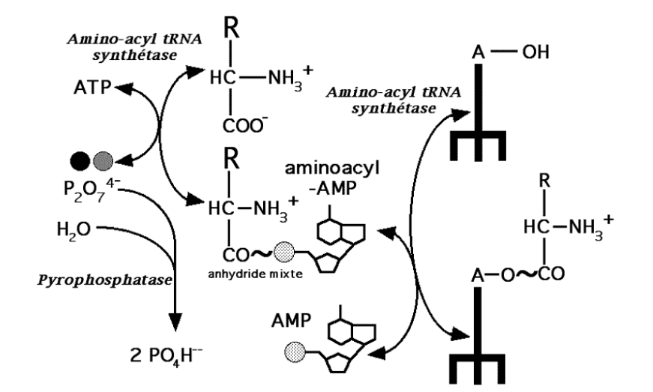
Amino Acid Activation
Free amino acids in the cytoplasm are the substrates for protein synthesis. To participate in translation, they must first be activated.
- Amino acid activation is catalyzed by specific enzymes: aminoacyl-tRNA synthetases. There is at least one synthetase for each of the 20 amino acids.
- These enzymes have dual specificity: they recognize a specific amino acid and the corresponding uncharged tRNA.
- The coenzyme ATP is hydrolyzed to AMP and pyrophosphate (PPi) to provide the necessary energy.
- The ester bond formed between the amino acid and its tRNA is high-energy and will be hydrolyzed during the elongation step of translation.

Translation Initiation
Translation initiation is the rate-limiting step of protein synthesis.
- Ribosomal subunits are dissociated in the cytoplasm. A cascade of events forms an initiation complex.
- At rest, eukaryotic initiation factor 2 (eIF2) carries GDP, a coenzyme hydrolyzed during the previous initiation cycle. In the presence of eIF2B, GDP is replaced with a new GTP. The activated eIF2 can then bind a charged tRNA carrying methionine, whose anticodon is complementary to the start codon (AUG) of the mRNA.
- With the cofactor eIF3, the small ribosomal subunit binds the activated eIF2-methionine-tRNA complex. The energy for forming this complex is provided by the hydrolysis of GTP on eIF2.
- The 5’ untranslated region (5’ UTR) of the mRNA is recognized by cofactors eIF4A, eIF4B, and eIF4F, which bind to it. Using ATP hydrolysis for energy, the mRNA is positioned on the small subunit at the P site, so that the start codon nucleotides pair with the anticodon of the initiator methionine tRNA.
- In the presence of the final cofactor eIF5, the complex associates with the large ribosomal subunit to form a functional ribosome. Initiation factors are released, and translation begins. eIF2, now bound to GDP, is released to start a new initiation cycle.

Translation Elongation
- Initiated ribosomes have an empty A site. The elongation factor eEF1B catalyzes the exchange of GDP for GTP on eEF1A. The activated eEF1A binds a charged tRNA, which is delivered to the A site, hydrolyzing GTP to GDP. Once the anticodon of the tRNA pairs complementarily with the codon in the A site, eEF1A is released with GDP.
- The ribosome then catalyzes the transfer of the peptide from the tRNA in the P site to the amino group of the amino acid on the tRNA in the A site. This reaction uses the energy stored in the high-energy ester bond between the peptide and the tRNA in the P site.
- Using eEF2 and the hydrolysis of another GTP, the tRNA in the P site is released, and the mRNA, remaining tRNA, and growing peptide are translocated from the A site to the P site, without separating the codon-anticodon pairing.
- The A site is free again to receive the next aminoacyl-tRNA.
- A charged tRNA binds to the free A site, and the codon-anticodon pairing allows incorporation of the new amino acid into the growing peptide. The ribosome catalyzes the transfer of the peptide chain from the P site tRNA to the amino group of the A site tRNA, using the energy of the ester bond.

Codon Translocation
- The free tRNA in the P site leaves the ribosome.
- The mRNA, remaining tRNA, and growing peptide are shifted (translocated) from the A site to the P site, without disrupting codon-anticodon base pairing.

Translation Termination
- When the A site encounters a stop codon, the ribosomal complex dissociates from the mRNA in the presence of the eukaryotic release factor (eRF).
- The ribosomal subunits dissociate, the newly synthesized protein is released, along with the last tRNA.

