Expression of Genetic Information
1. Structure of RNA
Single-stranded nucleic acids (RNA or Ribonucleic Acid)
Like DNA, RNA is a polymer of nucleotides linked by phosphodiester bonds. However, there are important structural differences between DNA and RNA. Instead of deoxyribose present in DNA nucleotides, RNA nucleotides contain a ribose sugar. Another significant difference is that thymine, one of the two pyrimidines found in DNA, is replaced by uracil in RNA (Pierce, 2012). RNA usually exists as a single-stranded molecule (Figure 21). A consequence of the single-stranded nature of RNA is that short complementary internal regions can base-pair and form secondary structures.
1. Classes of RNA
RNA molecules perform a variety of tasks in the cell. Ribosomal RNA (rRNA), associated with proteins, constitutes the ribosomal subunits, the site of protein assembly. Messenger RNA (mRNA) carries instructions encoded by DNA from the nucleus to the ribosome for polypeptide chain synthesis. Transfer RNA (tRNA) links the coding nucleotide sequence of mRNA to the amino acid sequence of a polypeptide chain (Pierce, 2012). Other classes of RNA molecules are present in the nucleus of eukaryotic cells. Small nuclear RNAs (snRNAs) combine with small protein subunits to form small nuclear ribonucleoproteins (snRNPs). MicroRNAs (miRNAs) and small interfering RNAs (siRNAs) can help, through a process, to trigger the degradation of mRNA or inhibit its translation into protein (Pierce, 2012).
2. Transcription and RNA Maturation
2.1 Transcription
From the sequence of a gene, protein synthesis obligatorily involves several steps: (1) transcription of the gene into pre-messenger RNA (pre-mRNA); (2) maturation of pre-mRNA, which includes intron splicing, capping, and polyadenylation; (3) transport of mature mRNA from the nucleus to the cytoplasm, where its concentration is controlled by elements that stabilize or degrade it; and simultaneously (4) its more or less efficient translation. Gene expression in a cell thus results from the coordinated regulation of each of these steps, particularly during the transfer of mRNA from the nucleus to its cytoplasmic destination (Pallier, 2001).
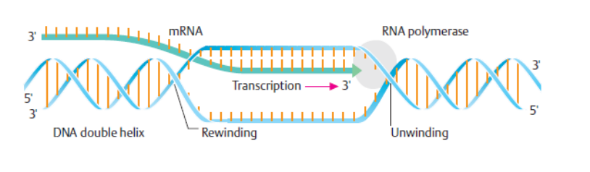
Figure 1: Steps of Transcription (Passarge, 2007)
Initiation, Elongation, and Termination of Transcription
Initiation:
A DNA sequence to which RNA polymerase binds to initiate transcription is called a promoter. A promoter is part of the regulatory region adjacent to the coding region of a gene.
Elongation:
RNA polymerase moves along the DNA, keeping a transcription bubble open to expose the template strand, and catalyzes the elongation of the RNA strand in the 3’ direction. The polymerase compares free ribonucleoside triphosphates with the exposed base on the DNA template and incorporates complementary nucleotides.
Termination:
When RNA polymerase recognizes specific nucleotide sequences in DNA that act as termination signals, the RNA strand and polymerase are released from the DNA template. Termination sequences are about 40 base pairs long and end with a GC-rich sequence followed by a run of six or more A residues on the template strand. The GC sequences are arranged such that the transcript can form complementary base-pairing with itself in this region, producing a hairpin loop. This is followed by a stretch of U residues corresponding to the A residues on the DNA template. The hairpin and the U stretch appear to serve as a signal for RNA polymerase release and transcription termination (Griffiths et al., 2001).
2.2 RNA Maturation – Messenger RNA (mRNA)
mRNA serves as the template for protein synthesis; it carries genetic information from DNA to the ribosome and assists in the orderly assembly of amino acids. In bacteria, mRNA is the direct product of transcription, but in eukaryotes, the primary transcript is a pre-mRNA, which is subsequently modified to produce mature mRNA (Pierce, 2012).
- 5’ Capping: During maturation, a 5’ cap, consisting of a methylated guanine at the N7 position, is added to the 5’ end of most pre-mRNAs via a 5’-5’ triphosphate linkage. This cap participates in nuclear splicing and polyadenylation reactions, nucleocytoplasmic transport of mRNAs, initiation of translation, and protection against 5’→3’ exonuclease degradation (Lewis and Izaurralde, 1997).
- Poly(A) Tail Addition: Another modification in eukaryotic mRNA is the addition of 50 to 250 adenine nucleotides at the 3’ end. This process is critical for gene expression. The poly(A) tail of a mature mRNA is essential for its stability, cytoplasmic translocation, translation, and overall mRNA lifespan (Wahle and Kuhn, 1997).
- Splicing of mRNA: Another important modification of eukaryotic pre-mRNA is the removal of introns followed by the joining of exons. Introns are cleaved at consensus sequences located at both ends. The first sequence, called the 5’ splice donor site, is GT; the other, the 3’ splice acceptor site, is AG. A third intronic sequence, the branch site, is involved in splicing and is located about 40 nucleotides upstream of the AG nucleotide. The branch site forms a lariat structure by attaching to a portion of the intron (Pierce, 2012).

