TD N°1 of Géologie

EXERCISE 1
Considering that the earth is spherical and has a radius of 6378 km with an acceleration g = 9.8.
The gravitational constant G= 6.67. 10⁻¹¹ N/kg²m².
1. Calculate the mass of the earth in kg.
2. Calculate its average density.
Know that the density of the inner core is 12.What would be its mass? What do you infer?

EXERCISE 2
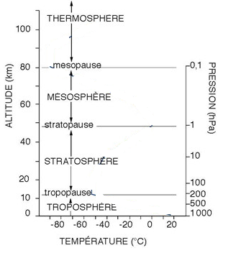

- Why Does Air Pressure Change with Height?

- The graph shows how the pressure changes as you move up through the atmosphere. On the graph, draw a curve showing how the temperature changes. (Use the information from Chap.2 to answer)

EXERCISE 3
Give the exact term for these definitions:

- The point on Earth’s surface directly above an earthquake’s starting point, or focus
- The point along a fault at which the first motion of an earthquake occurs
- A tracing of earthquake motion that is recorded by a seismograph
- An instrument that records vibrations in the ground and determines the location and strength of an earthquake.
- A wave of energy that travels through the Earth, away from an earthquake in all directions
- The soft layer of the mantle on which the tectonic plates move
- The solid, outer layer of Earth that consists of the crust and the rigid upper part of the mantle

Complete the table below.
 | Crust | Mantle | Core
Thickness or radius |  |  | 3430 km
Location | outer layer of the Earth
Percent of Earth’s
mass

EXERCISE 4
An earthquake occurred in San Francisco (northern California) in 1989. The above figure is a seismogram of the earthquake at the Eureka station in northern California.
The origin of the landmark (t = 0 s) was chosen at the date of the beginning of the earthquake in San Francisco.
The seismogram shows two wave trains identified by A and B.
a. What is the wave type (S or P) of each train? Justify your answer.
b. Knowing that the beginning of the earthquake was detected at Eureka at 8:15:20 UTC (Universal Time),
Determine the time TU (h min s) at which the earthquake started in San Francisco (epicenter of the earthquake).
c. Knowing that P waves propagate at an average speed of 10 km. s⁻¹, calculate the distance from the epicenter to the Eureka earthquake.
d. Calculate the v-mean velocity of S waves.

