S2 Translation Activities

- Read the text carefully.
- Answer the questions and do the activities below, in English and according to the text in Arabic.
- Occasionally there is more than one correct answer, so choose all of the possible answers.
- Occasionally, there is no correct answer at all. Mention when this is the case.
- In some activities, the answers provided are simply implied (i.e not stated explicitly in the text). Mention when this is the case
- In some activities, the answers provided are not stated in the text at all. Mention such answers.

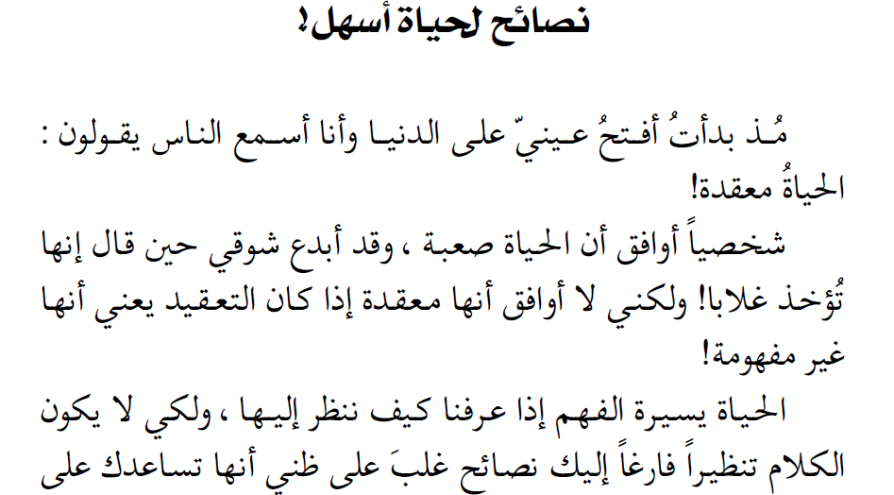
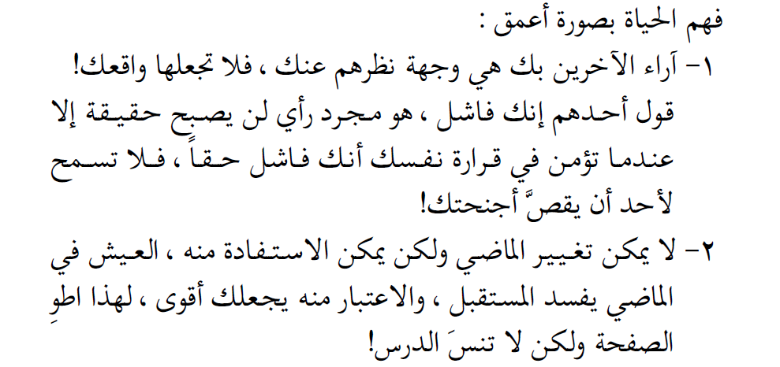

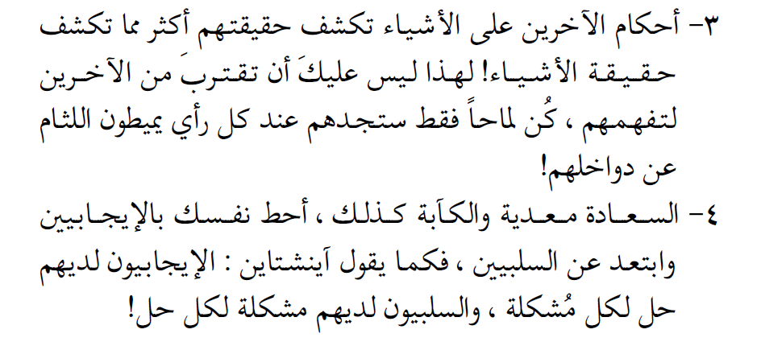
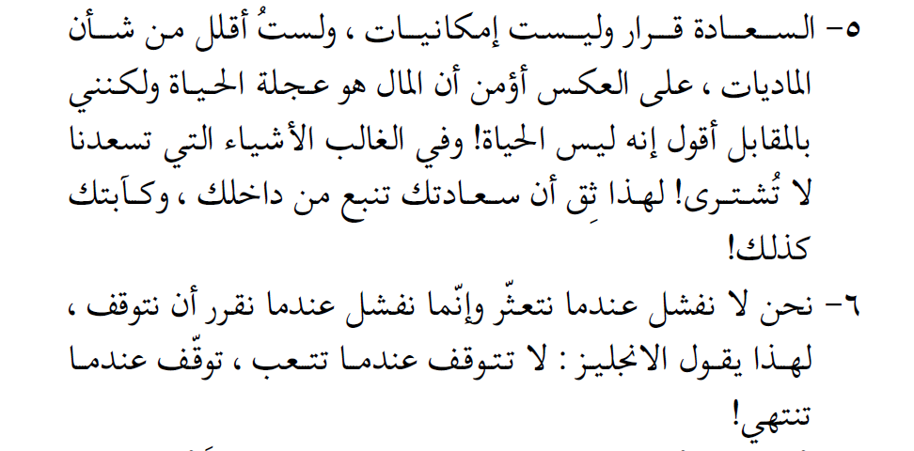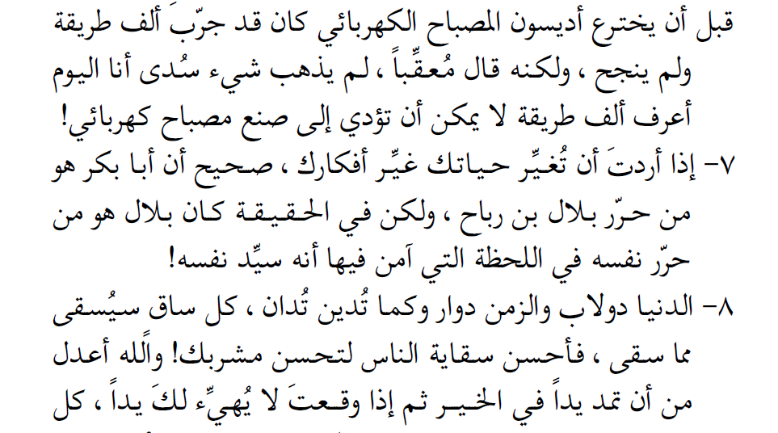
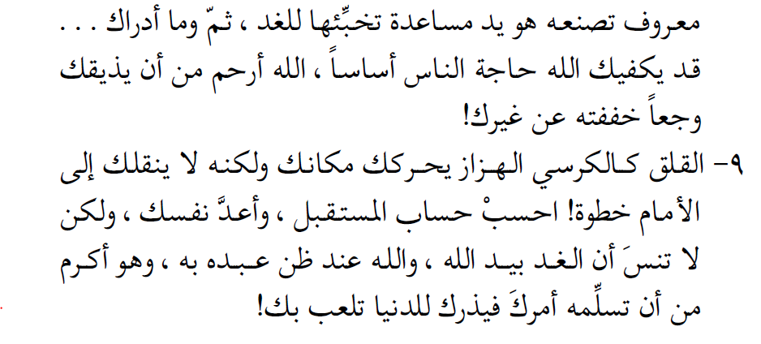

مقتطف من كتاب "نبأ يقين" لأدهم شرقاوي

1. What is the overall idea that the author tries to convey through the text ?
Life may be complicated or difficult, but it is fully possible to overcome its challenge and be happy.
2. The author considers that :
life is complex – life is complicated – life is difficult – life is misunderstood – life is a mystery – life is easy to understand – life is hard to understand – life is a misunderstanding.
3. The author gives advice to help the reader :
have a better life (implied) – have an easier life (implied) – have a better understanding of life – have more experience in life – have a successful life (implied) – have a better outlook on life.
4. The advice the author gives are meant to be :
practical – theoretical – applicable – useful – empty theorising.
5. The author is :
sure the advice will help the reader – confident the advice will help the reader – sceptical about the advice helping the reader – he asserts that the advice will help the reader.
6. The first advice tells the reader :
to care about people - to care about people’s opinions – to disregard people’s opinions – to not care about people’s opinions on you – to make people’s opinions your reality – to treat people’s opinions as truth – respect people’s opinions - opinions are truths – opinions are not facts.
7. In the first advice, what is the exact point that the author tries to make ?
You should believe in yourself regardless of what other people think of you.

8. The second advice is about the importance of :
living in the past – changing the past – not living in the past – trying to change the past – learning from the past – making the future (implied) – ruining the future
9. What makes you « stronger » for the author in his second advice ?
Learning and benefiting from the past.

10. The third advice is about :
trying to know people(implied) – judging people(implied) – not being judgemental – learning from people – learning about people – getting close to people.
11. The point in the third advice is that :
people’s opinions give away their inner nature – people’s opinions about things give an accurate image about the nature of said things – people’s opinions about things give an accurate image of people themselves – people’s opinions about things reveal their true selves
12. What is the main idea in the fourth advice ?
The importance of surrounding oneself with positivity as opposed to negativity, (in order to maintain it and reflect it back on one’s environment), as both are contagious.
13. What is the description of positive people and negative people in this advice ?
Positive people are described (by Einstein) as having a solution to every problem. Negative people on the other hand are described as seeing a problem in every solution.
14. What is the point in the fifth advice ?
Happiness comes from within and is not a result of possessing a lot of wealth : money cannot buy most of what makes one happy.
15. According to the author :
money is the source of happiness – money is happiness – money brings happiness – money help bring happiness – money can contribute to happiness – money can’t buy happiness.
16. Does the author think that materialism is the path to happiness ? Justify your answer by translating the relavant passage that indicates it.
No, actually he thinks that it is not. A translation of the relevant passage may be :
« Happiness is a decision, and not wealth. And I’m not underestimating the importance of the latter, I actually believe that money is the wheel of life. But I would say it is not life itself… »
17. Where does happiness stem from, for the author, in this particular advice ?
According to the author, happiness stems from within, (i.e from our inner selves and minds).

18. The sixth advice is about failure, how should you consider failure according to the author ?
Failure is not when one trips (over a difficulty), but rather when one stops trying or quits.
19. Finish up this translation :
«we do not fail when we stumble We fail when we decide to stop ».
20. The author gives the example of Thomas Edison. What is Edison’s outlook on his experiment in creating the lamp ?
Edison’s outlook was of one who sees « the full half of the glass ». Instead of dwelling on the failure of his experiments or the time and material they cost, he saw in his experiments knowledge and experience about a thousand ways or routes which won’t lead to making an electric lamp.
21. What is the point made in the seventh advice ?
Changing one’s life starts with changing one’s thoughts and ways of thinking.
22. For the author :
you are your ideas (figuratively) – your ideas can change your life (explicitly said) – your ideas can change your attitude (implied) – your ideas can change the future(implied) – your ideas are important(implied) – you should watch your ideas.(implied)
23. The eighth advice is about the fact that :
life will trun around – what comes around goes around – what goes around comes around - if you are kind you must receive kindness – if you are kind to others you will recieve kindness from them - it is possible to be generous and not be treated with generosity – you get what you give– you should give what you get – life is a game – goodness will pay off (implied) - you reap what you sow. (implied)
24. Explain the imagery used in the nineth advice. (the rocking chair)
A rocking chair only moves one back and forth without making him (or her) change their place or go somewhere else. Worrying is similar in that it just gives the illusion of movement, but in reality it doesn’t move one anywhere different, i.e worrying doesn’t help solve problems or prepare for the future.
25. The author recommends :
worrying about the future – not worrying about the future – preparing the future – not preparing the future – relying on Allah – having good faith in Allah – preparing oneself.

26. Retrieve from the text the equivalents of the following words/phrases :
« lift the veil » | يميطون اللثام عن دواخلهم | « contagious » | معدية
« hand your affair to » | أن تسلمه أمرك | « allusive » | كن لمّاحا
« create » | قبل أن يخترع | « surround » | أحط نفسك
« forcefully » | تأخذ الدنيا غلابا | « alleviate ». | وجعا خففته

27. Finish up the following translation in accordance to the relevant passage in the text :
« Other people’s opinions about you are their viewpoints on you, so don’t make them your reality. Someone’s saying that you are a failure is but an opinion which won’t become reality unless you believe deep down that you are truly a failure.
Don’t let anyone clip your wings. »
28. The following translation is erroneous on many levels (semantically, grammtically, spelling wise, vocabulary choice, etc).
Read it, identify the original passage, and correct the mistakes.
« Happiness is a decision, not wealth, and I am not underestimating the importance of material possessions. On the contrary, I believe that money is the wheel of life ! But on the other hand, I would say that it is not life itself ! Mostly, the things which makes us happy can’t be purchased . Therefore, be sure that your happiness comes from within and so do your low spirits »

