**Exercises  🡺 Articles**

**Exercise 01:** Underline the correct word.

1. I don’t like that coat. ***The* / *A***colour is horrible.
2. He doesn't like going to see ***the* / *a***dentist.
3. She asked for ***the* / *a***cup of coffee, but she got tea instead.
4. ***The / A*** laboratory is a place where scientific experiments are done.
5. I don't believe he's ***the* / *a***policeman, he looks too young!
6. She is ***a* / *an***intelligent woman.
7. I went to ***the* / *a***bank today and they said I didn't have any money!
8. Who left ***the* / *a***door open?
9. ***A* / *An***hotel is more expensive than a / an youth hostel.
10. ***The* / *A***film starts at half past seven.

**Exercise 02:** Choose the correct form, A, B or C, to complete the sentence.

1. If you want to be healthier, think carefully about ........... you eat.
2. *food* ***B.*** *the food* ***C.*** *a food*
3. If you don't enjoy ........... , do something else.

***A).*** *the exercise* ***B)***. *an exercise* ***C)*** *exercise*

1. Try learning ...........

***A).*** *a new sport* ***B).*** *new sport* ***C).*** *the new sport*

1. Sometimes the food you eat is less important than ...........

***A).*** *food you don't eat* ***B).*** *a food you don't eat* ***C).*** *the food you don't eat*

1. Do you eat enough ........... ?

***A).*** *fruit and vegetables?* ***B).*** *the fruit and vegetables?* ***C).*** *fruit and the vegetables?*

1. There is a saying, “ ........... a day keeps the doctor away”.

***A).*** *The apple* ***B).*** *A apple* ***C).*** *An apple*

1. ........... chocolate cake should only be eaten occasionally.

***A).*** *The piece* of ***B).*** *Piece* of ***C).*** *A piece* of

1. Stress also makes ........... unhealthy.

***A).*** *the people* ***B).*** *people* ***C).*** *a people*

1. If you've had ........... ,try and do something nice for yourself.

A). *the bad day* B). *bad day* C). *a bad day*

1. You could visit a friend or go to ...........

A). *cinema* B). *the cinema* C). *a cinema*

**Exercise 03 :**

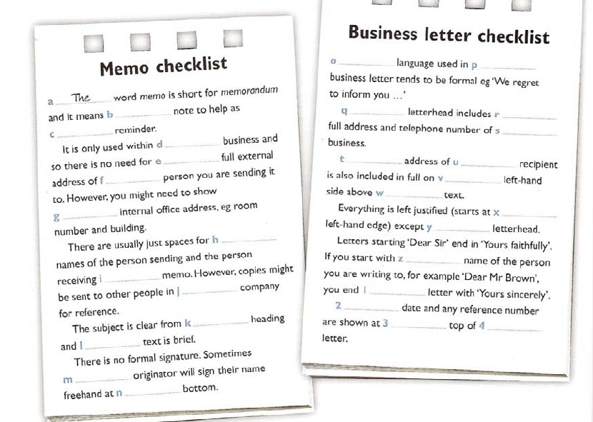

**Exercise 04 :**

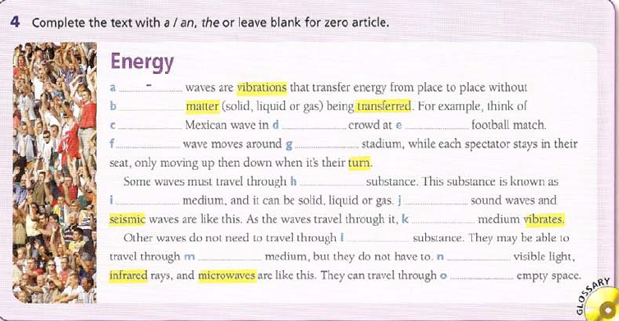

**Exercise 05 :**

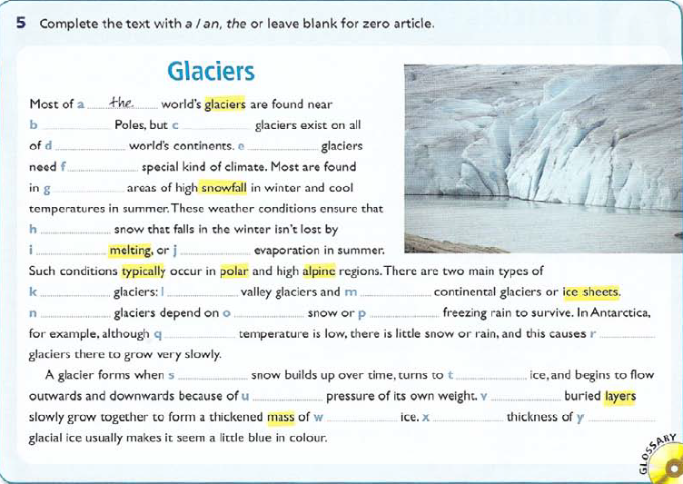



**Exercise 06 :** Complete each sentence with ‘***the’****, ‘****a’*** / ‘***an’*** or zero article (***Ø***).

1. Last week at school we learned how to make ................. barometer.
2. This is................. cardboard which we used to make our barometer.
3. And this is................. bottle we used. We attached the cardboard to it.
4. We made ................. measuring scale and attached it to the side of the bottle.
5. This is ................. bowl we also used as part of our barometer. We filled the bowl with water, and filled the bottle three quarters full, and then turned the bottle upside down in the bowl.
6. The pressure of air has an interesting effect on................. water you put in the bowl.
7. The pressure makes ................. water in the bottle rise.
8. We used................. measuring scale on the side of the bottle to measure the air pressure.