Module : Grammar Mohamed Kheider University
Level : First year LMD
Lesson One : The Parts of Speech

8. Conjunctions

A conjunction connects phrases, clauses, words or parts of speech which are of the same syntactic importance.
Types of Conjunctions:
- Coordinating conjunction is a single connecting word. It connects words, phrases, and clauses. These words are the FANBOYS
and  But | Or  Nor | for  Yet
- The boys and girls worked at the fair. (And joins two nouns)
S
- The soup was hot and delicious. ( two adjectives) He speaks quickly and fluently. (two adverbs)
S.C
- My cat Buster has beautiful blue eyes but a destructive personality. (two phrases)
D.O
- The students did a test and corrected it.
compound predicate
- Alex likes to fish, and he is going fishing on Friday. (compound sentence)
- I would like to help you, but I will be busy tonight. (But joins two independent clauses./ contrast)
- Subordinating conjunctions join a subordinate dependent clause to a main/independent clause. An adverb clause is always introduced by a subordinating conjunction. The following is a list of the most common subordinating conjunctions:
After, although, as, as if, as long as, as much as,  as soon as, as though,  because, before,  even, even if,  even though,  if, if only, if when, if then,  inasmuch, in order that  so that, in order to  such that | Just as, lest, now, now since, now that, now when, once  Provided, provided that  rather than,  since  so that, supposing,  than  that  though, till  unless | until  when  whenever  where  whereas  wherever  whether, which  while, who, whoever  why
- As it was getting late, I decided to go home.
subordinate/adverbial clause of reason
- Ronnie begins to sneeze fiercely whenever he opens the door to greet a fresh spring day.
- He took the course in order that he could get a better job.
- I will call you provided that I have enough time.
- She was so weak that she couldn’t walk.
- I won’t allow you to see that movie even though you are old enough.
- I will come to see you wherever you live.
- Correlative conjunctions are pairs of conjunctions that must be together as connecting words.
Both…and  either … or  As many … as  No sooner … than | Neither … nor  Not only … but also  Such … that | Whether … or  As … as  Scarcely … when  Rather … than

Examples:
Both Henry and Henrietta are leaving now. (The correlative conjunctions join two names.)
Not only will they leave now, but they will also not be here to help clean up.
(The correlative conjunctions join two sentences or complete ideas.)
Either go with them or stay here and help. (The correlative conjunctions illustrate a choice.)
He went neither to the stadium nor to the concert hall during this vacation. ( two prepositional phrases.)
Would you rather go shopping or spend the day at the beach?
Bowling isn’t as fun as skeet shooting.
Such was the nature of their relationship that they never would have made it even if they’d wanted to.
I had scarcely walked in the door when I got the call and had to run right back out again.
There are as many curtains as there are windows.
I’d no sooner lie to you than strangle a puppy.
She’d rather play the drums than sing.

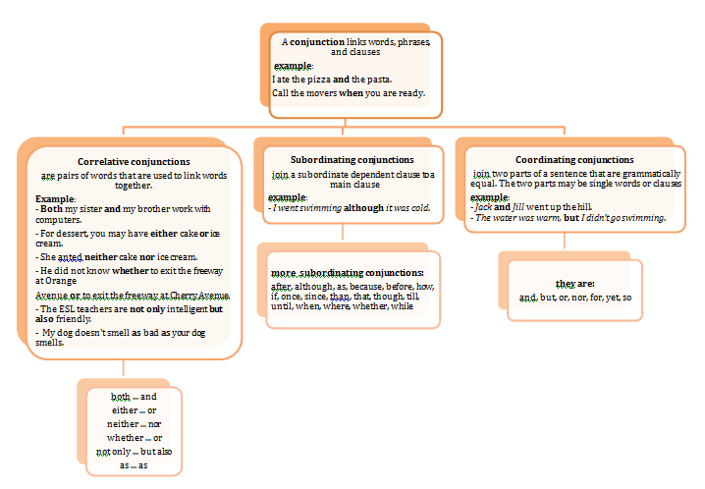

Practice Circle the conjunction or pair of conjunctions in each sentence:

- Lyle chose both steak and salad for his dinner.
- I chose neither steak nor salad for my dinner.
- Either you or he can drive Dad to the train station tomorrow morning.
- The panda wanted to eat, for he was hungry.
- Peanut butter and jelly is Rex’s favorite sandwich.
- Not only the girls but also the boys will be invited to the assembly.
- Sara did not know whether to swing at the ball or take the pitch.
- Mark would like to go, but he cannot.
- Rich likes the food at this restaurant, yet he seldom eats here.
- Run with him or her.
Task 2: Use an appropriate coordinating conjunctions to combine the sentences below.
- I wanted to backpack through Europe last summer. My mom told me I couldn’t.
______________________________________________________________________
- Maria didn’t finish her essay. She did finish her math.
________________________________________________________________________
- Julie bought her mom a sweater. Her mother loved it.
_________________________________________________________________________
- I am going to the beach. I worry about sunburn.
__________________________________________________________________________
- Jill spent all her money at the Banana Republic sale. She went back the next day for more bargains.
__________________________________________________________________________
- You can take a cruise to Greece. You can travel to Mexico.
___________________________________________________________________________
- Ted didn’t have enough money to fly to Boston. He took the train.
____________________________________________________________________________
- She could not go to the show. She did not have enough money.
_____________________________________________________________________________

