Module : Grammar Mohamed Kheider University
Lesson: Parts of speech Level : 1st year LMD

- Pronouns
A pronoun is a word that is used in place of a noun or a noun phrase (called its antecedent) to avoid repeating it. It is also used to make our writing clearer, smoother, and less awkward.
In the sentence, “Roberto feels that he can win the race,” he is the pronoun, and Roberto is the antecedent.
There are eight types of pronouns.

- Personal Pronouns
They refer to specific persons or things (that have been already mentioned) and change their form to indicate person, number, gender, and case. They can be subjective personal pronouns ( I, you, she, he, it, we, you, they) used to act as subjects of a verb. e.g: I do the washing; he does the cooking; and they watch TV.
→ We usually use « it » for an animal. We can use he and she when we think of the animal as having human qualities or a special personality ; for example, when it’s a pet or a character of a story.
e.g : Pooh is a friendly bear. He enjoys eating and playing with his friends.

Personal pronouns can work also as direct or indirect objects (objective personal pronouns) of a verb or after a preposition. They are me, you, her, him, it, us, you, them.
e.g. I saw her yesterday. (direct object)
You told us news. (indirect object)
She travelled only with him. (object of preposition)

- Possessive Pronouns
They are forms of personal pronouns that show ownership or relation. They are: mine, yours, hers, his, its, ours, theirs. We use them in place of possessive noun phrases
e.g. I couldn’t work in Mary’s room. Hers is even smaller than yours or mine.

- Reflexive Pronouns
They are used to refer back to the subject of the sentence and stand as objects (of a verb or a preposition). They indicate that someone or something acts upon itself. They are formed by combining personal pronouns with « self » or « selves »: myself, yourself, himself, herself, itself, ourselves, yourselves, themselves.
e.g. She stretched herself out in the sofa.
I wrote it to myself.
→ Reflexive pronouns are also used after nouns or pronouns to emphasize them. They are called intensive pronouns.
e.g. The teacher himself gave me his address.
We met the Queen herself.

- Demonstrative Pronouns
demonstrate (verb): to show; to indicate; to point to
Demonstrative pronouns point to and identify a noun or a pronoun. They are : this, these, that, those. → near in distance or time (this, these) → far in distance or time (that, those)
e.g. This is my seat ; that is yours. (subjects)
→We can use this/these to introduce people and that/those to identify people.
This is Ann Thomas and these are her two sons, Nick and Jason. (introducing them)
That’s Mrs. Parker and those are her two grandchildren. (identifying them in the distance)

BECAREFUL Do not confuse demonstrative pronouns with demonstrative adjectives. They are identical, but a demonstrative pronoun stands alone, while a demonstrative adjective qualifies a noun.
That smells bad. (demonstrative pronoun)
That dog smells bad. (demonstrative adjective + noun)

- Interrogative Pronouns
They are used to ask questions. They are : who, whom, which, what, whose.
→ who, whom, and occasionally which are used to refer to people.
→ which and what are used to refer to things and animals.
e.g. Who told you? John told me. (subject)
Whom did you tell? I told Mary. (object)
What's happened? An accident's happened. (subject)
What do you want? I want coffee. (object)
Which came first? The Porsche 911 came first. (subject)
Which will the doctor see first? The doctor will see the patient in blue first. (object)
There is one car missing. Whose hasn't arrived? John's (car) hasn't arrived. (subject)
We've found everyone's keys. Whose did you find? I found John's (keys). (object)
Note: We sometimes use the suffix "-ever" to make compounds from some of these pronouns (mainly whoever, whatever, whichever). When we add "-ever", we use it for emphasis, often to show confusion or surprise. Look at these examples:
Whoever would want to do such a nasty thing?
Whatever did he say to make her cry like that?
They are all fantastic! Whichever will you choose?

- Relative Pronouns
A relative pronoun introduces a relative clause. It is called a "relative" pronoun because it "relates" to the word that its relative clause modifies.They are who, whom, that, whose, which, where, why, when, what, whoever, whomever, whichever.
e.g. George, who is my best friend, is a teacher.
relative clause

→ We use « who », « whomever », « which », « that » to refer to the subject of a clause or sentence. e.g. The candidate who wins the greatest popular vote is not always elected. (in this sentence, the relative pronoun “who” is the subject of the verb « wins » and introduces the adjective clause « who wins the greatest popular vote ». This clause acts as an adjective modifying « candidate »).
→ We use « whom », « which », « that » to refer to the object of a sentence.
e.g : The girl whom you saw is my sister.
The cake which you gave me is very sweet.
→ We use « whose » for possession. e.g. My brother, whose phone you just heard, is a doctor.
→ Relative clauses can be restrictive (defining) or non-restrictive (non-defining)
e.g. Mrs. Pratt, whom I like very much, is our neighbour. (Non-restricive)
The person whom I phoned last night is my teacher. (Restrictive)
The blue car, which is a taxi, exploded. (Non-restrictive)
The car which I drive is old. (Restrictive)

- Indefinite Pronouns
They refer to identifiable but not specified persons or things. They do not indicate exactly who or what they are. We use them to talk about people and things in a very general way, usually because we can’t or we don’t want to identify them more specifically. The most common indefinite pronouns are : all, another, any, anybody, anyone, anything, anywhere, each, everybody, everyone, everything, everywhere, few, many, much, little, no one, none, nobody, nothing, nowhere, one, ones, several, some, someone, somebody, something, somewhere, either, neither, both, other, others, another.
e.g : - Many were invited to the lunch but only twelve showed up.
S
- We donated everything we found in the attic to the women’s shelter. (affirmative sent)
D.O
- There isn’t anything to eat. (negative sent)
- Make sure you give everyone a copy of the program.
I.O
- Give a registration package to each.
Object of preposition

→ We use a singular verb with somebody, everybody,....(Everybody is happy) and we use he/she, him/her, .... to refer back to these pronouns
e.g. Somebody left his or her book.
BUT → In everyday informal English, a plural personal pronoun is often used to refer to an indefinite pronoun.
e.g. Someone has left their coat in my car.
Everybody is enjoying themselves.
→ Indefinite pronouns can work also as adjectives if they are followed by a noun.
e.g. Each knows what to do. (pronoun)
Each man knows what to do. (adjective)

- Reciprocal Pronouns
They are used for an action or feeling that is reciprocated. The two most common reciprocal pronouns are "each other" and "one another". (both have the same meaning)
e.g : - You can shout at each other/one another as much as you like outside.
→ We can use reciprocal pronouns after prepositions and as possessives.
e.g : The two girls never argued with one another.
They even wore each other’s/one another’s clothes sometimes.
You can use one another instead of each other
- How long have you and Ben known each other? or ... known one another?
- Sue and Alice don't like each other. or ... don't like one another.

→We can use each as subject and the other(s) as object when the action of the verb goes both ways. e.g. I asked the boys if they had broken the window and each blamed the other.
Compare: -selves and each other:

- Kate and Joe stood in front of the mirror and looked at themselves. (= Kate and Joe looked at Kate and Joe)
- Kate looked at Joe; Joe looked at Kate. They looked at each other.
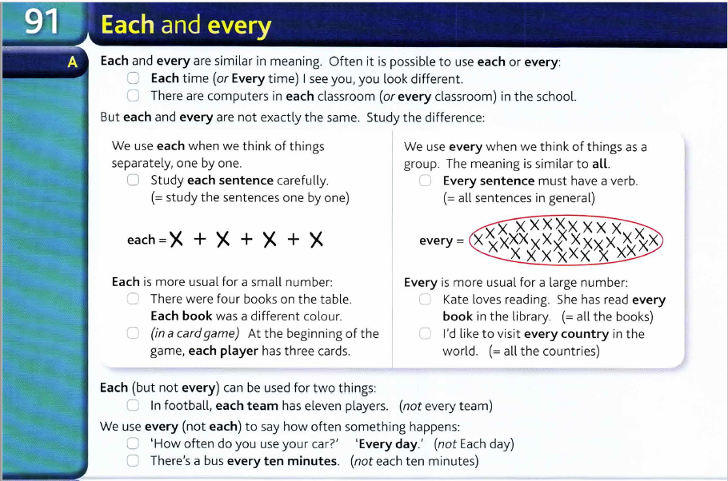
Practice :
- Insert the pronoun between brackets making any necessary changes.
- Our teacher praised (I)........yesterday.
- The only guests not to come yet are John and (she)........
- The letter was addressed to (he)........
- The car one belonged to Paul’s mother, but now it’s (he).......
- Their teacher is taking (they)........to the museum.
- He didn’t bring his book, so I lent him (I) .........
- Lest’s contact (we) ........ once we’ve made some progress.
- She made (she) ....... a sandwich and a cup of coffee.
- We are going out. You can come with ......
- I cannot use my pen. Can I use ..... ?

- Circle the correct answer.
- Did somebody/anybody notice that Luke wasn’t at the meal ?
- No one/anyone asked about him.
- Nobody from our group was/were there.
- There was/were somebody from Tom’s drama group.
- I haven’t seen nobody/anybody today.
- Everyone is/are at home with his/ their family.
- I am very tired, so I don’t to go somewhere/anywhere.

