Lecture 01: Introduction to Cognitive Psychology

What is psychology?
The word “psychology” comes from the Greek words “psyche”, meaning life, and “ logos”, meaning explanation. Psychology is a science dedicated to the study of behavior and mental processes.
Behavior = outward or avert actions and reactions:–Talking, facial expressions and movement.
Mental Process = internal, covert activity: Thinking, feeling and remembering.

The Most Important Schools of Psychology
 | Description | Important contributors
Structuralism | Uses the method of introspection to identify the basic elements or “stru ctures‖ of psychological experience | Wilhelm Wundt, Edward B. Titchener
Functionalism | Attempts to understand why animals and humans have developed the particular psychological aspects that they currently possess | William James
Psychodynamic | Focuses on the role of our unconscious thoughts, feelings, and memories and our early childhood experiences in determining behavior | Sigmund Freud, Carl Jung, Alfred Adler, Erik Erickson
Behaviorism | Based on the premise that it is not possible to objectively study the mind, and therefore that psychologists should limit their attention to the study of behavior itself | John B. Watson, B. F. Skinner
Cognitive | The study of mental processes, including perception, thinking, memory, and judgments | Hermann Ebbinghaus, Sir Frederic Bartlett, Jean Piaget
Social-cultural | The study of how the social situations and the cultures in which people find themselves influence thinking and behavior | Fritz Heider, Leon Festinger, Stanley Schachter

During the 20th century, psychology focused mostly on solving psychological problems, such as mental disorders and social disturbances. Most people associate psychologists with the changing of bad behaviors

and problematic mental processes; however, psychologists also study and work with psychologically healthy people. The following two movements focus on the study of healthy psychology:
Humanistic Psychology: An approach proposed in the middle of the 20th century. This movement was led by Maslow and Rogers. They emphasized the free will of people and their capacity for understanding and solving their own challenges.
Positive Psychology: This movement emerged at the beginning of the 21st century, and it attempts to promote the study of positive psychological phenomena such as creativity, optimism, and effective social relations.

What is cognitive psychology?
- The word ‘cognition’ is derived from the Latin word cognoscere, meaning “to know” or “to come to know”. Thus, cognition includes the activities and processes concerned with the acquisition, storage, retrieval and processing of knowledge. In other words, it might include the processes that help us to perceive, attend, remember, think, categorize, reason, decide, and so on.
- Cognitive psychology, as the name suggests, is that branch of psychology that deals with cognitive mental processes.
- Sternberg (1999) defined Cognitive psychology as that which deals with how people perceive, learn, remember, and think about information.”
- In 2005, Solso gave another definition of Cognitive psychology as the study of processes underlying mental events. In general, Cognitive psychology can thus be defines as that branch of psychology that is concerned with how people acquire, store, transform, use and communicate language.
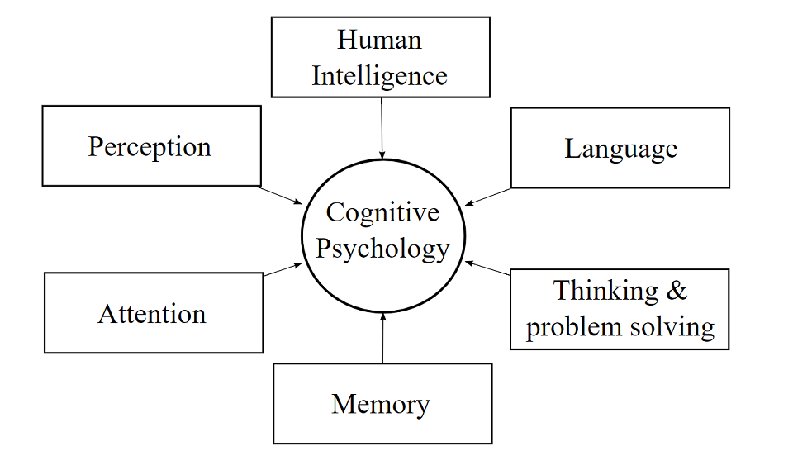
- A Brief History of Cognitive Psychology
- The roots of cognitive psychology can be traced back much further, and is intimately intertwined with the history of experimental psychology. This leads back to the time period when the empiricist, rationalist, and structuralist schools of thought which included philosophical works of Plato, Aristotle that dealt with the philosophy of mind, and also to the later works of Wundt, and Titchner involving introspection. However, for some period, the behaviorist school of thought dominated all the others, and the focus was shifted from thought to behavior.
- Around the time between the 1950s and 1970s, the tide began to shift against behavioral psychology to focus on topics such as attention, memory and problem-solving. The formal discipline of “Cognitive Psychology” started in the mid-1900s during the cognitive revolution, and the term ‘cognitive psychology’ did not emerge until 1967. Dissatisfaction with behaviorism, World War II, and the growing technological advances in other fields such as computer sciences were a few major reasons behind the Cognitive revolution. The mental processes regained their focus in psychology, and their measurement began in objective, quantifiable methods.
- In recent times, a number of different disciplines have started to come together and collaborate such as the fields of psychology, artificial intelligence, linguistics, philosophy, anthropology, and neuroscience, in order to gain a better insight into the field of cognitive psychology.

- Approaches to Cognitive Psychology
A number of different approaches have been proposed in order to better understand the field of Cognitive psychology. Each of these approaches emphasizes a different aspect and highlight distinct features underlying the cognitive processes. These methods provide us with an insight into how the human mind functions by giving us a general idea about the workings of the basic cognitive processes that we engage in. Broadly, there are four major approaches that try to explain the various cognitive processes by highlighting the different important features. These approaches are: Experimental Cognitive Psychology, Computational Cognitive Science, Cognitive Neuropsychology, and Cognitive Neuroscience.
- Experimental Cognitive Psychology
This approach involves conducting tightly controlled experiments under laboratory conditions on healthy individuals. It generally includes experiments that designed in such a way that they might disrupt the cognitive processes and reveal their workings. The findings obtained through such experiments then lead to formulation of the theories, which in turn lead to testable claims.
For example, a researcher wants to examine the effect of arousal on reaction time. He uses the experimental approach, and the reaction time is assessed through a machine where the buttons light up and the time to respond is measured. The arousal is also assessed through heart rate measurement, under the following conditions; after rest, after cognitive overload, after exercise, after caffeine, and after both exercise and caffeine. The results obtained through such experimental methods can thus lead to formulation of some theories, which later can be tested.
- Computational Cognitive Science
This approach involves computational modeling through the recreation of some of the aspects of human cognition in the form of some computer program, or formula in order to predict behavior in novel situations. In other words, this approach basically involves creating computer based models of human cognitive functions, as well as some work on artificial intelligence. Usually, there are a number of ways in which a particular cognitive phenomenon can be modeled. However, there is a lack of a definite method for relating a computational model’s behavior to human behavior, and thus,

It is extremely difficult, if not impossible, to take every cognitive factor into account when creating a model (e.g. Do models of language processing take into account the emotional connotations of particular sentences for particular individuals?).
- Cognitive Neuropsychology
This approach to cognition investigates the various cognitive processes by studying the people who have suffered brain damage, and to find out whether damage to a particular brain region would result in a specific cognitive impartment. For example, damage to region X disrupts abilityY, and the people who have lost ability Y also have problems with ability. Thus, such studies involving people with brain damages help us to make assertions regarding the healthy brain functions. However, such studies are difficult and cannot be manipulated according to the wishes of the researcher as it would be unethical to cause damage to a particular brain region of a person so that its role in a specific cognitive function can be observed. Also, if a person has suffered damage to several brain areas, then the interpretation of the resultant findings is difficult.
- Cognitive Neuroscience
This approach has gained popularity over the past decade or so, and involves brain-imaging devices to study cognitive functions. This can help to discover where these processes occur in the brain, and when. In other words, this approach involves using brain imaging and brain anatomy to study ‘live’ cognitive functioning in healthy individuals. As the technology improves, these studies are becoming more influential and potentially useful. Some of the methods used in the cognitive neuroscientific approach include:
- Single Unit Recording
- Event Related Potentials (ERPs)
- Positron Emission Tomography (PET)
- (Functional) Magnetic Resonance Imaging (fMRI, MRI)
- Magneto-encephalography (MEG)
- Transcranial magnetic stimulation (TMS)

However, these techniques might be of questionable use with high-order functioning which might not be organized in a concise way. Also, if data from several individuals is averaged the interpretations become accordingly blunt. Sometimes, when using these methods, tendency for research to be conducted is just for the sake of research. Papers can often be lacking any theoretical basis, and result in hypotheses. Furthermore, threshold levels need to be set to disregard noise, and these levels are a debatable issue.
- Stages of Cognitive Processing
Information taken in by the sense organs goes through:
- An initial stage of perception, which involves the analysis of its content. Even at this early stage of processing, the brain is already extracting meaning from the input in an effort to make sense of the information it contains.
- The process of perception will often lead to the making of some kind of record of the input received, and this is the process we call learning and memory storage. Once a memory has been created for some item of information it can be retained for later use, to assist the individual in some other setting. This will normally require the retrieval of the information.
- Retrieval is sometimes carried out for its own sake, merely to access some information stored in the past. For example, if you were asked what you did this morning, you might simply attempt to retrieve that information without making any more use of it. On the other hand, we sometimes retrieve information to provide the basis for further mental activities. Retrieval is often used as a part of the thought process, to assist in dealing with some new situation or Problem.
- Sometimes this involves the rearrangement and manipulation of stored information, in order to make it fit in with some new perceptual input. Thought is thus rather more than just retrieval of old memories.
- Cognitive Psychology vs. Cognitive Neuroscience
It would be very convenient if we could understand the nature of cognition without the nature of the brain itself. Yet, it is very difficult to build and prove theories about our thinking in absence of neurobiological constraints.
- Neuroscience comprises the study of neuroanatomy (the study of the relationship between structure and function in the nervous system), neurophysiology (is the branch of physiology dealing with the functions of the nervous system), brain functions, and related psychological and computer based models. For years, investigations on a neuronal level were completely separated from those on a cognitive or psychological level. The thinking process is so vast and complex that there are too many conceivable solutions to the problem of how cognitive operation could be accomplished.
- Neurobiological data provide physical evidence for a theoretical approach to the investigation of cognition. Therefore it narrows the research area and makes it much more exact. The correlation between brain pathology and behaviour supports scientists in their research. It has been known for a long time that different types of brain damage, traumas, lesions, and tumours affect behaviour and cause changes in some mental functions.
- The rise of new technologies allows us to see and investigate brain structures and processes never seen before. This provides us with a lot of information and material to build simulation models which help us to understand processes in our mind. As neuroscience is not always able to explain all the observations made in laboratories, neurobiologists turn towards Cognitive Psychology in order to find models of brain and behaviour on an interdisciplinary level –Cognitive Neuropsychology. This “inter-science” as a bridge connects and integrates the two most important domains and their methods of research of the human mind. Research at one level provides constraints, correlations and inspirations for research at another level.

- The Importance of Cognitive Psychology in EFL Classes
Current cognitive approaches to learning stress that learning is an active, constructive, cumulative, and self-directed process that is dependent on the mental activities of the learner (Shuell 1986; Sternberg 1996). The cognitive orientation focuses on the mental activities of the learner that lead to successful learning. This explicitly acknowledges the role of metacognitive processes and the use of various learning strategies. Memory and learning both require the learner to actively construct new knowledge and strategies

(Rumelhart and Norman 1981). Transfer of information into permanent storage is facilitated by rehearsal of the information (particularly if the information is elaborated meaningfully), by organization (e.g., categorization) of the information, by the use of met memory strategies (e.g., writing lists or taking notes). The learners tend to remember better when knowledge is acquired through distributed practice across various study sessions, rather than through massed practice, although the distribution of time during any given study session does not seem to affect transfer into long-term storage (Anderson 1983; Sternberg 1996).
Key Term
Experimental psychology: The scientific testing of psychological processes in human and animal subjects.
Computer modeling: The simulation of human cognitive processes by computer. Often used as a method of testing the feasibility of an information processing mechanism.
Cognitive neuropsychology: The study of the brain activities underlying cognitive processes, often by investigating cognitive impairment in brain-damaged patients.
Cognitive neuroscience: The investigation of human cognition by relating it to brain structure and function, normally obtained from brain imaging techniques.
Neuroscience : is a branch of biology that began as the study of the anatomy and physiology of neural tissue. It grew out of clinical neurology and neurobiology, which evolved into neuroscience. Neurobiology concerns itself first and foremost with the observed anatomy and physiology of the brain, from major structures down to neurons and molecules. Neuroscience adds to that the study of how the brain works, mechanistically, functionally, and systemically to produce observable behavior. Recently, cognitive science and neuroscience have been meeting in the middle.

