Level: L1 Module: Oral Expression Teacher: Ms. Ghennai

Group:08 Academic Year: 2020/2021

***Making Small Talk***

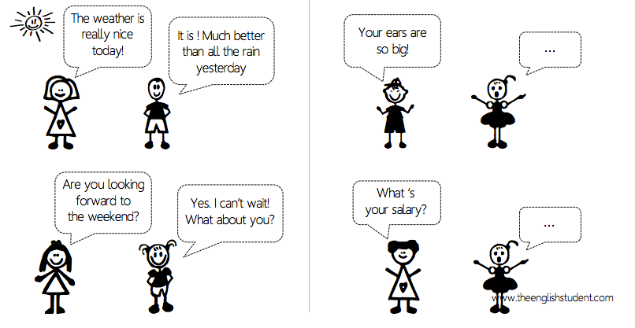**Here are four illustrations of people making small talk. Which one is a bad way to make a small talk?**



