Principles of Microeconomics Name:___Solution____________
ECON 101
Exam 1 Student ID:_________________
7-3-06

1. Economics deals with how
a. individuals make decisions to use scarce resources in order to satisfy their unlimited wants.
b. to run a business.
c. individuals become rich.
d. society can eliminate scarcity.
e. how to increase the profits of firms.

2. The opportunity cost of a choice is the
a. cost associated with making a choice.
b. value of the next best alternative which was not chosen.
c. fair market price of whatever is chosen.
d. amount paid to purchase whatever is chosen.
e. value of all the forgone alternatives not chosen.

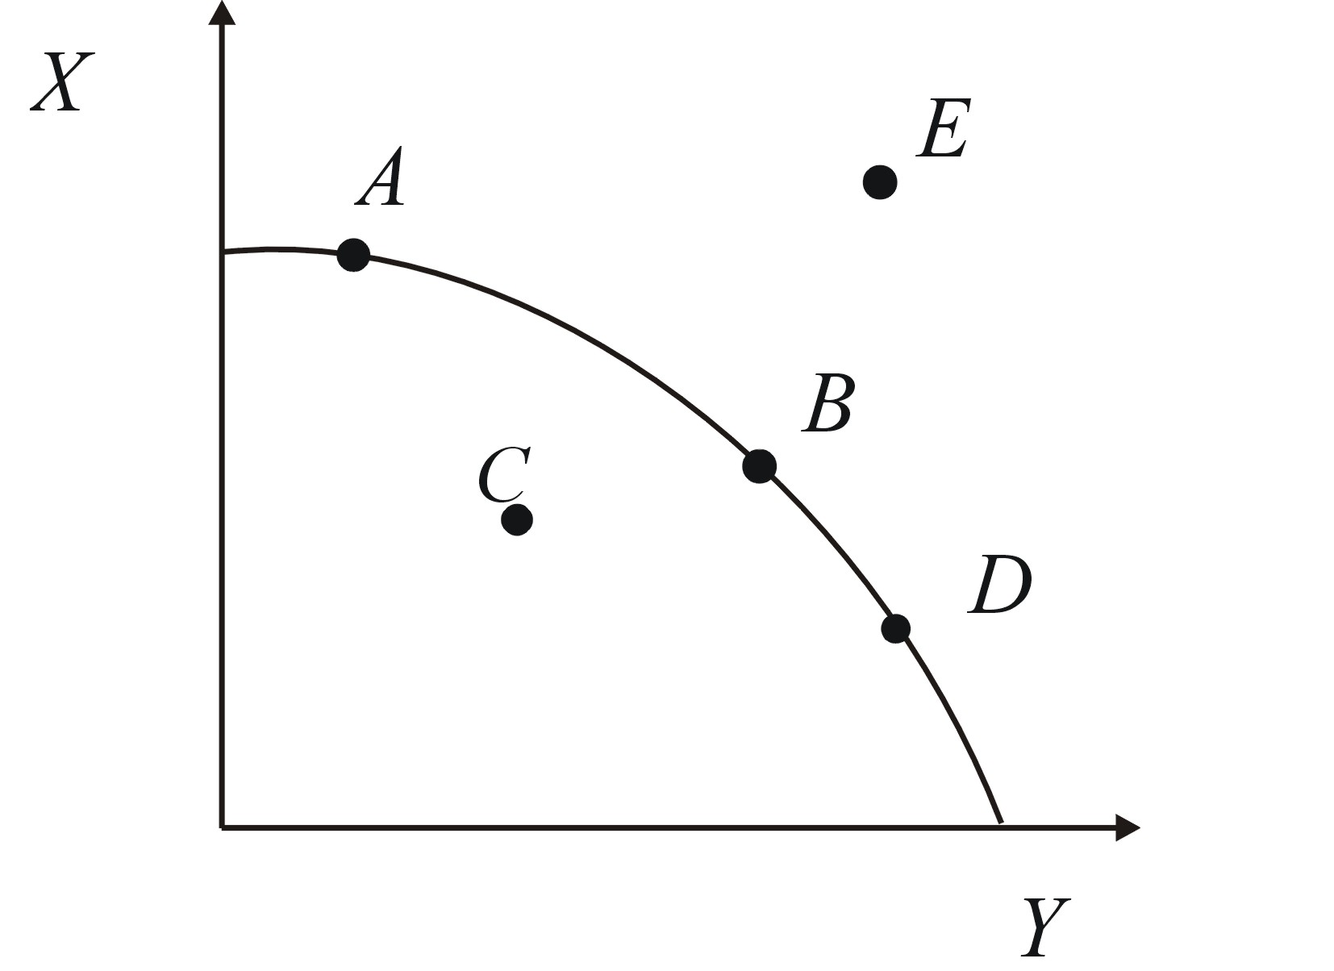
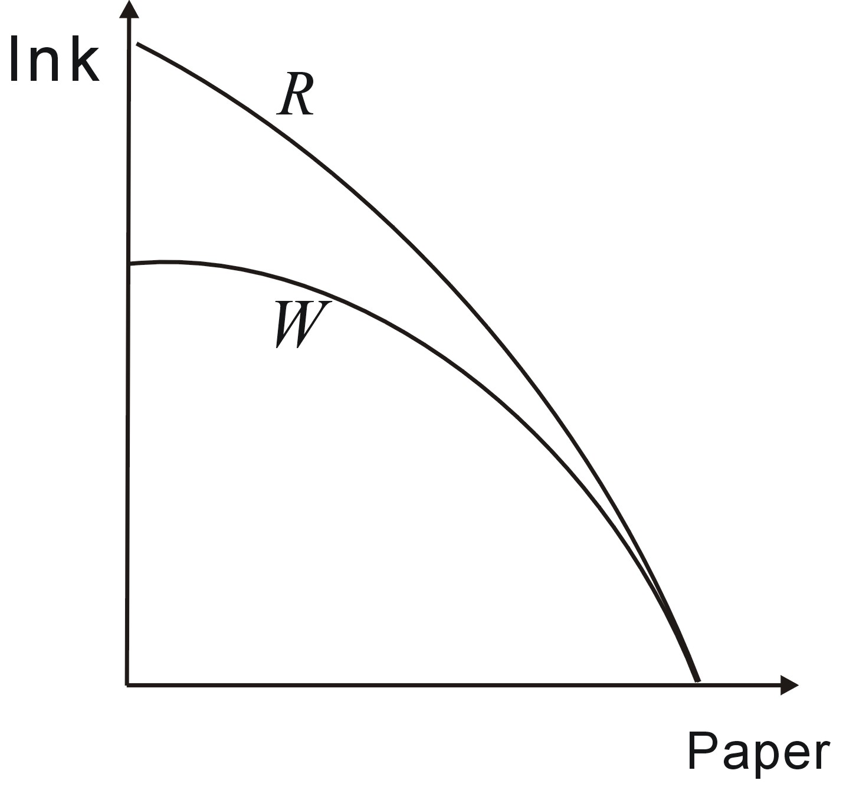
3. Which of the following would shift the production possibilities curve from curve "W" to "R"?
a. an improvement in the technology for producing ink
b. an improvement in the technology for producing paper
c. an improvement in widely applicable technology
d. an increase in the unemployment rate
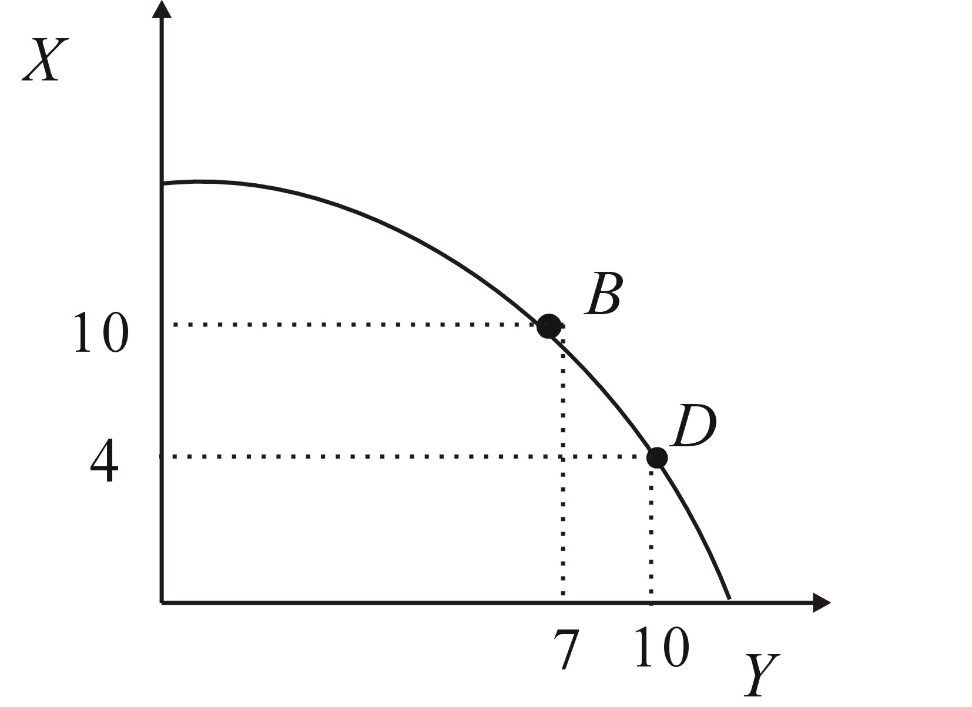
e. people demand more ink
4. The opportunity cost of moving from Point B to Point D is
a. 4 units of X.
b. 6 units of X.
c. 10 units of Y.
d. 3 units of Y.
e. 4 units of X and 3 units of Y.

5. Point E would most likely represent?
a. an unattainable point.
b inefficiency.
c. the best possible choice.
d. an equally acceptable alternative available to society.

6. The demand curve for pizza is downward sloping because
a. as the price of pizza rises, people will seek other, relatively cheaper alternatives, like hamburgers or tacos.
b. pizza is popular and there are more pizza parlors.
c. when fewer pizzas are produced, the money in people’s pizza budgets does not have to stretch as far.
d. when pizza prices rises, the price of other goods must also be rising, so people cannot afford to buy as much.

7. Which of the following will not increase the demand for hotdogs (i.e., which will not shift demand to the right)?
a. An expectation of a decline in the price of hotdogs in the future.
b. The price of hotdogs fall.
c. An increase in the price of a substitute, such as hamburgers.
d. A decrease in the price of a complement, such as hotdog buns.
e. A celebrity effectively promotes the healthful attributes of hotdogs.

8. When incomes are rising, new car sales increase while used car sales decrease. This indicates that
a. new and used cars are both normal goods.
b. new cars are normal goods while used cars are inferior goods.
c. new and used cars are complements.
d. new and used cars are both inferior goods.
e. new cars are inferior goods and used cars are normal goods.

9. Due to the recent success of ISU athletic teams, let’s say Cyclones T-Shirts become more popular. We would expect
a. both the equilibrium price and quantity to increase.
b. both the equilibrium price and quantity to decrease.
c. the equilibrium price to increase and the equilibrium quantity will decrease..
d. the equilibrium price to decrease and the equilibrium quantity will increase..

10. If nothing changes except that producers sell more of a good or service when the price increases, we know this is an example of the law of
a. increasing profit.
b. supply.
c. demand.
d. opportunity cost.
e. reduced real income.

11. If a drought in Ecuador reduces the amount of bananas grown, then
a. the demand curve of Ecuador bananas shifts to the left.
b. the demand curve of Ecuador bananas shifts to the right.
c. the supply curve of Ecuador bananas shifts to the left.
d. the supply curve of Ecuador bananas shifts to the right.

12. If technology improves in producing computers, what will happen to the equilibrium price and quantity of computers?
a. both the equilibrium price and quantity will increase.
b. both the equilibrium price and quantity will decrease.
c. the equilibrium price will increase and the equilibrium quantity will decrease.
d. the equilibrium price will decrease and the equilibrium quantity will increase.

Price | Quantity Demanded | Quantity Supplied
$.90 | 20 | 50
$.80 | 25 | 40
$.70 | 30 | 30
$.60 | 35 | 20
$.50 | 40 | 10

13. If price is $.50 in the table, there is
a. a surplus of 30 units.
b. a surplus of 40 units.
c. a shortage of 40 units.
d. a shortage of 30 units.
e. neither a surplus or shortage; the market is in equilibrium.

14. In the market represented in the table above, there will be upward pressure on prices, or in other words, a tendency for the price to increase, at which price level?
a. $.90
b. $.80
c. $.70
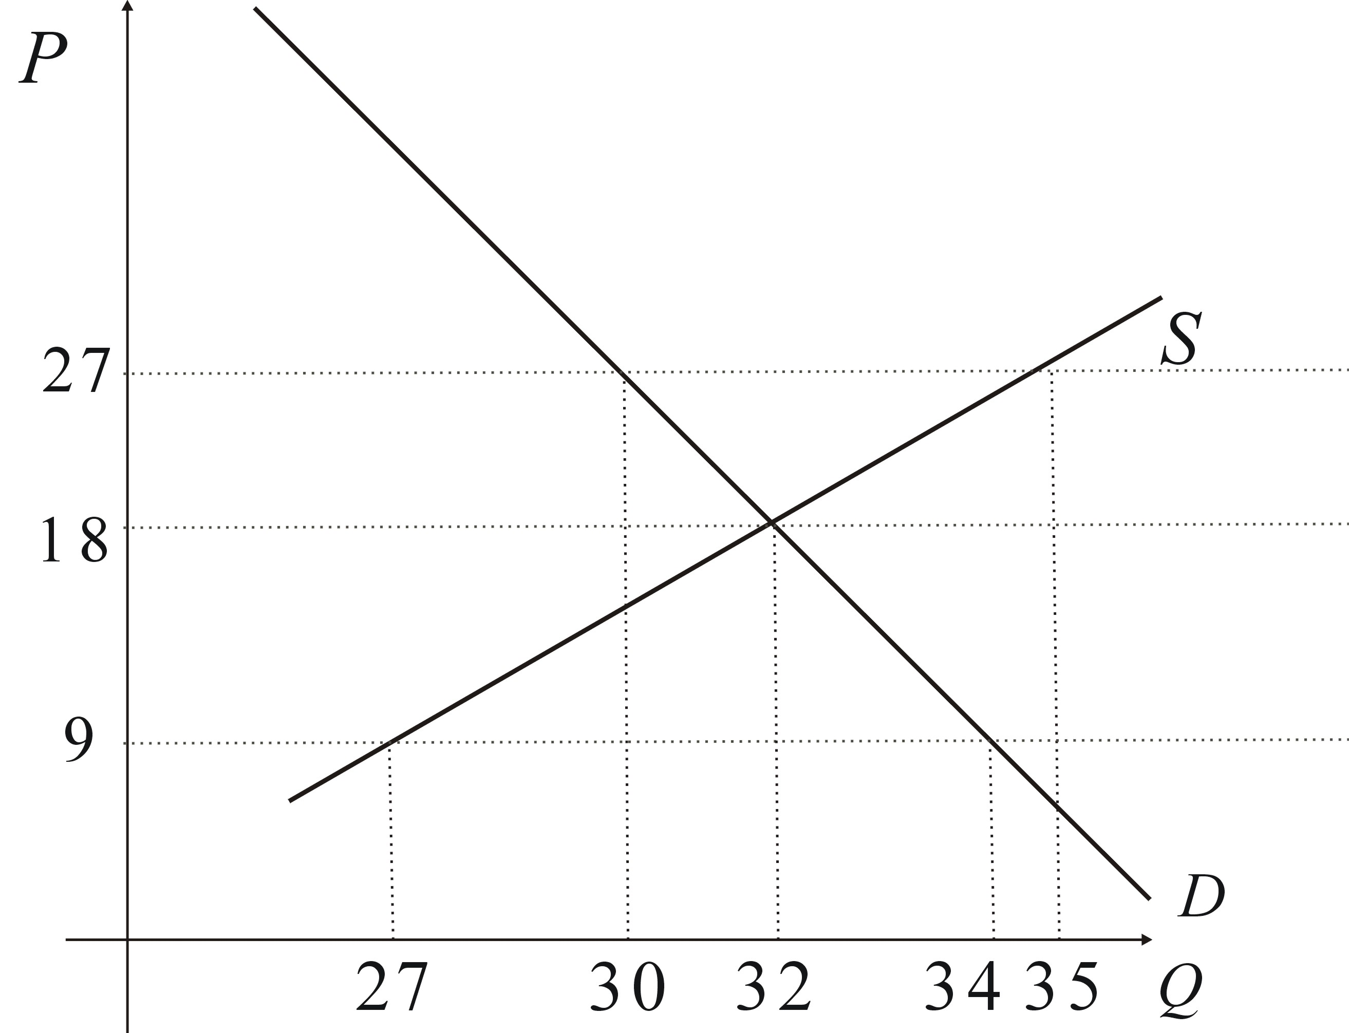
d. $.60

15. Refer to the figure to the right. A shortage of ______ units will result at a price of ______.

a. 34; $9
b. 32; $18
c. 30; $27
d. 5; $27
e. 7; $9

16. Refer to the diagram again. The equilibrium price in the market is
a. $27. b. $18. c. $9. d. approximately $42.

17. Refer to the diagram again. The equilibrium quantity is
a. 27 units. b. 30 units. c. 32 units. d. 34 units. e. 35 units.
18. T F Price ceilings, e.g., Rent controls on apartments typically cause shortages.
Price | Quantity Demanded | Quantity Supplied
$.90 | 20 | 50
$.80 | 25 | 40
$.70 | 30 | 30
$.60 | 35 | 20
$.50 | 40 | 10

19. Refer to the table. Calculate the elasticity of supply between $.80 and $.70. Indicate whether the supply curve is elastic, inelastic or unitary here. Write down the formula you are using before you begin your calculations, and show at least some work for partial credit.

20.Create your own supply and demand curves, and then assume that either supply or demand changes, but not both. Indicate the direction and change in either supply or demand that must have occurred to produce a decrease in equilibrium price and a decrease in equilibrium quantity. Your answer need not include numbers; however, the best answers will include a diagram with the curves and axes labeled.

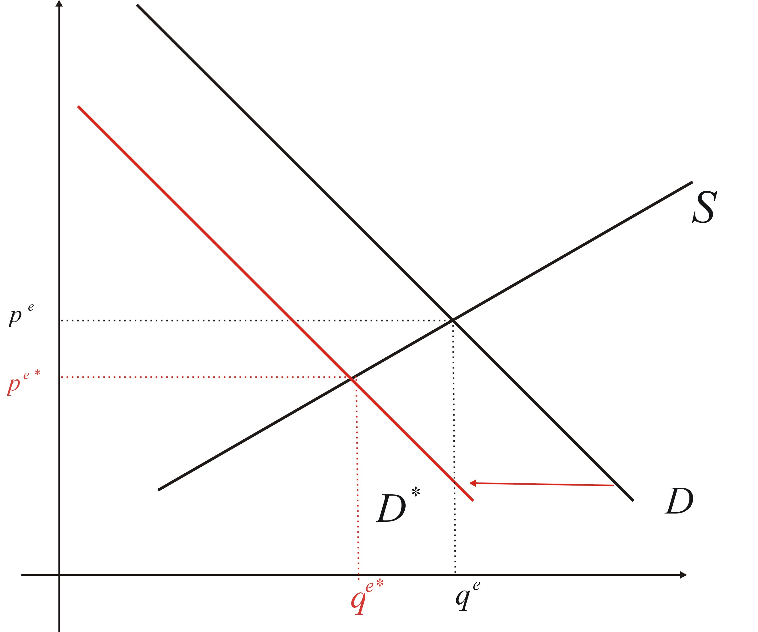
The original supply and demand curves are shown in black. We can see that in order to produce a reduction in both equilibrium price and equilibrium quantity we know this must have been caused by a decrease in demand. (i.e., the demand curve shifted to the left.)

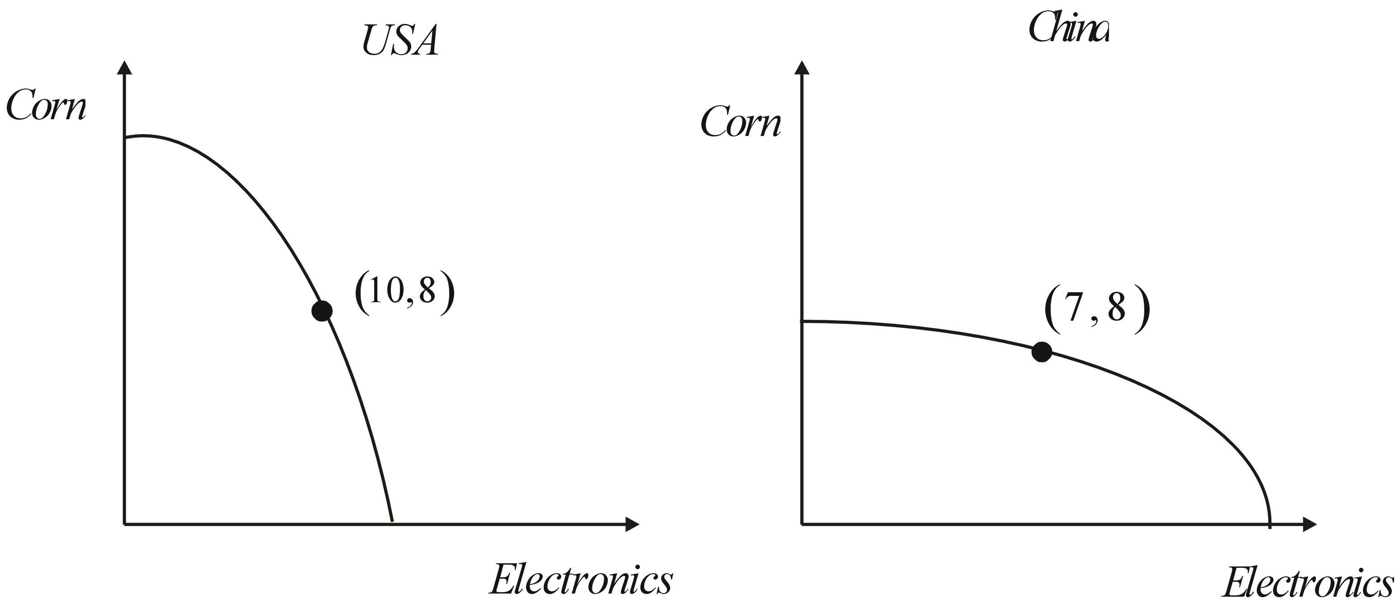
21. Suppose the production possibility frontiers above are the “corn, electronics” ppf’s for the United States and China, respectively. Also, suppose each country is producing at the points indicated in the graphs, and not trading with each other.
Your task is to suggest a trade that would likely be accepted by both parties. You don’t have to make up numbers to go along with your answer; however, but you might find it helpful. The best answers will use phrases like, “opportunity cost,” and “comparative advantage.”

We can see from the slopes of the two ppf’s that the United States has a comparative advantage in producing corn, and China has a comparative advantage in producing electronics. That is, the United States has a lower opportunity cost of producing corn than does China. Similarly, China has a lower opportunity cost of producing electronics than does the United States. So, a mutually beneficial trade will involve the United States specializing in the good in which they have a comparative advantage, which is corn. Likewise, China will specialize in the good in which they have a comparative advantage, electronics. Then the two countries will trade.

For example, suppose the U.S. produces at the point , and China produces at the point . Then the following trade is suggested. The U.S. will give China eight units of corn in exchange for seven units of electronics. Then the U.S. will be able to consume at the point , and China will be able to consume at the point . Both these points are outside the respective country’s ppf, so this trade is mutually beneficial.

