UMK, Biskra Level: 1st Year LMD
Module: Study Skills
Instructor: Mrs. Hebiret

Lesson: Note Taking Methods

Introduction
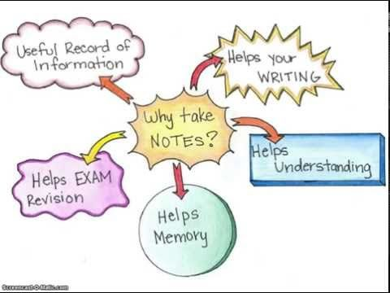
Definition of note-taking
Note taking is a technique used by students at university, so they record what their teachers say. It is a complex activity which combines reading and listening with selecting, summarizing and writing. The main principle in taking notes is that students do not use long sentences but simple and short ones. They may also use phrases, in addition to using abbreviations and symbols which are the main elements in note taking.
Benefits of note-taking
Note-taking is a useful strategy that students need to be trained to use it inside the classroom. It has several benefits: (a) through note-taking system, students would develop more analytic capacities through time in classroom; (b) notes anchor memory. Indeed, studies have shown that people may forget 50% of the perceived information within 24 hours, 80% in two weeks, and 95 % within one month if they do not take notes. When we take notes during a lesson, we are artificially lengthening the span of our working memory; and lastly (c) notes increases concentration. Taking notes make us actively involved with what is being said, makes us try to understand and extract meaning as we go along . If the skill takes all of our attention; leaving no space for the desire to doing nothing else, and we are aware, then we are really concentrating. If there is no challenge within the task; then, learners simply will feel boredom and total disinterest.
Note-taking methods
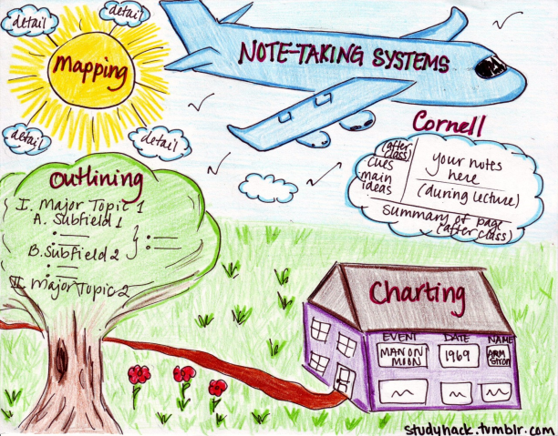
Taking notes is very essential while we perceive knowledge while listening, observing, discussing, or thinking, so that we will be able to build up a full account of all what we perceive. There are five major note taking methods which prove to be useful for students to utilize them along their learning process to facilitate comprehension, memorization and retention of knowledge for examination purposes. We are going to present them in details below.
2.1. Cornell Method
the Cornell note taking system was made popular by ,,,,,,,. an education professor at Cornell University. Cornell Note is helpful in class while reading text-book or listening to the teacher during the lecture.
Layout of the page
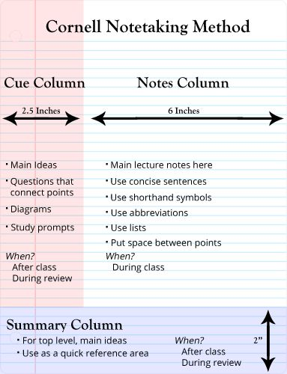

Cornell note-taking framework
1. Notes at the top of the page: The first column at the top of the page is where the course title, date, and name should be written, e.g. "Adjectives", Dr. Harmer, 15/3/2020".
2. Note Taking Area: Directly after writing the title of the lesson, the students are required to record lecture as fully and as meaningfully as possible. During the lecture, the students need to record in the Notes Column many meaningful facts and ideas, draw, insert lists, and use abbreviations as they can or need. It is important to SKIP a line when the instructor moves to a new idea.
3. Cue Column: After the lecture or reading a textbook, the students are required to go back to "note column" and pull out: main ideas, key points, important people, or dates, questions and write them in the "cue column". the aim of this section is to Recite, Review, and Reflect on the notes for examinations.
3.1. Questions: As soon after class as possible, formulate questions based on the notes in the right-hand column. Writing questions helps to clarify meanings, reveal relationships, establish continuity, and strengthen memory. Also, the writing of questions sets up a perfect stage for exam-studying later.
3.2. Recite: Cover the note-taking column with a sheet of paper. Then, looking at the questions or cue-words in the question and cue column only, say aloud, in your own words, the answers to the questions, facts, or ideas indicated by the cue-words.
3.3. Reflect: Reflect on the material by asking yourself questions, for example: “What’s the significance of these facts? What principle are they based on? How can I apply them? How do they fit in with what I already know? What’s beyond them?
3.4. Review: Spend at least ten minutes every week reviewing all your previous notes. If you do, you’ll retain a great deal for current use, as well as, for the exam.
4. Summaries: the bottom section is for the summary. this would be a few sentences that Sum up key notes.

Cornell note-taking sample 01: While Reading textbook
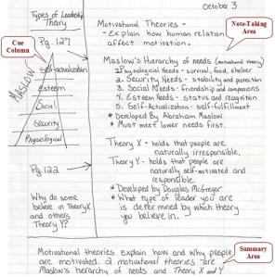
Cornell note-taking sample 02: While listening to the teacher
Practice
Based on the previous samples and in a separate paper, apply Cornell note-taking method to reading lesson, grammar lesson, or written expression of your choice. follow instructions carefully. use colors, drawing, diagrams, abbreviation, etc.

Charting note-taking method
One of the most effective note taking methods for university students when it comes to summarization of long content is that of the charting method. In charting note taking technique, the recorded information will be organized with appropriate headings in several columns in a table format. Each column represents a unique category which facilitates comparison. Students can use this method when they need to memorize a lot of information as a preparation for examination. one good example of charting note taking is presented below:
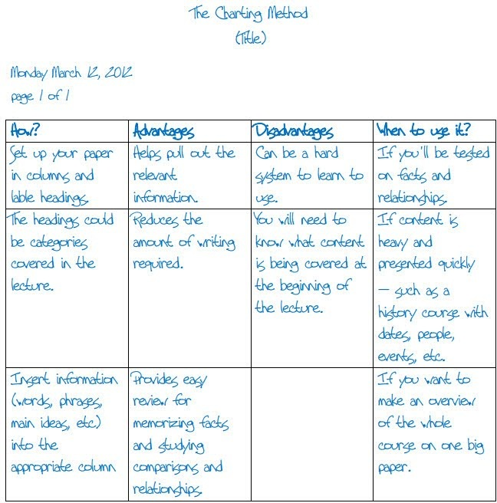
Exercise
Read the text below and then summarize the information using charting note-taking method.

William Shakespeare was an English poet, playwright, and actor. He was born on 26 April 1564 in Stratford-upon-Avon. His father was a successful local businessman and his mother was the daughter of a landowner. Shakespeare is widely regarded as the greatest writer in the English language and the world's pre-eminent dramatist. He is often called England's national poet and nicknamed the Bard of Avon. He wrote about 38 plays, 154 sonnets, two long narrative poems, and a few other verses, of which the authorship of some is uncertain. His plays have been translated into every major living language and are performed more often than those of any other playwright.

Marriage and career
Shakespeare married Anne Hathaway at the age of 18. She was eight years older than him. They had three children: Susanna, and twins Hamnet and Judith. After his marriage information about his life became very rare. But he is thought to have spent most of his time in London writing and performing in his plays. Between 1585 and 1592, he began a successful career in London as an actor, writer, and part-owner of a playing company called the Lord Chamberlain's Men, later known as the King's Men.

Retirement and death
Around 1613, at the age of 49, he retired to Stratford , where he died three years later. Few records of Shakespeare's private life survive. He died on 23 April 1616, at the age of 52. He died within a month of signing his will, a document which he begins by describing himself as being in "perfect health". In his will, Shakespeare left the bulk of his large estate to his elder daughter Susanna.

His work
Shakespeare produced most of his known work between 1589 and 1613. His early plays were mainly comedies and histories and these works remain regarded as some of the best work produced in these genres. He then wrote mainly tragedies until about 1608, including Hamlet, Othello, King Lear, and Macbeth, considered some of the finest works in the English language. In his last phase, he wrote tragicomedies, also known as romances, and collaborated with other playwrights.
Shakespeare's plays remain highly popular today and are constantly studied, performed, and reinterpreted in diverse cultural and political contexts throughout the world.

3. Outlining note-taking method

The outlining method is one of the best and most popular note-taking methods for university students. This method requires students to organize their notes in an outline format using bullet points, Roman numerals, letters, or decimals. Directly after this step, they need to write major ideas followed with sub-ideas below them, based on space indentation. To better understand the outlining note-taking format, see the image below.
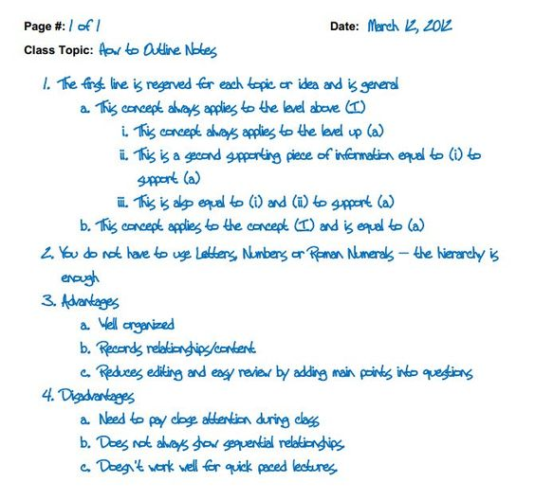
Practice
Based on the previous samples and in a separate paper, apply outlining note-taking method to reading lesson, grammar lesson, or written expression of your choice. follow instructions carefully. use color.
4. Mapping not-taking method

Mapping note-taking method is the means by which one organizes and records information for later review and study. It is an excellent method to summarize large sections of the course or reading assignments. This technique is useful for visual learners who struggle to study heavy lectures. It facilitates long term retention of information.
To start with, the student should write the main topic in the center of the page, then draw lines or arrows connecting the original topic to create sub-topics that represent different ideas. Subtopics can be branched out to represent more detailed concepts. Each note represents different idea. To better understand mind map note taking format, see the image below:

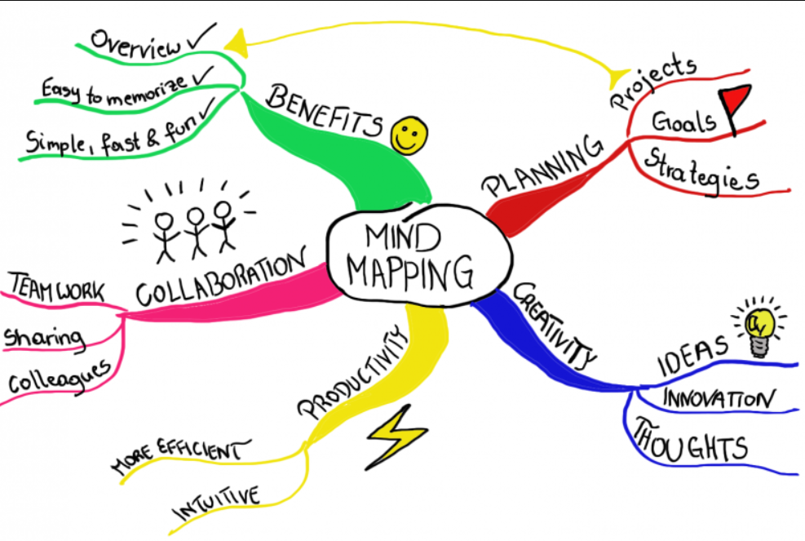

Practice

Convert the following written text into mind map note taking format. Do not forget to write the title of the text above the map.

Structure of the human needs theory
Maslow’s theory of human needs is a hierarchical structure. The theory states that when our basic needs are met, humans begin to develop loftier desires. Maslow categorized these needs into five levels:
Physiological needs. These constitute the greatest part of the pyramid because they’re related to our survival and reproduction. At this level we find needs like homoeostasis, the body’s effort to maintain a normal and constant state. In addition, we find needs such as food, third, maintaining an adequate body temperature, sex, and breathing in this level.
Security needs. In this part of the pyramid we seek a sense of order and stability. We need stability, employment, resources, health, and protection. These desires are related to our fear of losing control over our lives.
Social needs. Once we meet our physiological and security needs, our motivation focuses on the social part of our lives. We desire company with other humans and its affective aspect. In this level are needs such as communicating with others, establishing friendships, expressing and receiving affection, living in community, and belonging to and being accepted by a group.
The need for recognition, also known as self-esteem. In this level we need to feel appreciated, to have prestige, and to stand out within our social group. Maslow also includes self-esteem and self-respect in this section.
Self-improvement needs. We can call these needs “self-realization needs“. This section contains the most difficult goals to achieve. Maslow speculates that at this level humans want to transcend their own mortality and leave their mark on the world. Other desires at this level include our need to develop talents and carry out our own work. These needs are related to our moral and spiritual development as we search for a mission in life.

5. Sentence note-taking method
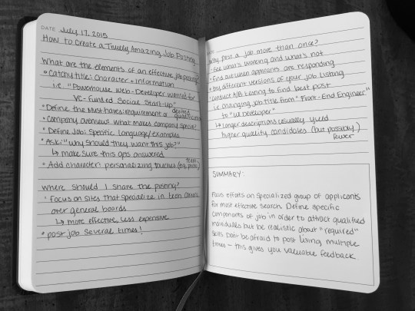
The sentence note-taking method is like free writing for notes. The aim of this technique is to write down thoughts as quickly as possible. Because speed is the focus, sentence method format is kept to a minimum. This means every new thought is written on a new line. So that, it is slightly more organized, but there is no way to pick out major or minor points from a sequence.

This method works well with lectures that lack organization and with information that is presented very quickly. Because this system lacks organization, it can hard to understand unless the students review and edit the recorded information.
Conclusion
Note-taking is a crucial part of every students' life and the way they do it can have a great impact on their studies and results. If the students' notes are messy, it can be difficult to review them and find important information before tests and exams. This is why they should consider these five different ways to take notes effectively. Not only they will deepen their understanding of the information, speed up their revision, and improve their recall, but they will also help them stay disciplined and organized, maximizing their chances to fetch good marks.

